**3GPP TSG-SA5 Meeting #157 *S5-246008***

Hyderabad, India, 14 - 18 October 2024

**Source: Rakuten Mobile**

**Title: Add declarative section and evaluation of solutions for modification of a NF deployment instance**

**Document for: Approval**

**Agenda Item: 6.19.6**

# 1 Decision/action requested

***For approval***

# 2 References

[1] 3GPP TR 28.869: “Study on cloud aspects of management and orchestration”.

# 3 Rationale

Added a section to discuss usage of declarative descriptor and another for evaluation of solutions for modification of a NF deployment instance.

# 4 Detailed proposal

It is proposed to make the following changes to TR 28.869 [1].

|  |
| --- |
| **1st change** |

##### 5.2.4.3.2 Use of deployment management reference point based on declarative descriptor

In this solution, as illustrated in figure 5.2.4.3.2-1, the 3GPP management system interacts with an orchestration and management entity using the deployment management reference point as described in clause 5.2.1.3 for modification of a NF deployment instance based on declarative descriptor.

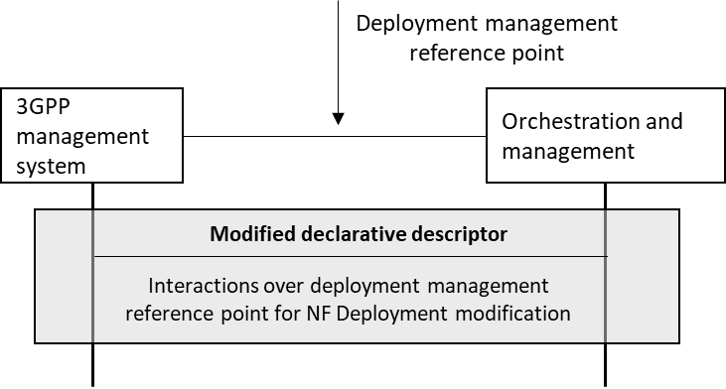

Figure 5.2.4.3.2-1. interaction between 3GPP management system and orchestration and management system using deployment management reference point based on declarative descriptor

The modified requirements of the deployment of a NF deployment instance are conveyed from the 3GPP management system to the orchestration and management system via a modified version of the declarative descriptor that was used for creation of the NF deployment instance. It shall be possible to reference to modified parts, or different parts in an existing declarative descriptor to purpose the declarative modification request.

|  |
| --- |
| **2nd change** |

#### 5.2.4.4 Evaluation of solutions

The proposed solution 5.2.4.3.1 defines the lifecycle operation for the modification of a NF deployment instance by a 3GPP management system using the deployment management reference point. In the proposed solution 5.2.4.3.2, the descriptor containing the deployment requirements for the NF deployment is transferred or referenced over the deployment management reference point. The orchestration and management entity processes the requirements in the descriptor, updates the NF deployment by modifying the resources allocated to the NF deployment. The deployment management declarative approach (5.2.4.3.2) using the reference point (5.2.4.3.1) enables interoperability and decoupling between the 3GPP management system and the orchestration entity and fulfils the use case requirements expressed in clause 5.2.4.2.

|  |
| --- |
| **End of changes** |