3GPP TSG-SA5 Meeting #157 S5-245299
Hyderabad, India, 14 - 18 October 2024

Source: Huawei

Title: Rel-19 pCR TR 28.858 add use case of managing NWDAF inference function

Document for: Approval
Agenda Item: 6.19.1

1 Decision/action requested
The group is asked to discuss and agree on the proposal.

2 References
[1] SP-231780 " New SID: Study on AI/ML management - phase 2".
[2] 3GPP TS 28.105 " Artificial Intelligence / Machine Learning (AI/ML) management"
[3] 3GPP TS 28.541: " Management and orchestration; 5G Network Resource Model (NRM); Stage 2 and stage 3"

3 Rationale
TS 28.105 [1] define the AI/ML functionalities management scenarios are described to support managing where the ML model training and AI/ML inference are both located in CN in clause 4a.2 as following, and it states that for NWDAF, the ML training function can be located in the MTLF of the NWDAF or the management system, the AI/ML inference function is in the AnLF.
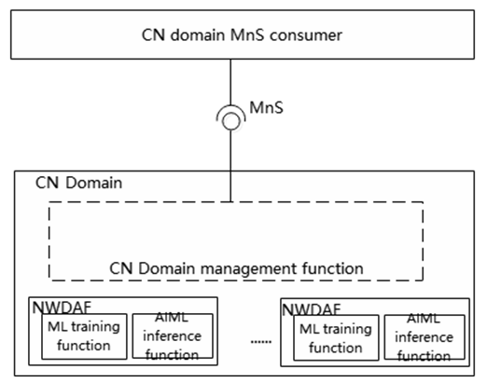
In TS 28.541, the NWDAFFunction IOC defines the attribute NwdafInfo including MlAnalyticsInfo with flCapabilityType and flTimeInterval.
=================================extract from TS 28.541 [2]=================================

5.3.18 NWDAFFunction

5.3.18.1 Definition
This IOC represents the NWDAF function in 5GC. For more information about the NWDAF, see TS 23.501 [2]. Several attributes (including "nwdafInfo", " administrativeState " and "ManagedNFProfile.servingScope") are used to control the functionalities (identified by nwdafEvent defined in TS 29.520 [85]) of the NWDAF instance.
The attribute "ManagedNFProfile.servingScope" is used to represent specified certain geographical area(s) can be served by the NWDAF instance.
The attribute "NwdafInfo.taiList" and " NwdafInfo.taiRangeList " is used to represent specified certain tracking area(s) can be served by the NWDAF instance.

5.3.18.2 Attributes
The NWDAFFunction IOC includes attributes inherited from ManagedFunction IOC (defined in TS 28.622[30]) and the following attributes:

Attribute name | S | isReadable | isWritable | isInvariant | isNotifyable
pLMNInfoList | M | T | T | F | T
sBIFQDN | M | T | T | F | T
managedNFProfile | M | T | T | F | T
commModelList | M | T | T | F | T
networkSliceInfoList | CM | T | T | T | T
nwdafInfo | M | T | T | F | T
administrativeState | O | T | T | F | T
nwdafLogicalFuncSupported | O | T | F | F | T

5.3.142e MlAnalyticsInfo <<dataType>>

5.3.142e.1 Definition
This data type represents ML Analytics Filter information supported by the Nnwdaf_MLModelProvision service (See TS 29.510 [23]).

5.3.142e.2 Attributes
Attribute name | S | isReadable | isWritable | isInvariant | isNotifyable
mlAnalyticsIds | CM | T | T | F | T
sNSSAIList | O | T | T | F | T
trackingAreaList | O | T | T | F | T
mlModelInterInfo | O | T | T | F | T
flCapabilityType | O | T | T | F | T
flTimeInterval | O | T | T | F | T

=================================end of extract=================================
In addition，in TS 28.541, the AnLFFunction IOC states that the AnLF is a type of AI/ML inference function.
=================================extract from TS 28.541 [2]=================================

5.3.226 AnLFFunction

5.3.226.1 Definition
This IOC represents the Analytics logical function (AnLF) contained by NWDAF (see TS 23.288 [101]).
The AnLF may be supported by AI/ML, and in this case the AnLF is a type of AI/ML inference function.

5.3.226.2 Attributes
This IOC includes attributes inherited from ManagedFunction (defined in TS 28.622[30]) and the following attributes:
Attribute name | S | isReadable | isWritable | isInvariant | isNotifyable
activationStatus | M | T | F | F | T

=================================end of extract=================================
According to these definitions, it can be seen that the MnS consumer can manage and configure the NWDAF function and AnLF function related with ML model and inference. We need to reflect this use case in the TS 28.105 to make it clear.
This contribution proposes to add the use case and requirement of Managing NWDAF inference function.

4 Detailed proposal
Start of First change

5.5 AI/ML inference

5.5.x AI/ML inference capability configuration management for 5GC

5.5.x.1 Description
In TS 28.105 [2], the existing AI/ML functionalities management scenarios are described to support managing where the ML model training and AI/ML inference are both located in CN.

5.5.x.2 Use cases

5.5.x.2.1 Managing NWDAF inference function
An NWDAF may use one or more ML models or AI/ML Inference Functions to derive analytics results. The MnS consumer may configure the federated learning capability type supported by NWDAF containing MTLF, and configure the time window at which the indicated federated learning capability type supported by NWDAF MTLF is available.
For the AnLF management, the MnS consumer may activate and deactivate an AnLF for this type of AI/ML inference function

5.5.x.3 Potential Requirements
REQ-AIML_INF-01: The MnS producer should enable an authorized MnS consumer to manage the ML model and/or AI/ML Inference Function related to NWDAF functions and AnLF function.

5.5.x.4 Possible solutions
The exsting NWDAFFunction IOC and AnLFFunction defined in TS 28.541[4] can be reused to support managing NWDAF and AnLF function. In TS 28.541 [4] define the NWDAFFunction IOC and AnLFFunction, and it defines the attribute NwdafInfo including MlAnalyticsInfo with ML model information (e.g. mlModelInterInfo) and FL related attributes (e.g. flCapabilityType and flTimeInterval). That means the MnS consumer have capability to manage the ML model and/or AI/ML inference function related to NWDAF functions.

End of First change

