3GPP TSG-SA5 Meeting #157 S5-245529
Hyderabad, India, 14- 18 Oct 2024

Source: Rakuten Mobile

Title: pCR 28.869 Add evaluation of solutions for data streaming for cloud native network function use case

Document for: Approval
Agenda Item: 6.19.6

1 Decision/action requested
The group is asked to discuss and approve.

2 References
[1] 3GPP TR 28.869 v0.4.0 Study on cloud aspects of management and orchestration
[2] SP-231730 New SID: Study on Cloud Aspects of Management and Orchestration

3 Rationale
This contribution evaluation of solution for WT-2 use case 2, data streaming for cloud native network function.

4 Detailed proposal
It proposes to make the following changes to TR 28.869 [1].

1st Change

5.2.2.1 Description
Currently 3GPP management system support WebSocket based data streaming for PM, tracing and analytic [10] which establish point-to-point connection between the streaming data reporting MnS consumer and MnS producer.
There are newly developed and evolved industry solutions for data streaming in cloud-native environment that leverage industry standards, e.g. message bus-based solution. Such industry solutions including WebSocket and non-WebSocket based can be used to address challenges related to NF Deployment instances e.g. for hybrid cloud deployments that deploy cloud native applications with hyperscale cloud providers. This use case considers the scenarios where the 3GPP management architecture is flexible to support use of cfor the streaming data reporting of NF Deployment instance.

5.2.2.2 Potential requirements
PREQ-FS_Cloud-OAM-01 The 3GPP management system should have the capability enabling the MnS consumer to configure the MnS producer for the streaming of management data.
Note: The management data includes performance measurements or KPIs defined in TS 28.552[14] and TS 28.554[15], trace reporting data and analytic reporting data [10].
PREQ-FS_Cloud-OAM-02 The 3GPP management system should have the capability enabling the MnS producer to stream management data to the MnS consumer with cloud-native data streaming mechanisms based on industry solutions not limit to WebSocket.

2nd Change

5.2.2.3 Potential solutions

5.2.2.3.1 Solution #1: Management data streaming based on message bus
This potential solution proposes the addition of a new reporting method for management data for network functions running in the cloud. The solution proposes the use of message bus for the reporting of management data from the MnS producer to the MnS consumer as shown in figure 5.2.2.3.1-1.
MnS producer
MnS consumer
Message bus communication

Management data job control (e.g., PM or trace job creation, PM metric subscription, conveying end-point information)

Figure 5.2.2.3.1-1: Potential solution for management data streaming based on message bus
The proposed solution enables MnS producer(s) to stream management data to the message bus when ready while also enabling the MnS consumer(s) to consume the data from the message bus whenever they need to. There is no persistent connection and keep-alive message needed. In addition, this potential solution decouples the production of management data from the consumption of management data such that they can be auto-scaled independently. Furthermore, the message bus communication provides strong fault protection through redundant message bus communication endpoints and auto fail-over capabilities.
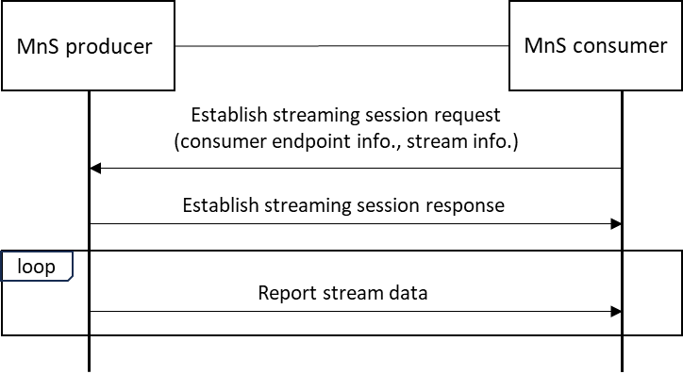
Figure 5.2.2.3.1-2: Interactions between MnS producer and MnS consumer for management data streaming based on message bus
The interactions between MnS producer and MnS consumer for management data streaming based on message bus is illustrated in in Figure 5.2.2.3.1-2. The MnS consumer send request to the MnS producer to establish a message bus streaming session containing the consumer’s message bus communication endpoint information and stream information (the same streamInfoList in 3GPP TS 28.532, clause 12.5). The MnS producer after established the message bus streaming session sends response to the MnS consumer. The MnS producer start reporting the stream data to the message bus communication endpoint(s) provided by the MnS consumer. New streaming data reporting service APIs maybe defined in 3GPP TS 28.532 for the above interactions, or the existing streaming data reporting service APIs maybe modified.
There are multiple options of streaming protocols can be used for the management data streaming reporting, e.g. Kafka, HTTP and gRPC etc. The supported streaming protocol(s) by the MnS producer can be informed to the MnS consumer before the streaming session establishment.

If a MnS producer support WebSocket only for cloud-native NF data streaming, the existing streaming data reporting service APIs (3GPP TS 28.532) can be used.
3rd Change

5.2.2.4 Evaluation of solutions
The proposed solution adds new management data streaming solution based on message bus technology for the reporting of management data from the MnS producer to the MnS consumer. It provides efficient, scalable, fault-tolerant streaming solution in cloud native deployment environment. The solution is technology and implementation agnostic allowing multiple message bus technologies and communication protocol to be used. The interaction between MnS producer and MnS consumer are analysed. There is certain impact to the streaming data reporting services APIs defined in 3GPP TS 28.532 but there is no impact to the service-based architecture of the 3GPP management system. The solution can also coexist with WebSocket based data streaming solutions, allowing multiple options, WebSocekt or Non-WebSocket based, to be used for cloud-native NF data streaming. It fulfils the use case requirements expressed in clause 5.2.2.2.

End of change

