**3GPP TSG- Meeting # *S5-245076***

**, , -**

|  |  |  |  |  |  |  |  |  |
| --- | --- | --- | --- | --- | --- | --- | --- | --- |
| *CR-Form-v12.3* | | | | | | | | |
| **CHANGE REQUEST** | | | | | | | | |
|  | | | | | | | | |
|  |  | **CR** |  | **rev** | **1** | **Current version:** |  |  |
|  | | | | | | | | |
| *For* [***HE******LP***](http://www.3gpp.org/3G_Specs/CRs.htm#_blank)*on using this form: comprehensive instructions can be found at* [*http://www.3gpp.org/Change-Requests*](http://www.3gpp.org/Change-Requests)*.* | | | | | | | | |
|  | | | | | | | | |

|  |  |  |  |  |  |  |  |  |
| --- | --- | --- | --- | --- | --- | --- | --- | --- |
| ***Proposed change affects:*** | UICC apps |  | ME |  | Radio Access Network | **X** | Core Network |  |

|  |  |  |  |  |  |  |  |  |  |  |
| --- | --- | --- | --- | --- | --- | --- | --- | --- | --- | --- |
|  | | | | | | | | | | |
| ***Title:*** | Rel-16 CR TS 28.541 Correct the allow value of numberOfPreambleSent for RACH | | | | | | | | | |
|  |  | | | | | | | | | |
| ***Source to WG:*** | Huawei | | | | | | | | | |
| ***Source to TSG:*** | S5 | | | | | | | | | |
|  |  | | | | | | | | | |
| ***Work item code:*** | TEI16 | | | | |  | ***Date:*** | | | 2024-07-29 |
|  |  | | | |  | |  | | |  |
| ***Category:*** | **F** |  | | | | | ***Release:*** | | | Rel-16 |
|  | *Use one of the following categories:* ***F*** *(correction)* ***A*** *(mirror corresponding to a change in an earlier release)* ***B*** *(addition of feature),* ***C*** *(functional modification of feature)* ***D*** *(editorial modification)*  Detailed explanations of the above categories can be found in 3GPP [TR 21.900](http://www.3gpp.org/ftp/Specs/html-info/21900.htm). | | | | | | | | *Use one of the following releases: Rel-8 (Release 8) Rel-9 (Release 9) Rel-10 (Release 10) Rel-11 (Release 11) … Rel-15 (Release 15) Rel-16 (Release 16) Rel-17 (Release 17) Rel-18 (Release 18)* | |
|  |  | | | | | | | | | |
| ***Reason for change:*** | | * The proxyClass name “NRCellDU” of NRM for DRACH management is incorrect. * According to RAN definition in TS 38.331, the allow value of Max number of preambles Sent is   ENUMERATED {n3, n4, n5, n6, n7, n8, n10, n20, n50, n100, n200}  The defintion of attribute numberOfPreamblesSent is inconsistent with that in RAN. | | | | | | | | |
|  | |  | | | | | | | | |
| ***Summary of change:*** | | * Correct the allowvalue of numberOfPreamblesSent. * Correct the typo of DRACH NRM. | | | | | | | | |
|  | |  | | | | | | | | |
| ***Consequences if not approved:*** | | The RACH Function would not be possible. | | | | | | | | |
|  | |  | | | | | | | | |
| ***Clauses affected:*** | | 4.2.1.1, 4.4.1 | | | | | | | | |
|  | |  | | | | | | | | |
|  | | **Y** | **N** |  | | | |  | | |
| ***Other specs*** | |  | **X** | Other core specifications | | | | TS/TR ... CR ... | | |
| ***affected:*** | |  | **X** | Test specifications | | | | TS/TR ... CR ... | | |
| ***(show related CRs)*** | |  | **X** | O&M Specifications | | | | TS/TR ... CR ... | | |
|  | |  | | | | | | | | |
| ***Other comments:*** | | Forge link: https://forge.3gpp.org/rep/sa5/MnS/-/merge_requests/1291 | | | | | | | | |
|  | |  | | | | | | | | |
| ***This CR's revision history:*** | |  | | | | | | | | |

|  |
| --- |
| **1st modified section** |

### 4.2.1 Class diagram for gNB and en-gNB

#### 4.2.1.1 Relationships

This clause depicts the set of classes (e.g. IOCs) that encapsulates the information relevant for this gNB and en-gNB. For the UML semantics, see 3GPP TS 32.156 [43]. Subsequent clauses provide more detailed specification of various aspects of these classes.

The model fragments are for management representation of gNB and en-gNB for all NG-RAN deployment scenario as listed below:

- Non-split NG-RAN deployment scenario, represents the gNB defined in 3GPP TS 38.401[4]. In this scenario, a gNB is represented by a combination of a GNBCUCPFunction, one or more GNBCUUPFunctions and one or more GNBDUFunctions.

- 2-split NG-RAN deployment scenario, represents the gNB consist of gNB-CU and gNB-DU defined in 3GPP TS 38.401[4] clause 6.1.1. In this scenario, a gNB-CU is represented by a combination of a GNBCUCPFunction and one or more GNBCUUPFunctions, whereas a gNB-DU is represented by a GNBDUFunction.

- 3-split NG-RAN deployment scenario, represents the gNB consist of gNB-CU-CP, gNB-CU-UP and gNB-DU defined in 3GPP TS 38.401[4] clause 6.1.2. In this scenario, a gNB-CU-CP is represented by a GNBCUCPFunction, a gNB-CU-UP is represented by a GNBCUUPFunction, and a gNB-DU is represented by a GNBDUFunction.

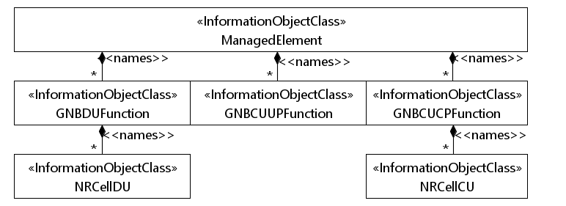

Figure 4.2.1.1-1: NRM for all deployment scenarios

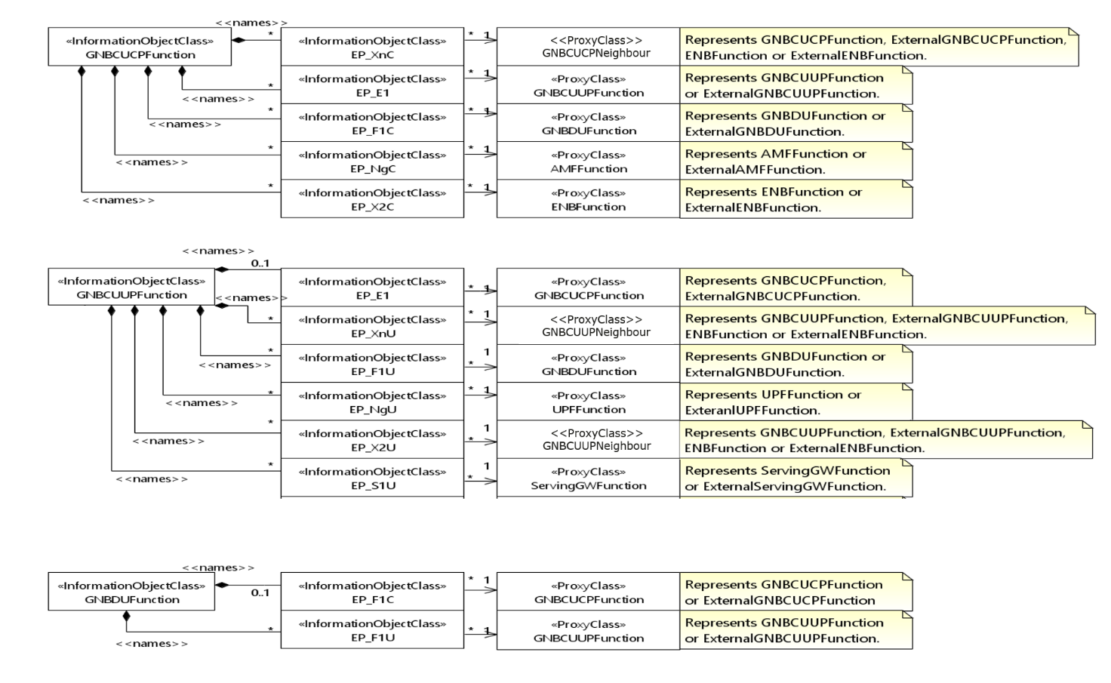

Figure 4.2.1.1-2: NRM for EPs for all deployment scenarios

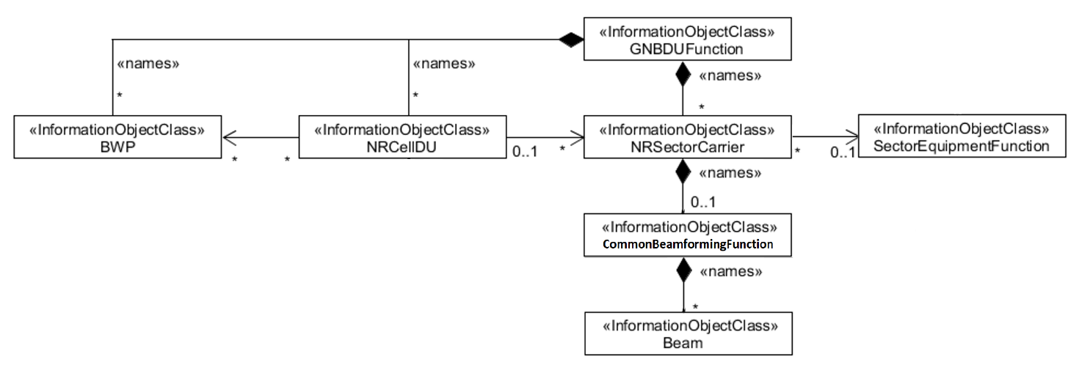

Figure 4.2.1.1-3: NRM for <<IOC>>NRSectorCarrier and <<IOC>>BWP for all deployment scenarios

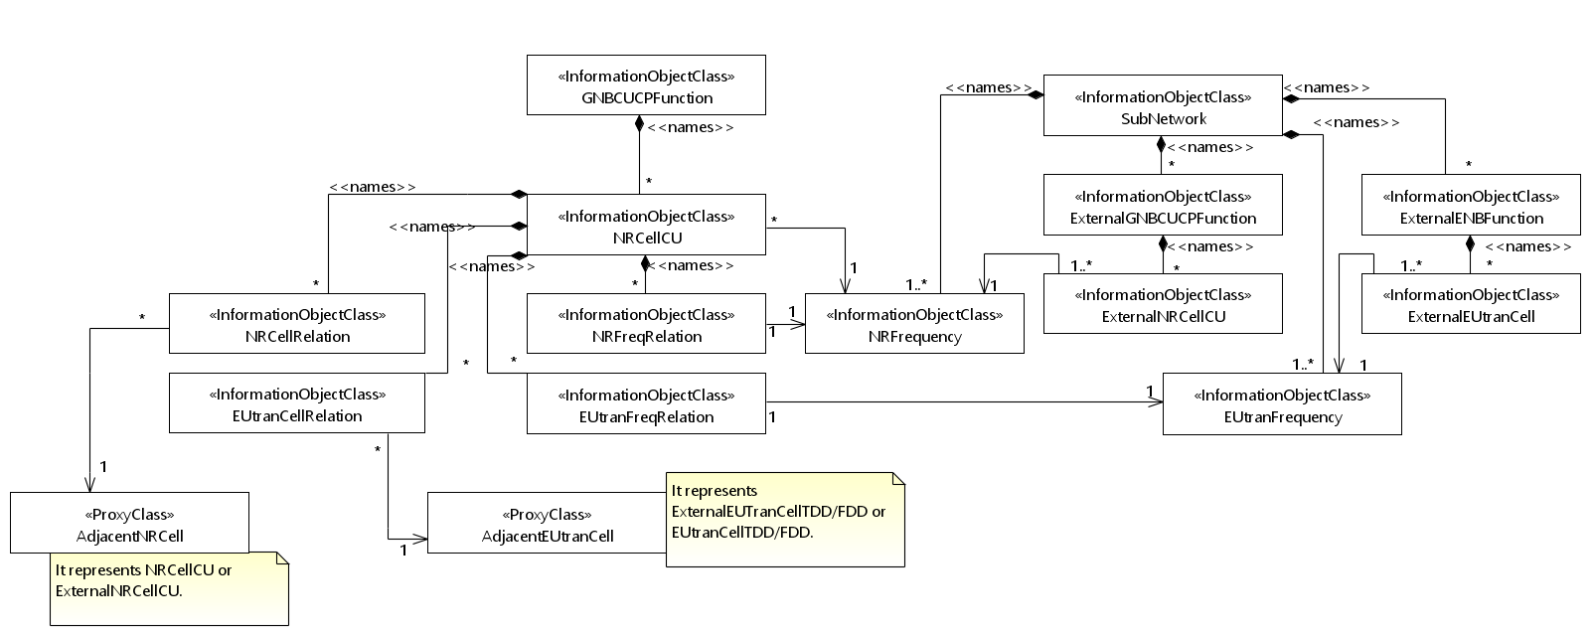

Figure 4.2.1.1-4: Cell Relation view for all deployment scenarios

NOTE 1: The above NRM fragment uses SubNetwork to hold both NR and LTE external entities and frequencies.

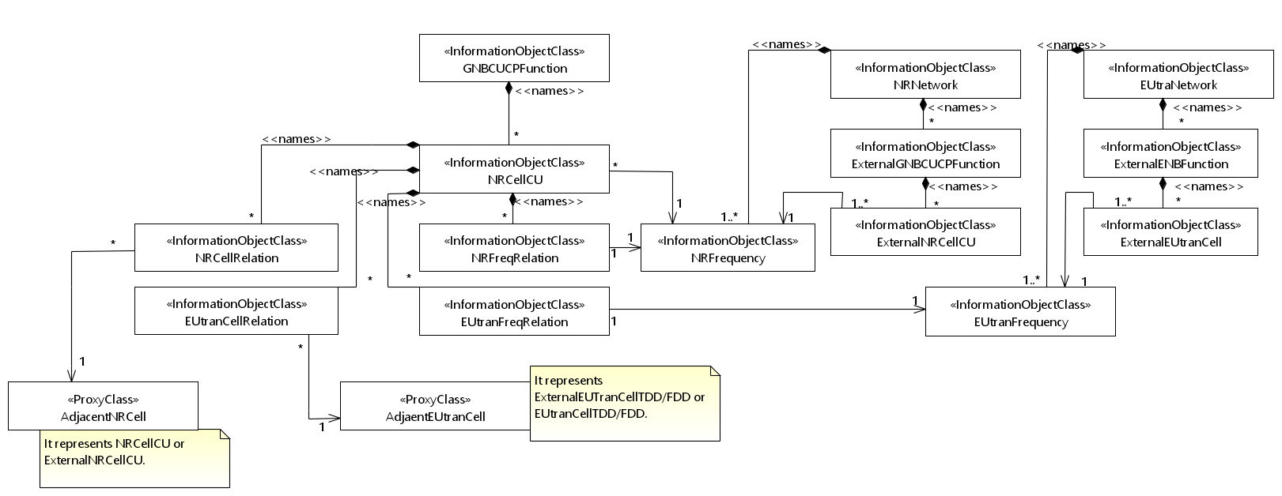

Figure 4.2.1.1-5: Cell Relation view for all deployment scenarios

NOTE 2: The above NRM fragment uses NRNetwork to hold NR external entities and frequency and using EUtraNetwork to hold LTE external entities and frequency. The NRNetwork and EUtraNetwork are subclasses of SubNetwork (defined in 3GPP TS 28.622 [30]) with no additional attributes. The reason using NRNetwork and EUtraNetwork is for a clean separation of NR external entities and frequency and LTE external entities and frequency.



Figure 4.2.1.1-6: NRM fragment for abstract RRM Policies



**Figure 4.2.1.1-7a: NRM fragment for RRMPolicyRatio**

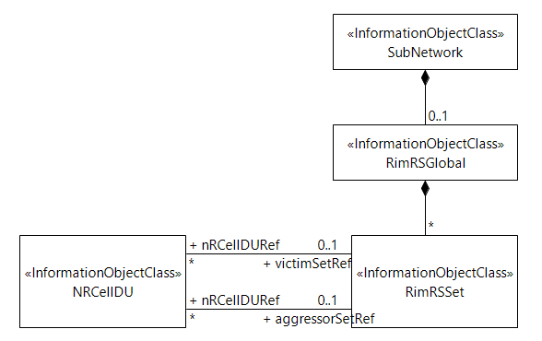

Figure 4.2.1.1-7: NRM fragment to support RIM

Figure 4.2.1.1-8 shows the NRM fragment for pre-configured 5QIs in NG-RAN.



Figure 4.2.1.1-8: NRM fragment for pre-configured 5QIs in NG-RAN

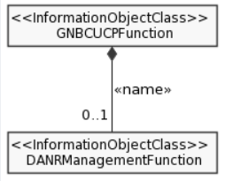

Figure 4.2.1.1-9: NRM fragment for DANR Management

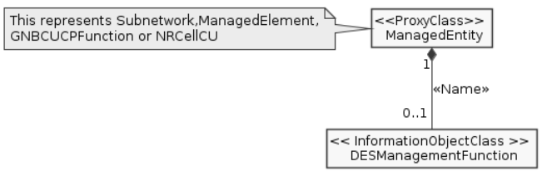

Figure 4.2.1.1-10: NRM fragment for DES Management

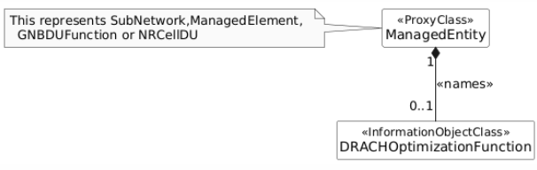

Figure 4.2.1.1-11: NRM fragment for DRACH Management



Figure 4.2.1.1-12: NRM fragment for DMRO Management



Figure 4.2.1.1-13: NRM fragment for DPCI Management

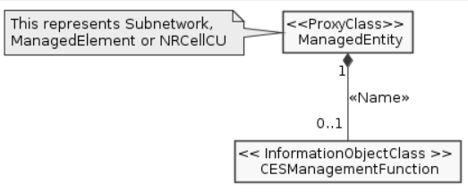

Figure 4.2.1.1-14: NRM fragment for CES Management

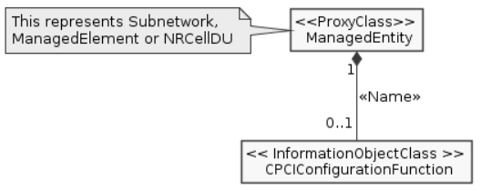

Figure 4.2.1.1-15: NRM fragment for CPCI Management

Figure 4.2.1.1-16 shows the NRM fragment for dynamically assigned 5QIs in NG-RAN.



Figure 4.2.1.1-16: NRM fragment for dynamically assigned 5QIs in NG-RAN

|  |
| --- |
| **End of change** |