**3GPP TSG- Meeting #**

**, , -**

|  |  |  |  |  |  |  |  |  |
| --- | --- | --- | --- | --- | --- | --- | --- | --- |
| *CR-Form-v12.3* | | | | | | | | |
| **CHANGE REQUEST** | | | | | | | | |
|  | | | | | | | | |
|  |  | **CR** |  | **rev** | **1** | **Current version:** |  |  |
|  | | | | | | | | |
| *For* [***HE******LP***](http://www.3gpp.org/3G_Specs/CRs.htm#_blank)*on using this form: comprehensive instructions can be found at* [*http://www.3gpp.org/Change-Requests*](http://www.3gpp.org/Change-Requests)*.* | | | | | | | | |
|  | | | | | | | | |

|  |  |  |  |  |  |  |  |  |
| --- | --- | --- | --- | --- | --- | --- | --- | --- |
| ***Proposed change affects:*** | UICC apps |  | ME |  | Radio Access Network | **X** | Core Network | **X** |

|  |  |  |  |  |  |  |  |  |  |  |
| --- | --- | --- | --- | --- | --- | --- | --- | --- | --- | --- |
|  | | | | | | | | | | |
| ***Title:*** | Rel-19 CR TS 28.541 Correct the capitalisation of stereotype in figure 5.2.1.1-25 | | | | | | | | | |
|  |  | | | | | | | | | |
| ***Source to WG:*** | China Telecom Corporation Ltd.,Nokia, Nokia Shanghai Bell | | | | | | | | | |
| ***Source to TSG:*** | S5 | | | | | | | | | |
|  |  | | | | | | | | | |
| ***Work item code:*** | TEI17 | | | | |  | ***Date:*** | | | 2024-08-07 |
|  |  | | | |  | |  | | |  |
| ***Category:*** | **A** |  | | | | | ***Release:*** | | | Rel-19 |
|  | *Use one of the following categories:* ***F*** *(correction)* ***A*** *(mirror corresponding to a change in an earlier release)* ***B*** *(addition of feature),* ***C*** *(functional modification of feature)* ***D*** *(editorial modification)*  Detailed explanations of the above categories can be found in 3GPP [TR 21.900](http://www.3gpp.org/ftp/Specs/html-info/21900.htm). | | | | | | | | *Use one of the following releases: Rel-8 (Release 8) Rel-9 (Release 9) Rel-10 (Release 10) Rel-11 (Release 11) … Rel-15 (Release 15) Rel-16 (Release 16) Rel-17 (Release 17) Rel-18 (Release 18)* | |
|  |  | | | | | | | | | |
| ***Reason for change:*** | | Based on the definition in TS 32.156, stereotype <<names>> should be all lowercase. But in figure 5.2.1.1-25, it is not correct. | | | | | | | | |
|  | |  | | | | | | | | |
| ***Summary of change:*** | | Correct figure 5.2.1.1-25 to depict right stereotype. | | | | | | | | |
|  | |  | | | | | | | | |
| ***Consequences if not approved:*** | | Incorrect specification may cause confusion. | | | | | | | | |
|  | |  | | | | | | | | |
| ***Clauses affected:*** | | 5.2.1.1 | | | | | | | | |
|  | |  | | | | | | | | |
|  | | **Y** | **N** |  | | | |  | | |
| ***Other specs*** | |  | **X** | Other core specifications | | | | TS/TR ... CR ... | | |
| ***affected:*** | |  | **X** | Test specifications | | | | TS/TR ... CR ... | | |
| ***(show related CRs)*** | |  | **X** | O&M Specifications | | | | TS/TR ... CR ... | | |
|  | |  | | | | | | | | |
| ***Other comments:*** | | Mirror of S5-243606 | | | | | | | | |
|  | |  | | | | | | | | |
| ***This CR's revision history:*** | | Revision of S5-243608. | | | | | | | | |

|  |
| --- |
| **Start of change** |

5.2.1 Class diagram of 5GC NFs

5.2.1.1 Relationships

This clause depicts the set of classes (e.g. IOCs) that encapsulates the information relevant for NRM of 5GC NFs definitions. This clause provides the overview of the relationships of relevant classes in UML. Subsequent clauses provide more detailed specification of various aspects of these classes.

The Figure 5.2.1.1-1 shows the 5GC NF NRM containment/naming relationship.



**Figure 5.2.1.1-1: 5GC NRM containment/naming relationship**



**Figure 5.2.1.1-2: Transport view of AMF NRM**

The Figure 5.2.1.1-3 shows the transport view of SMF NRM.



**Figure 5.2.1.1-3: Transport view of SMF NRM**

The Figure 5.2.1.1-4 shows the transport view of UPF NRM.



**Figure 5.2.1.1-4: Transport view of UPF NRM**

The Figure 5.2.1.1-5 shows the transport view of N3IWF NRM.



**Figure 5.2.1.1-5: Transport view of N3IWF NRM**

The Figure 5.2.1.1-6 shows the transport view of PCF NRM.

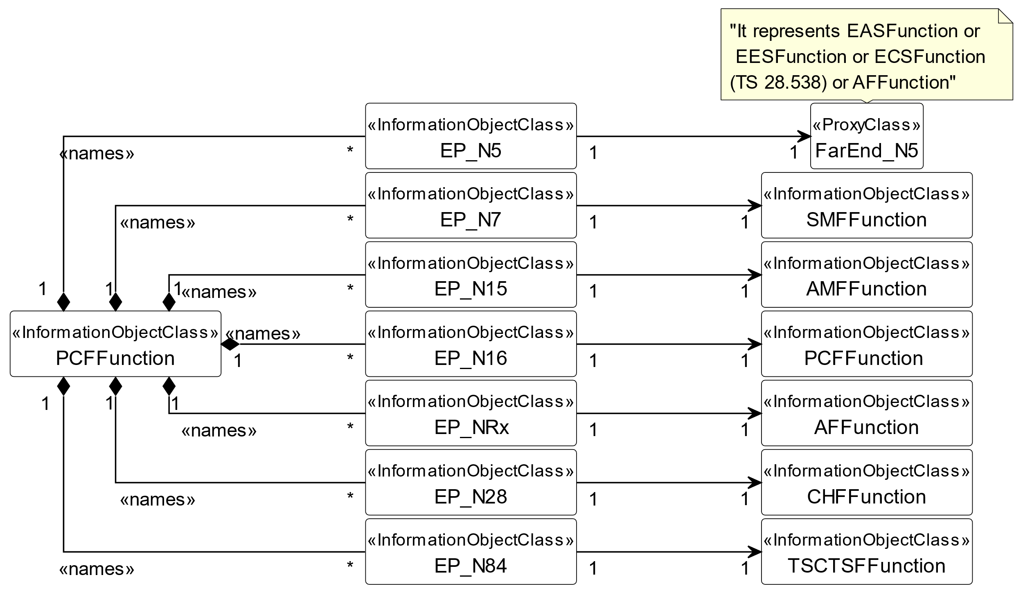

**Figure 5.2.1.1-6: Transport view of PCF NRM**

The Figure 5.2.1.1-7 shows the transport view of AUSF NRM.

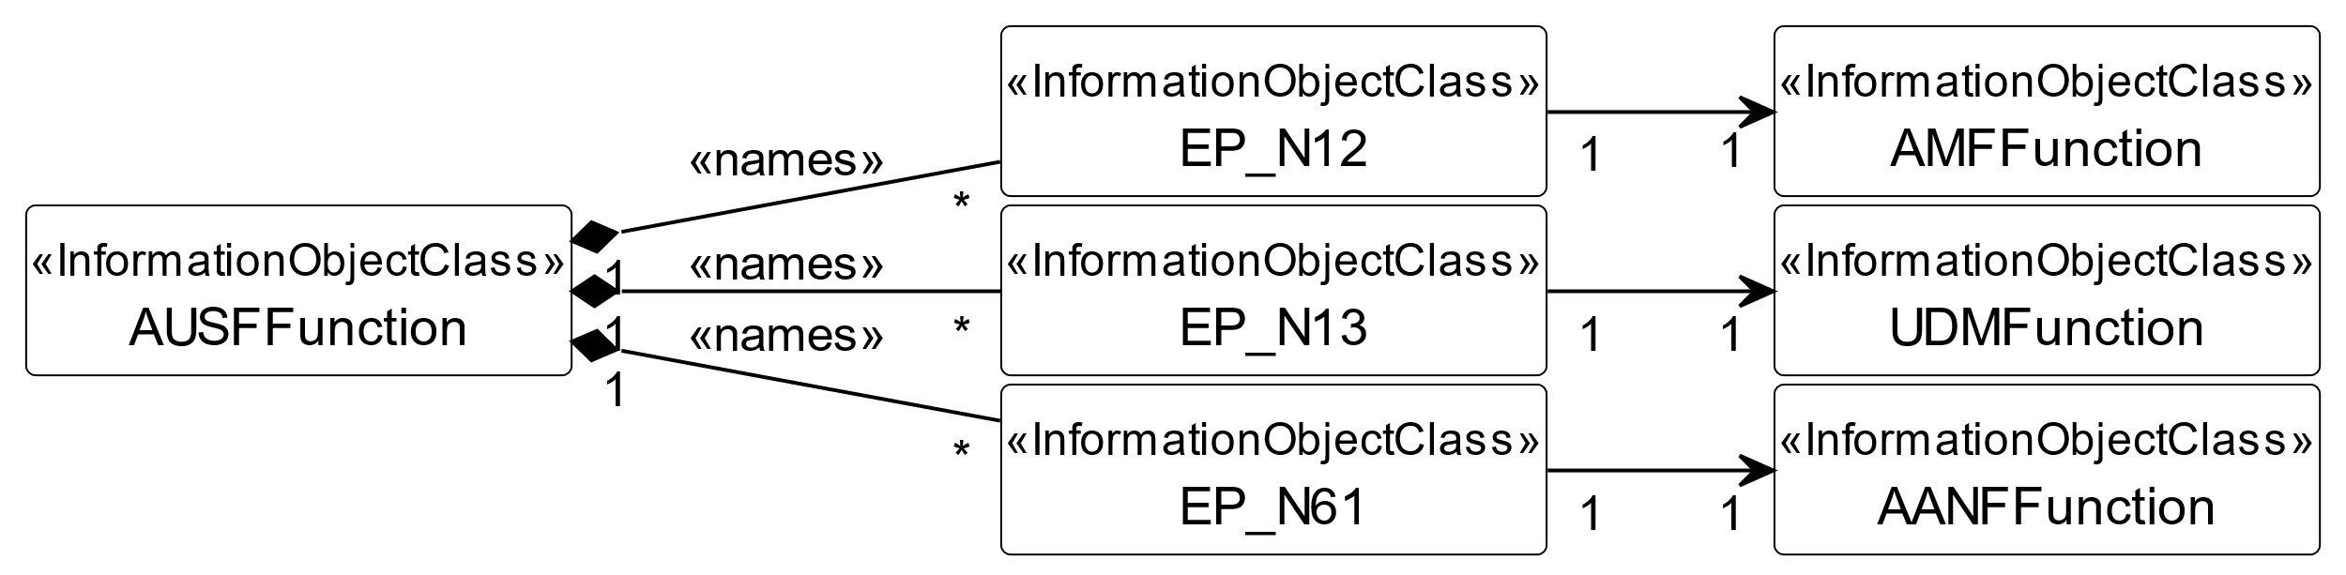

**Figure 5.2.1.1-7: Transport view of AUSF NRM**

The Figure 5.2.1.1-8 shows the transport view of UDM NRM.

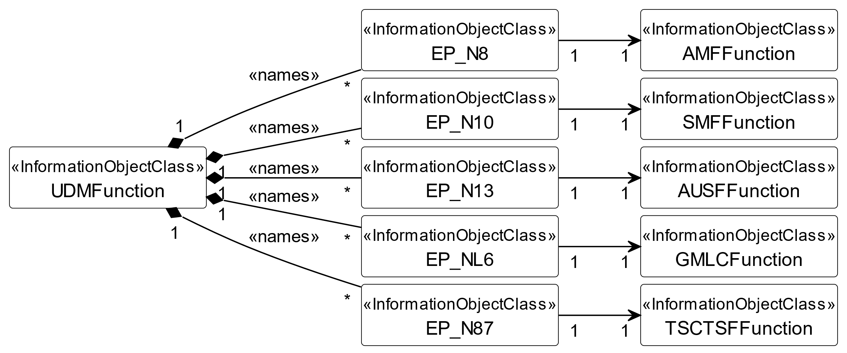

**Figure 5.2.1.1-8: Transport view of UDM NRM**

The Figure 5.2.1.1-9 shows the transport view of NRF NRM.



**Figure 5.2.1.1-9: Transport view of NRF NRM**

The Figure 5.2.1.1-10 shows the transport view of NSSF NRM.



**Figure 5.2.1.1-10: Transport view of NSSF NRM**

The Figure 5.2.1.1-11 shows the transport view of SMSF NRM.



**Figure 5.2.1.1-11: Transport view of SMSF NRM**

The Figure 5.2.1.1-12 shows the transport view of 5G location service related NRM.



**Figure 5.2.1.1-12: Transport view of LMF NRM**

The Figure 5.2.1.1-13 shows the transport view of 5G-EIR NRM.



**Figure 5.2.1.1-13: Transport view of 5G-EIR NRM**

The Figure 5.2.1.1-14 shows the transport view of SEPP NRM.



**Figure 5.2.1.1-14: Transport view of SEPP NRM**

The Figure 5.2.1.1-15 shows the NRM fragment for control of QoS monitoring per QoS flow per UE.



**Figure 5.2.1.1-15: NRM fragment for control of QoS monitoring per QoS flow per UE**

The Figure 5.2.1.1-16 shows the NRM fragment for control of GTP-U path QoS monitoring.



**Figure 5.2.1.1-16: NRM fragment for control of GTP-U path QoS monitoring**

The Figure 5.2.1.1-17 shows the NRM fragment for pre-configured 5QIs in 5GC.



**Figure 5.2.1.1-17: NRM fragment for pre-configured 5QIs in 5GC**

The Figure 5.2.1.1-18 shows the NRM fragment for 5QI and DSCP mapping.



**Figure 5.2.1.1-18: NRM fragment for 5QI and DSCP mapping.**

The Figure 5.2.1.1-19 shows the NRM fragment for predefined PCC rule.



**Figure 5.2.1.1-19: NRM fragment for predefined PCC rule**

The Figure 5.2.1.1-20 shows the NRM fragment for dynamically assigned 5QIs in 5GC.



**Figure 5.2.1.1-20: NRM fragment for dynamically assigned 5QIs in 5GC**

The Figure 5.2.1.1-21 shows the transport view of NSACF NRM.



**Figure 5.2.1.1-21: Transport view of NSACF NRM**

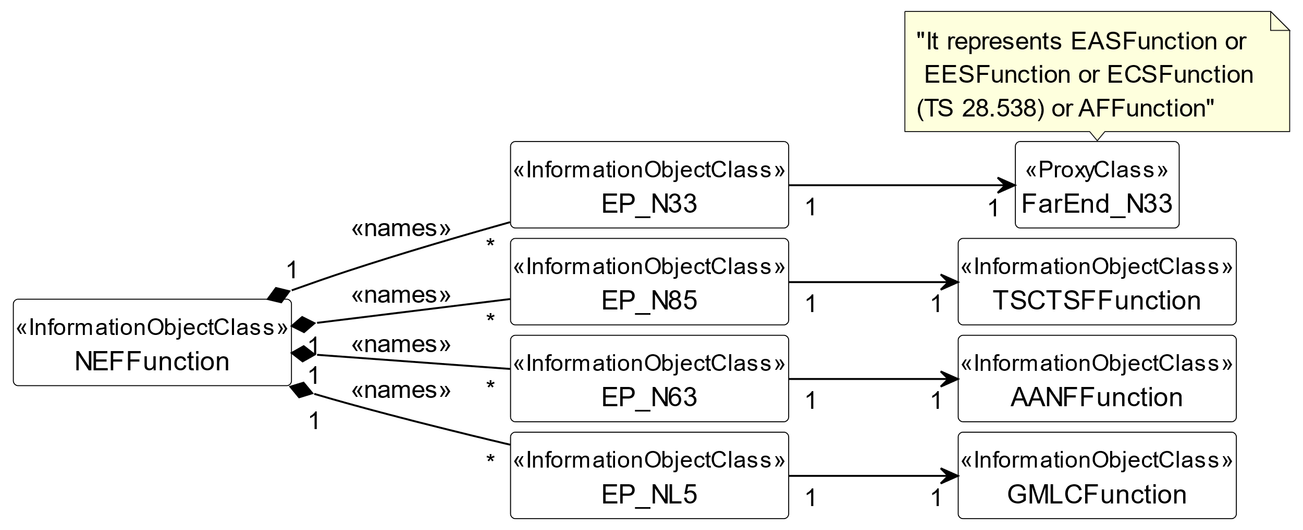

**Figure 5.2.1.1-22: Transport view of NEF NRM**

The Figure 5.2.1.1-23 shows the transport view of 5G DDNMF NRM.



**Figure 5.2.1.1-23: Transport view of 5G DDNMF NRM**

The Figure 5.2.1.1-24 shows the transport view of 5G EASDF NRM.



**Figure 5.2.1.1-24: Transport view of 5G EASDF NRM**

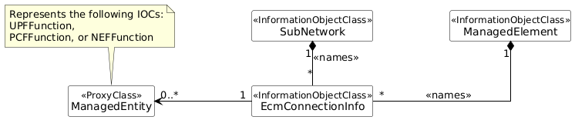**Figure 5.2.1.1-25: EcmConnectionInfo NRM**

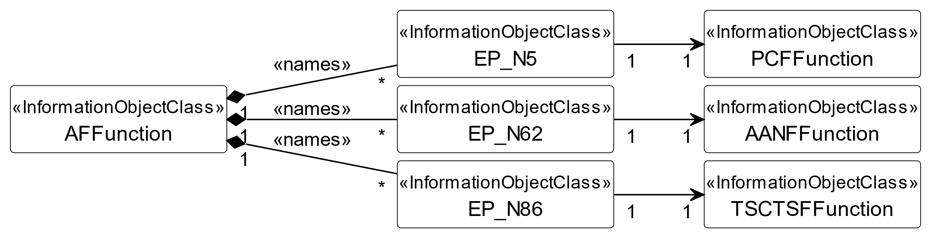

**Figure 5.2.1.1-26: AFFunction NRM**



**Figure 5.2.1.1-27: NSSAAFFunction NRM**

The Figure 5.2.1.1-28 shows the transport view of CHFFunction NRM:



**Figure 5.2.1.1-28: Transport view of CHFFunction NRM**

The Figure 5.2.1.1-29 shows the transport view of AANFFunction NRM:

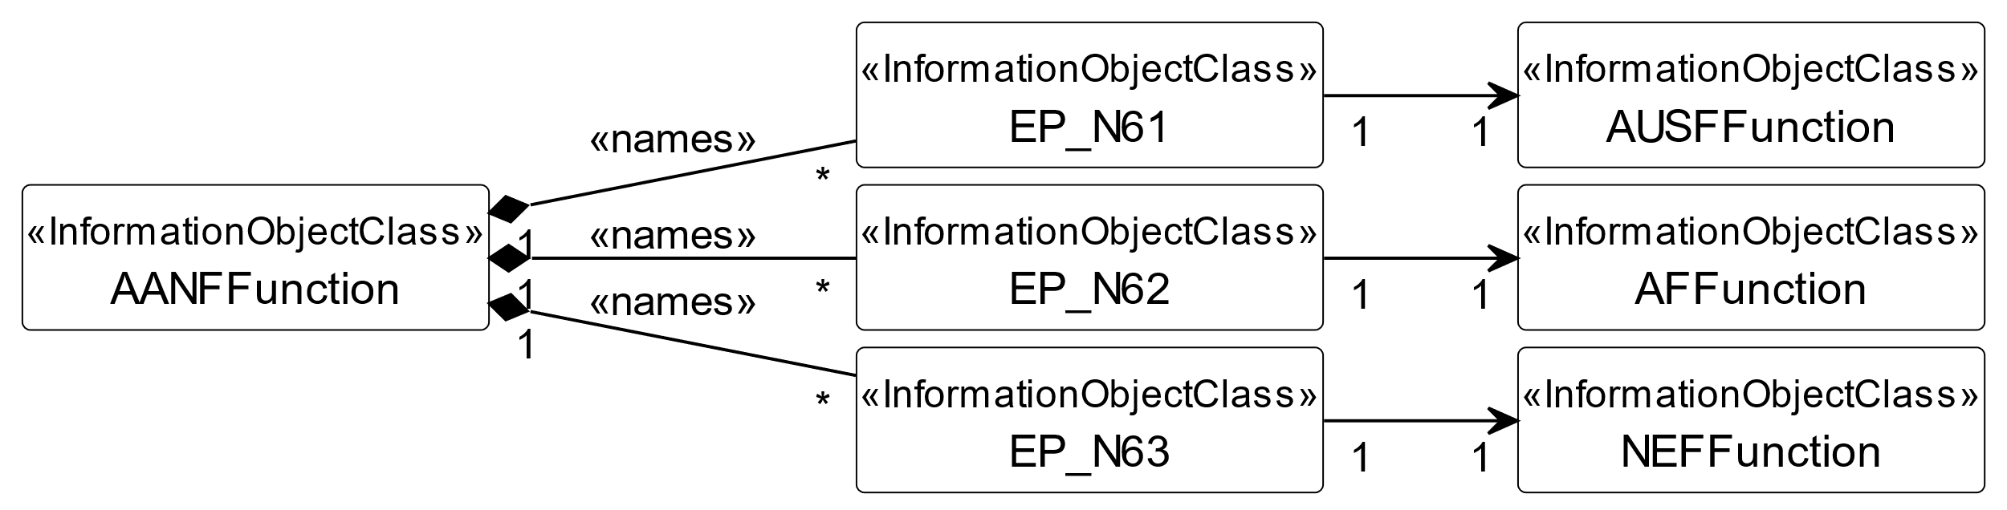

**Figure 5.2.1.1-29: Transport view of AANFFunction NRM fragment**

The Figure 5.2.1.1-30 shows the transport view of GMLCFunction NRM:

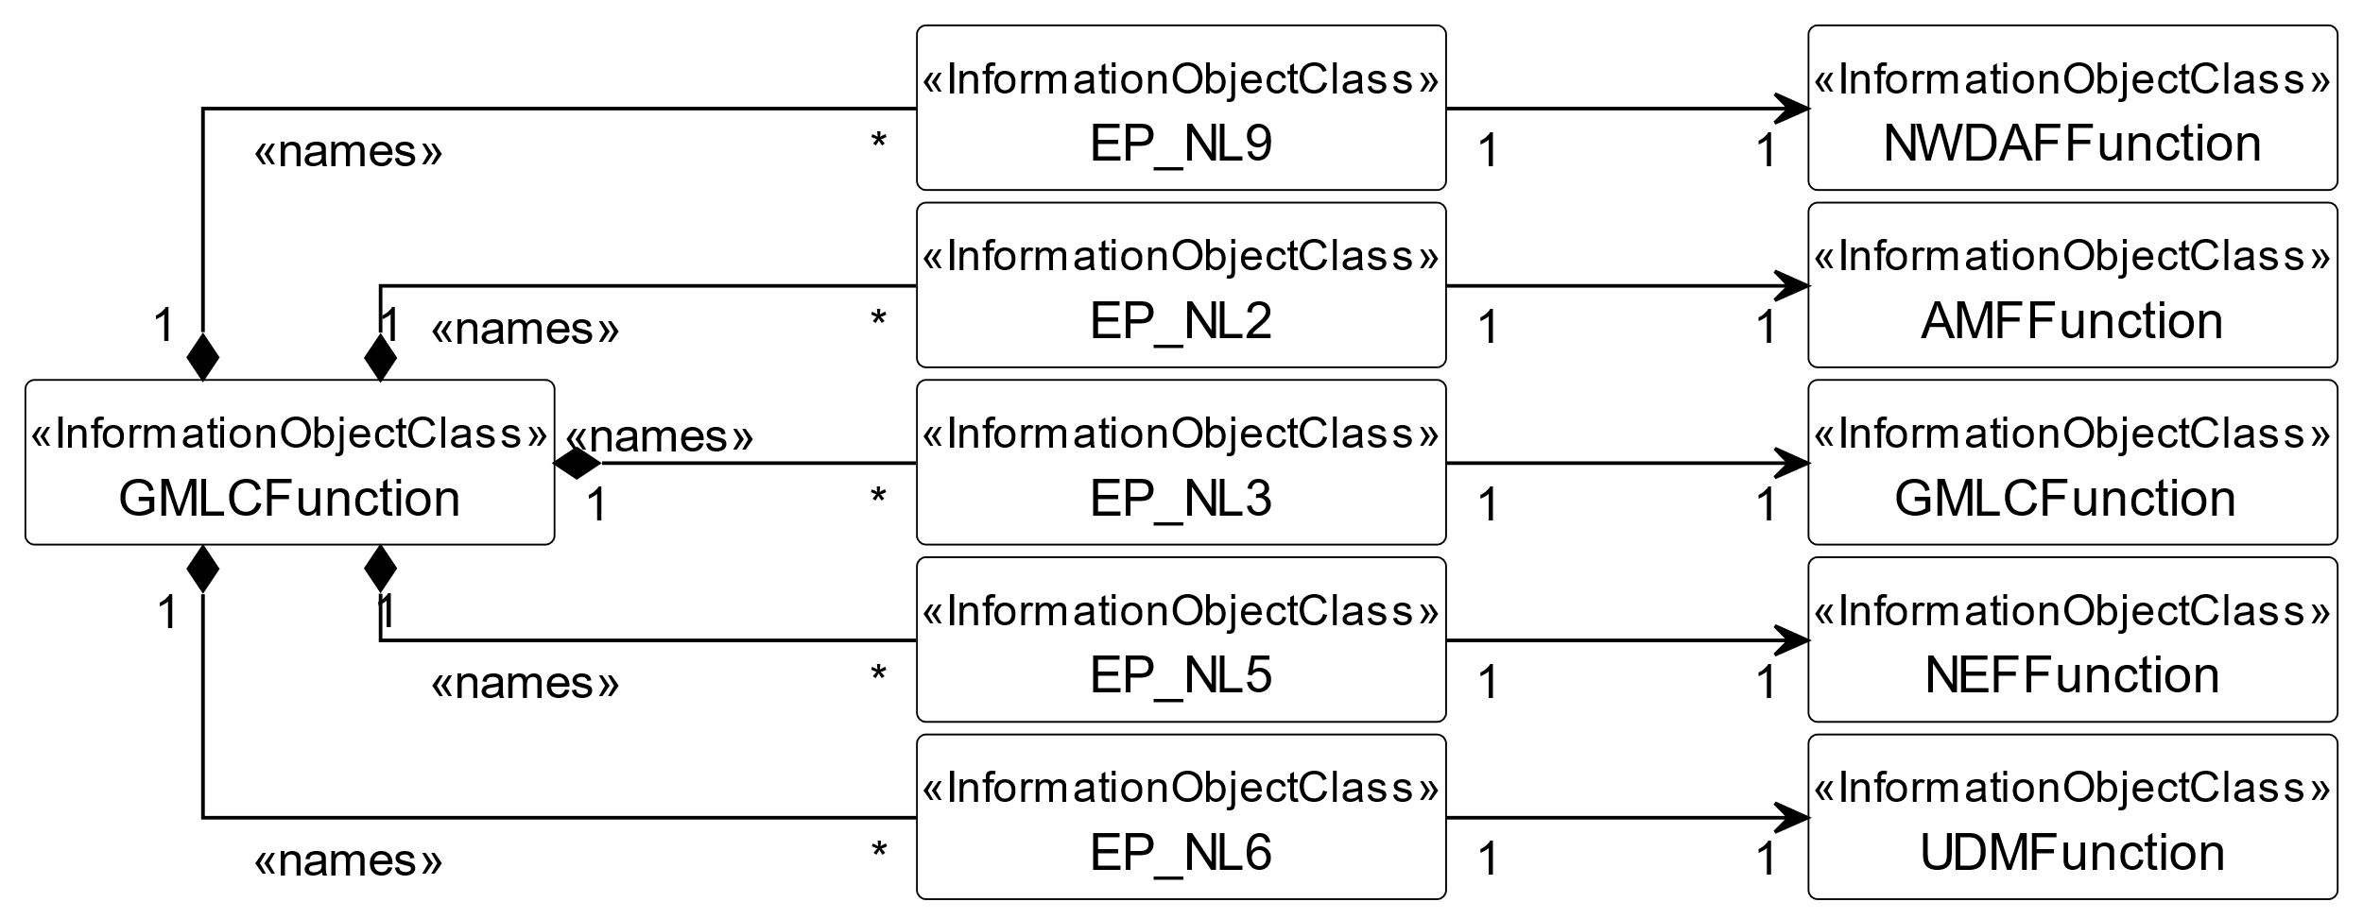

**Figure 5.2.1.1-30: Transport view of GMLCFunction NRM fragment**

The Figure 5.2.1.1-31 shows the transport view of NWDAFFunction NRM:



**Figure 5.2.1.1-31: Transport view of NWDAFFunction NRM fragment**

The Figure 5.2.1.1-32 shows the transport view of TSCTSFFunction NRM:

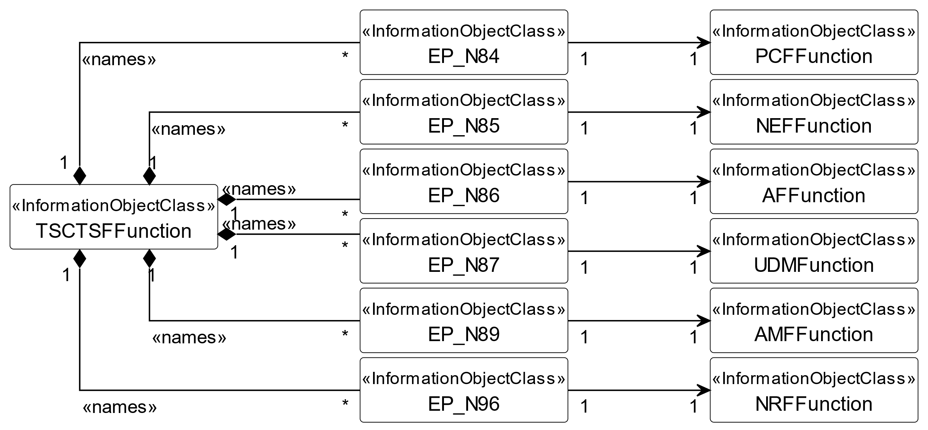

**Figure 5.2.1.1-32: Transport view of TSCTSFFunction NRM fragment**

The Figure 5.2.1.1-33 shows the transport view of MBSMFFunction NRM:



**Figure 5.2.1.1-33: Transport view of MB-SMF Function NRM fragment**

The Figure 5.2.1.1-34 shows the transport view of MBUPFFunction NRM:



**Figure 5.2.1.1-34: Transport view of MB-UPF Function NRM fragment**

The Figure 5.2.1.1-35 shows the transport view of SCPFunction NRM:



**Figure 5.2.1.1-35: Transport view of SCPFunction NRM fragment**



**Figure 5.2.1.1-36: Functional view of NWDAF NRM fragment**

**Figure 5.2.1.1-37: NRM fragment for ManagedFunction (representing 5GC NF) and ManagedNFService**

|  |
| --- |
| **End of change** |