**3GPP TSG-SA5 Meeting #156 *S5-244852***

Maastricht, Netherlands, 19 - 23 August 2024

**Source:** **China Mobile, NTT DOCOMO, ZTE**

**Title: pCR Add potential solutions for Cloud-native VNF** **traffic management**

**Document for: Approval**

**Agenda Item: 6.19.6**

# 1 Decision/action requested

***In this box give a very clear / short /concise statement of what is wanted.***

# 2 References

1. 3GPP TR 28.869 v0.3.0 Study on cloud aspects of management and orchestration.

# 3 Rationale

The contribution proposes to add a solution for cloud-native VNF policy management.

# 4 Detailed proposal

It proposes to make the following changes to TR 28.869 [1].

|  |
| --- |
| **1st Change** |

# 5 Use cases, potential requirements, and potential solutions

## 5.1 Use of VNF generic OAM functions

Editor's Note: This clause describes the use cases, issues, requirements, and solutions related to WT-1.

### 5.1.x Use case #X：Cloud-native VNF traffic management

#### 5.1.X.3 Potential solutions

##### 5.1.x.3.y Traffic Enforcer function

As shown in figure 5.1.X.3.y-1, this solution introduces a platform entity that interacts with 3GPP management system for traffic management of cloud-native VNFs via a new PaaS reference point.

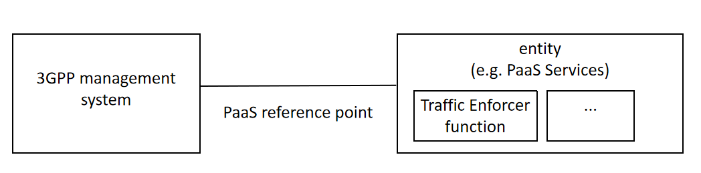

figure 5.1.X.3.y-1 Traffic management of cloud native VNF

The solution proposes using Traffic Enforcer function defined in ETSI GS ISG NFV-IFA 049 [2], which is one of the VNF generic OAM functions. Some key functionalities supported by the Traffic Enforcer function are the capability to perform the required traffic blocking and rerouting operations on the VNFC instances.

According to ETSI GS ISG NFV-IFA 049 [2] Traffic Enforcer functionality can be called by functions residing inside the 3GPP management system or other VNF generic OAM functions (e.g., the Upgrade VNF function) or other PaaS Services (e.g., the Policy Agent).

The present solution addresses the potential requirement REQ-CVNF_TM-2.

|  |
| --- |
| **End of Changes** |