3GPP TSG-SA5 Meeting #156 S5-244848
Maastricht, Netherlands, 19- 23 Aug 2024

Source: Ericsson, Rakuten Mobile, AT&T

Title: pCR 28.869 remove editor’s note and adopt to new concept in use case3

Document for: Approval
Agenda Item: 6.19.6

1 Decision/action requested
The group is asked to discuss and approve.

2 References
[1] 3GPP TR 28.869 v0.3.0 Study on cloud aspects of management and orchestration

3 Rationale
This contribution removed editor’s note in use case #3 and adopt to the new concept and terminology.

4 Detailed proposal
It proposes to make the following changes to TR 28.869 [1].
1st Change

5.2.3 Use case #3: Creation of a Cloud NF Deployment instance

5.2.3.1 Description
In this use case the 3GPP management system interacts with an orchestration and management entity for creation of a Cloud NF Deployment instance.
In order to deploy a Cloud NF Deployment instance the 3GPP management system conveys the description of the Cloud NF Deployment instance requirements and parameters to the orchestration and management entity. The collection of this information, referred to as descriptor, includes all necessary information needed by the orchestration and management entity to select and configure the appropriate cloud resources and to deploy the Cloud NF Deployment instance.
The 3GPP management system needs to be able to request an orchestration and management entity to create a Cloud NF Deployment instance.

5.2.3.2 Potential requirements
REQ_CMO-LCM-CREATE-1: The deployment management reference point should have the capability enabling the 3GPP management system to request creation of a Cloud NF Deployment instance based on Cloud NF Deployment instance requirements.
REQ-CMO-LCM-CREATE-2: The deployment management reference point should have the capability enabling the orchestration and management entity to inform the 3GPP management system of the result of the request for creation of a Cloud NF Deployment instance.

5.2.3.3 Potential solutions

5.2.3.3.1 Use of deployment management reference point
In this solution the 3GPP management system interacts with an orchestration and management entity using the deployment management reference point as described in clause 5.2.1.3 for creation of a Cloud NF Deployment instance.
Figure 5.2.3.3.1-1 depicts a high-level view of proposed procedure for creation of a Cloud NF Deployment instance.

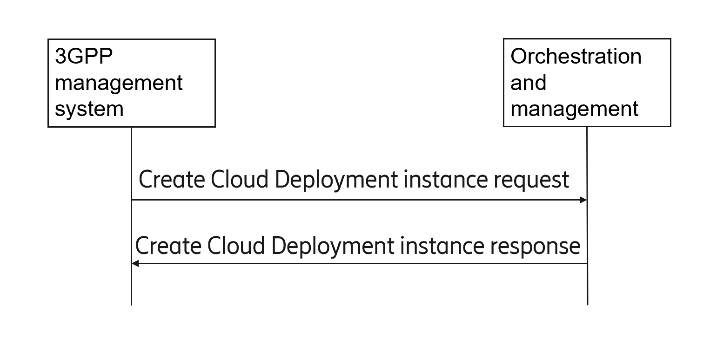
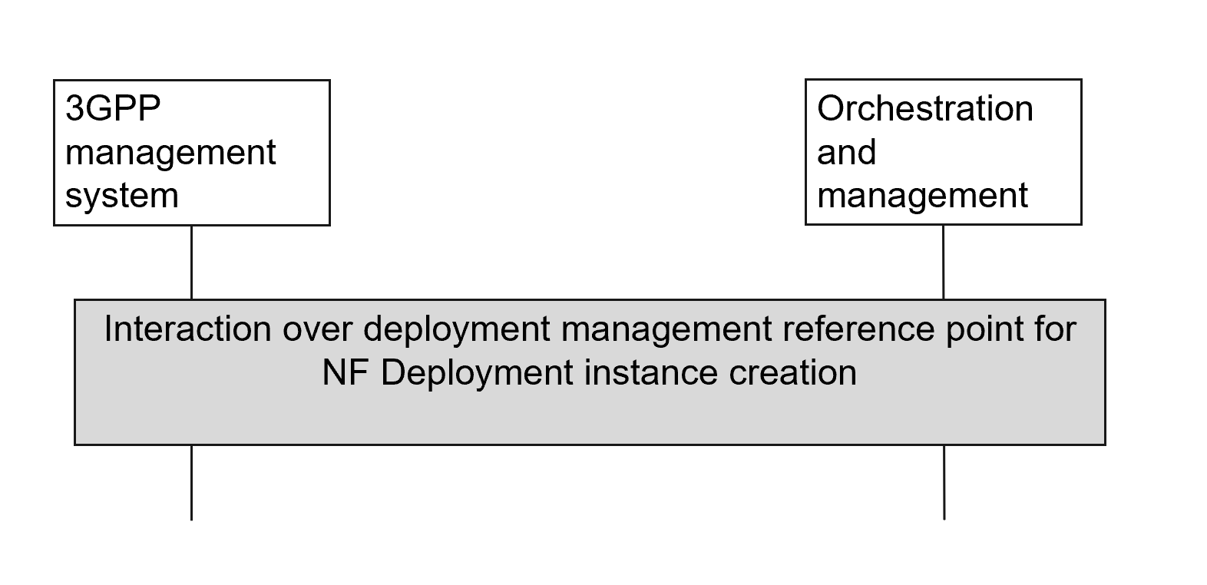
Figure 5.2.3.3.1-1. High level procedure for Cloud NF Deployment instance creation procedure
The 3GPP management system requests creation of a Cloud NF Deployment instance over deployment management reference point, and receives the result of the request for creation of the Cloud NF Deployment instance from the orchestration and management entity.
If the orchestration and management entity is ETSI NFV MANO, the interactions over deployment management reference point are as specified in clause 7.10 of TS 28.531 [7].

End of change

