3GPP TSG-SA5 Meeting #156 S5-244847
Maastricht, Netherlands, 19- 23 Aug 2024

Source: Ericsson, Rakuten Mobile, AT&T

Title: pCR 28.869 remove editor’s note and adopt to new concept in use case1

Document for: Approval
Agenda Item: 6.19.6

1 Decision/action requested
The group is asked to discuss and approve.

2 References
[1] 3GPP TR 28.869 v0.3.0 Study on cloud aspects of management and orchestration

3 Rationale
This contribution removed editor’s note in use case #1 and adopt to the new concept and terminology. It proposes to name XYZ reference point as deployment management reference point.

4 Detailed proposal
It proposes to make the following changes to TR 28.869 [1].
1st Change

5.2.1 Use case #1: 3GPP management architecture evolution to support LCM of Cloud NF Deployment instance

5.2.1.1 Description
3GPP specifications specify the interaction with ETSI NFV MANO for the LCM of the virtualized part of NF (VNF). The requirements, use cases and procedures for the management of NF containing the virtualized part are specified in TS 28.531[7] for 5G network. The interfaces for the interaction with ETSI NFV MANO are provided via Os-Ma-nfvo and the Ve-Vnfm-em reference points specified in ETSI GS NFV-IFA013 [8] and ETSI GS NFV-IFA008 [9].
There are newly developed and evolved industry solutions for management and orchestration of cloud native applications that leverage industry standards, e.g., Kubernetes based solution. Such industry solutions including ETSI NFV MANO and non ETSI NFV MANO can be used to address challenges related to Cloud NF Deployment instances e.g., for hybrid cloud deployments that deploy cloud native applications with hyperscale cloud providers. This use case considers the scenarios where the 3GPP management architecture is flexible to support use of ETSI NFV MANO and Non ETSI NFV MANO for the LCM of Cloud NF Deployment instance.

5.2.1.2 Potential requirements
REQ _LCM-1 The deployment management reference point shall support the capability allowing the 3GPP management system to interact with an orchestration and management entity to perform the LCM of Cloud NF Deployment instance.

5.2.1.3 Potential solutions
Introduce a generic orchestration and management entity that interacts with 3GPP management system for LCM of Cloud NF Deployment instance via the new deployment management reference point .
The figure 5.2.1.3-1 below illustrates the interaction between 3GPP management system and orchestration and management entity in simplified view:

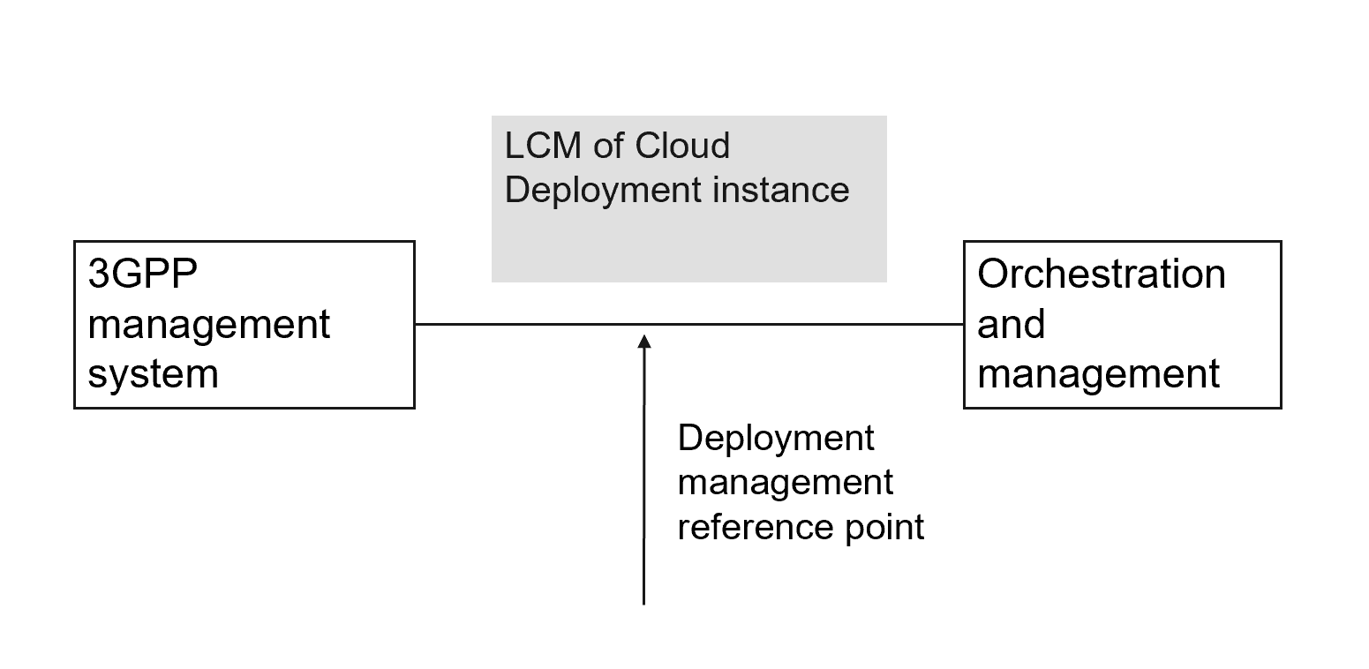
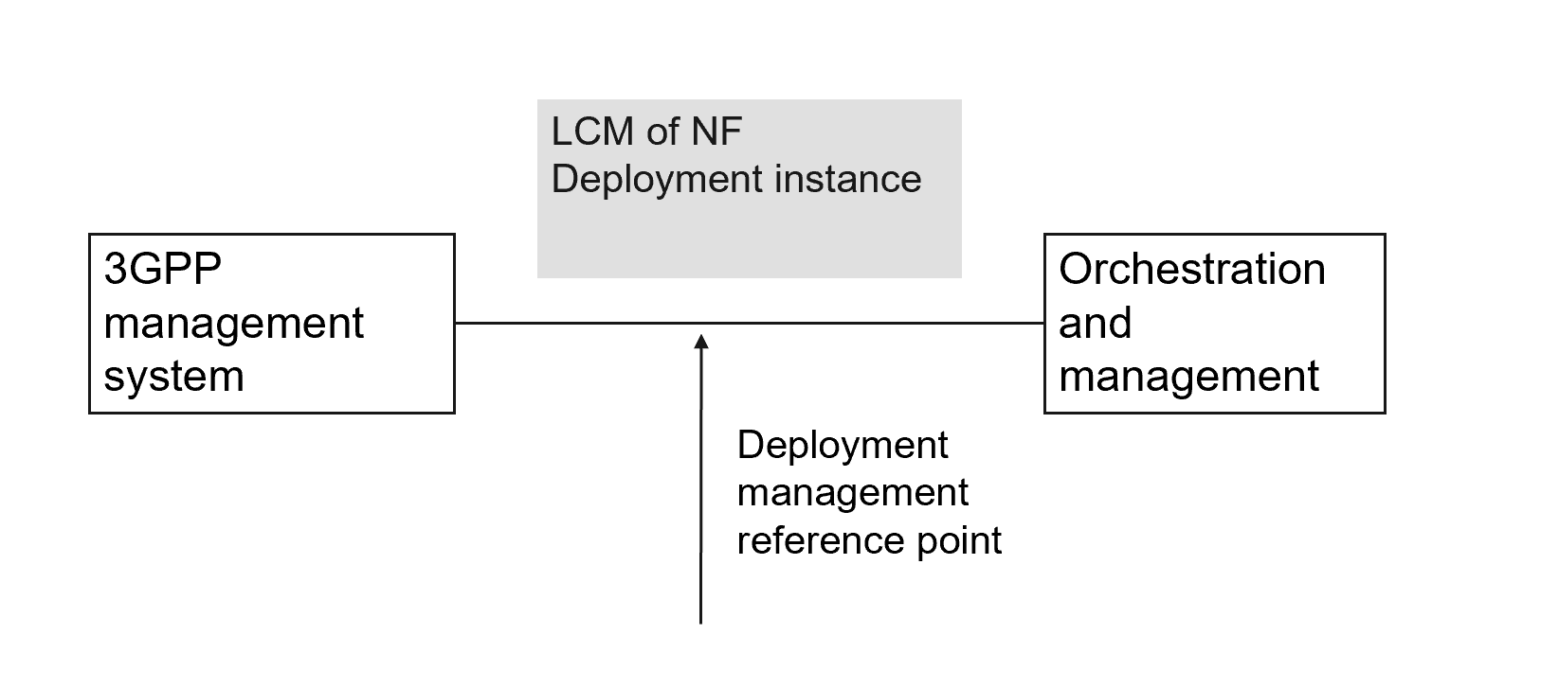
Figure 5.2.1.3-1 Lifecycle management of Cloud NF Deployment instance
The deployment management reference point includes the interfaces that 3GPP supports today with ETSI NFV MANO but not limited to it, e.g., Kubernetes based API.

End of change

