3GPP TSG-SA5 Meeting #156 S5-244846

Maastricht, Netherlands, 19th Aug 2024 - 23rd Aug 2024

Source: Nokia

Title: Rel-19 pCR TR 28.869 Add potential solution and solution evaluation for scaling cloud-native NFs use case

Document for: Approval
Agenda Item: 6.19.6

1 Decision/action requested
In this box give a very clear / short /concise statement of what is wanted.

2 References
[1] 3GPP TR 28.869, " Study on cloud aspects for management and orchestration."

3 Rationale
This pCR proposes to add a potential solution and solution evaluation to clause 5.2 of TR 28.869 [1] to enable the 3GPP management system to request the orchestration and management entity to scale cloud-native network functions.

4 Detailed proposal
It is proposed that the following changes be made to clause 5.2 of TR 28.869 [1].
First Change

5.2.x Use case #x: Scaling of cloud-native network functions

5.2.x.1 Description

5.2.x.2 Potential requirements

5.2.x.3 Potential solutions
In the proposed solution, the 3GPP management system interacts with the orchestration and management entity to request the horizontal scaling of a specific cloud-native NF.
To request the horizontal scaling of a specific cloud-native NF instance, the 3GPP management system interact with the orchestration and management entity to request the horizontal scaling of specific cloud-native NF component instances. For the horizontal scaling request, the 3GPP management system can specify, for example, the component instances of the cloud-native NF to be scaled and the maximum number of scaled instances.
For the configuration of the scaling information for the the orchestration and management entity to automatically trigger the horizontal scaling of the cloud-native NF, the 3GPP management system can specify the scaling information. The scaling information can specify for example: the targeted cloud-native NF instance, the activation/de-activation of autoscaling, the horizontal scaling triggering metrics (e.g., CPU usage level, memory usage level, and any other custom metrics), the minimum and maximum number of horizontally scaled instances, the cool-down period (i.e., waiting time before further scaling in or out of the cloud-native NF instance) and the sync period (i.e., how often to check the defined triggering metrics).

These high-level interactions are shown in Figure 5.2.x.3-1

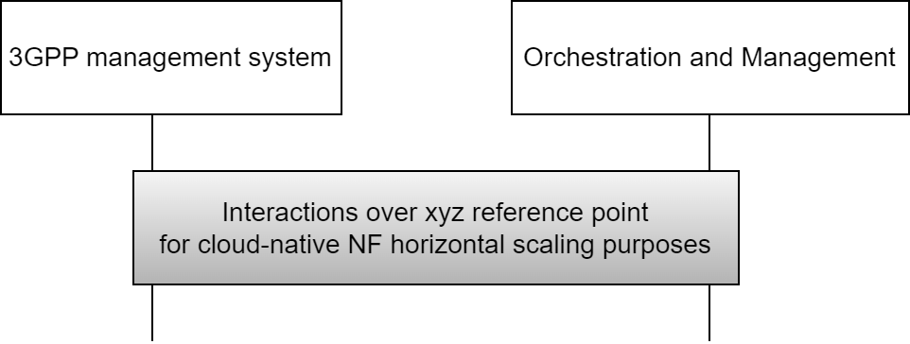
Figure 5.2.x.3-1. High-level interactions between the 3GPP management system and the orchestration and management entity to scale cloud-native NF instance(s)

If the orchestration and management entity is ETSI NFV MANO, the interactions over xyz reference point are as specified in clause 7.11 of 28.531 [7].

Editor's note: The term "cloud-native NF" is not yet defined.

5.2.x.4 Evaluation of solutions
The proposed solution adds new functionality on the XYZ reference point to enable the 3GPP management system to request the horizontal scaling of specific cloud-native NF instance(s) and to configure the scaling information to automatically trigger the horizontal scaling of the cloud-native NF instance.. It fulfills the use case requirements expressed in clause 5.2.x.2.

End of Change

