3GPP TSG-SA5 Meeting #156 S5-244846

Maastricht, Netherlands, 19th Aug 2024 - 23rd Aug 2024

Source: Nokia

Title: Rel-19 pCR TR 28.869 Add potential solution and solution evaluation for scaling cloud-native NFs use case

Document for: Approval
Agenda Item: 6.19.6

1 Decision/action requested
In this box give a very clear / short /concise statement of what is wanted.

2 References
[1] 3GPP TR 28.869, " Study on cloud aspects for management and orchestration."

3 Rationale
This pCR proposes to add a potential solution and solution evaluation to clause 5.2 of TR 28.869 [1] to enable the 3GPP management system to request the orchestration and management entity to scale cloud-native network functions.

4 Detailed proposal
It is proposed that the following changes be made to clause 5.2 of TR 28.869 [1].
First Change

5.2.x Use case #x: Scaling of cloud-native network functions

5.2.x.1 Description

5.2.x.2 Potential requirements

5.2.x.3 Potential solutions
In the proposed solution, the 3GPP management system interacts with the orchestration and management entity to request the horizontal scaling of a specific cloud-native NF.
To request the horizontal scaling of a specific cloud-native NF instance, the 3GPP management system should provide the horizontal scaling information of the cloud-native NF instance to the orchestration and management entity. The scaling information can specify for example: the targeted cloud-native NF instance, the horizontal scaling triggering metrics (e.g., CPU usage level, memory usage level, and any other custom metrics), the minimum and maximum number of horizontally scaled instances, the cool-down period (i.e., waiting time before further scaling in or out of the cloud-native NF instance) and the sync period (i.e., how often to check the defined triggering metrics).

These high-level interactions are shown in Figure 5.2.x.3-1

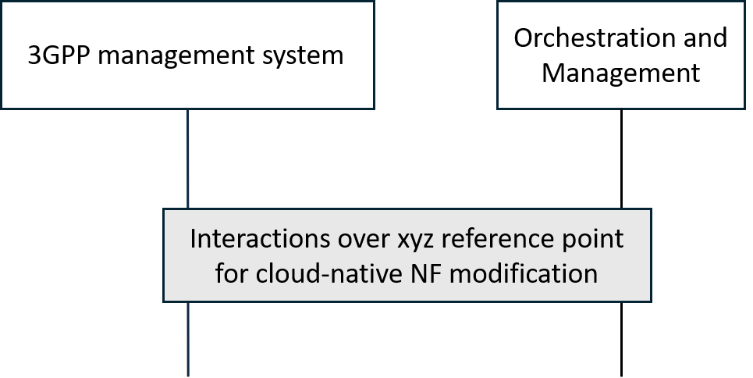
Figure 5.2.x.3-1. High-level interactions between the 3GPP management system and the orchestration and management entity to scale cloud-native NF instance(s)

Editor's note: The term "cloud-native NF" is not yet defined.

5.2.x.4 Evaluation of solutions
The proposed solution adds a new functionality on the XYZ reference point to enable the 3GPP management system to request the horizontal scalingof specific cloud-native NF instance(s). It fulfills the use case requirements expressed in clause 5.2.x.2.
Considering the proposed solution, in order for the 3GPP management system to be able to horizontally scale cloud-native NF instance(s), the orchestration and management entity should have enough nodes with sufficient resources (e.g., CPU, GPU, memory, or storage) to support the requested horizontal scaling operation as per the provided scaling information, otherwise the scaling operation might run into some errors.
NOTE: In this case, nodes refer to the entities (physical or virtual) hosting the cloud-native NF instances.

End of Change

