3GPP TSG-SA5 Meeting #156 S5-244842
Maastricht, Netherland, 19-23 Aug 2024

Source: Rakuten Mobile

Title: pCR 28.869 New use case and solution on LCM of cloud native NFs based on standard K8S CRD models

Document for: Approval
Agenda Item: 6.19.6

1 Decision/action requested
The group is asked to discuss and approve.

2 References
[1] 3GPP TR 28.869 v0.3.0 Study on cloud aspects of management and orchestration

3 Rationale
This contribution proposes to add new use case, potential requirement and solution on use of industry solutions for LCM of cloud native network functions based on standard K8S CRD models.

4 Detailed proposal
It proposes to make the following changes to TR 28.869 [1].
1st Change

5.2 Use of industry solutions for management of cloud-native network functions
Editor's Note: This clause describes the use cases, issues, requirements, and solutions related to WT-2.

5.2.3 Use case #3: Creation of a cloud-native network function instance

5.2.3.1 Description
In this use case the 3GPP management system interacts with an orchestration and management entity for creation of a cloud-native NF instance.
In order to deploy a cloud-native NF instance the 3GPP management system conveys the description of the NF requirements and parameters to the orchestration and management entity. The collection of this information, referred to as descriptor, includes all necessary information needed by the orchestration and management entity to select and configure the appropriate cloud resources and to deploy the cloud-native NF instance.
The 3GPP management system needs to be able to request an orchestration and management entity to create a cloud-native NF instance.
Editor’s note: The term “cloud-native NF” is not yet defined.

5.2.3.2 Potential requirements
REQ_CMO-LCM-CREATE-1: The xyz reference point should have the capability enabling the 3GPP management system to request creation of a cloud-native NF instance based on cloud-native NF-specific requirements.
REQ-CMO-LCM-CREATE-2: The xyz reference point should have the capability enabling the orchestration and management entity to inform the 3GPP management system of the result of the request for creation of a cloud-native NF instance.
Editor’s note: The term “cloud-native NF” is not yet defined.

5.2.3.3 Potential solutions

5.2.3.3.2 Use of xyz reference point based on declarative descriptor
In this solution the 3GPP management system interacts with an orchestration and management entity using the xyz reference point as described in clause 5.2.1.3 for creation of a cloud-native NF instance. The deployment requirements when creating a workload of a NF are conveyed from the 3GPP management system to the orchestration and management system via a declarative descriptor that is standardized.
NOTE: the standard of the descriptor doesn’t exist today.
Figure 5.2.3.3.2-1 depicts a high-level view of proposed procedure for creation of a cloud-native NF instance based on declarative descriptor.
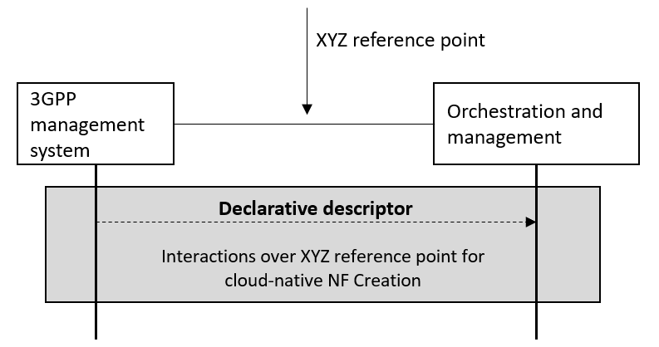
Figure 5.2.3.3.2-1. interaction between 3GPP management system and orchestration and management system using xyz reference point based on declarative descriptor
The declarative descriptor provides a declaration in high-level on what to be achieved by the orchestration system rather than how to achieve it, and only focus on the common, non-differentiating aspects of vendors’ solutions, leaving it completely to vendor implementations to develop unique and value critical features.
If the orchestration and management entity is ETSI NFV MANO, the interactions over xyz reference point are as specified in clause 7.10 of 28.531 [7].
Editor’s note: The term “cloud-native NF” is not yet defined.

2nd Change

Use case #4: Modification of a cloud-native network function instance

5.2.4.1 Description
In this use case the 3GPP management system interacts with an orchestration and management entity for modification of a cloud-native NF.
An already deployed cloud-native 3GPP network function may be modified (e.g., reconfiguration). In order to modify a cloud-native NF instance an updated description of the NF requirements and parameters can be conveyed to the orchestration and management entity.
The 3GPP management system needs to be able to request an orchestration and management entity to modify a cloud-native NF instance.
Editor’s note: The term “cloud-native NF” is not yet defined.

5.2.x.2 Potential requirements
REQ-LCM-MODIFY-1: The xyz reference point should have the capability enabling the 3GPP management system to request modification of a cloud-native NF based on cloud-native NF-specific requirements.
REQ-LCM-MODIFY-2: The xyz reference point should have the capability enabling the orchestration and management entity to inform the 3GPP management system of the result of the request for modification of a cloud-native NF.
Editor’s note: The term “cloud-native NF” is not yet defined.

5.2.4.3 Potential solutions

5.2.4.3.2 Use of xyz reference point based on declarative descriptor
In this solution the 3GPP management system interacts with an orchestration and management entity using the xyz reference point as described in clause 5.2.1.3, for modification of a cloud-native NF instance. The modified requirements of the deployment of a cloud-native NF instance are conveyed from the 3GPP management system to the orchestration and management system via a modified version of the declarative descriptor that was used for creation of the cloud-native NF instance.
Figure 5.2.4.3.2-1 depicts a high-level view of proposed procedure for modification of a cloud-native NF instance based on declarative descriptor.
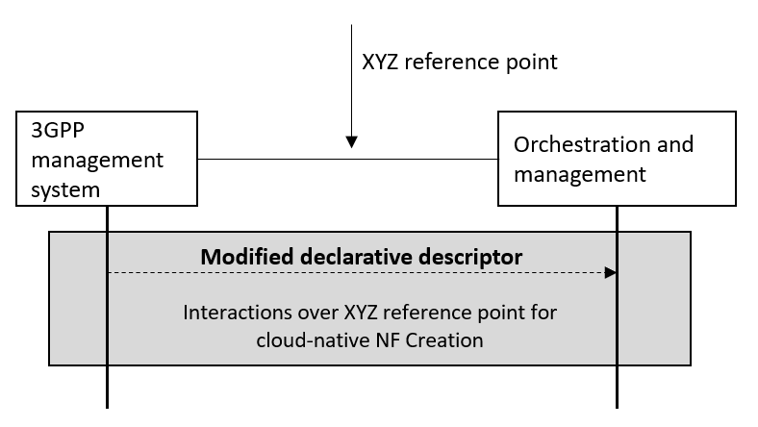
Figure 5.2.4.3.2-1. interaction between 3GPP management system and orchestration and management system using xyz reference point based on declarative descriptor
If the orchestration and management entity is ETSI NFV MANO, the interactions over xyz reference point are as specified in clause 7.11 of 28.531 [7].
Editor’s note: The term “cloud-native NF” is not yet defined.

