**3GPP TSG SA WG5 Meeting #156 S5-244834**

**Maastricht, The Netherlands 19 - 23 August 2024**

**Source: China Mobile, Huawei**

**Title: Add solution of configuration verification for TR 28.915**

**Document for: Approval**

**Agenda Item: 6.19.5**

# 1 Decision/action requested

***In this box give a very clear / short /concise statement of what is wanted.***

# 2 References

[1] 3GPP draft TR 28.915: “Management and orchestration; Study on management aspects of Network Digital Twin v0.1.0”.

[2] SP-231727 "New Study on management aspects of Network Digital Twin"

# 3 Rationale

This contribution proposes to add solution of configuration verification for TR 28.915 based on SP-231727 [2]

# 4 Detailed proposal

|  |
| --- |
| **First Change** |

## 5.9 Use case 9: Configuration verification

### 5.9.1 Description

When operating a mobile network, various configuration and software/hardware modifications (are required to achieve or preserve an efficient operational state (e.g., software updates, launching new instances, terminating instances, etc.). It is difficult to predict the impact of the configurations and operations because mobile network is built by many components. Unintended network failures can occur because of the new or updated settings and operations.

For example, 5GC is responsible for managing and controlling the mobile network, such as processing call requests and session connections from UEs. Incorrect configuration (e.g., conflict IP address setting at NFs, wrong TAC setting at AMF and etc.) may increase the risk of network failure. In the worst case, it may cause network interruptions and impact the user experience, this may also cause economic loss to the service providers. Therefore, to ensure the correct configuration, especially when updating some of the parameters of 5GC NFs is very important. The digital twin technology may be used to evaluate the impact when updating configuration of one or more 5GC NFs and check whether the new configuration has any side effects of the network (e.g., cause performance degradation or failure).

In another example, when the wireless coverage of a RAN base station cannot meet the performance requirements, updating the RAN base station configuration or creating a new RAN base station may be required. By using NDT, the RAN network performance can be simulated with the new changes and evaluate the result to check whether the network performance can met network coverage goal.

By using NDT, consumer can investigate potential impact in the network operation when new settings are applied (e.g., in which NF does congestion or service disruption occur and how many subscribers are impacted, etc.).

As an example, the impact of the configurations and operations is verified using NDT as follows:

1. The network operator wants to introduce new configurations or do some operation.
2. The network operator synchronizes the replica network to ensure that the replica network is up to date.
3. The network operator applies new configuration or operation to the replica network.
4. The replica network simulates the behavior of the mobile network.
5. The network operator observes and analyses the behavior of the replica network.
6. The network operator decides to apply new configuration or operation.

Consumers can request NDT to simulate various configuration settings and operations and analyze potential impact on the operation of the real network as a result.

### 5.9.2 Potential requirements

**REQ-NDT-FUN-01:** The NDT shall have the capability allowing the consumer to submit provisioning MnS operations to the NDT.

**REQ-NDT-FUN-02:** The NDT shall have the capability to report the result of applied configuration changes.

### 5.9.3 Potential solutions

#### 5.9.3.1 Potential solution 1

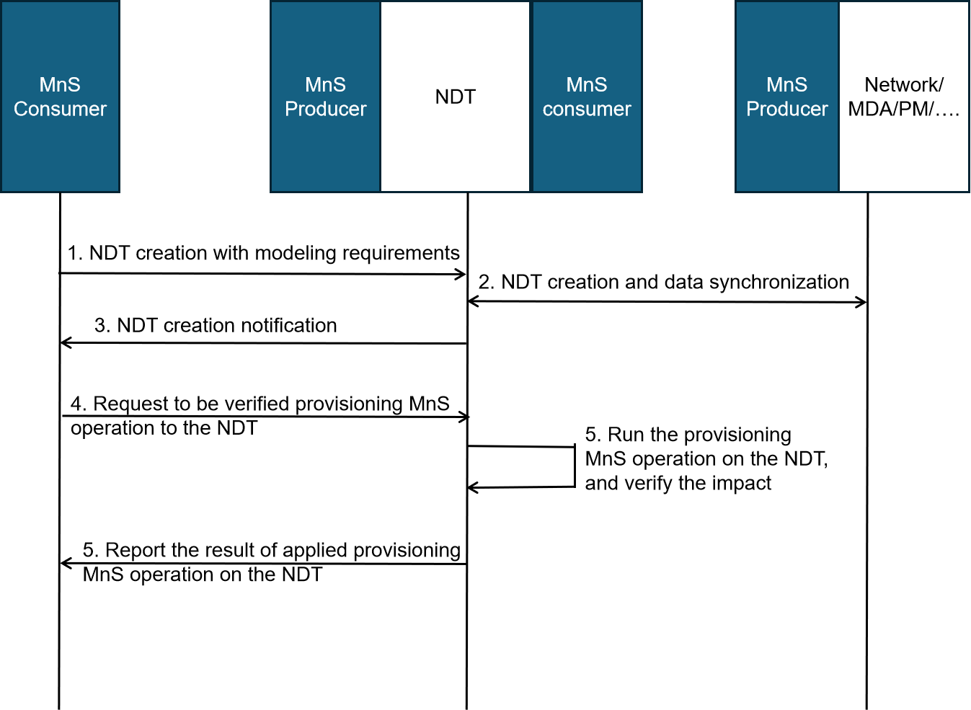

Figure 5.9.3-1: NDT for configuration verification

1. MnS consumer requests NDT to create an NDT instance with modeling requirements. The modeling requirements are used to specify the scope of the network to be modelled either using simulation or emulation based method, which may include,

* NDT scope: the area of actual mobile network or the managed object that needs to be simulated or emulated in NDT. For instance, a geography area, a network slice, etc.
* Modeling data: the selected data to be modeled by NDT, e.g., 5GC PM data as defined in TS 28.552/28.554, CM data as defined in TS 28.541/28.622, etc.

1. Based on the modeling requirements given in step 1, the MnS producer sends the inquiry request for the network object related information and synchronizes the data from the managed entities .
2. MnS producer notifies MnS consumer that the NDT instance is created.
3. MnS consumer requests NDT to verify the provisioning operation to be implemented. The request parameters may include:

* Provisioning operation type: the operation as defined in TS 28.532, e.g., modifyMOIAttributes operation.
* Configuration data: the 5GC NRM configuration data as described in TS 28.541 carried in the operation.
* Impact detectors: specified performance metrics and/or alarm types that needs to be collected and reported by NDT after the behaviour happens in NDT.

1. NDT runs the provisioning operation to be verified and collects its impact on the NDT instance. The impact could be performance measurement or alarm reporting from the NDT instance.
2. MnS producer reports the impact and result when implementing the provisioning operation on the NDT instance to MnS consumer. The report content may include the impact which is a key-value list where the keys contain the impact detectors specified in step 4. Alarms are reported if any raised.

|  |
| --- |
| **End of Changes** |