**3GPP TSG SA WG5 Meeting #156 S5-244832**

**Maastricht, The Netherlands 19 - 23 August 2024**

**Source: China Mobile, Huawei**

**Title: Update the solution of signaling storm analysis for TR 28.915**

**Document for: Approval**

**Agenda Item: 6.19.5**

# 1 Decision/action requested

***In this box give a very clear / short /concise statement of what is wanted.***

# 2 References

[1] 3GPP draft TR 28.915: “Management and orchestration; Study on management aspects of Network Digital Twin v0.1.0”.

[2] SP-231727 "New Study on management aspects of Network Digital Twin"

# 3 Rationale

This contribution proposes to update the solution of signaling storm analysis for TR 28.915 based on SP-231727 [2]

# 4 Detailed proposal

|  |
| --- |
| **First Change** |

## 5.2 Use case 2: Signaling storm analysis

### 5.2.1 Description

Signaling storm refers to the situation where a large number of signaling messages suddenly surge in the mobile communication network, resulting in the network processing capacity overload, thus affecting the network performance and stability. Signaling storm may be caused because of big event happened that too many users request service at the same time, or by network failure, configuration error or malicious attacks. During this period, users will repeatedly try to establish the connection until reconnected, thus generating a large number of signaling messages surge suddenly, causing signaling storm. By using NDT to model (either simulation or emulation) various network scenarios such as network failure or surge of requests, the network operator can determine whether the current network can defend against ~~if signaling storm happened~~. a possible future signaling storm.

Also, if an actual signalling storm~~If a signaling storm still~~ occurs on the network (e.g., by checking network performance data), to prevent potential impacts caused by signaling storm, the operator needs to effectively control the flow of each signaling control node on the network to avoid nodes working improperly caused by signaling storm. For example, as depicted in figure 1, AMF, SMF, and UDM in the 5G network might be all potential signaling storm impact points when network signaling storm happens. The NDT can be used to model the network behaviors and help find the optimal flow control parameters of each signaling impact point to avoid serious damage to the 5G network when it is affected by signaling storm.

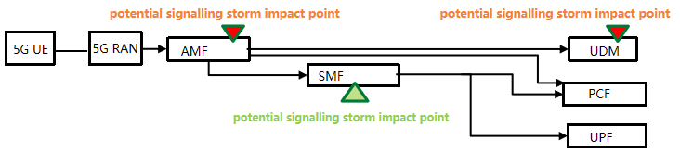

### 5.2.2 Potential requirements

**REQ-SIMULATION_NDT-01:** NDT should have the capability to model (either using emulation method or simulation method) the behaviour of signaling storm.

**REQ-SIMULATION_NDT-02:** NDT should have a capability enabling the MnS consumer to configure the network scenario to be modelled for checking the network response to a signaling storm.

**REQ-SIMULATION_NDT-03:** NDT should have the capability to report the results for signaling storm analysis.

**REQ-SIMULATION_NDT-04:** NDT should have a capability enabling the MnS consumer to configure the parameters of the NDT instance of the objects to be modelled for a signaling storm

### 5.2.3 Potential solutions

### 5.2.3.1 solution 1

This solution addresses the following issues of use case 2. When a signaling storm occurs on the network (e.g. identified by MDA, see MDA type for 5GC control plane congestion analysis), NDT is used to evaluate whether the suggested solution can resolve the signaling storm issue. The NDT utilizes network related information on signaling storms from the MnS producer to generate a report of simulation and validation resultswith the following approach:

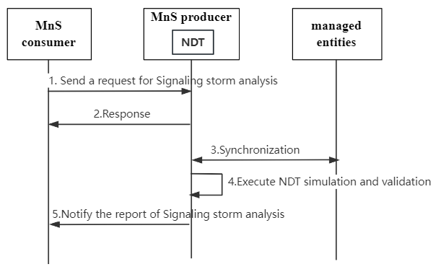

Figure 5.2.3: NDT for signaling storm simulation and validation

1. The MnS consumer sends a request to NDT as the MnS provider for signaling storm simulation, including the simulated network objects(e.g., network functions, S-NSSAI, etc) and optional network optimization actions to resolve the issue caused by signaling storm (e.g. setting the maximum rate of traffic received at a network node, flow control rules).
2. The NDT as the MnS provider provides a response to MnS consumer indicating the status of the request based on a feasibility check (success or failure).
3. The NDT as the MnS consumer synchronizes the network objects related information from MnS providers(Managed entities) for network simulation and validation. The network related information may include network capability related information, network slicing information regarding the resource aspects and/or other relevant data (e.g., the number of current subscribers,traffic collected in recent and historical periods) for simulation and validation of the behaviour of signaling storm.
4. The NDT executes the network simulation and validation for signaling storm and generates the report.
5. The NDT as the MnS provider sends the report including the results to MnS consumer. The report can include:

- Simulated behavior: Use of network simulation to analyse the behavior and impacts of signaling storms based on current and historical data.

- Validation Result: Indicate when the issue caused by signaling storm is resovled. Together with the PM, KPIs and/or alarms after validation.

|  |
| --- |
| **End of Changes** |