**3GPP TSG-SA5 Meeting #156 *S5-243748***

**Maastricht, Netherlands 19 - 23 August 2024**

**Source: Huawei**

**Title: pCR TR 28.915** **Evaluation of potential solutions for UC1**

**Document for: Approval**

**Agenda Item: 6.19.5**

# 1 Decision/action requested

***The group is asked to discuss and agree on the proposal.***

# 2 References

[1] 3GPP TR 28.915: " Study on management aspects of Network Digital Twin"

# 3 Rationale

It’s proposed to add Evaluation of potential solutions for use case Network management policy verification using NDT as described in clause 5.1 of [1]

There are five functional categories can be extracted from existing NDT use cases as below:

* Verification
  + RAN energy saving policy verification (see clause 5.1)
  + Signalling storm configuration verification (see clause 5.2)
  + Emergency preparedness (see clause 5.3)
  + Configuration verification (see clause 5.9)
* Visualization
  + Network topology and traffic visualization (see clause 5.8)
* Prediction
  + Network failure and risk prediction (see clause 5.4)
* Simulated data generation
  + ML model training data generation (see clause 5.6)
* NDT specific technology
  + Nested NDT (see clause 5.7)
  + NDT supporting network and service management automation functions (see clause 5.5)

Therefore one key principle for NDT solution is that a solution should be able to reflect it is for which NDT service category, e.g., verification or visualization. Under each category, the solution for specific use cases should specify the parameters that are applicable only for this use case. For example, NDT solution for RAN energy saving policy verification focuses on the parameters for ES policy that need to verified by NDT, while NDT solution for signalling storm focuses on the configuration parameters related to signalling storm that need to verified by NDT.

# 4 Detailed proposal

This document proposes the following changes in TR 28.915.

|  |
| --- |
| **1st Change** |

### 5.1.3 Potential solutions

### 5.1.3.1 solution1

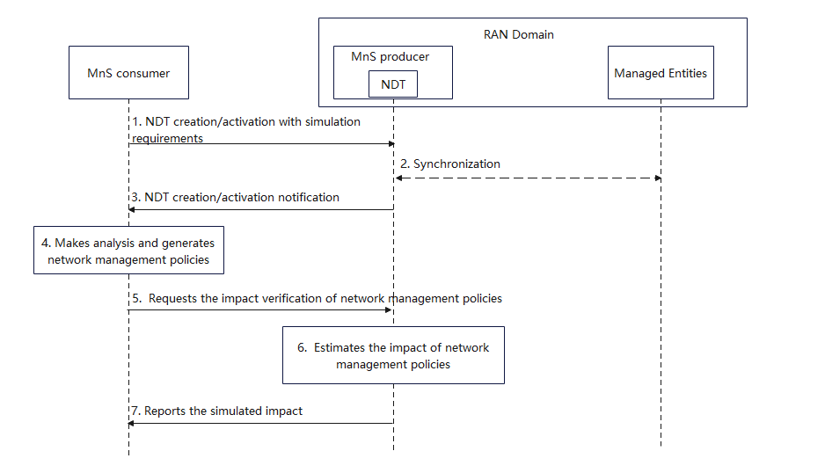

Figure 5.1.3-1: procedure of network management policy verification

1. MnS consumer requests MnS producer (the entity who provides the NDT for network simulation) to create/active an NDT with simulation requirements. Simulation requirements are used to specify the scope and time of the simulated network in NDT.

* Simulation scope: the area of actual mobile network or the managed object that needs to be simulated in NDT. For instance, a geography area, a network slice, etc.
* Simulation time: the timestamp indicates if the simulation is for the past, present, or future.
* Simulation data: the data that collected for NDT simulation, e.g., PM data as defined in TS 28.552/28.554, CM data as defined in TS 28.541/28.622, etc.

1. Based on the simulation requirements given in step 1, NDT collects the data from the managed entities within the specified simulation scope, time and data. If the Simulation time indicates the timestamp in the past, NDT collects the historical network data. If the Simulation time indicates the timestamp in the present, NDT collects the data from live network. If the Simulation time indicates the timestamp in the future, NDT collects the data based on prediction. In this step NDT is also fed with the performance data and/or KPI which can help to induce a particular network state to be simulated
2. MnS producer receives the simulation requirements for NDT and create/activate the NDT capability. MnS producer notifies MnS consumer that the NDT capability is ready.
3. MnS consumer makes analysis and generates network management policy. For instance, MnS consumer collects and analyses energy saving related performance measurements and notices that the energy consumption is too high. MnS consumer decides to lower the energy consumption and generates RAN energy saving policies. A simple example of RAN energy saving policy could be the configuration on certain NR capacity booster cells which specifies to enter the energySaving state or not.
4. MnS consumer requests NDT to verify the policy in the simulated network which synchronizes with actual mobile network. The request parameters may include:

* Policy: the relevant policy for a certain use case. For example, the policy for RAN ES policies verification use case could be the ES policy as described in TS 28.310.
* Impact detectors: specified performance metrics and/or alarm types that needs to be collected and reported by NDT after the behaviour happens in NDT.
* Performance requirements: the expected network simulation performance of NDT. For instance, the time spent for the network simulation, the expected proximity between the network simulation results and the actual network execution outcome.

1. NDT executes network management policy according to the performance requirements and collects its impact on the simulated network. The impact could be performance measurement or alarm reporting from simulated network.
2. MnS producer reports the simulated impact and result to MnS consumer. The report content may include the impact which is a key-value list where the keys contain the impact detectors specified in step5. Alarms are reported if any raised. Possibly an indicator, which shows whether the performance of the network simulation satisfies the performance requirements or not, is also reported.

Editor’s note: whether NDT can optionally reside outside of MnS producer is FFS.

### 5.1.3.2 solution 2

Introduce an IOC for an NDT, which may be called NDT. This may be name contained in a subnetwork or managed function to respectively represent a standalone NDT and an NDT contained in another function, e.g. in a SON function.

- The consumer can configure on to the NDT instance the network scenario to be modelled. The scenario can include the scope to be considered for evaluating ES policies.

* introduce a data type and an attribute on the NDT of the scope to be modelled or simulated by the NDT instance. This may be called nDTSimulationScope.

The consumer can configure the parameters of the NDT instance, including the configurations indicating the ES policy

* Introduce a data type and an attribute on the NDT to represent a configuration plan. The datatype which may be called nDTConfigurationPlan indicates the parameter values to be applied by the NDT instance..

Note: the specific characteristics of RAN energy saving policy can be added as an attribute of the nDTSimulationScope and nDTConfigurationPlan

The NDT can provide output to the MnS consumer, the output including values on PMs and KPIs of all the objects that have been modelled by the NDT instance. These include the values indicating the impact of the configured ES policies.

* Introduce a data type and an attribute on the NDT to represent the output of the NDT instance. This may be called nDTOutput and will contain attributes similar to those of existining network objects like cells

Note: the specific characteristics of reports for RAN energy saving policy can be added as an attribute of the nDTOutput



5.1.4 Evaluation of potential solutionsThe common part of solution 1 and solution 2:

1. nDTSimulationScope in solution 2, which represents the scope to be modelled or simulated by the NDT instance, is similar with Simulation scope given in solution 1.

2. nDTConfigurationPlan in solution 2, which indicates the configurations to be verified by NDT, can be specialized by RAN ES Policy given in solution 1.

3. nDTOutput in solution 2, which represents the output of the verification service, is similar with report given in solution 1.

The specific parameters for RAN ES policy verification use case mentioned in solution 1:

1. Simulation scope can further include frequency range and RAT (e.g., NR or E-UTRAN) in this use case.

2. Simulation data can be further focus on energy efficiency, RAN UE throughput, latency as defined in TS 28.552/28.554, CM data for ES management function as defined in TS 28.541, etc.

3. RAN ES Policy is defined in TS 28.310.

4. Impact detectors: specified performance metrics and/or alarm types which include Energy efficiency, RAN UE throughput, latency, etc., that needs to be collected and reported by NDT after the RAN ES Policy executed in NDT.

5. Performance requirements: the expected network simulation performance of NDT. For instance, the time spent for the network simulation, the expected proximity between the network simulation results and the actual network execution outcome.

6. Simulation time: the timestamp indicates if the simulation is for the past, present, or future.

It’s recommended to keep common attributes in a general NDT solution framework, based on which the use case specific attributes are defined case by case.

|  |
| --- |
| **Next Change** |

|  |
| --- |
| **End of change** |