**3GPP TSG-SA5 Meeting #156 *S5-243972***

**Maastricht, Netherlands 19 - 23 August 2024**

**Source: Huawei**

**Title: pCR TR 28.880 Potential solution of renewable energy based LBO**

**Document for: Approval**

**Agenda Item: 6.19.20**

# 1 Decision/action requested

***The group is asked to discuss and agree on the proposal.***

# 2 References

[1] 3GPP TS 28.313: " Management and orchestration; Self-Organizing Networks (SON) for 5G networks ".

[2] 3GPP TR 28.880: " Study on energy efficiency and energy saving aspects of 5G networks and services."

# 3 Rationale

This contribution is the potential solution for the new use case Renewable energy based LBO described in clause 5.7 of [2].

There is the existing LBO management service provided by SON [1] which can achieve the management of load transfer between network elements. It is proposed to reuse the existing solution as much as possible with enhancement of renewable energy awareness capability.

# 4 Detailed proposal

This document proposes the following changes in TR 28.880 [2].

|  |
| --- |
| **1st Change** |

# References

The following documents contain provisions which, through reference in this text, constitute provisions of the present document.

- References are either specific (identified by date of publication, edition number, version number, etc.) or non‑specific.

- For a specific reference, subsequent revisions do not apply.

- For a non-specific reference, the latest version applies. In the case of a reference to a 3GPP document (including a GSM document), a non-specific reference implicitly refers to the latest version of that document *in the same Release as the present document*.

[1] 3GPP TR 21.905: "Vocabulary for 3GPP Specifications".

[2] 3GPP TS 28.554: "Management and orchestration; 5G end to end Key Performance Indicators (KPI)".

[3] ETSI GR NFV-IFA 029 V3.3.1 (2019-11): "Network Functions Virtualisation (NFV) Release 3; Architecture; Report on the Enhancements of the NFV architecture towards "Cloud-native" and "PaaS"".

[4] ETSI GS NFV-IFA 040 V4.3.1 (2022-05): "Network Functions Virtualisation (NFV) Release 4; Management and Orchestration; Requirements for service interfaces and object model for OS container management and orchestration specification".

[5] ETSI GS NFV-IFA 027 V4.3.1 (2022-06): "Network Functions Virtualisation (NFV) Release 4; Management and Orchestration; Performance Measurements Specification".

[6] ETSI GS NFV-IFA 027 V5.1.1 (2024-4): "Network Functions Virtualisation (NFV) Release 5; Management and Orchestration; Performance Measurements Specification".

[7] 3GPP TS 22.261: Service requirements for the 5G system; Stage 1

[8] ETSI GS OEU 020: "Operational energy Efficiency for Users (OEU); Carbon equivalent Intensity measurement; Operational infrastructures; Global KPIs; Global KPIs for ICT Sites".

[9] ETSI EN 303 472: "Environmental Engineering (EE); Energy Efficiency measurement methodology and metrics for RAN equipment".

[10] ISO/IEC 30134-3:2016: Information technology - Data centres - Key performance indicators - Part 3: Renewable energy factor (REF)

[11] 3GPP TS 28.552: "Management and orchestration; 5G performance measurements".

[12] 3GPP TS 28.310: "Management and orchestration; Energy efficiency of 5G"

[13] 3GPP TS 28.313: " Management and orchestration; Self-Organizing Networks (SON) for 5G networks ".

[14] 3GPP TS 28.622: "Generic Network Resource Model (NRM) Integration Reference Point (IRP); Information Service (IS)".

[b] 3GPP TS 28.541: " Management and orchestration; 5G Network Resource Model (NRM); Stage 2 and stage 3 ".

Editor’s note: reference [6] is not published yet, will be published soon, the latest draft of DGS/NFV-IFA027 is available in the following location: https://docbox.etsi.org/ISG/NFV/Open/Drafts/IFA027ed451

|  |
| --- |
| **Next Change** |

### 5.7.3 Potential solutions

##### 5.7.3.1 Introduction

In this potential solution, MnS producer (e.g., D-SON management function) collects renewable energy related information from external entity (e.g., energy supplier), such as carbon emission, carbon emission efficiency and provides the LBO management service with consideration of renewable energy related information.

NOTE: how the MnS producer gets the renewable energy related information is out of the scope of present study.

##### 5.7.3.2 Description

1. MnS consumer sends a renewable energy usage policy to MnS producer, which indicates the high priority of transferring load to the gNB that is powered by renewable energy if there are multiple candidates when performing load balancing optimization. To support this capability, the enhancement could add one parameter (i.e., dlboRenewableControl, as shown in the Table 5.7.3.2-1 below) for IOC DLBOFunction defined in TS 28.541 clause 4.3.69 [b], which indicates whether the LBO should be done with consideration of renewable energy when the operator enables the LBO functionality.

Table 5.7.3.2-1: New attribute for existing IOC DLBOFunction

|  |  |  |  |  |  |
| --- | --- | --- | --- | --- | --- |
| *Attribute name* | *S* | *isReadable* | *isWritable* | *isInvariant* | *isNotifyable* |
| *dlboControl* | *M* | *T* | *T* | *F* | *T* |
| *maximumDeviationHoTriggerLow* | *M* | *T* | *T* | *F* | *T* |
| *maximumDeviationHoTriggerHigh* | *M* | *T* | *T* | *F* | *T* |
| *minimumTimeBetweenHoTriggerChange* | *M* | *T* | *T* | *F* | *T* |
| dlboRenewableControl | CO | T | T | F | T |

The condition for dlboRenewableControl is that the renewable energy is used by gNBs.

Note: Only the last attribute is new.

| Attribute Name | Documentation and Allowed Values | Properties |
| --- | --- | --- |
| dlboRenewableControl | This attribute determines whether the LBO should be done with consideration of renewable energy when the operator enables the LBO functionality.  allowedValues: TRUE, FALSE | type: Boolean  multiplicity: 1  isOrdered: N/A  isUnique: N/A  defaultValue: None  isNullable: False |

NOTE: How this new parameter impacts the procedure of RAN Load balancing action needs further investigation which is up to RAN.

1. MnS producer collects renewable energy related information and takes it into consideration when updating LBO configurations. Figure 5.X.3.2-1 shows the LBO between gNB A and gNB B. The gNB A and gNB C are both candidates to receive traffic load transferred from gNB B. The only difference between gNB A and gNB C is that gNB A is fully powered by renewable energy. With the guidance of renewable energy usage policy, gNB B gives gNB A higher priority and chooses gNB A. To support this capability, the enhancement could be for procedure of SON LBO described in TS 28.313 clause 8.2.4 [13], the performance measurements related to LBO may include renewable energy related information, such as carbon emission, carbon emission efficiency and renewable energy usage

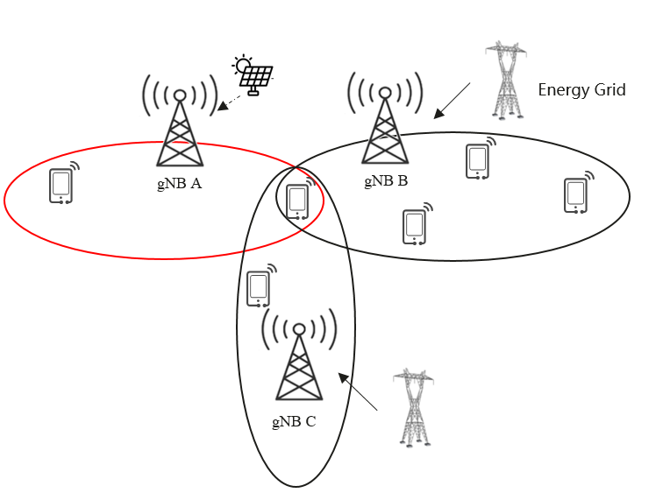

Figure 5.7.3.2-1: LBO between gNB A and gNB B

|  |
| --- |
| **End of change** |