**3GPP TSG-SA5 Meeting#156 *S5-244447***

**Maastricht, Netherland, 19thAug – 23rdAug 2024**

**Source: Samsung, Deutsche Telekom**

**Title: Energy-saving service**

**Document for: Approval**

**Agenda Item: 6.19.20**

# 1 Decision/action requested

***In this box give a very clear / short /concise statement of what is wanted.***

# 2 References

[1] 3GPP TR 28.880: "Study on energy efficiency and energy saving aspects of 5G networks and services"

# 3 Rationale

This provides the new use case of energy saving by adapting some of the UE services QoS parameters as per a pre-agreement between subscriber and the operator. By using such adaptable service the performance requirements on the network can be reduced in order to achieve energy saving.

# 4 Detailed proposal

The following changes are proposed for TR 28.880[1].

|  |
| --- |
| **First Change** |

## 5.X Use case #X: Energy saving by converting QoS of a service

### 5.X.1 Description

5G system architecture characterise the 5G services with the QoS model. 5G QoS model is based on QoS flows. A QoS flow ID (QFI) identifies a QoS flow in the 5G system where same traffic forwarding treatment is applied to the user plane traffic with the same QFI. Each QoS flow is specified by a set of QoS parameters and QoS characteristics in 3GPP TS 23.501. Energy-saving service can be realised by lowering some of the QoS requirements for the service. For example, any service identified by 5QI=X1 requiring high throughput can be reconfigured into a Energy-saving service by adjusting the QoS parameters such as guaranteed flow bit rate (GFBR) and maximum flow bit rate (MFBR) to lower down throughput requirements for the network. Alternatively, a service’s all QoS criteria can be removed turning that service into a best-effort traffic [TS 22.261]. This modification of QoS criteria would result in reduced performance requirements for the network and hence, resulting in reduced energy consumption. Thus a Energy saving method can be based on defining an Eco-friendly Energy-saving service and dynamically switching users to such service when a significant energy saving is predicted in network. Energy-saving service will only be utilised when a much larger energy saving is predicted by the network, so only during limited time intervals.

This can also be used in extending the time for which a network node remain in energy saving mode. A cell energy saving mode time is depicted in figure below, where a capacity cell is put to energy saving mode when the load is lower than the energy saving mode threshold. A adaptable QoS threshold is defined which will specify a threshold at which service(s) can be converted into Energy-saving service. When cell load is above the energy saving mode threshold but lower than adaptable QoS threshold, user’s service QoS parameters can be reconfigured so that they utilise less resources in the cell. Consequently, cell load is expected to reduce down to the energy saving mode threshold earlier and the cell is put to energy saving mode earlier to further increase energy saving. Figure below illustrates the cell load reduction due to adaptable QoS reconfiguration and the extended time of energy saving mode for a cell.

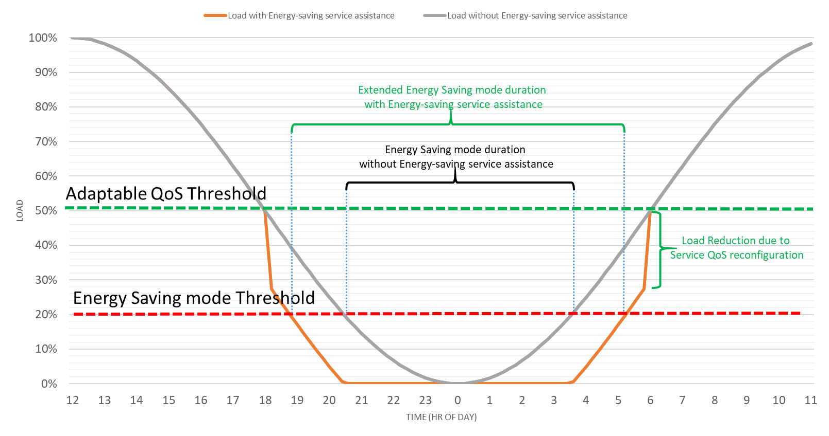

### 5.X.2 Potential requirements

**REQ-Energy_Saving_AdaptQoS-ES-1**: The management service producer responsible for energy saving should have capability enabling authorized consumers to request for updating an existing 5QI characteristics available with 5GS for the purpose of energy saving.

Note: An existing service can be modified to save energy by lowering some of its QoS parameters. For example, any service identified by 5QI=X1 (where X1 indicates an operator defined 5QI number) requiring high throughput can be reconfigured by adjusting its QoS parameters such as guaranteed flow bit rate (GFBR) and maximum flow bit rate (MFBR) in order to reduce performance requirements on the network. Alternatively, a service’s QoS criteria can be removed all together turning that service flow into a best-effort traffic

**REQ-Energy_Saving_AdaptQoS-ES-2**: The management service producer responsible for energy saving should have capability enabling authorized consumers to configure a load threshold which when crossed, the 5QI characteristics should be updated.

Note: Load can be related with for example a cell load, PDU session load, edge server load etc.

Editor Note: Usage of threshold monitor and generic provisioning MnS for the solutions of this use case is FFS.

|  |
| --- |
| **End of Changes** |