**3GPP TSG-SA5 Meeting #155 *S5-244735***

Maastricht, The Netherlands, 19 - 23 August 2024

**Source: Vodafone**

**Title: pCR TR 28.880 Add use case Network Slice deployment considering renewable sourced energy**

**Document for: Approval**

**Agenda Item: 6.19.20**

# 1 Decision/action requested

***The group is asked to discuss and agree on the proposal.***

# 2 References

[1] 3GPP TR 28.880 v0.3.0: Study on energy efficiency and energy saving aspects of 5G networks and services

# 3 Rationale

The use of renewable energy is increasing, and its use might be a requirement from the Service Provider or from the actual customer instructing the deployment of a Network Slice. There can be operator sites using renewable energy locally sourced or coming from the electricity grid specified by contract. A binary approach could be unrealistic as it would assume sites using only renewable energy. A request of a percentage seems more realistic, being a parameter in the slice provisioning.

# 4 Detailed proposal

This document proposes the following changes in TR 28.880 [1].

|  |
| --- |
| **1st Change** |

### 5.x Use case #X: Deployment of Network Slices depending on the energy source of the operator site

##### 5.x.1 Description

In a Service Provider network, the operator sites are supplied with a different mix of energy sources, that can be renewable or not. This renewable energy might come from the electricity grid or from local infrastructure in the data centre. Prioritizing those operator sites that use renewable sourced energy would have an immediate positive impact in potentially reducing the cost of energy, in case such renewable energy is sourced locally, and also in reducing the carbon footprint. It can be either the Service Provider or the actual customer who decides to request a minimum percentage of renewable sourced energy.

##### 5.x.2 Potential requirements

REQ-ENERGY-RENEWABLE-1: The 3GPP management system shall be able to consider as a requirement when a slice is deployed the percentage of energy from a renewable source in an operator site.

### 5.x.3 Potential solutions

#### 5.x.3.1 Potential solution #1:

In the provision stage of the Network Slice a new parameter will be added stating the minimum percentage of renewable sourced energy that the slice will use. For knowing where the Network Slice can be deployed a label would be assigned per operator site that would have the information about the percentage of renewable sourced energy and its origin (either local or from the electrical grid) The 3GPP management system would take the requested percentage of renewable sourced energy and will check in the inventory which operator sites will be the ones where this requirement can be fulfilled. That will trigger the feasibility check of the network slice to check the rest of parameters before providing the final feasibility and reservation conclusion.

The properties of the network slice related requirements that should be supported by a NetworkSlice instance in a 5G network are covered in the ServiceProfile data type (TS 28.541). The GST (generic slice template) defined by GSMA and the service performance requirements defined in 3GPP TS 22.261 and TS 22.104 are all considered as input for the network slice related requirements. An NSP may add additional requirements not directly derived from SLA’s, associated to the NSP internal goals as it can be seen in this diagram:

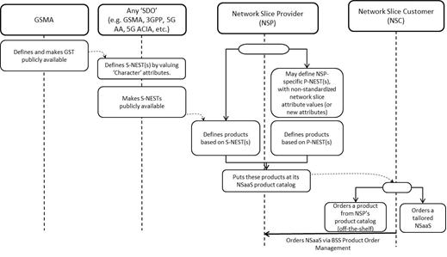

Figure 5.x.3.1-1: From GST to S-(/P-)NEST based product ordering

The use of renewable sourced energy can be an additional requirement. That would mean that in the provisioning stage the operator site with a sufficient percentage of renewable sourced energy will be chosen.

For defining it a new parameter would be added in the ServiceProfile.

The ServiceProfile input is translated into SliceProfile attribute of NetworkSliceSubnet IOC that can follow this criteria.

As stated in the TS 28.541, The NetworkSliceSubnet can be categorized by following types:

-RANSliceSubnet represent the RAN network slice subnet in a 5G network, which is associated to one or multiple “RANSliceSubnetProfile”.

-CNSliceSubnet represent the CN network slice subnet in a 5G network, which is associated to one or multiple “CNSliceSubnetProfile”.

-TopSliceSubnet represent the top network slice subnet in a 5G network, which is associated to one or multiple “TopSliceSubnetProfile”.

There might not be much flexibility in the RAN as the slice might cover specific areas so this translation might not happen for RAN, but in the CN there is more flexibility for allocating the slice where the percentage of renewable sourced energy is enough for fulfilling the parameter as part of the feasibility process.

It is proposed to include in the list of requirements in the ServiceProfile a new one with the following parameter as an implementation example:

|  |  |  |  |  |  |
| --- | --- | --- | --- | --- | --- |
| **Attribute name** | **S** | **isReadable** | **isWritable** | **isInvariant** | **isNotifyable** |
| RenewableEnergyPercentage | M | T | T | F | T |



|  |
| --- |
| **End of Change** |