3GPP TSG-SA5 Meeting #156 S5-244732d1
Maastricht, Netherlands, 19 - 23 August 2024

Source: Huawei

Title: Overall view of energy efficient networks

Document for: Approval
Agenda Item: 6.19.20

1 Decision/action requested
The group is asked to discuss and agree on the proposal.

2 References
[1] 3GPP TR 28.880 v0.3.0: Study on energy efficiency and energy saving aspects of 5G networks and services

3 Rationale
This contribution proposes to update concepts clause in TR 28.880 [1].

4 Detailed proposal
This document proposes the following changes in TR 28.880 [1].
1st Change

2 References
The following documents contain provisions which, through reference in this text, constitute provisions of the present document.
- References are either specific (identified by date of publication, edition number, version number, etc.) or non-specific.
- For a specific reference, subsequent revisions do not apply.
- For a non-specific reference, the latest version applies. In the case of a reference to a 3GPP document (including a GSM document), a non-specific reference implicitly refers to the latest version of that document in the same Release as the present document.
[1] 3GPP TR 21.905: "Vocabulary for 3GPP Specifications".
[2] 3GPP TS 28.554: "Management and orchestration; 5G end to end Key Performance Indicators (KPI)".
[3] ETSI GR NFV-IFA 029 V3.3.1 (2019-11): "Network Functions Virtualisation (NFV) Release 3; Architecture; Report on the Enhancements of the NFV architecture towards "Cloud-native" and "PaaS"".
[4] ETSI GS NFV-IFA 040 V4.3.1 (2022-05): "Network Functions Virtualisation (NFV) Release 4; Management and Orchestration; Requirements for service interfaces and object model for OS container management and orchestration specification".
[5] ETSI GS NFV-IFA 027 V4.3.1 (2022-06): "Network Functions Virtualisation (NFV) Release 4; Management and Orchestration; Performance Measurements Specification".
[6] ETSI GS NFV-IFA 027 V5.1.1 (2024-4): "Network Functions Virtualisation (NFV) Release 5; Management and Orchestration; Performance Measurements Specification".
[7] 3GPP TS 22.261: Service requirements for the 5G system; Stage 1
[8] ETSI GS OEU 020: "Operational energy Efficiency for Users (OEU); Carbon equivalent Intensity measurement; Operational infrastructures; Global KPIs; Global KPIs for ICT Sites".
[9] ETSI EN 303 472: "Environmental Engineering (EE); Energy Efficiency measurement methodology and metrics for RAN equipment".
[10] ISO/IEC 30134-3:2016: Information technology - Data centres - Key performance indicators - Part 3: Renewable energy factor (REF)
[11] 3GPP TS 28.552: "Management and orchestration; 5G performance measurements".
[12] 3GPP TS 28.310: "Management and orchestration; Energy efficiency of 5G"
[13] 3GPP TS 28.313: " Management and orchestration; Self-Organizing Networks (SON) for 5G networks ".
[14] 3GPP TS 28.622: "Generic Network Resource Model (NRM) Integration Reference Point (IRP); Information Service (IS)".
[XX] Energy Benchmark 2023: Telco Insights and Industry Health Check (https://www.gsmaintelligence.com/wp-content/uploads/2024/03/EnergyBenchmarkDeck_forWeb-1.pdf)
Editor’s note: reference [6] is not published yet, will be published soon, the latest draft of DGS/NFV-IFA027 is available in the following location: https://docbox.etsi.org/ISG/NFV/Open/Drafts/IFA027ed451

Next Change

4 Concepts and background

4.X Overall view of energy efficient networks
In addition to traditional policy-based energy-saving solutions, operators and vendors are developing many solutions aimed at enhancing overall energy efficiency throughout 3GPP networks,
such as deployment of intent driven RAN energy saving solutions and AI-driven energy saving solutions focused on improving energy efficiency and preventing unnecessary energy consumption in networks.

According to network energy distribution published by GSMA Intelligence, see figure 4.X-1 which illustrates the area of energy consumption, RAN is still the most power consuming part in mobile networks at 76% of total. See reference [XX] for further info of the data based on GSMA Intelligence Telco Energy Benchmark study in 2024 with 65 mobile networks.
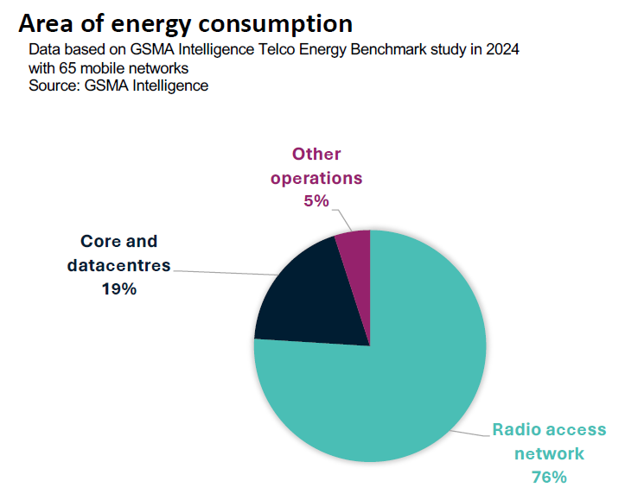
Figure 4.X-1: Area of energy consumption
There are many initiatives on energy efficiency and energy saving in 3GPP and other SDOs/fora. During the past 3GPP releases, SA5 has been working jointly with external SDOs/groups on EE and will continue to synchronize with e.g. ETSI TC EE, ITU-T SG5, NGMN GFN (Green Future Networks), ETSI NFV ISG, and more recently with ITU-T SG11.

End of change

