3GPP TSG-SA5 Meeting #156 S5-244700
Maastricht, Netherlands, 19- 23 Aug 2024

Source: Ericsson, Rakuten Mobile, AT&T

Title: pCR 28.869 concept and terminology

Document for: Approval
Agenda Item: 6.19.6

1 Decision/action requested
The group is asked to discuss and approve.

2 References
[1] 3GPP TR 28.869 v0.3.0 Study on cloud aspects of management and orchestration

3 Rationale
This contribution proposes the concept and terminology to use in 3GPP for LCM of cloud native network function.

4 Detailed proposal
It proposes to make the following changes to TR 28.869 [1].
1st Change

2 References
The following documents contain provisions which, through reference in this text, constitute provisions of the present document.
- References are either specific (identified by date of publication, edition number, version number, etc.) or non-specific.
- For a specific reference, subsequent revisions do not apply.
- For a non-specific reference, the latest version applies. In the case of a reference to a 3GPP document (including a GSM document), a non-specific reference implicitly refers to the latest version of that document in the same Release as the present document.
[1] 3GPP TR 21.905: "Vocabulary for 3GPP Specifications".
[2] ETSI GS NFV-IFA 049: “Network Functions Virtualisation (NFV) Release 5; Architectural Framework; VNF generic OAM functions specification.
[3] ETSI GR NFV-EVE 019: "Network Functions Virtualisation (NFV) ;Architectural Framework;Report on VNF generic OAM functions".
[4] 3GPP TR 28.834: "Study on management of cloud-native Virtualized Network Functions (VNF)".
[5] SP-230764 New WID on Management of cloud-native Virtualized Network Functions.
[6] 3GPP TS 28.526: "Telecommunication management; Life Cycle Management (LCM) for mobile networks that include virtualized network functions; Procedures".
[7] 3GPP TS 28.531: “Management and orchestration; Provisioning”.
[8] ETSI GS NFV-IFA 013 (V4.5.1) (2023-09): "Network Function Virtualisation (NFV); Release 4; Management and Orchestration; Os-Ma-nfvo reference point - Interface and Information Model Specification".
[9] ETSI GS NFV-IFA 008 (V4.3.1) (2022-05): "Network Function Virtualisation (NFV); Release 4; Management and Orchestration; Ve-Vnfm reference point - Interface and Information Model Specification".
[10] 3GPP TR 28.532: “Management and orchestration; Generic management services”.
[11] ETSI GR NFV 003 (V1.8.3): "Network Functions Virtualisation (NFV); Terminology for Main Concepts in NFV".
[12] 3GPP TS 28.555: "Management and orchestration; Network policy management for 5G mobile networks; Stage 1".
[13] ETSI GR NFV-IFA 023 (V3.1.1): "Network Functions Virtualisation (NFV); Management and Orchestration; Report on Policy Management in MANO; Release 3".
[14] 3GPP TS 28.552: " Management and orchestration; 5G performance measurements ".
[15] 3GPP TS 28.554: "Management and orchestration; 5G end to end Key Performance Indicators (KPIs)".
- 3GPP TS 28.533: “Management and orchestration; Architecture framework”.
[17] 3GPP TS 28.541: "Management and orchestration; 5G Network Resource Model (NRM); Stage 2 and stage 3".
[18] ETSI GS NFV 006: "Network Functions Virtualisation (NFV) Release 4; Management and Orchestration; Architectural Framework Specification".
[19] ETSI GS NFV-IFA 007: "Network Functions Virtualisation (NFV) Release 5; Management and Orchestration; Or-Vnfm reference point - Interface and Information Model Specification".
[20] ETSI GS NFV-IFA 008: "Network Functions Virtualisation (NFV) Release 5; Management and Orchestration; Ve-Vnfm reference point - Interface and Information Model Specification".
[21] ETSI GS NFV-IFA 010: "Network Functions Virtualisation (NFV) Release 5; Management and Orchestration; Functional requirements specification".
[22] ETSI GS NFV-IFA 011: "Network Functions Virtualisation (NFV) Release 5; Management and Orchestration; VNF Descriptor and Packaging Specification".
[23] ETSI GS NFV-IFA 013: "Network Functions Virtualisation (NFV) Release 5; Management and Orchestration; Os-Ma-nfvo reference point - Interface and Information Model Specification".
[24] ETSI GS NFV-IFA 014: "Network Functions Virtualisation (NFV) Release 5; Management and Orchestration; Network Service Templates Specification".
[25] ETSI GR NFV-IFA 029: "Network Functions Virtualisation (NFV) Release 3; Architecture;Report on the Enhancements of the NFV architecture towards "Cloud-native" and "PaaS".
[26] ETSI GS NFV-IFA 036: "Network Functions Virtualisation (NFV) Release 5; Management and Orchestration; Requirements for service interfaces and object model for container cluster management and orchestration specification".
[27] ETSI GR NFV-IFA 038: "Network Functions Virtualisation (NFV) Release 4; Architectural Framework; Report on network connectivity for container-based VNF".
[28] ETSI GS NFV-IFA 040: "Network Functions Virtualisation (NFV) Release 5; Management and Orchestration; Requirements for service interfaces and object model for OS container management and orchestration specification".
[29] ETSI GR NFV-IFA 043: "Network Functions Virtualisation (NFV) Release 5; Architectural Framework; Report on enhanced container networking".
[30] ETSI GS NFV-SOL 001: "Network Functions Virtualisation (NFV) Release 5; Protocols and Data Models; NFV descriptors based on TOSCA specification".
[31] ETSI GS NFV-SOL 002: "Network Functions Virtualisation (NFV) Release 5; Protocols and Data Models; RESTful protocols specification for the Ve-Vnfm Reference Point".
[32] ETSI GS NFV-SOL 003: "Network Functions Virtualisation (NFV) Release 5; Protocols and Data Models; RESTful protocols specification for the Or-Vnfm Reference Point".
[33] ETSI GS NFV-SOL 004: "Network Functions Virtualisation (NFV) Release 5; Protocols and Data Models; VNF Package and PNFD Archive specification".
[34] ETSI GS NFV-SOL 005: "Network Functions Virtualisation (NFV) Release 5; Protocols and Data Models; RESTful protocols specification for the Os-Ma-nfvo Reference Point".
[35] ETSI GS NFV-SOL 016: "Network Functions Virtualisation (NFV) Release 4; Protocols and Data Models; NFV-MANO procedures specification".
[36] ETSI GS NFV-SOL 018: "Network Functions Virtualisation (NFV) Release 5; Protocols and Data Models; Profiling specification of protocol and data model solutions for OS Container management and orchestration".
[37] ETSI GS NFV-SOL 020: "Network Functions Virtualisation (NFV) Release 5; Protocols and Data Models Specification of protocols and data models for Container Infrastructure Service Cluster Management".
- ETSI GS NFV-IFA 027: "Network Functions Virtualisation (NFV) Release 5; Management and Orchestration; Performance Measurements Specification".
- ETSI GR NFV-EVE 021: "Network Functions Virtualisation (NFV) Release 5; Evolution and Ecosystem;Report on energy efficiency aspects for NFV".
- ETSI GS NFV-IFA 053: "Network Functions Virtualisation (NFV) Release 5; Management and Orchestration; Requirements and interface specification for Physical Infrastructure Management".
[x] 3GPP TS 23.501: “System architecture for the 5G System (5GS)”.

…

2nd Change

3 Definitions of terms, symbols and abbreviations

3.1 Terms
For the purposes of the present document, the terms given in 3GPP TR 21.905 [1] and the following apply. A term defined in the present document takes precedence over the definition of the same term, if any, in 3GPP TR 21.905 [1].
example: text used to clarify abstract rules by applying them literally.

3.2 Symbols
For the purposes of the present document, the following symbols apply:
<symbol> <Explanation>

3.3 Abbreviations
For the purposes of the present document, the abbreviations given in 3GPP TR 21.905 [1] and the following apply. An abbreviation defined in the present document takes precedence over the definition of the same abbreviation, if any, in 3GPP TR 21.905 [1].
<ABBREVIATION> <Expansion>
LCM Life Cycle Management
CNDC Cloud Native Deployment Component

3rd Change

4.2 Terminology considerations

4.2.1 Terminology and concepts used in this report

3GPP network function (NF) is specified in TS 23.501 [x]:
Network Function: A 3GPP adopted or 3GPP defined processing function in a network, which has defined functional behaviour and 3GPP defined interfaces.
To support cloud native technology in 3GPP, a NF Deployment instance provides realizes part of, one of, or many instances of 3GPP NF types as specified in TS 23.501 [x] clause 4.2.
A CNDC NF Deployment instance is a deployed software instance designed to run on cloud, deployed and managed using technologies and principles evolving in the cloud eco system. A fundamental cloud native principle is to partition systems into smaller, separately manageable parts. This allows for faster and more automated upgrades, improve operational efficiency and shorter time to market for new services.
Figure 4.2-1 illustrates the relationship between 3GPP NF and NF Deployment with added support of Cloud Deployment which can be of type ETSI VNF or CNDC in Rel-19.

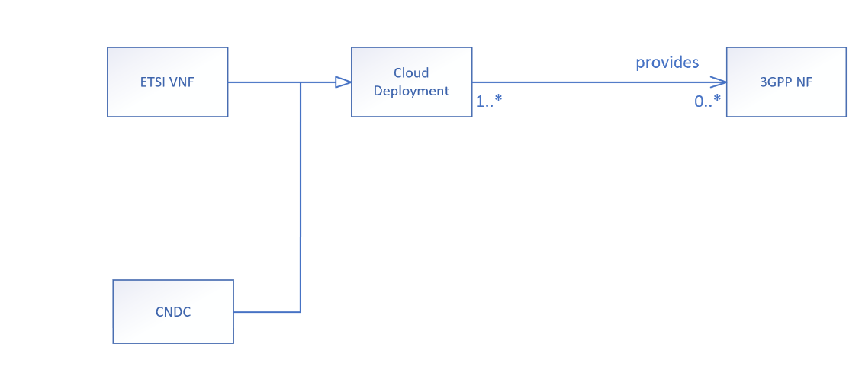
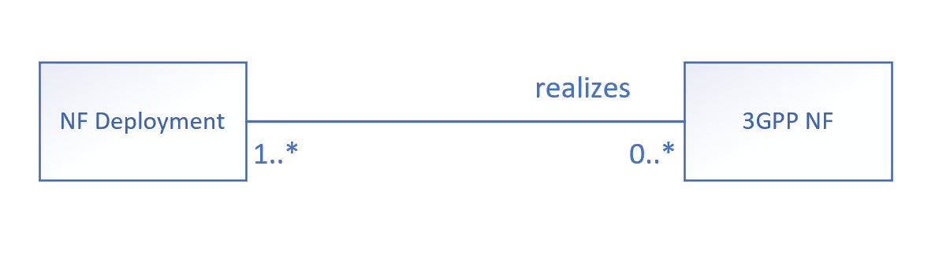
Figure 4.2-1 Relationship between 3GPP NF and NF Deployment with added support of CNDC
This study proposes to use NF Deployment as concept and terminology in 3GPP. The instance(s) of NF Deployment is/are created, modified, or terminated through the LCM of CNDC(s) based on cloud native principles or using ETSI NFV MANO for LCM of ETSI VNF(s). using an orchestration and management system. Accordingly, the agreed and subsequent contributions in this study shall adopt to this concept.

End of change

