**3GPP TSG-SA5 Meeting #156 *S5-244695***

**Maastricht, Netherlands 19 - 23 August 2024 revision of S5-243747**

**Source: Huawei, Nokia**

**Title: pCR TR 28.915 Solution for using NDT to generate ML training data**

**Document for: Approval**

**Agenda Item: 6.19.5**

# 1 Decision/action requested

***The group is asked to discuss and agree on the proposal.***

# 2 References

[1] 3GPP TR 28.915: " Study on management aspects of Network Digital Twin"

# 3 Rationale

It’s proposed to add solution for use case Using NDT to generate ML training data as described in clause 5.6 of [1]

# 4 Detailed proposal

This document proposes the following changes in TR 28.915.

|  |
| --- |
| **1st Change** |

### 5.6.3 Potential solutions

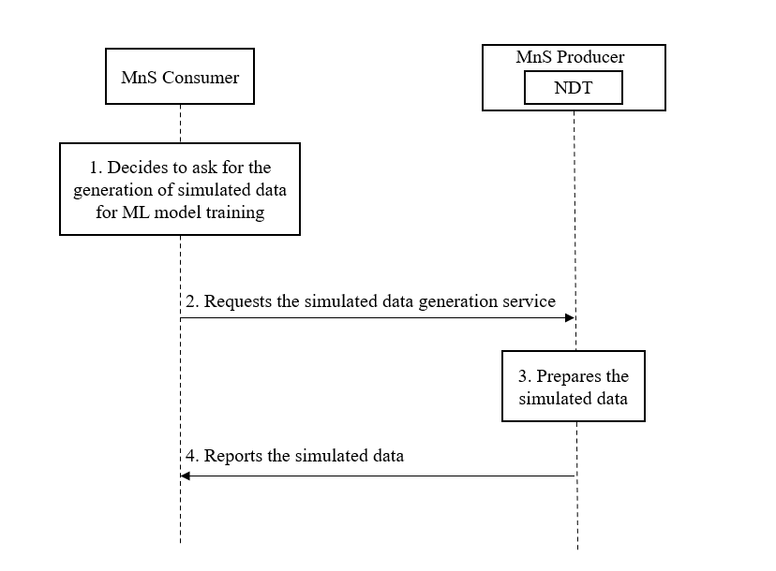

Figure 5.6.3-x: procedure of simulated data generation for ML model training

Pre-condition: NDT is created and can support the simulated data generation.

1. The MnS consumer, e.g., ML training function, makes preparation of ML model training and decides to collect simulated data to enrich ML model training dataset.
2. The MnS consumer requests NDT to generate simulated data. The request parameters may include:

* Object: the managed object which the simulated data is related to, e.g., network slice.
* Data type: the type of data that needs to be generated by NDT for certain managed object, e.g., KPIs/alarms.

1. NDT the prepares the simulated data as requested in step 5. NDT simulates the injection and then collects the required simulation data if the injection is contained in step5.
2. MnS producer reports the simulated data to MnS consumer. The simulated data is for specific managed object with specific data type as requested in step5.

|  |
| --- |
| **End of change** |