3GPP TSG-SA5 Meeting #156 S5-243535

19 - 23 August 2024, Maastricht, Netherlands

Source: Nokia

Title: Rel-19 pCR TR28.867 CCL dynamic composition solution

Document for: Approval

Agenda Item: 6.19.4

1 Decision/action requested
The group is asked to discuss and agree on the proposal.

2 References
[1] 3GPP TR 28.867: “Closed control loop management” v0.3.0

3 Rationale
Use cases 5.1 in this TR introduces requirements and a high-level solution on dynamic composition of CCLs, but the solution is not clear enough. This pCR enhances the solution for dynamic composition to clarify how the information objects may be used.

4 Detailed proposal

First Change

5.1 Use case 1: Dynamic CCL Creation
5.1.1 Description
5.1.1.1 Overview
CCLs may be dynamically realized. There are two aspects to dynamically realization of CCLs – dynamic instantiation of a CCL from an existing template and dynamically composing the CCL.

5.1.1.2 Dynamic composition of CCLs
A CCL may be composed on stages provided by different management functions or management services. i.e., the CCLs is assembled on demand by MnS consumers, using capabilities offered by the Management system, e.g., from independent management functions. The CCLs components, as well as the communication and interoperation between components, are based the different 3GPP management services. Accordingly, the MnS consumer should be able to identify and indicate the MnFs or MnS producers that should be used to compose a CCL. Moreover, the MnS consumer may indicate towards the MnS producer the request to compose the CL of a particular type (e.g. for optimizing energy efficiency) without requiring to state the specific components that should be used.

When composing or instantiating a closed loop, since a SON function may accomplish the goals of a closed control loop, the MnS consumer should be enabled to indicate that a specific SON function may be employed to fulfil the objectives of closed control loop. For example, the MnS consumer may require to instantiate a closed control loop within the management system whose capabilities are fulfilled by D-SON function on the gNB. The MnS consumer should be enabled to state that the CCL should employ the specific D-SON function for the instantiated closed control loop.

5.1.1.3 Examples for scenarios for Dynamic composition of CCLs
5.1.1.3.1 Composition from management Functions
Different management functions may be used to realize the different stages of a closed loop, for example, an MDA function may realize the analytics stage of the CCL while another management function may realize the decision stage of the CCL.

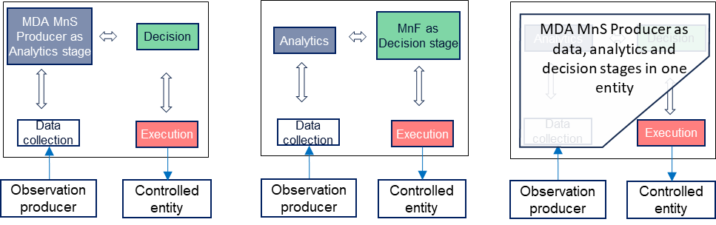
Figure 5.1.3.1-1: Management functions as stages of a closed control loop

5.1.1.3.2 Composition from management services
Different management services may be used to realize the different stages of a closed loop, i.e. the management service provides the output expected from a specific stage. For example, a capability of the MDA MnS realizes an analytics stage of the CCL while another capability may realize a specific data collection stage of the CCL.
a)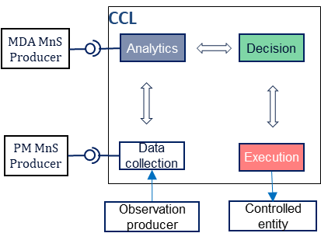 b)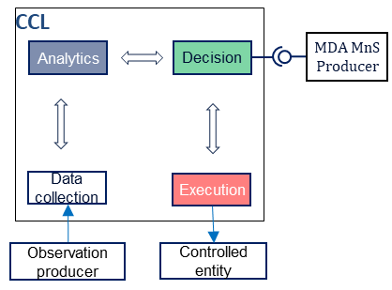
Figure 5.1.3.2-1: management services used as implementations of CCL stages: a) MDA MnS and PM job the respective implementations of the analysis and data collection stages and b) MDA MnS as the implementation of the decision stage
The MnS consumer should be enabled to manage the composition of such a CCL. The MnS consumer could request for and be notified about the composition of a CCL from a set of specific components (i.e., specific management functions or management services). The request could indicate components with specific given capabilities (such as analytics services with specific analytics types) which should be combined to achieve the closed loop. Moreover, the request could be for composition of a CCL required to achieve a specific set of desired outcomes or goals.

5.1.1.4 Conditional decision activation of CCLs
For the CCLs that have been instantiated, the MnS consumer may want to request for a CCL to be triggered to execute when certain conditions are met, e.g. when the performance on a certain threshold is crossed. The MnS consumer should be enabled to define those conditions for executing the CCL and that the CCL is triggered to execute when the stated conditions are met.

5.1.2 Potential Requirements
REQ-CCL-CRTN-1: The CCL MnS Producer should support a capability enabling the MnS consumer to request for a CCL (instance) to be composed from a set of management function types or instances or management services.
REQ-CCL-CRTN-1: The MnS producer for CCL management should support a capability enabling the MnS consumer to request that a CCL of a specific type or fulfilling a stated goal should be composed from a set of management function types or instances or services.
REQ-CCL-CRTN-2: The MnS producer for CCL management should support a capability enabling the MnS consumer to provide conditions under which a CCL can be dynamically composed or instantiated or triggered to execute.
REQ-CCL-CRTN-3: The MnS producer for CCL management should support a capability enabling the MnS consumer to be notified when a CCL is dynamically composed or instantiated or triggered to execute.

5.1.3 Potential Solutions
5.1.2.1 Solution-1
To enable dynamic composition of the CCL
- Extend the existing ACCL IOC to represent a general Closed Control Loop, say named CCL.
Note: the best name for this IOC and how to extend is FFS
  - The CCL may include information on a CCL Category, which indicates the CCL Category to be instantiated.
    - Introduce an attribute for a type of CCL, say called CCLCategory. The CCL Category indicates the kind of capability that is accomplished by the CCL instance, e.g. ENERGYOPTIMIZATION, SLICEASSURANCE, etc.
  - The CCL may include an attribute that contains information on the conditions under which a CCL can be dynamically composed . The attribute can be of type condition.
- introduce a datatype representing a step of the CCL, say named cCLStep. The cCLStep represents either a MnF or a MnS producer which can be part of the CCL.
  - The cCLStep may have a role among those identified, i.e. DATACOLLECTION; ANALYSIS; DECISION; EXECUTION
  - Note: the CCL may combine the defined cCLSteps with other capabilities that are internal to the CCL for some of the roles
  - The cCLStep may indicate the DN of an MOI or the combination of URI and DN of an MnsInfo that shall be used to fulfil that role.
    - The identifier may also be a query of the MnS registry defined as a condition expressed as JEX/XPATH expression
  - The cCLStep may contain information on how the specific step shall be constructed. This may be represented as configuration plan as will be agreed in TS 28.872 or as a JEX/XPATH expression.
Note: The representation of the cCLStep as configuration plan as will be agreed in TS 28.872 or as a JEX/XPATH expression is FFS.
- introduce on the CCL IOC, an attribute representing the sequence of steps of the CCL, say called cCLSequence. The MnS consumer can provide the list of MnFs or MnS producers that should be combined into a CCL.
  - cCLSequence may be used as the request to compose a CCL (instance) through its members with each as a cCLStep identifying the DNs of the managed service producers or identifiers of management services (capabilities) that the MnS consumer wants to be used in a CCL (instance). The set of DNs may be 1 or more, e.g. only 1 if a single SON function fulfils the objectives of the CCL
Introduce in CCL an attribute providing information related to the identifiers of the required management functions and the required configuration that make the CCL. When a combination of the sets of management functions and services are all defined to include their data sources, the combination is equivalent to a dynamically composed CCL.

To enable dynamic Conditional decision activation of the CCL
- introduce on the CCL IOC, an attribute representing the set of conditions to be monitored for activation of the CCL. The attribute may be of type threshold monitor defined in TS28.622, condition monitor as defined in TS28.622 or expectation Target defined in TS28.312

5.1.4 Evaluation of solutions

The potential solution described in clause 5.1.3 is a fully NRM-based approach that extends the existing NRM fragments to realise dynamic composition of a CCL. The solution allows the MnS consumer to either directly compose the CCL or to request a MnS producer to compose the CCL. The solution enhances the existing ACCL with small straightforward implementable changes that reuse existing information elements like the condition monitor.
Therefore, the solution described in clause 5.1.3 is a feasible solution for dynamic composition of CCLs.

Next Change

6 Conclusions and recommendations

