3GPP TSG-SA5 Meeting #156 S5-244634d1

Maastricht, The Netherlands 19 - 23 August 2024

Source: Huawei, Samsung, Nokia, ZTE

Title: Rel-19 pCR TR 28.858 add use cases, requirements for reinforcement learning management

Document for: Approval
Agenda Item: 6.19.1

1 Decision/action requested
The group is asked to discuss and agree on the proposal.

2 References
[1] SP-231780 " New SID: Study on AI/ML management - phase 2".

3 Rationale
Amongst other study objectives in [1], WT-4 addresses the issue about the enhancement of the management and operation capabilities to support the reinforcement learning:
“WT-4. Study the AI/ML management and operation capabilities to support different types of AI/ML technologies as needed to support the AI/ML in 5GS, such as Federated Learning, Reinforcement Learning, Online and Offline training, Distributed Learning, and Generative AI.”
Therefore, this contribution introduces a use case and requirements of reinforcement learning management.

4 Detailed proposal
Start of First change

2 References
The following documents contain provisions which, through reference in this text, constitute provisions of the present document.
- References are either specific (identified by date of publication, edition number, version number, etc.) or non-specific.
- For a specific reference, subsequent revisions do not apply.
- For a non-specific reference, the latest version applies. In the case of a reference to a 3GPP document (including a GSM document), a non-specific reference implicitly refers to the latest version of that document in the same Release as the present document.
[1] 3GPP TR 21.905: "Vocabulary for 3GPP Specifications".
[2] 3GPP TS 28.104: " Management Data Analytics (MDA)".

Next change

5 AI/ML management use cases and requirements

5.1 ML model training

5.1.6 Management of Reinforcement Learning

5.1.6.1 Description
Reinforcement Learning (RL) is a type of machine learning where an agent learns to make decisions by taking actions in an environment to achieve a goal. The agent learns from the consequences of its actions, rather than from being explicitly taught and it selects its actions based on its past experiences (exploitation) and also by new choices (exploration), which is essentially a trial-and-error approach. In RL, an agent interacts with the environment in discrete time steps. At each time step, the agent receives the current state of the environment and selects an action. The environment, in turn, provides a reward and the new state. As illustrated as Figure 5.1.6.1, take MDA use case coverage problem analysis as example, when RL is applied for coverage problem analysis use case, the RL agent can be an ML model for coverage problem analysis, the RL environment can be the simulation environment. The actions can be the values of network adjustable parameters like recommended actions (e.g. change the transmission power of the NR sector carrier, see TS 28.104 [x]). The states can be the network PMs/KPIs like RSRP distribution etc. The reward can be the score of an RL performance metric to evaluate the PMs/KPIs. The goal of the agent is to learn a policy, which tells it what action to take under what circumstances, that maximizes the sum of rewards. The main advantage of this approach is in the ability to automatically adapt to the characteristics of the environment, making it suitable approach for handling dynamic environments such as mobile networks.
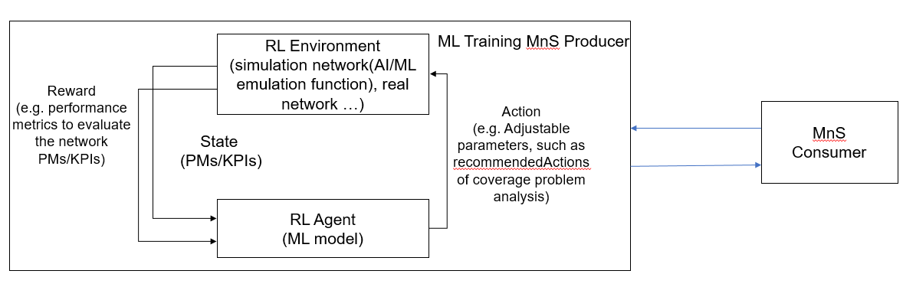
Figure 5.1.6.1: Reinforcement Learning in Domain Management Function

5.1.6.2 Use cases

5.1.6.2.1 Exploration in Reinforcement Learning
Reinforcement Learning (RL) has the ability to learn and adapt itself to dynamic environments and thus finds the near optimal solution to the problem. This makes the RL-based approaches very interesting for applications in the mobile networks. However, the potential negative impact to the mobile network caused by RL is still the main drawback. In particular, during the exploration step performing trials and learning from errors may have an impact on the operational network and may result in unsafe operations causing network performance degradations. Therefore, the exploration step in RL needs to be under a controlled environment that are not supposed to violate system performance requirements. If the RL agent behaves in an unexpected manner, there needs to be a set of fall-back actions in place, e.g., to switch from RL-based solution to non-RL-based solution.

For managing the RL, the MnS consumer can query producer if RL training is supported in order to manage them correspondingly. When using RL training in the context of the telecom networks, it is crucial to select the appropriate RL environment scope, to enable an agent to execute the actions, and get the rewards. A consumer may have specific requirements (e.g area scope, location, or time) that should be supported by the environment used for RL. It is desirable to provide mechanisms enabling consumer to provide information that can be used to identify an appropriate network environment for RL during training. The MnS consumer may also wish to declare the RL environment type (e.g. RL on simulation environments or RL on the real network) that the RL based training should be done online or offline. Online implies that the RL actions are taken on the real network. Whereas, offline would imply that the producer will have to perform RL on an appropriate simulation environment.

5.1.6.3 Potential Requirements
REQ-RL_MGMT-01: The ML training MnS producer should have a capability allowing an authorized MnS consumer to query if RL training is supported.
REQ-RL_MGMT-02: The ML training MnS producer should have a capability allowing an authorized MnS consumer to specify the preferred RL environment type.

REQ-RL_MGMT-03: The ML training MnS producer should have a capability to allow an authorized MnS consumer to specify the preferred RL environment scope

End of First change

