3GPP TSG-SA5 Meeting #156 S5-244627
Maastricht, Netherlands, 19 – 23 August 2024

Source: Nokia

Title: Rel-19 pCR Evaluation and conclusion for HO and service correlation analytics

Document for: Approval
Agenda Item: 6.19.2

1 Decision/action requested
In this box give a very clear / short /concise statement of what is wanted.

2 References

3 Rationale
This pCR proposes the evaluation of existing solution for HO and service data correlation analytics.

4 Detailed proposal
Start of first change

5.3.5 Use case 4: Handover and service data correlation analytics

5.3.5.1 Description
Handover performance may be affected by multiple aspects including:
- Signal measurements, either as measured in the network or as predicted.
- User speeds which may be measured or predicted.
User paths or trajectories, by predicting the likely destination based on the user current path and learning from previous user trajectories. These may be combined in different forma to either derive the optimal handover settings or to also determine the related service configurations. It is desired that the MDA supports analytics that enables the consumer to request analytics on real or predicted signal measurements, on real or predicted user speeds, on learned and predicted user trajectories or paths, or any combination of these aspects. The predicted user speed and predicted trajectory mentioned here are referring to the RAN3 agreed predicted outputs on the same as described in TS 37.817 [9] and TS 38.423 [10].
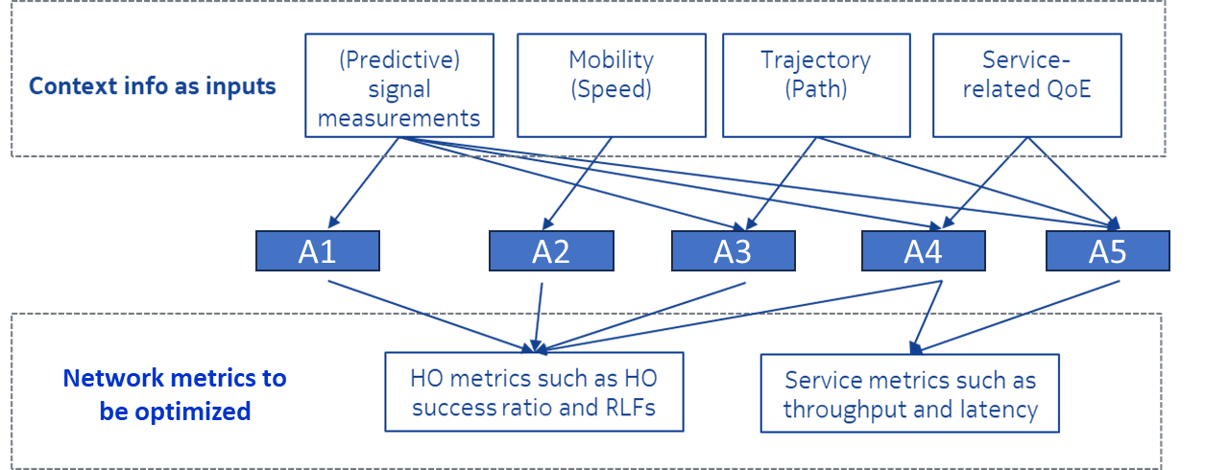
Figure 5.3.5.1-1: Examples of various context information and HO performance metrics can be used for handover optimization through different combinations A1 to A5.

5.3.5.2 Potential requirements
REQ-MDA-CORR-1: The MDA producer for handover and service data correlation analytics should have a capability of allowing the use the predicted signal measurements, predicted user speeds and predicted user trajectories for providing recommendations for Handover analytics.
REQ-MDA-CORR-2: The MDA producer for handover and service data correlation analytics should have a capability of allowing the consumer to use the service characteristics.
Note: The service characteristics may include information such as QoE for handover and service data correlation analytics.

5.3.5.3 Potential solutions

5.3.5.3.1 Possible solution for handover and service data correlation analytics
- Extend the existing usecase on Handover optimization analytics by enhancing the enabling data to include predicted signalling measurements, predicted user trajectories and predicted signal measurements.
- Extend the existing usecase on Handover optimization analytics by enhancing the enabling data to include service characteristics such as QoE.

5.3.5.4 Evaluation of solutions
The solution proposed in clause 5.3.5.3.1 satisfies the requirements and this solution is feasible for normative work.

Start of next change

6 Conclusions and Recommendations

6.x Data correlation analytics
The use case, requirements and solution for the capability of handover and service data correlation analytics is described in clause 5.3.5. It is recommended to extend the input data as described in clause 5.3.5.3 in TS 28.104 [2].

End of changes

