3GPP TSG-SA WG5 #156 S5-244610
Maastricht, The Netherlands 19 - 23 August 2024

Source: SA5 SWG Chair
Title: Breakout Notes for 6.4.25 EE cost index and RAN3 LS on improved KPIs
Document for: Information
Agenda Item: 6.4.25

Agenda

The following tdocs are discussed in breakout session:
- EE cost index (3855/3832/3591/3595/4204) (60min)
- RAN3 LS on improved KPIs (3882/ 3883/3920/3921/3767/3768) (30min)

6.4.25 Rel-18 CAT B/C alignment CR(s) due to the work led by other 3GPP Working Groups
S5-243591 | Rel-18 CR TS 28.622 Add GenericCollection and EnergySavingsGroup MOI to support grouping for energy cost mapping rule (Nokia) (Srilakshmi Srinivasaraju)  Group has discussed this tdoc and the summary of proposal see notes in 4204. | CR0410r, TS/TR 28.622 v18.7.0, Rel-18, Cat. B  Source modified on 8/9/2024. Original source : Nokia
S5-243595 | Rel-18 CR TS 28.541 Add support for energy cost mapping rule (Nokia) (Srilakshmi Srinivasaraju)  Group has discussed this tdoc and the summary of proposal see notes in 4204. | CR1278r, TS/TR 28.541 v18.8.0, Rel-18, Cat. B  Source modified on 8/9/2024. Original source : Nokia
S5-243832 | Introduce NRM definitions for NG-RAN energy saving based on energy cost – Stage 2 (Huawei) (Jean-Michel CORNILY)  E: why need an extra group?  - Whether need to allow all gNBs in a subnetwork share the same mapping rule?  - Whether need to allow multiple gNBs share the same mapping rule?  - Whether allow single gNB to have its specific mapping rule?  - Whether need to consider gNB-CU/DU to have separate mapping rule?  - What’s in the scope of R18?  The configuration is based on:  - Group? Single gNB? subnetwork? | CR1322r, TS/TR 28.541 v18.8.0, Rel-18, Cat. B  Title modified on 8/9/2024. Original title : Rel-18 CR TS 28.541 Introduce NRM definitions for AIML energy saving in NG-RAN - Stage 2<br/><br/>Source modified on 8/9/2024. Original source : Huawei
S5-243855 | Discussion Paper on options to model NG-RAN energy saving groups (Huawei) (Jean-Michel CORNILY)  The following 3 options are discussed.  Op1: Huawei 3832  Op2: Nokia 3591/3595  Op3: Ericsson 4204rev1 | discussion
S5-244204 | Rel-18 CR TS 28.541 Align with TS 38.423 to introduce NRM definitions for NG-RAN energy cost Reporting supporting (Ericsson (China)) (Gang Li)  Reallocate 6.4.22->6.4.25  MCC comments.  Group has discussed 4204rev1 and the summary of proposal is captured below.  EE cost index:  - Group agreed to move forward in Rel-18 with the following NRM modeling, stage 3 will also be updated in SA5#156.  - The other enhancement to be discussed in Rel-19.  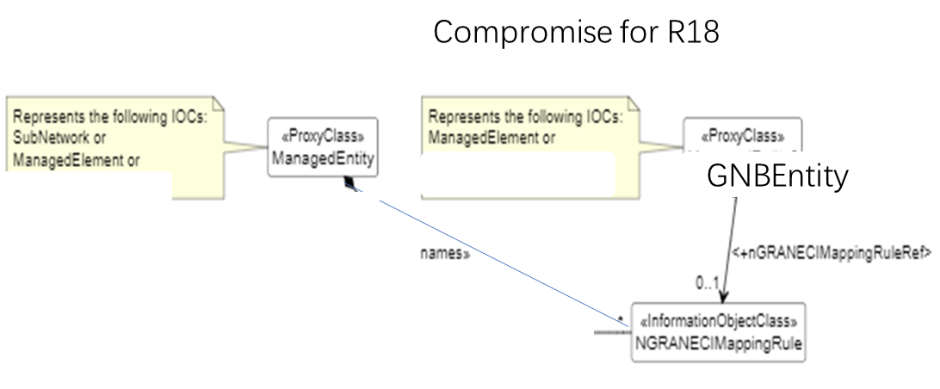 | CR1336r, TS/TR 28.541 v18.8.0, Rel-18, Cat. F
S5-243767 | Rel-18 CR TS 28.558 corrections on the loss rate measurements and the UE identifer (Huawei) (xiaoli Shi)  Reallocate 6.4.9->6.4.25  MCC comments.  Not open in Breakout session. | CR0011r, TS/TR 28.558 v18.1.0, Rel-18, Cat. F
S5-243768 | Rel-19 CR TS 28.558 corrections on the loss rate measurements and the UE identifer (Huawei) (xiaoli Shi)  Reallocate 6.4.9->6.4.25  MCC comments.  Not open in Breakout session. | CR0012r, TS/TR 28.558 v19.0.0, Rel-19, Cat. A
S5-243882 | Clarification of Measured UE Identifier in the measurement template (Intel, Ericsson) (Yizhi Yao)  Reallocate 6.3.12->6.4.25  Group had discussion on the meaning of bullet g.  - Whether 28.558 follows the template defined in 32.404? the bullet g is not aligned with template 32.404.  - Bullet g is for activation of PMJob  - Bullet g is used for reporting only  For reporting (management based trace):  Op1: no need UE identifier, using TSTR to identify UE as bullet g.  Op2: need UE identifier together with TSTR to identify UE as bullet g. | CR0013r, TS/TR 28.558 v18.1.0, Rel-18, Cat. F  Title modified on 8/9/2024. Original title : Rel18 CR 28.558 Clarification of Measured UE Identifier in the measurement template<br/><br/>Source modified on 8/9/2024. Original source : Intel, Ericsson
S5-243883 | Clarification of Measured UE Identifier in the measurement template (Intel, Ericsson) (Yizhi Yao)  Reallocate 6.3.12->6.4.25  Not open in Breakout session. | CR0014r, TS/TR 28.558 v19.0.0, Rel-19, Cat. A  Title modified on 8/9/2024. Original title : Rel19 CR 28.558 Clarification of Measured UE Identifier in the measurement template<br/><br/>Source modified on 8/9/2024. Original source : Intel, Ericsson
S5-243920 | Rel-18 CR TS 28.558 Replacing S-TMSI with TR/TRSR (Nokia) (Sivaramakrishnan Swaminathan)  Reallocate 6.4.9->6.4.25  Not open in Breakout session. | CR0019r, TS/TR 28.558 v18.1.0, Rel-18, Cat. F
S5-243921 | Rel-19 CR TS 28.558 Replacing S-TMSI with TR/TRSR (Nokia) (Sivaramakrishnan Swaminathan)  Reallocate 6.4.9->6.4.25  Not open in Breakout session. | CR0020r, TS/TR 28.558 v19.0.0, Rel-19, Cat. A

