**3GPP TSG-SA5 Meeting #156 S5-244134**

**Maastricht, Netherlands, 19 - 23 August 2024**

**Source: Ericsson LM**

**Title: Use of CHF Group ID for CHF selection**

**Document for: Endorsement**

**Agenda Item: 7.4.1**

1 Decision/action requested

***The group is asked to discuss and agree on the proposal.***

2 References

[1] 3GPP TR 28.840 Study on CHF Segmentation

[2] 3GPP TS 23.501 System architecture for the 5G System (5GS); Stage 2

[3] 3GPP TS 23.502 Procedures for the 5G System (5GS); Stage 2

[4] 3GPP TS 29.504 5G System; Unified Data Repository Services; Stage 3

[5] 3GPP TS 29.510 5G System; Network Function Repository Services; Stage 3

[6] 3GPP TS 32.255 Charging management; 5G data connectivity domain charging; Stage 2

[7] 3GPP TS 29.503 5G System; Unified Data Management Services; Stage 3

3.1 Background

In TR 28.840 [1] there are three solutions using the CHF Group ID: #1.1 CHF Selection and Discovery for NF Service Consumers Solution based on UDM, #1.6 NRF inferred CHF Group ID, and #1.7 SCP retrieved CHF Group ID. The #1.6 and #1.7 follows the recommendations in TS 23.501 [2] clause 6.3.11 and 6.2.19 while the #1.1 requires a new type of interaction between CHF and UDM/UDR.

3.2 Solutions

### 3.2.1 UDR based Group ID

There are five Group IDs defined: UDM, UDR, AUSF, PCF, CHF, and HSS. According to TS 23.501 [2] the CHF Group ID works similarly to the Group ID for: UDM, AUSF, and PCF. All the Group IDs are described for the NF Profile in NRF, TS 23.501 [2] clause 6.2.6.2, except for CHF which is missing.

The NF Group ID can, according to TS 23.501 [2] table 7.2.10-1, be retrieved from the UDR using the Nudr_GroupIDmap service defined in TS 23.502 [3] clause 5.2.12.9, the Nudr_GroupIDmap is however defined in TS 23.502 [3] clause 5.2.12.3.

There are only two NF service consumers mentioned of the Nudr_GroupIDmap service in TS 29.504 [4] clause 5.3.1.1 and they are: SCP and NRF.

This means that if an NF Consumer would like to find a NF provider for the Nchf_ConvergedService, which is missing in TS 29.510 [5] table 6.1.6.3.11-1, the flows could look as follows.

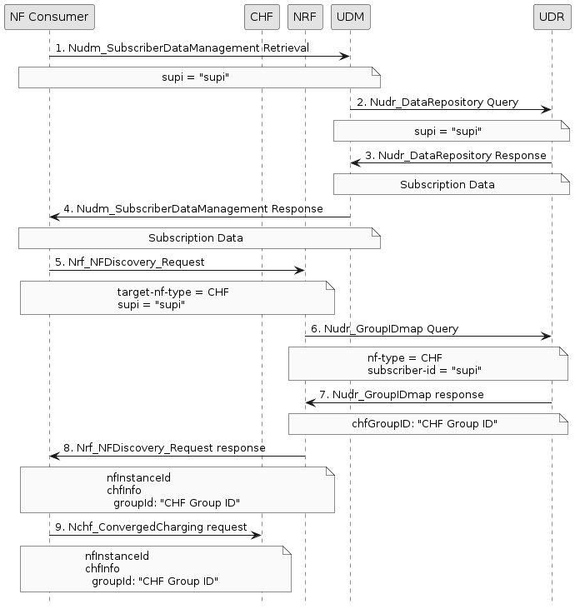

**Figure 3.2.1-1:** **Message Flow for UDR based CHF Group ID**

1 NF Consumer request retrieval of subscription data for a SUPI.

2. UDM requests subscription data for a SUPI.

3. UDR responds with subscription data.

4. UDM responds with subscription data.

5. An NF Consumer that would like to find a NF Provider that can provide the Nchf_ConvergedService service will do a discovery towards the NRF and may include service name and SUPI that it would like to find the NF provider for.

6. NRF decides that it needs to find the CHF Group ID to be able to find the correct CHF, and therefore query the UDR for the NF of type CHF and may include the SUPI.

7. UDR responds with the CHF Group ID applicable for the SUPI provided.

8. NRF responds with the CHF instances applicable and may include the CHF Group ID.

9. NF Consumer initiates a converged charging service with a CHF instance provided by the NRF, it may use the CHF Group ID provided if a reselection is required.

If an SCP with delegated discovery is used between the NF Consumer and the CHF, then the SCP may do the query for CHF Group ID towards the UDR instead of the NRF. There is also a possibility for NRF and SCP to subscribe to changes of the mapping between user ID and NF Group ID

### 3.2.2 Charging Characteristic based Group ID

The Charging Characteristics can be used to indicate the URI of Primary and Secondary CHF addresses, CHF instance ID(s), and CHF set ID(s) according to TS 32.255 [6] Annex A, this means that it could also be used to indicate to a CHF Group ID.

The Charging Characteristics can, according to TS 29.503 [7] clauses 6.1.6.2.4 and 6.1.6.2.8, be retrieved from the UDM for session management as well as access and mobility.

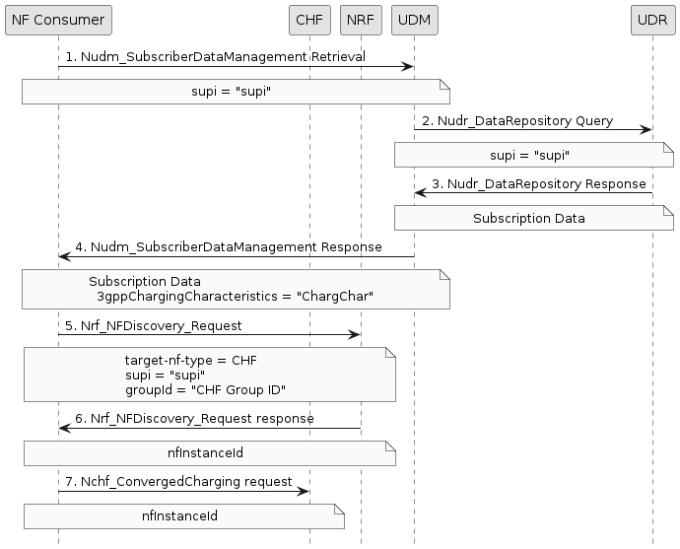

**Figure 3.2.2-1:** **Message Flow for Charging Characteristic based Group-ID**

1 NF Consumer request retrieval of subscription data for a SUPI.

2. UDM requests subscription data for a SUPI.

3. UDR responds with subscription data.

4. UDM responds with subscription data, including 3gppChargingChara1cteristics.

5. NF Consumer that would like to find a NF Provider that can provide the Nchf_ConvergedService service will map the 3gppChargingCharacteristics to a CHF Group ID and do a discovery towards the NRF which may include service name, SUPI, and CHF Group ID that it would like to find the NF provider for.

6. NRF responds with the CHF instances applicable.

7. NF Consumer initiates a converged charging service with a CHF instance provided by the NRF.

### 3.2.3 Charging Characteristic based NRF lookup

The Charging Characteristics can be used to indicate several things like CHF addresses, charging method, charging service, etc., according to TS 32.255 [6] Annex A. This means that it could be possible to use the charging characteristics directly to find CHF that support the charging characteristics required, by adding it as a part of the chfInfo in the NRF, TS 29.510 [5] clause 6.1.6.2.32.

The Charging Characteristics can, according to TS 29.503 [7] clauses 6.1.6.2.4 and 6.1.6.2.8, be retrieved from the UDM for session management as well as access and mobility.

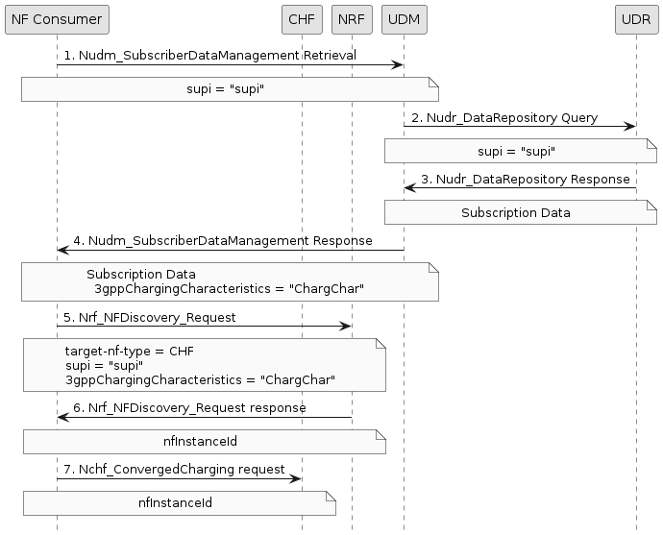

**Figure 3.2.3-1: Message Flow for Charging Characteristic based Group-ID**

1 NF Consumer request retrieval of subscription data for a SUPI.

2. URM responds with subscription data, including 3gppChargingCharacteristics.

3. NF Consumer that would like to find a NF Provider that can provide the Nchf_ConvergedService service will do a discovery towards the NRF which may include service name, SUPI, and charging characteristics that it would like to find the NF provider for.

4. NRF responds with the CHF instances applicable.

5. NF Consumer initiates a converged charging service with a CHF instance provided by the NRF.

### 3.2.4 UDM based Group ID

There are six Group IDs defined: UDM, UDR, AUSF, PCF, CHF, and HSS. According to TS 23.501 [2] the CHF Group ID works similarly to the Group ID for: UDM, AUSF, and PCF. All the Group IDs are described for the NF Profile in NRF, TS 23.501 [2] clause 6.2.6.2, except for CHF which is missing.

The NF Group ID can, according to TS 23.501 [2] table 7.2.10-1, be retrieved from the UDR using the Nudr_GroupIDmap service defined in TS 23.502 [3] clause 5.2.12.9, the Nudr_GroupIDmap is however defined in TS 23.502 [3] clause 5.2.12.3.

It could be possible to add the NF Group ID to the Nudm_SubscriberDataManagement retrieval if either the NF Group ID was added to the subscription data or if the UDM would also be able to use the GroupIDmap service.

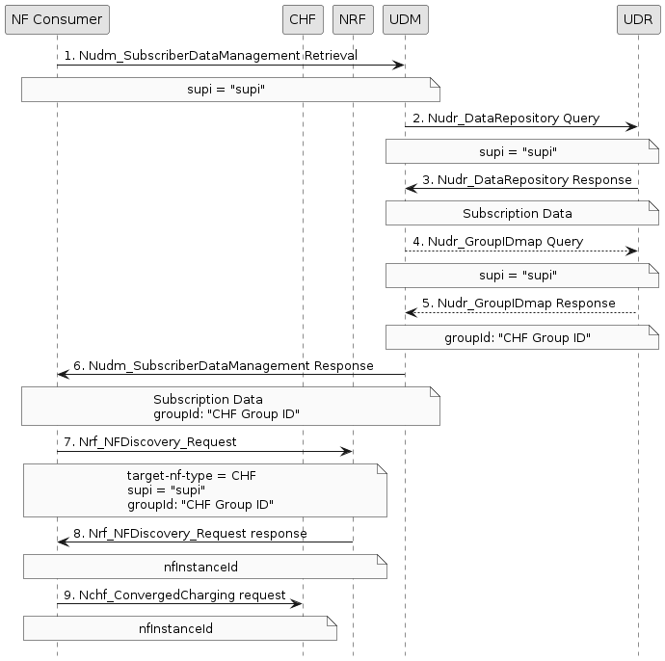

**Figure 3.2.4-1: Message Flow for UDM based Group ID**

1 NF Consumer request retrieval of subscription data for a SUPI.

2. UDM requests subscription data for a SUPI.

3. UDR responds with subscription data.

4. UDM may query (if not included in the subscription data) the UDR for the NF of type CHF for a SUPI.

5. UDR responds with the CHF Group ID applicable for the SUPI provided.

6. UDM responds with subscription data, with the CHF Group ID added.

7. NF Consumer that would like to find a NF Provider that can provide the Nchf_ConvergedService service will do a discovery towards the NRF which may include service name, SUPI, and CHF Group ID that it would like to find the NF provider for.

8. NRF responds with the CHF instances applicable.

9. NF Consumer initiates a converged charging service with a CHF instance provided by the NRF.

3.3 Evaluation

The solutions in clause 3.2.1and 3.2.2 are the existing solutions for doing CHF selection based on the CHF Group ID, the 3.2.2 however have some limitations in regards to supported NF (i.e., only AMF and SMF). This means that to support more NF the 3gppChargingCharacteristics would have to be added to more Nudm_SubscriberDataManagement retrievals.

The solution in 3.2.3 would (similarly to 3.2.2) require 3gppChargingCharacteristics to be added to more Nudm_SubscriberDataManagement retrievals, as well as adding it to the chfInfo in the NRF. It would however support other CHF selections than just CHF Group ID based.

The solution in 3.2.4 would require update to Nudm_SubscriberDataManagement to include CHF Group ID in the responses. To have the CHF Group ID available in the UDM will require either additions to the subscription data (i.e., adding CHF Group ID) or having the UDM retrieve group ID mapping data.

Solution 3.2.1 will add latency in the response from the NRF, while solution 3.2.4 may add latency in the response from the UDM (depending on the solution) compared to the solutions 3.2.2 and 3.2.3.

There are some issues with the specifications in relation to Group ID:

- CHF Group IDs is missing in the description of NF Profile in NRF, TS 23.501 [2] clause 6.2.6.2.

- Nudr_GroupIDmap in TS 23.501 [2] table 7.2.10-1 should refer to TS 23.502 [3] clause 5.2.12.3 (instead of 5.2.12.9).

- Nchf_ConvergedService is missing in TS 29.510 [5] table 6.1.6.3.11-1.

3.4 Conclusion

No further specification is required to be able to use the CHF Group ID for CHF instance selection, it would however be good to add that the charging characteristics can be used to indicate CHF Group ID as well as extending the use of the charging characteristics by more NFs and possibly also the NRF.

Updating the subscription data or having the UDM also retrieve group ID mapping needs to be further evaluated.

4 Detailed proposal

Add description on the use CHF Group ID for CHF instance selection see clause 3.4.

Annex A (informative):  
Plant UML source code

A.1 Message flow for UDR based CHF Group ID

@startuml

skinparam shadowing false

skinparam monochrome true

hide footbox

participant "NF Consumer" as SMF

participant "CHF" as CHF

participant "NRF" as NRF

participant "UDM" as UDM

participant "UDR" as UDR

SMF -> UDM : 1. Nudm_SubscriberDataManagement Retrieval

note over SMF, UDM

supi = "supi"

end note

UDM -> UDR : 2. Nudr_DataRepository Query

note over UDM, UDR

supi = "supi"

end note

UDR -> UDM : 3. Nudr_DataRepository Response

note over UDM, UDR

Subscription Data

end note

UDM -> SMF : 4. Nudm_SubscriberDataManagement Response

note over UDM, SMF

Subscription Data

end note

SMF -> NRF : 5. Nrf_NFDiscovery_Request

note over SMF, NRF

target-nf-type = CHF

supi = "supi"

end note

NRF -> UDR : 6. Nudr_GroupIDmap Query

note over NRF, UDR

nf-type = CHF

subscriber-id = "supi"

end note

UDR -> NRF : 7. Nudr_GroupIDmap response

note over UDR, NRF

chfGroupID: "CHF Group ID"

end note

NRF -> SMF : 8. Nrf_NFDiscovery_Request response

note over NRF, SMF

nfInstanceId

chfInfo

groupId: "CHF Group ID"

end note

SMF -> CHF : 9. Nchf_ConvergedCharging request

note over SMF, CHF

nfInstanceId

chfInfo

groupId: "CHF Group ID"

end note

@enduml

A.2 Message flow for Charging Characteristic based Group ID

@startuml

skinparam shadowing false

skinparam monochrome true

hide footbox

participant "NF Consumer" as SMF

participant "CHF" as CHF

participant "NRF" as NRF

participant "UDM" as UDM

participant "UDR" as UDR

SMF -> UDM : 1. Nudm_SubscriberDataManagement Retrieval

note over SMF, UDM

supi = "supi"

end note

UDM -> UDR : 2. Nudr_DataRepository Query

note over UDM, UDR

supi = "supi"

end note

UDR -> UDM : 3. Nudr_DataRepository Response

note over UDM, UDR

Subscription Data

end note

UDM -> SMF : 4. Nudm_SubscriberDataManagement Response

note over UDM, SMF

Subscription Data

3gppChargingCharacteristics = "ChargChar"

end note

SMF -> NRF : 5. Nrf_NFDiscovery_Request

note over SMF, NRF

target-nf-type = CHF

supi = "supi"

groupId = "CHF Group ID"

end note

NRF -> SMF : 6. Nrf_NFDiscovery_Request response

note over NRF, SMF

nfInstanceId

end note

SMF -> CHF : 7. Nchf_ConvergedCharging request

note over SMF, CHF

nfInstanceId

end note

@enduml

A.3 Message flow for Charging Characteristic based NRF lookup

@startuml

skinparam shadowing false

skinparam monochrome true

hide footbox

participant "NF Consumer" as SMF

participant "CHF" as CHF

participant "NRF" as NRF

participant "UDM" as UDM

participant "UDR" as UDR

SMF -> UDM : 1. Nudm_SubscriberDataManagement Retrieval

note over SMF, UDM

supi = "supi"

end note

UDM -> UDR : 2. Nudr_DataRepository Query

note over UDM, UDR

supi = "supi"

end note

UDR -> UDM : 3. Nudr_DataRepository Response

note over UDM, UDR

Subscription Data

end note

UDM -> SMF : 4. Nudm_SubscriberDataManagement Response

note over SMF, UDM

Subscription Data

3gppChargingCharacteristics = "ChargChar"

end note

SMF -> NRF : 5. Nrf_NFDiscovery_Request

note over SMF, NRF

target-nf-type = CHF

supi = "supi"

3gppChargingCharacteristics = "ChargChar"

end note

NRF -> SMF : 6. Nrf_NFDiscovery_Request response

note over NRF, SMF

nfInstanceId

end note

SMF -> CHF : 7. Nchf_ConvergedCharging request

note over SMF, CHF

nfInstanceId

end note

@enduml

A.4 Message flow for UDM based Group ID

@startuml

skinparam shadowing false

skinparam monochrome true

hide footbox

participant "NF Consumer" as SMF

participant "CHF" as CHF

participant "NRF" as NRF

participant "UDM" as UDM

participant "UDR" as UDR

SMF -> UDM : 1. Nudm_SubscriberDataManagement Retrieval

note over SMF, UDM

supi = "supi"

end note

UDM -> UDR : 2. Nudr_DataRepository Query

note over UDM, UDR

supi = "supi"

end note

UDR -> UDM : 3. Nudr_DataRepository Response

note over UDM, UDR

Subscription Data

end note

UDM --> UDR : 4. Nudr_GroupIDmap Query

note over UDM, UDR

supi = "supi"

end note

UDR --> UDM : 5. Nudr_GroupIDmap Response

note over UDM, UDR

groupId: "CHF Group ID"

end note

UDM -> SMF : 6. Nudm_SubscriberDataManagement Response

note over SMF, UDM

Subscription Data

groupId: "CHF Group ID"

end note

SMF -> NRF : 7. Nrf_NFDiscovery_Request

note over SMF, NRF

target-nf-type = CHF

supi = "supi"

groupId: "CHF Group ID"

end note

NRF -> SMF : 8. Nrf_NFDiscovery_Request response

note over NRF, SMF

nfInstanceId

end note

SMF -> CHF : 9. Nchf_ConvergedCharging request

note over SMF, CHF

nfInstanceId

end note

@enduml