3GPP TR 26.956 V0.2.0(2024-11)
Technical Report

3rd Generation Partnership Project;
Technical Specification Group Services and System Aspects;
Evaluation and Characterization of Beyond 2D Video Formats and Codecs
(Release 19)
 | 
The present document has been developed within the 3rd Generation Partnership Project (3GPP TM) and may be further elaborated for the purposes of 3GPP.
The present document has not been subject to any approval process by the 3GPP Organizational Partners and shall not be implemented.
This Specification is provided for future development work within 3GPP only. The Organizational Partners accept no liability for any use of this Specification.
Specifications and Reports for implementation of the 3GPP TM system should be obtained via the 3GPP Organizational Partners' Publications Offices.

3GPP
Postal address

3GPP support office address
650 Route des Lucioles - Sophia Antipolis
Valbonne - FRANCE
Tel.: +33 4 92 94 42 00 Fax: +33 4 93 65 47 16
Internet
http://www.3gpp.org

Copyright Notification
No part may be reproduced except as authorized by written permission.
The copyright and the foregoing restriction extend to reproduction in all media.

© 2024, 3GPP Organizational Partners (ARIB, ATIS, CCSA, ETSI, TSDSI, TTA, TTC).
All rights reserved.

UMTS™ is a Trade Mark of ETSI registered for the benefit of its members
3GPP™ is a Trade Mark of ETSI registered for the benefit of its Members and of the 3GPP Organizational Partners
LTE™ is a Trade Mark of ETSI registered for the benefit of its Members and of the 3GPP Organizational Partners
GSM® and the GSM logo are registered and owned by the GSM Association

Contents

Foreword 7
Introduction 8
1 Scope 9
2 References 9
3 Definitions of terms, symbols and abbreviations 13
3.1 Terms 14
3.2 Symbols 14
3.3 Abbreviations 14
4 Beyond 2D Video Formats 14
4.1 Introduction 14
4.2 Reference Model for Beyond 2D Video 14
4.2.1 Overview 14
4.3 Beyond 2D Video Representation Formats 15
4.3.1 Introduction 16
4.3.2 Extensions to Stereoscopic Video Representation Formats 16
4.3.2.2 Stereoscopic Video format description according to TS 26.265 16
4.3.2.1 Definition 17
4.3.2.3 Extensions to Stereoscopic Video Representation formats 17
4.3.2.4 Production and Capturing Systems 20
4.3.2.5 Rendering and Display Systems 21
4.3.2.6 Supporting Information 21
4.3.2.7 Benefits and Limitations 22
4.3.2.7.1 Benefits 22
4.3.2.7.2 Limitations 22
4.3.3 Dense Dynamic Point Cloud representation format 22
4.3.3.1 Definition 22
4.3.3.2 Production and Capturing Systems 23
4.3.3.3 Rendering and Display Systems 23
4.3.3.4 Support Information 24
4.3.3.4.1 Test and reference sequences 24
4.3.3.4.2 Uncompressed data size 24
4.3.3.4.3 Known compression technology 24
4.3.3.4.4 Conversion from other formats 24
4.3.3.4.5 Typical quality criteria 24
4.3.3.5 Benefits and Limitations 25
4.3.3.5.1 Benefits 25
4.3.3.5.2 Limitations 25
4.3.4 Multi-view video representation 25
4.3.4.1 Definition 25
4.3.4.2 Production and Capturing Systems 27
4.3.4.3 Rendering and Display Systems 28
4.3.4.4 Supporting Information 28
4.3.4.4.1 Camera placement 28
4.3.4.4.2 Spatial resolution 29
4.3.4.4.2 Objective metrics 29
4.3.4.4.3 Coding and delivery options 30
4.3.4.5 Benefits and Limitations 30
4.3.4.5.1 Benefits 30
4.3.4.5.2 Limitations 30
4.3.X Formats under Research 30
4.3.X.1 Neural Radiance Fields 30
4.3.X.1.1 Introduction 30
4.3.X.1.2 Definition 30
4.3.X.1.3 Production and Capturing Systems 31
4.3.X.1.4 Rendering and Display Systems 33
4.3.X.1.5 Supporting Information 33
4.3.X.1.6 Benefits and Limitations 33
4.3.X.1.6.1 Benefits 33
4.3.X.1.6.2 Limitations 33
4.3.X.2 Light Fields Video 34
4.3.X.2.1 Definition 34
4.3.X.2.2 Production and Capturing Systems 35
4.3.X.2.3 Rendering and Display Systems 37
4.3.X.2.4 Supporting Information 38
4.3.X.2.5 Benefits and Limitations 39
4.3.X.2.5.1 Benefits 39
4.3.X.2.5.2 Limitations 40
5 Overview of existing "Beyond 2D" Video Capabilities in 3GPP 40
5.1 Introduction 41
5.2 AR Video Capabilities 41
5.3 VR Video Profiles 41
5.4 Messaging Services 42
6 Evaluation and Characterization Framework 42
6.1 Overview 42
6.2 Reference Sequences 43
6.3 Reference Software Tools 43
6.4 Metrics 43
6.5 Encoding Constraints 43
7 Considered Scenarios 44
7.1 Introduction 44
7.2 Scenario 1: UE-to-UE Stereoscopic Video Live Streaming 44
7.2.1 Motivation 44
7.2.2 Description of the Anticipated Application 44
7.2.2.1 Overall Description 44
7.2.2.2 Capturing and processing 45
7.2.2.3 Encoding 46
7.2.2.4 Packing and Delivery 46
7.2.2.5 Decoding 46
7.2.2.6 Rendering 46
7.2.3 Source Format Properties 46
7.2.4 Encoding and Decoding Constraints 47
7.2.5 Performance Metrics 47
7.2.6 Interoperability Consideration 47
7.2.7 Reference Sequences 48
7.2.8 Anchor Definition 48
7.2.9 Anchor Result 48
7.3 Scenario 2: Streaming of professionally produced Volumetric Video with single asset containing people 48
7.3.1 Scenario name 48
7.3.2 Motivation for the scenario 48
7.3.3 Description of the scenario 50
7.3.4 Source format properties 54
7.3.4.1 Conversion and quantization 55
7.3.4.2 Impact of rendering 55
7.3.4.3 Impact of the background 55
7.3.4.5 Visual quality examples sequences in dense dynamic point cloud format 56
7.3.4.5.1 Thomas near with representative renderer (splat blend mode) and neutral background 57
7.3.4.5.2 Thomas near with representative renderer (cube mode) and neutral background 60
7.3.5 Encoding and decoding constraints and settings 63
7.3.6 Performance Metrics and Requirements 63
7.3.6.1 Anchors 63
7.3.6.2 Objective tests 63
7.3.6.3 Subjective tests 64
7.3.6.4 Correlation between the objective and subjective metrics 65
7.3.6.5 Verification and crosscheck 65
7.3.7 Interoperability Considerations for the application 65
7.3.8 Test Sequences 65
7.3.8.1 Candidate source dense point cloud sequences 65
[7.3.8.2 Selected source dense point cloud sequences 66
7.3.8.3 Metadata for source dense point cloud sequences 67
7.3.8.3.1 Overview 67
7.3.8.3.2 JSON Scheme 68
7.3.8.3.3 Example 76
7.3.9 Detailed test conditions 77
7.3.9.1 V-PCC test model and configuration files 77
7.3.9.2 Rate points and test conditions 77
7.3.9.3 Profiles 77
7.3.9.4 Bitstream Generation, output 77
7.3.9.5 Videos Generation for subjective tests 79
7.3.9.6 Verification / crosschecks 80
7.3.10 External Performance data 80
7.3.11 Additional information 80
7.4 Scenario 3: <tbd> 81
7.x Scenario x: <tbd> 81
8 Common Evaluation Features 81
9 Evaluation of Selected Scenarios 81
9.1 Introduction 81
9.2 Scenario 1: <tbd> 81
9.2.1 Evaluation Overview 81
9.2.2 Reference Sequences 81
9.2.3 Performance Metrics 81
9.2.4 Candidate Solutions 81
9.2.4.1 Solution 1: <Name> 81
9.2.4.1.1 Introduction 81
9.2.4.1.2 Reference Software 81
9.2.4.1.3 Parameter Settings 81
9.2.4.1.4 Distribution 81
9.2.4.1.5 Evaluation Results 81
9.2.4.1.6 Network Requirements 81
9.2.4.2 Solution 2: <Name> 82
9.2.4.2.1 Introduction 82
9.2.4.2.2 Reference Software 82
9.2.4.2.3 Parameter Settings 82
8.2.4.2.4 Distribution 82
9.2.4.2.5 Evaluation Results 82
9.2.4.2.6 Network Requirements 82
9.2.5 Summary of Evaluation 82
9.3 Scenario 2: <tbd> 82
9.4 Scenario x: <tbd> 82
10 Gaps and Optimization Potential 82
10.1 Identified Gaps and Deficiencies with Video Capabilities 82
10.2 Potential Requirements for New Video Capabilities 82
10.3 Potential Network Optimizations 82
11 Conclusions and Proposed Next Steps 82
Annex A: Scenario Template 82
A.1 Introduction 82
A.2 Template 83
Annex B: Data Formats and Metrics 85
B.1 Introduction 85
B.2 Raw Video Sequences 85
B.2.1 Overview 85
B.2.2 JSON Schema 85
Annex C: Reference Sequences 87
C.1 Introduction 87

For definitive guidance on drafting 3GPP TSs and TRs, see 3GPP TS 21.801 supplemented by the 3GPP web page http://www.3gpp.org/specifications-groups/delegates-corner/writing-a-new-spec.
Ensure all blue guidance text is removed before submitting the TS/TR to the TSG for approval.

Foreword
This Technical Report has been produced by the 3rd Generation Partnership Project (3GPP).
The contents of the present document are subject to continuing work within the TSG and may change following formal TSG approval. Should the TSG modify the contents of the present document, it will be re-released by the TSG with an identifying change of release date and an increase in version number as follows:
Version x.y.z
where:
x the first digit:
1 presented to TSG for information;
2 presented to TSG for approval;
3 or greater indicates TSG approved document under change control.
y the second digit is incremented for all changes of substance, i.e. technical enhancements, corrections, updates, etc.
z the third digit is incremented when editorial only changes have been incorporated in the document.
In the present document, modal verbs have the following meanings:
shall indicates a mandatory requirement to do something
shall not indicates an interdiction (prohibition) to do something
The constructions "shall" and "shall not" are confined to the context of normative provisions, and do not appear in Technical Reports.
The constructions "must" and "must not" are not used as substitutes for "shall" and "shall not". Their use is avoided insofar as possible, and they are not used in a normative context except in a direct citation from an external, referenced, non-3GPP document, or so as to maintain continuity of style when extending or modifying the provisions of such a referenced document.
should indicates a recommendation to do something
should not indicates a recommendation not to do something
may indicates permission to do something
need not indicates permission not to do something
The construction "may not" is ambiguous and is not used in normative elements. The unambiguous constructions "might not" or "shall not" are used instead, depending upon the meaning intended.
can indicates that something is possible
cannot indicates that something is impossible
The constructions "can" and "cannot" are not substitutes for "may" and "need not".
will indicates that something is certain or expected to happen as a result of action taken by an agency the behaviour of which is outside the scope of the present document
will not indicates that something is certain or expected not to happen as a result of action taken by an agency the behaviour of which is outside the scope of the present document
might indicates a likelihood that something will happen as a result of action taken by some agency the behaviour of which is outside the scope of the present document
might not indicates a likelihood that something will not happen as a result of action taken by some agency the behaviour of which is outside the scope of the present document
In addition:
is (or any other verb in the indicative mood) indicates a statement of fact
is not (or any other negative verb in the indicative mood) indicates a statement of fact
The constructions "is" and "is not" do not indicate requirements.

Introduction
In recent years, video services are evolving from traditional two-dimensional formats to beyond 2D video, which offer users a more lifelike and immersive experience. Research studies indicate that the beyond 2D market was valued at approximately multi-million USD in 2023 and is anticipated to register a CAGR (Compound Annual Growth Rate) of over 24.5% between 2024 and 2032 [2][3][4].
A variety of beyond 2D video formats and video compression technologies are available and emerging. Therefore, in order to determine appropriate beyond 2D video formats for different services, it is essential to evaluate their feasibility and performance, considering implementation constraints, performance indicators, and interoperability considerations. In addition, advanced network capabilities and service extension also need to be investigated to meet the delay and data rate requirements of beyond 2D-related services.
This document provides an overview of available and emerging beyond 2D video formats and compression technologies, which are mostly related to specific types of capturing systems and display technologies; documents a set of end-to-end reference scenarios and workflows for beyond 2D video; analyzes 3GPP-defined video compression technologies and potential new technologies to support each documented scenario; identifies gaps and offer recommendations to potentially extend 3GPP video specifications and capabilities.

1 Scope
The present document collects beyond 2D video formats within 3GPP services, as well as a set of beyond 2D video end-to-end reference scenarios and corresponding workflows. It also documents relevant implementation constraints, performance characteristics, and interoperability requirements of existing 3GPP codecs as well as potentially new codecs to support these scenarios. [The primary scope of the present document includes the following aspects:
1. Identify and document beyond 2D formats, that are market-relevant within the next few years, generated from established and emerging capturing systems (including cameras for spatial video capturing), contribution, and usable on display technologies (smartphones, VR HMDs, AR glasses, autostereoscopic and multiscopic displays).
2. Establish and document a set of beyond 2D video end-to-end reference scenarios, including real-time communication, streaming services, split rendering, and messaging and corresponding workflows (capturing, encoding, packaging, delivery, decoding, rendering, including general constraints on latency, as well as complexity) to support 3GPP network related delivery and devices leveraging the generation or display technologies. This includes identifying and defining relevant beyond 2D formats in the context of above workflows, and representation technologies to support delivery of these formats within 3GPP networks.
3. Prioritize the scenarios and the associated formats based on market relevance for further evaluation.
4. Define concrete evaluation framework per scenario (test conditions, KPIs, Metrics, test sequences, agreed reference signals) based on the above prioritized reference scenarios, and evaluate the feasibility and performance of existing 3GPP codecs as well as potentially new codecs to support the scenarios.
5. Based on the findings in steps 1, 2, and 4 document (i) interoperability requirements, (ii) traffic characteristics and (iii) potential QoS optimizations or requirements, to support the above workflows and evaluate the feasibility of new formats with different services, considering the implementation constraints and performance indicators such as encoding, decoding, and rendering complexity, bandwidth utilization, and interoperability considerations.
6. Based on the findings in steps 1, 2, 4 and 5, identify potential gaps or deficiencies of existing 3GPP codecs, and offer recommendations to potentially extend 3GPP video specifications and capabilities.
- Identify potential areas for normative work as the next phase and communicate with other 3GPP WGs regarding relevant aspects related to the study to the extent needed.]
Editor’s note: The scope may be updated as study progressed.

2 References
The following documents contain provisions which, through reference in this text, constitute provisions of the present document.
- References are either specific (identified by date of publication, edition number, version number, etc.) or non-specific.
- For a specific reference, subsequent revisions do not apply.
- For a non-specific reference, the latest version applies. In the case of a reference to a 3GPP document (including a GSM document), a non-specific reference implicitly refers to the latest version of that document in the same Release as the present document.
[1] 3GPP TR 21.905: "Vocabulary for 3GPP Specifications".
[2] Allied Market Research, “3D Technology Market Size, Share, Competitive Landscape and Trend Analysis Report by Product, Application : Global Opportunity Analysis and Industry Forecast, 2021-2030.”, www.alliedmarketresearch.com/3d-technology-market.
[3] Mordor Intelligence, “Mobile 3D Market Size & Share Analysis - Growth Trends & Forecasts (2024 - 2029).”, https://www.mordorintelligence.com/industry-reports/mobile-3d-market.
[4] Grand View Research, “Immersive Technology Market Size, Share & Trends Analysis Report By Component (Hardware, Software, Services), By Technology, By Application, By Industry, By Region, And Segment Forecasts, 2023 - 2030.”, https://www.grandviewresearch.com/industry-analysis/immersive-technology-market-report.
[5] 3GPP TS 26.119: "Media Capabilities for Augmented Reality".
[6] 3GPP TS 26.118: "Virtual Reality (VR) profiles for streaming applications".
[7] 3GPP TS 26.143: "Messaging Media Profiles".
[8] 3GPP TS 26.511: "5G Media Streaming (5GMS); Profiles, codecs and formats".
[9] 3GPP TR 26.966: " Evaluation of new HEVC coding tools".
[10] 3GPP TS 26.265: "Media Delivery: Video Capabilities and Operating Points".
[11] 3GPP TR 26.955: "Video codec characteristics for 5G-based services and applications".
[S1] Apple HEVC Stereo Video - Interoperability Profile (Beta), Version 0.9, June 21, 2023, https://developer.apple.com/av-foundation/HEVC-Stereo-Video-Profile.pdf
[S2] Mike Swanson, "Spatial Video", March 7 2024, https://blog.mikeswanson.com/spatial-video/
[S3] Video Contour Map Payload, Version 0.9, June 21, 2023, https://developer.apple.com/av-foundation/Video-Contour-Map-Metadata.pdf
[S4] ITU-T H.273 (09/23), Coding-independent code points for video signal type identification
[S5] M. Satya, "3D Image Reconstruction From Multi-View Stereo", https://medium.com/@satya15july_11937/3d-image-reconstruction-from-multi-view-stereo-782e6912435b, March, 2023.
[D1] Greg Turk, The Polygon File Format, Stanford University, 1994.
[D2] Volumetric Format Association VFA, https://www.volumetricformat.org/
[D3] V-PCC, Visual volumetric video-based coding (V3C) and video-based point cloud compression (V-PCC), ISO/IEC 23090-5 2nd Ed, Nov 2023.
[D4] G-PCC, Geometry-based point cloud compression, ISO/IEC 23090-9, Mar 2023
[D5] Draco Bitstream Specification, https://google.github.io/draco/spec/
[N1] Ben Mildenhall, Pratul P. Srinivasan, Matthew Tancik, Jonathan T. Barron, Ravi Ramamoorthi, and Ren Ng. 2021. NeRF: representing scenes as neural radiance fields for view synthesis. Commun. ACM 65, 1 (January 2022), 99–106. https://doi.org/10.1145/3503250
[N2] Gao, Kyle et al. “NeRF: Neural Radiance Field in 3D Vision, A Comprehensive Review.” (2022).
[N3] Li, Sicheng et al. “NeRFCodec: Neural Feature Compression Meets Neural Radiance Fields for Memory-Efficient Scene Representation.” ArXiv abs/2404.02185 (2024): n. pag.
[N4] Dong-Ha Kim, Jun Young Jeong, Gwangsoon Lee, and Jae-Gon Kim "Compression method of NeRF model using NNC and VVC", Proc. SPIE 13164, International Workshop on Advanced Imaging Technology (IWAIT) 2024, 131642V (2 May 2024); https://doi.org/10.1117/12.3019533
[N5] G. Lafruit, Y. Liao, and G. Bang, “AhG on Implicit Neural Video Representations (INVR),” ISO/IEC JTC1/SC 29/WG04, M60641, Oct. 2022.G. Lafruit, Y. Liao, and G. Bang, “AhG on Implicit Neural Video Representations (INVR),” ISO/IEC JTC1/SC 29/WG04, M60641, Oct. 2022
[N6] RABBY, AKM SHAHARIAR AZAD and Chengcui Zhang. “BeyondPixels: A Comprehensive Review of the Evolution of Neural Radiance Fields.” ArXiv abs/2306.03000 (2023): n. pag.
[N7] Daniel Duckworth, Peter Hedman, Christian Reiser, Peter Zhizhin, Jean-François Thibert, Mario Lučić, Richard Szeliski, and Jonathan T. Barron. 2024. SMERF: Streamable Memory Efficient Radiance Fields for Real-Time Large-Scene Exploration. ACM Trans. Graph. 43, 4, Article 63 (July 2024), 13 pages. https://doi.org/10.1145/3658193
[N8] Müller, T., Evans, A., Schied, C., & Keller, A. (2022). Instant neural graphics primitives with a multiresolution hash encoding. ACM transactions on graphics (TOG), 41(4), 1-15..
[R1] OpenCV, https://opencv.org.
[R2] Colmap, https://colmap.github.io/index.html.
[R3] AliceVision Photogrammetric Computer Vision Framework, https://alicevision.org.
[R4] Open Multiple View Geometry (openMVG), https://github.com/openMVG/openMVG.
[R5] Immersive Video Depth Estimation (IVDE), https://gitlab.com/mpeg-i-visual/ivde.
[R6] Test model for MPEG immersive video, https://gitlab.com/mpeg-i-visual/tmiv.
[R7] Reference view synthesizer, https://gitlab.com/mpeg-i-visual/rvs.
[R8] Open Realtime Depth Image Based Renderer (OpenDIBR), https://github.com/IDLabMedia/open-dibr.
[R9] A. Dziembowski, D. Mieloch, J. Stankowski and A. Grzelka, "IV-PSNR – the objective quality metric for immersive video applications," in IEEE Transactions on Circuits and Systems for Video Technology, doi: 10.1109/TCSVT.2022.3179575, software: https://gitlab.com/mpeg-i-visual/ivpsnr
[R10] Quality Metrics for Immersive Video (QMIV), https://gitlab.com/mpeg-i-visual/ivpsnr.
[3dtv] A. Quested and B. Zegel, "3D-TV production standards - first report of the ITU-R Rapporteurs", EBU Technical Review, 2011 Q2, https://tech.ebu.ch/publications/trev_2011-Q2_3dtv_quested
[LF-1] Gershun A (1939) The light field. Moscow, 1936. Translated by Moon P, Timoshenko G in J Math Phys XVIII:51–151
[LF-2] Marc Levoy and Pat Hanrahan. 1996. Light field rendering. In Proceedings of the 23rd annual conference on Computer graphics and interactive techniques (SIGGRAPH '96).
[LF-3] Google Light Stage X4, https://www.fxguide.com/fxfeatured/exclusive-paul-debevec-and-the-light-stage-research-at-google/
[LF-4] USC Lightstage X6, https://vgl.ict.usc.edu/Data/LightStage/
[LF-5] Zhou, Taotao, et al. "Relightable neural human assets from multi-view gradient illuminations." Proceedings of the IEEE/CVF Conference on Computer Vision and Pattern Recognition. 2023.
[LF-6] Michael Broxton, John Flynn, Ryan Overbeck, Daniel Erickson, Peter Hedman, Matthew Duvall, Jason Dourgarian, Jay Busch, Matt Whalen, and Paul Debevec. 2020. Immersive light field video with a layered mesh representation. ACM Trans. Graph. 39, 4, Article 86 (August 2020), 15 pages. https://doi.org/10.1145/3386569.3392485
[LF-7] M. B. de Carvalho et al., "A 4D DCT-Based Lenslet Light Field Codec," 2018 25th IEEE International Conference on Image Processing (ICIP), Athens, Greece, 2018, pp. 435-439, doi: 10.1109/ICIP.2018.8451684.
[LF-8] ISO/IEC JTC 1/SC 29/WG 04, w24268, “Overview of lenslet video coding activities”, MPEG 147, Sapporo.
[LF-9] Daniel, Jamison R. et al. “Initial work on development of an open Streaming Media Standard for Field of Light Displays (SMFoLD).” SD&A (2018).
[LF-10] X. Min, J. Zhou, G. Zhai, P. Le Callet, X. Yang and X. Guan, "A Metric for Light Field Reconstruction, Compression, and Display Quality Evaluation," in IEEE Transactions on Image Processing, vol. 29, pp. 3790-3804, 2020, doi: 10.1109/TIP.2020.2966081.
[LF-11] ISO/IEC JTC 1/SC29/WG1 N100306, REQ "Use Cases and Requirements for Light Field Quality Assessment v5.0", 97th JPEG Meeting, Online, October 2022.
[LF-12] What you should know about light-field, https://www.digitalmedia.fraunhofer.de/en/mediainformation/trendbrochures/trendbrochure-2021/what-you-should-know-about-light-field-.html
[LF-13] "A Visual Introduction to the Past, Present, and Future of Light Field Technology", https://cubicleninjas.com/light-field-technology/
[LF-14] Ruben Verhack, "AI-Driven Breakthroughs in Image-Based Rendering: Light Fields, SMoE, Gaussian Splatting, NeRFs and beyond", https://cubicleninjas.com/light-field-technology/, Tech Posts Computer Graphics, https://blog.datameister.ai/ai-driven-breakthroughs-image-based-rendering, February 2024.
[LS-1] Wang, Y., Lu, Z., Cao, P. et al. How Live Streaming Changes Shopping Decisions in E-commerce: A Study of Live Streaming Commerce. Comput Supported Coop Work 31, 701–729 (2022). https://doi.org/10.1007/s10606-022-09439-2
[LS-2] Xie, Junyuan et al. “Deep3D: Fully Automatic 2D-to-3D Video Conversion with Deep Convolutional Neural Networks.” European Conference on Computer Vision (2016).
[LS-3] Dumic, E. et al.. “Transmission of 3D Video Content. In: Assunção, P., Gotchev, A. (eds) 3D Visual Content Creation, Coding and Delivery.” Signals and Communication Technology (2019). Springer, Cham. https://doi.org/10.1007/978-3-319-77842-6_8
[LS-4] Schierl, Thomas and Sam Narasimhan. “Transport and Storage Systems for 3-D Video Using MPEG-2 Systems, RTP, and ISO File Format.” Proceedings of the IEEE 99 (2011): 671-683.
[LS-5] 3GPP TR 26.905 V 18.0.0: "Mobile stereoscopic 3D video"
[R1] KDDI, Transmission experiment using real-time codec compliant with the latest international standard of point cloud compression, https://www.kddi-research.jp/english/newsrelease/2023/012401.html
[R2] SBTVD Forum, Brazilian Forum for digital terrestrial TV, https://forumsbtvd.org.br/tv3_0/
[R3] VFA, The Volumetric Format Association, https://www.volumetricformat.org/
[R4] Arcturus, on-demand streaming of volumetric video, https://arcturus.studio/stream/
[R5] 8i, stream volumetric video to any device, browser, or VR/AR headset, https://8i.com/stream/
[R6] Broadpeak, V3C standardized content distribution at scale, https://broadpeak.tv/newsroom/mpeg-v3c-standardized-content-distribution-at-scale/
[R7] Arcturus, playback solution with broad delivery capabilities, https://arcturus.studio/playback/
[R8] 5G-MAG, V3C Immersive platform, https://5g-mag.github.io/Getting-Started/pages/v3c-immersive-platform/
[R9] DVB project, DVB Study Mission Report S101, DVB Bluebook S101
[R10] Ultra Video Group, Voxelized Point Cloud Dataset for Visual Volumetric Video-based Coding, https://ieeexplore.ieee.org/document/10178589
[R11] ISO/IEC 23090-5 Visual Volumetric Video-based Coding (V3C) and Video-based Point Cloud Compression (V-PCC) – 2nd edition
[R12] ISO/IEC 23090-10 Carriage of visual volumetric video-based coding data – 1st edition
[R13] By C. Guede et al., IBC 2023 Tech Papers, https://www.ibc.org/technical-papers/ibc2023-tech-papers-efficient-delivery-and-rendering-on-client-devices-via-mpeg-i-standards-for-emerging-volumetric-video-experiences/10277.article
[R14] Futuresource Consulting, Spotlight on HEVC, https://www.interdigital.com/white_papers/spotlight-on-hevc-the-codec-of-choice-for-the-video-streaming-industry
[R1] ISO/IEC 23090-5 Visual Volumetric Video-based Coding (V3C) and Video-based Point Cloud Compression (V-PCC) – 2nd edition
[R2] MPEG WG7, Call for Proposals for Point Cloud Compression V2, https://mpeg.chiariglione.org/standards/mpeg-i/point-cloud-compression/call-proposals-point-cloud-compression-v2.html
[R3] PCQM: A Full-Reference Quality Metric for Colored 3D Point Clouds, Gabriel Meynet, Yana Nehmé, Julie Digne, Guillaume Lavoué, https://hal.science/hal-02529668/document
[R4] Patched mpeg-pcc-mmetric, TBD
[R5] Representative renderer, TBD
[R6] MPEG, Subjective verification test report for V-PCC, https://www.mpeg.org/wp-content/uploads/mpeg_meetings/136_OnLine/w20992.zip
[R1] Renderpeople, https://renderpeople.com/
[R2] Volucap, https://volucap.com/
[R3] ISO/IEC 23090-10 Carriage of visual volumetric video-based coding data – 1st edition
[X1] XD Productions, https://xdprod.com/
[X2] Volucap, https://volucap.com/
[X3] Renderpeople free 4D People sample: https://4dpeople.com/samples/
[X4] Renderpeople 4D People catalogue: https://4dpeople.com/
[X5] Ultra Video Group – UVG-VPC Dataset, https://ultravideo.fi/UVG-VPC/index.html
[R1] MPEG, V-PCC test model tmc2, https://github.com/MPEGGroup/mpeg-pcc-tmc2
[R2] MPEG, Random Access configuration, https://github.com/MPEGGroup/mpeg-pcc-tmc2/blob/master/cfg/condition/ctc-random-access.cfg
[R3] MPEG, Subjective verification test report for V-PCC, https://www.mpeg.org/wp-content/uploads/mpeg_meetings/136_OnLine/w20992.zip
[R4] MPEG, Rate configuration, https://github.com/MPEGGroup/mpeg-pcc-tmc2/tree/master/cfg/rate
[R5] Patched mpeg-pcc-mmetric, TBD
[R6] Representative renderer, TBD
[R8] List of camera paths and splat blend parameter options for each tested sequence
[R9] SBTVD, SBTVD TV 3.0 test report for video, https://forumsbtvd.org.br/wp-content/uploads/2021/12/SBTVD-TV_3_0-VC-Report.pdf

3 Definitions of terms, symbols and abbreviations
This clause and its three subclauses are mandatory. The contents shall be shown as "void" if the TS/TR does not define any terms, symbols, or abbreviations.

3.1 Terms
For the purposes of the present document, the terms given in 3GPP TR 21.905 [1] and the following apply. A term defined in the present document takes precedence over the definition of the same term, if any, in 3GPP TR 21.905 [1].
Definition format (Normal)
<defined term>: <definition>.
example: text used to clarify abstract rules by applying them literally.

3.2 Symbols
For the purposes of the present document, the following symbols apply:
Symbol format (EW)
<symbol> <Explanation>

3.3 Abbreviations
For the purposes of the present document, the abbreviations given in 3GPP TR 21.905 [1] and the following apply. An abbreviation defined in the present document takes precedence over the definition of the same abbreviation, if any, in 3GPP TR 21.905 [1].
<ABBREVIATION> <Expansion>

4 Beyond 2D Video Formats

4.1 Introduction
Editor’s note: This clause documents beyond 2D video formats that are market-relevant within next few years.

4.2 Reference Model for Beyond 2D Video

4.2.1 Overview
In contrast to well-established 2D-based video formats and work flows, for beyond 2D video a variety of emerging formats and reference workflows are under discussion. This aspect makes it more difficult to harmonize specific interop points and formats, also taking into account new developments in the industry and in research. In addition, without systematic and explicit identification of format interop points, beyond 2D scenarios or workflows may look overly complex.
However, basing beyond 2D workflows and scenarios on 2D reference workflows and formats, as for example evaluated in TR 26.955 [11] and extending existing workflows seems to be promising way forward. However, when comparing for example to TR 26.955 [11] for 2D formats or even omnidirectional video formats as defined in TS 26.118 [6], additional aspects may need to be considered for beyond 2D video. To help the situation, a generic reference model for beyond 2D video content is introduced in this sub-clause. This systematic and accurate identification of interoperability points and subcomponents for Beyond 2D video with a high level of abstraction covers the majority of use cases and scenarios.
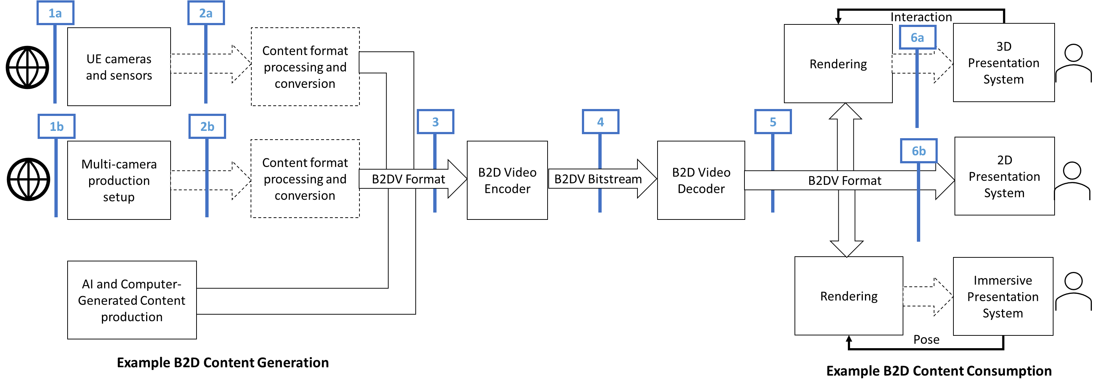
Figure 4.2-1 Beyond 2D Video end-to-end reference model
Figure 4.Y.1-1 illustrates a generic beyond 2D Video end-to-end reference model. For example, it considers three methods of creation of source content. The first apply a naturalistic way to capture sources indicated in reference point (1) and includes for example variants of UE-based cameras and sensor (1a) or a multi-camera production setup (1b). The third option is based on authoring using computer graphics interfacing technologies or other media production technologies. These may sometimes be combined and, possibly with slight variations, these options cover the majority of media production cases.
The capture of content using cameras, for example light fields using sensors is generalized including traditional passive sensors, cameras, camera arrays, or plenoptic cameras. For simplicity we also include active sensors LiDaR, Time of Flight in this category. These active sensors also transmit a signal before capturing the reflections. Depending on the setup, the collected data may be quite different depending on the capturing system, expressed in reference point (2) with variants (2a) and (2b).
In the general case, some processing based on the captured data would happen to generate a well defined B2DV format, possibly referred to as sensed data converter. This step is mainly about converting the multiple digital image formats plus metadata to a well-defined beyond 2D representation or format, referenced with reference identifer (3).
For typical 5G workflows, a compressed digital representation of the B2DV is needed for efficient transmission. The B2DV Encoder executes a processing step that will result in the compressed Beyond 2D video bitstream that includes a digitally compressed lossy version of the B2DV format and optional metadata, referred to as reference point (4). The B2DV bitstream is typically delivered through content delivery protocols and 5G radio systems, not shown in Figure 4.2.1-1.
The B2DV decoder decodes the B2DV video bitstream and recovers a B2DV format, presented in reference point (5). The recovered signal is forwared to the rendering and display system. In some cases, one viewport of the B2DV format may for example be displayed directly in a 2D Presentation System. In a 3D Presentation System, interacting with the rendering component may allow to generate different views on the content. In an immersive presentation system, pose information may be used to render the views of the content. The format generated by the renderer for the presentation system, indicated in reference point (6), is implementation specific as shown in Figure 4.2.1-1.
Generally, beyond 2D video performance measurement should typically be between interop points (3) and (5) based on the B2DV formats. The last block in the diagram includes the user interactions. Some B2DV scenarios may involve some types of user interactions, such as changing the viewpoint or other interactions. These are captured in the reference diagram for completeness.

4.3 Beyond 2D Video Representation Formats
Editor’s note: The documented format should be referenced by at least one scenario in clause 5, and the following aspects may be provided.

4.3.1 Introduction
As shown in Figure 4.2.1, beyond 2D video representation formats may originate from different production systems and have to target different rendering systems. This clause collects relevant Beyond 2D Video representation formats and provides a discussion on the relevancy of the formats. In order to assess the relevancy of the formats, for each format different aspects are collected, among others:
- Definition of the format, this is preferably backed by a specification.
- Typical applications of the format, e.g. knowledge about support of the format in workflows (tools, etc.)
- Production options of the representation format
- Rendering of the representation format
- Benefits and limitation of the format
- Supporting information
- Typical quality criteria for evaluating the format
- Existing test and reference sequences
- Conversion from other formats (lossless, lossy)
- Uncompressed data size
- Known compression technologies
- Extensibility of the format

4.3.2 Extensions to Stereoscopic Video Representation Formats
Editor’s Note: Some additional references need to be extracted.

4.3.2.2 Stereoscopic Video format description according to TS 26.265
Stereoscopic video is defined in TS 26.265 [26265]. The focus on the definition in TS 26.265 is on providing a consistent description of stereoscopic video based on professional production, for example Hollywood movies. In this case, a view is available to be presented to the left eye and another view is available to be presented simultaneously to the right eye. The presentation of both the left and right views allows for an effect known as stereopsis which can be defined as "the perception of depth produced by the reception in the brain of visual stimuli from both eyes in combination; binocular vision." For signal representations, [3dtv] recommends that and Left and Right eyes comply to regular image formats auch as Rec ITU-R BT.709 or Rec ITU-T BT.2100 and any necessary 3D-specific metadata is incorporated with the data. Hence, for stereoscopic video, two synchronized video signals are available, each with identical parameters. The baseline content is described in TS 26.265 as part of the 3GPP Stereoscopic 3D TV Format in clause 4.4.3.4 as follows:
The stereoscopic 3D Cinema format uses two signals, one for the left eye and another view for the right eye as defined in Table 4.4.2-1. The components for each eye closely follow the specifications of the 3GPP HDR signals, but there are some restrictions and extensions, namely:
- Frame rates include high frame rate for movies, namely 48 fps.
- the spatial resolution is restricted to 4K
An informative summary of the parameters of a 3GPP Stereoscopic 3D TV format based on the parameters defined in Table 4.4.2-1 of TS 26.265 is provided in Table 4.3.2.1-1.
Table 4.3.2.1-1 Video Signal Parameters for 3GPP Stereoscopic 3D Cinema format
Parameter | Restrictions
Picture aspect ratio | 16:9
Spatial Resolution width x height | 3 840 × 2 160, 1 920 × 1 080  NOTE: For 1080, typically the encoded signal has 1088 lines and cropping is applied to remove spatial samples that are not presented.
Scan Type | the source scan type of the pictures as defined in clause 7.3 of Rec. ITU-T H.273 is progressive
Chroma format indicator | The chroma format indicator is 4:2:0.
Colour primaries  Transfer Characteristics  Matrix Coefficients | Only the following value combinations are permitted: (1, 1, 1), (9, 16, 9), and (9, 18, 9) for SDR, HDR PQ and HDR HLG, respectively.
Bit depth | The permitted value is 10 bit.
Colour primaries | Only the value 9 as defined in clause 8.2 of Rec. ITU-T H.273 is permitted.
Transfer Characteristics | Only the value 16 (for PQ) as defined in clause 8.2 of Rec. ITU-T H.273 is permitted.
Matrix Coefficients | Only the value 9 as defined in clause 8.2 of Rec. ITU-T H.273 is permitted.
Frame rates | The permitted values are 60, 60/1.001, 48, 48/1.001, 50, 30, 30/1.001, 25, 24, 24/1.001 fps.
Frame packing | No frame packing is applied.
Projection | No projection is used.
Sample aspect ratio | The pixel aspect ratio is 1 (square pixel), i.e. only the value 1 as defined in clause 7.3 of Rec. ITU-T H.273 is permitted.
Chroma sample location type | For SDR, the location of chroma samples relative to the luma samples for progressive frames as defined in Rec. ITU-T H.273, clause 8.7 is set to 0 (Chroma samples are colocated with the luma samples at the top-left corner).  For HDR PQ and HLG, the location of chroma samples relative to the luma samples for progressive frames as defined in Rec. ITU-T H.273, clause 8.7 is set to 2 (chroma samples are centered horizontally between two luma samples).
Chroma sample location type | the location of chroma samples relative to the luma samples for progressive frames as defined in Rec. ITU-T H.273, clause 8.7 is set to 2 (chroma samples are centered horizontally between two luma samples).
Range | Restricted video range is used.
Stereoscopic Video | A signal for the Left and for the Right Eye is provided whereby the signals have the identical parameters as above and are timely synchronized.

The format focuses on existing professionally generated movie content. This study will not evaluate further this format.

4.3.2.1 Definition
Stereoscopic video presents one image to the user’s left eye and another image (typically correlated) to the user’s right eye to produce the stereopsis effect, defined as "the perception of depth produced by the reception in the brain of visual stimuli from both eyes in combination; binocular vision." [S1].

4.3.2.3 Extensions to Stereoscopic Video Representation formats
Extensions to the above content format result from different new use cases:
1) User generated stereoscopic content from modern devices that allow to capture beyond 2D video formats.
2) Higher-quality projected stereoscopic video that includes higher resolution and projections for professional content
The above use cases require extensions to the Stereoscopic 3D Cinema format defined in TS 26.265.
For user-generated stereoscopic content production systems as introduced in clause 4.3.2.2, extensions to the above basic signals are to be considered. The major extensions are more flexible spatial resolutions beyond 16:9, as well as additional metadata, including alpha and depth information. Offline postprocess can be used to acquire accompanying depth and such information is beneficial in the rendering to reduce parallax effects.
Stereoscopic video for user-generated content may use projections to left and right eye as follows [S2]:
- rectangular, traditional 3D
- extensions with additional depth data, also referred to as video contour maps [S3].
- extensions with additional alpha maps.
In addition, the detailed signal properties of the video each eye needs to be defined:
- Sample aspect ratio for each eye, defined according to the ITU-T H.273 [S4], SampleAspectRatio. Typical parameters are 1:1 (value 1) or 4:3 (value 14).
- Picture aspect ratio for each eye. Typical parameters are 1:1 or 16:9.
- Resolutions per eye of left eye and right eye are
- for picture aspect ratio 1:1: 1080x1080, 1440x1440, 2160x2160
- for picture aspect ratio 16:9: 1280x720, 1440x1080 (with sample aspect ratio 4:3), 3840x2160
- Framerates for each eye are: 30 fps, 50fps, 60 fps, and 90 fps and possibly fractional variants.
- Signal characteristics
- The video signal is YUV with 4:2:0 chroma subsampling.
- Bit depth: 8 or 10 bits
- Colour primaries, defined according to the ITU-T H.273 [S4], ColourPrimaries. Typical parameters are BT-709 (value 1), and BT-2020/BT-2100 (value 9).
- Transfer characteristics, defined according to the ITU-T H.273 [S4], TransferCharacteristics. Typical parameters are BT-709 (value 1), BT-2020 (value 14), BT-2100 PQ (value 16) and BT-2100 HLG (value 18).
- Matrix coefficients, defined according to the ITU-T H.273 [S4], MatrixCoefficients. Typical parameters are BT-709 (value 1), and BT-2020/BT-2100 non-constant luminance (value 9).
- Typical combined values are BT-709 SDR with (1,1,1) and HDR PQ with (9,16,9).
Additional metadata may be present, either on a static or per frame basis, as follows:
- hero eye: A value that indicates which eye is the primary eye when rendering in 2D.
- camera parameters: camera parameters are typically represented in a 3 × 4 projection matrix called the camera matrix. The extrinsic parameters define the camera pose (position and orientation) while the intrinsic parameters specify the camera image format, specifically:
- extrinsic parameters denote the coordinate system transformations from 3D world coordinates to 3D camera coordinates. For details see: https://en.wikipedia.org/wiki/Camera_resectioning#Extrinsic_parameters
- intrinsic parameters describe a specific camera model. These parameters encompass focal length, image sensor format, and camera principal point. For details see: https://en.wikipedia.org/wiki/Camera_resectioning#Intrinsic_parameters
- disparity adjustment:
- horizontal disparity adjustment, a value that indicates a relative shift of the left and right images, which changes the zero-parallax plane.
- Disparity/depth map: 10bit, same resolution as source content, monochrome, can possibly be sub-sampled
- alpha maps: 8 bit, same resolution as source content
- Line time (per camera) – rolling shutter readout time, only relevant in poorer quality/reduced functionality camera pipelines typically used on HMD tracking cameras.
- Examples: https://github.com/MPEGGroup/FileFormatConformance/tree/m62054_exintrinsics/data/file_features/under_consideration
For higher-quality projected stereoscopic video, the following are the core extensions beyond the TS 26.265 3D TV Format:
- projected video
- higher resolutions up to 8K
- additional depth and alpha data
For higher-quality projected stereoscopic video extensions content may use projections to left and right eye as follows [S2]:
- spherically-projected 3D video as defined in TS 26.118 [6].
- extended with additional depth data, also referred to as video contour maps [S3].
In addition, the detailed signal properties of the video each eye needs to be defined:
- Sample aspect ratio for each eye, defined according to the ITU-T H.273 [S4], SampleAspectRatio. Typical parameters are 1:1 (value 1) or 4:3 (value 14).
- Picture aspect ratio for each eye. Typical parameters are 1:1 or 16:9.
- Resolutions per eye of left eye and right eye are
- for picture aspect ratio 1:1: 2160x2160, 4320x4320
- for picture aspect ratio 16:9: 3840x2160, 7680x4320
NOTE: 8K resolution is supported in TS 26.118 [6], and also supported in terms of decoding on modern mobile systems-on-chip. Whether 8K is supported in a full end-to-end workflow is application dependent, but withr appropriate capability negotation, a suitable resolution can be determined.
- Framerates for each eye are: 24 fps, 30 fps, 48fps, 50fps, 60 fps, 90 fps, 120 fps, 144 fps and possibly fractional variants.
NOTE: 120 and 144 fps are supported in terms of decoding on modern mobile systems-on-chip. Whether such high-frame rates supported in a full end-to-end workflow is application dependent, but withr appropriate capability negotation, a suitable resolution can be determined.
- Signal characteristics
- The video signal is YUV with 4:2:0 chroma subsampling.
- Bit depth: 10 bits
- Colour primaries, defined according to the ITU-T H.273 [S4], ColourPrimaries being BT-2100 (value 9).
- Transfer characteristics, defined according to the ITU-T H.273 [S4], TransferCharacteristics. being BT-2100 PQ (value 16).
- Matrix coefficients, defined according to the ITU-T H.273 [S4], MatrixCoefficients being BT-2100 non-constant luminance (value 9).
- The core presentation format is HDR PQ with (9,16,9).
- Projection parameters:
- Projection: fisheye, equirectangular
- Field-of-view and restricted coverage, typically 180 degree.
NOTE: The parameters may be aligned with TS 26.118 [6]
Additional metadata may be present, either on a static or per frame basis, as follows:
- hero eye: A value that indicates which eye is the primary eye when rendering in 2D.
- disparity adjustment:
- horizontal disparity adjustment, a value that indicates a relative shift of the left and right images, which changes the zero-parallax plane.
- Disparity/depth map: 10bit, same resolution as source content, monochrome, can possibly be sub-sampled

4.3.2.4 Production and Capturing Systems
The formats as defined in clause 4.3.2.1 may be captured at least with a reduced set of parameters by mobile devices and Head Mounted Displays (HMD) – for more details refer to the following information:
- https://techcrunch.com/2023/12/11/apple-releases-spatial-video-recording-on-iphone-15-pro/
- Spatial Video with 1080p at 30fps
- https://9to5mac.com/2024/01/04/will-the-iphone-16-be-able-to-record-4k-spatial-video/
- Spatial Video with 4K is expected to be available
- https://appleinsider.com/articles/24/03/06/capturing-spatial-video-apple-vision-pro-vs-iphone-15-pro
- The spatial video captured is in a square 1:1 format at 2200 pixels by 2200 pixels. It is a near-perfect recreation of the passthrough viewed by the user.
- Once stereo is captured on supporting phones, offline postprocess can be used to acquire accompanying depth (using for example Depth-Anything https://github.com/DepthAnything/Depth-Anything-V2/tree/main and ZoeDepth https://github.com/isl-org/ZoeDepth or similar).
- Meta Quest™ can record spatial video: https://360rumors.com/quest-3-3d-videos/
- After recording, the video or photo is captured in side-by-side format, with a square aspect ratio. Photos will also be side-by-side but they are stretched vertically, and need to be edited to fix that.
- https://deovr.com/blog/84-record-vr-footage-on-the-meta-quest-3
- The Meta Quest 3™ features two cameras that deliver full-color passthrough, allowing users to record content in 4K (2k per eye), using the Meta Quest Developer HUB (https://developer.oculus.com/documentation/unity/ts-odh).
- The Quest 3's passthrough cameras record footage that is flat 120-100 (possibly 90) degrees.
NOTE: In TV productions it was known that there were issues with visual fatigue, nausea due to bad content production. Guidelines that professional producers can take into account have been provided which minimize these effects. Indications whether this also is an issue for user generated content is for further study.
Beyond user-generated stereoscopic content, an ecosystem is developing around this format including movie production, documentaries and live sports. Examples are mentioned here:
- https://www.apple.com/newsroom/2024/02/2024-mls-season-kicks-off-today-exclusively-on-mls-season-pass-on-apple-tv/
- https://www.apple.com/newsroom/2024/01/apple-previews-new-entertainment-experiences-launching-with-apple-vision-pro/
- https://www.macrumors.com/2024/01/08/vision-pro-movies-games/
Latest information on content production can for example also be found here: https://www.provideocoalition.com/creating-stereoscopic-video-for-the-apple-vision-pro/.

4.3.2.5 Rendering and Display Systems
Stereoscopic video with the above parameters can be viewed on different rendering and display systems, including
- Backward-compatible to 2D (just view one eye), hence can be viewed on regular phones. The stereoscopic effect is lost in this case.
- Apple Vision Pro ™
- Meta Quest ™: https://techcrunch.com/2024/02/01/meta-quest-adds-support-for-apples-spatial-video-ahead-of-vision-pro-launch/
In addition, OpenXR and WebXR define APIs to render stereoscopic video with additional metadata.
- OpenXR APIs exist
- WebXR APIs exist
For rendering multi-view stereo video, including 3D reconstruction, refer to [S5]. It is shown, how additional metadata as defined in clause 4.3.2.1 can be used to improve rendering.

4.3.2.6 Supporting Information
The baseline video can be encoded using HEVC-based encoding tools:
- framepacking (see for example TS 26.118 [6])
- MV-HEVC (see TR 26.966 and TS 26.265)
The content can be delivered using regular ISO BMFF based distribution, including streaming with DASH/HLS/CMAF.
Uncompressed data rate can be computed as 2 x height x width x (1.5 + depthflag + alphaflag) * framerate * bitdepth. Some examples are provided in Table 4.3.2.6-1.
Table 4.3.2.6-1 Uncompressed data rate examples
Signal | Data rate
Stereoscopic 3D TV Format HD | 2 x 1080 x 1920 x (1.5 + 0 + 0) * 24 * 10 = 1.39 Gbit/s
Stereoscopic 3D TV Format UHD | 2 x 2160 x 3840 x (1.5 + 0 + 0) * 24 * 10 = 5.56 Gbit/s
User Generated Stereoscopic Content HD | 2 x 1080 x 1080 x (1.5 + 0 + 0) * 30 * 8 = 800 Mbit/s
User Generated Stereoscopic Content UHD with depth | 2 x 2160 x 2160 x (1.5 + 1 + 0) * 30 * 10 = 6.52 Gbit/s
Higher-quality projected stereoscopic video at 8K with alpha and depth | 2 x 4320 x7680 x (1.5 + 1 + 1) * 60 * 10 = 129.77 Gbit/s

Editor’s Note:
-Typical quality criteria for evaluating the format
- Existing test and reference sequences
-Conversion from other formats (lossless, lossy)
-Extensibility of the format

4.3.2.7 Benefits and Limitations

4.3.2.7.1 Benefits
The extended stereoscopic video format has the following benefits:
- Simplicity: The technology is supported by existing content production workflows
- Device Support: The technology is supported by emerging devices on the market
- In device decoding and rendering: The technology generally allows that decoding and rendering can be done in the device, which makes it robust against impaired or lossy network connections.
- Content Industry starts to embrace the format, for details see clause 4.3.2.2
- The format is extensible to add additional metadata, for details see clause 4.3.2.1
- User-generated content production workflows exist.
- Backward-compatible rendering. The content can be rendered on 2D displays.
- Very good B2D user experiences have been reported, when the content is properly produced and suitable devices for playback and rendering are used [S2].

4.3.2.7.2 Limitations
The format is primarily used to support lean-back and seated experiences, typically head movements with 3DOF and 3DOF+ can be supported, but may be extended in the future to address additional degrees freedom.
Editor’s Note: More Benefits and limitations will be added over time

4.3.3 Dense Dynamic Point Cloud representation format
There are many applications for point clouds such as representing highly accurate maps of landscapes, buildings, infrastructure, etc… but the format is also used to represent people, animals, objects and scenes composed from these. More precisely, for representing people and objects dense dynamic point clouds are in focus.

4.3.3.1 Definition
A point cloud frame is defined as set of (x,y,z) coordinates, where x,y,z have finite precision and dynamic range, , depending on the data type that is used for representing the coordinates. Each (x,y,z) can have multiple attributes associated to it (a1 ,a2, a3 …), where the attributes may correspond to color, reflectance, transparency, normals or other properties of the object/scene that would be associated with a point. Colour is typically represented as RGB and a normal is a normal to a point which can be used by the renderer for handling lighting. Typically, each point in a point cloud frame has the same number of attributes attached to it. Dynamic point clouds consist of several consecutive point cloud frames with the same coordinate system, precisions and attributes. The number of points typically changes from one frame to the other and there is no relation between a point of one frame to the other frame. A dense point cloud contains a high density of points with close neighbors (typically more than 500.000 points per frame for a person or object), where a renderer is able to produce a closed surface allowing for a highly detailed representation.
A simple and often used file format for point clouds is the Polygon File Format (PLY) that has been developed by Greg Turk at Stanford University in 1994 [D1]. Other formats, like the Object File Format (OBJ) can also be used to represent point clouds.
Editor’s Note: Will be completed during study

4.3.3.2 Production and Capturing Systems
Professional capturing of volumetric video is typically done with a rig of synchronized cameras aligned around the asset(s) to be captured. Depending on the rig, there can be one or more layers of cameras at different height positions, with each layer consisting of up to 60 cameras. Cameras can be equipped with depth sensors. Hardware such as cameras and depth sensors are typically off the shelf equipment, but the assembly in the rig is vendor dependent and proprietary.
The various camera and depth sensor signals are fed into a production pipeline that produces the asset. Production includes stitching the various signals, filling holes, correcting occlusions, etc. Persons or physical objects (e.g. a ball or an instrument) can be combined in an asset or separate assets can be used for each person or object. The representation format of a produced asset is typically a dense dynamic point cloud or a dynamic mesh.
The Volumetric Format Association (VFA) [D2] aims to “Drive the development of volumetric video as the next revolution for content creation, editing 3D content, distribution of 3D content and creating entirely new ways to tell stories and communicate with each other”. One result of their work is an end-to-end workflow consisting of Volumetric Capturing, Volumetric Processing, Volumetric Encoding and Decode/Render. The workflow can be downloaded from their website in PDF format. Volumetric Capturing is in line with our description above. Volumetric Processing shows the dynamic point cloud representation format as a central element. First a raw point cloud is created, and which is further processed (e.g. fill holes) and converted to the produced asset. Representation formats for the produced assets is either a dynamic point cloud (in the workflow named as a patch-based format) or a dynamic mesh.
The Volumetric Encoding step includes both options, point cloud and mesh. Once streamed and received on a device, the Decode/Render step includes rendering the mesh, the point-cloud as is or generating mesh or voxels prior to rendering.

4.3.3.3 Rendering and Display Systems
The dense dynamic point cloud representation format can be rendered to 2D displays such as in mobile phones, tablets, TV sets but also to HMDs or other 3D type displays.
The visual viewing quality of the point cloud format depends heavily on how voxels are rendered. Just reconstructing voxels in 3D space may bring a limited viewing experience and holes/cracks may become visible. To show the impact of rendering two renderers are investigated:
- MPEG renderer: Each voxel is replaced by a cube of a configurable fixed size. This renderer is deliberately simple for studying the pure impact of compression.
- Representative renderer: Each voxel is replaced by a splat of a size that depends on the viewing distance and some blending is implemented to avoid flickering of points. There are no sophisticated techniques such as lighting or use of normals integrated. It represents a minimum of what a device manufacturer would do to prevent holes or cracks to preserve a good subjective experience. It Is not state-of-the-art or most sophisticated renderer possible.
In the following we give an example of the impact of the renderer on the head of the sequence Thomas with Vox 10 conversion:
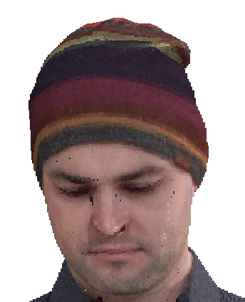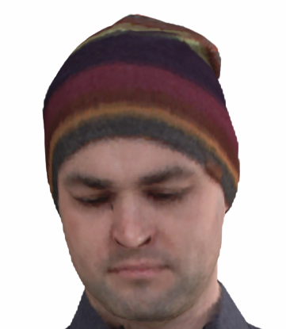
Figure 4.3.3.3-1 Vox 10 MPEG renderer Figure 4.3.3.3-2 Vox 10 Representative renderer
Both snapshots are rendered from the same Vox 10 sequence. In Figure 4.3.3.3-1 we see far more cracks and holes and the borderline of the sequence is less smooth. However, the eyebrows look a bit sharper in Figure 4.3.3.3-2. A high-end industry renderer may do better than the renderers illustrated here.
When evaluating or comparing the point cloud representation format it is essential to select a renderer that is representative of a minimum of what the industry would implement, as holes and cracks in images would influence evaluations negatively.
More sophisticated renderers in products could fill better potential holes, recreate detail and apply lighting depending on the scene. The point cloud representation format supports normals which are useful for lighting the scene. When rendering a point cloud sequence in a scene, correct lighting including shadows and colour alignment can greatly impact the realism of the resulting experience.
POINTS_GL is the simplest OpenGL [8] primitive type used for rendering (lines and polygons are others that are also commonly used) and a point cloud can be interpreted as a vertex stream that represents points (after ordering of the points). Therefore, a point cloud can be rendered in an extremely straightforward way using native OpenGL vertex shaders. The supported rendering in the standard OpenGL specified by the Khronos consortium implies that point clouds can be rendered on devices that support OpenGL which is rather common today. OpenGL vertex shader renders points size larger than zero, this can be set GL_PROGRAM_POINT_SIZE as a configuration of the rendering.
Specific optimizations for rendering are device manufacturer dependent.

4.3.3.4 Support Information

4.3.3.4.1 Test and reference sequences
<TBD>

4.3.3.4.2 Uncompressed data size
The uncompressed data size of a point cloud frame depends on the number of points and the number of attributes. The following table gives data size examples and raw bitrates for the sequence Thomas.
Table 4.3.3.4.2-1 Uncompressed data size and bitrate
Sequence | Quantization | #frames | #points | mean frame size (bytes) | bitrate (mbps)
Thomas | Vox10 | 32 | 19012250 | 4010396 | 979.10
Thomas | Vox11 | 32 | 76336020 | 16996692 | 4149.58
Thomas | Vox12 | 32 | 305897397 | 71694702 | 17503.59

4.3.3.4.3 Known compression technology
Visual volumetric video-based coding (V3C) and video-based point cloud compression (V-PCC) [D3]
Geometry-based point cloud compression (G-PCC) [D4]
Draco [D5]

4.3.3.4.4 Conversion from other formats
Point clouds can be obtained by sampling from surface-based formats such as meshes. Such transformation is lossy. There are different sampling methods (e.g. methods based on face sampling, on texture map sampling, on ray casting from a grid, etc.) and it’s up to the content provider to select the appropriate sampling method depending on the content and creative intent.

4.3.3.4.5 Typical quality criteria
The visual quality of a point cloud depends on the number of points (density) in the point cloud. For attributes colour is mandatory and there may be reflectance, transparency and normal. Colour is typically in RGB with each in 8 bits. Reflectance, transparency and normal can be used by the renderer when the point cloud is rendered in a scene.
Point clouds of around 1M points/frame allow to watch from a wider distance (e.g. from 3m*) and 2M points/frame allow to get closer (e.g to around 1.5m distance) at good quality for the target scenario. Emotional facial expressions and buttons and tissue structure of cloths is visible. More points per frame improve the details, but this may not be required for the target scenario. But if a scenario would require it, a professional volumetric video production system is able to capture details from e.g. skin or finer details of tissue and it can be represented with the point cloud representation format.
* A typical demonstration scenario would be to use e.g. a smartphone or tablet running a volumetric video application showing a real person of e.g. 3m distance on the screen captured by the camera and rendering at the same time a second person rendered from a point cloud next to the first person.
Other scenarios may require the representation of the full detail of a person and the number of required points can be approximated as follows:
Assumptions:
- The visual resolution of the human eye is 1/60 of a degree
- Average human body surface is about 1.9m2
- For simplification the body surface is approximated as a square
Number of points = 1.9/((tan1/60 * d)^2), where d is the viewing distance from the person.
This leads to the following number of points:
- 1.5m distance: 10 M pixels
- 3m distance: 2.5 M pixels

4.3.3.5 Benefits and Limitations

4.3.3.5.1 Benefits
Point cloud representation is simple in structure and representation, has high accuracy and resolution, is faithful to original data, and is easy to acquire from sensors or cameras. Point cloud generation needs less pre-processing as there is no need for surface reconstruction, if sensor data is not so noisy.
A point cloud can be rendered in an extremely straightforward way using native OpenGL vertex shaders.

4.3.3.5.2 Limitations
Point-cloud data does not include information on surfaces and is harder to edit or transform.
Editor’s Note: Will be completed during study.

4.3.4 Multi-view video representation

4.3.4.1 Definition
The multi-view video representation consists of multiple frames of multiple synchronized physical or virtual camera views. Each camera view is represented by a colour image (YCbCr), camera intrinsics and camera extrinsics. The combination of video and metadata allows for novel view synthesis (6DoF rendering).
A typical spatial resolution for each of the views is 1920 × 1080 (FullHD). For this representation in this study, we expect resolutions in a range around this number. A typical number of views is 2-4 for real-time capture with range-sensing cameras like the Azure Kinect, and typically 10-20 for offline capture with industrial or professional cameras. Typically, the frame rate is 25 or 30 Hz, and capture beyond 60 Hz is not expected for the coming years.
Optionally there is also a depth image of equal resolution. It is possible to have multi-view content for which some or all views lack depth information. This choice originates from the production and capturing system and thus it is the same for all frames of a view. The depth map image, if present, may also indicate that individual samples are missing. This indication can be used for range-sensing cameras that cannot sense depth in certain situations like object edges, non-reflecting and specular reflecting scene elements. It can also be useful in a production system to remove parts of an image that are not wanted (e.g. revealing camera rigs) or are also present in other views (scene background).
If a view has a depth map, then it must have corresponding depth quantization parameters: quantization type (normalized disparity or linear depth), nearest depth in scene units, furthest depth in scene units, and indication of invalid values. Normalized disparity [m⁻¹] is more commonly used when depth is estimated because it places the code points in a way that correlates with the amount of parallax, and it allows for far away scene elements like the horizon or the star field. Linear depth [m] is commonly used with range-sensing cameras (ToF, LiDAR, etc.) because they often have a limited depth range with equal depth resolution for that entire range.
The camera intrinsics are a model of the projection of points in space in the reference system of the camera to the image sensor (projection plane). Typical parameters include projection type (perspective, fisheye, etc.), and projection-type specific parameters, such as principal point and focal length for perspective projection. Optionally lens distortion parameters may be provided if the camera images are not already corrected for that.
The camera extrinsics model the translation and rotation of a camera in space with respect to the reference system of the scene.
The source format has at least two views. It is expected that most or all test data will have perspective projection (PSP), but test data with equirectangular projection (ERP) may be included.
While this representation allows for 6DoF rendering, it depends on the position and field of view of the cameras, if such a rendering has an acceptable quality. Preferably, the virtual viewpoints are within a viewing space that can be provided as metadata or implicitly derived from the parameters of the set of source views.
Each view has the following video components and metadata:
Component | Texture (mandatory) | Depth (optional)
Spatial resolution | At least 960 × 540  At most 3840 × 2160 | The same as the texture component
Chroma format | YCbCr | Luma only or YCbCr with chroma planes set to neutral gray
Chroma subsampling | 4:2:0 | 4:0:0 or 4:2:0 with chroma planes set to neutral gray
Pixel aspect ratio | 1:1 | 1:1
Frame rate | 30, 50, 60 | The same as the texture component
Colour space format | ITU-R BT.709 or ITU-R BT.2100 | Undefined
Transfer characteristics | Limited range or full range with transfer characteristics matching to the colour space format.  Mastering characteristics such as MDCV (master display colour volume) and CLLI (content light level information) SEI (supplementary enhancement information) messages defined in TS 26.116 Section 4.5.5.7 will be considered. | Full range, linear transfer
Bit depth | Either 8 bits or 10 bits for all channels | At least 8 bits  At most 16 bits
Metadata | Camera intrinsics:  Projection type (Perpsective, ERP)  - Projection type (Perpsective, ERP)  - For perspective projection:  - Focal length [px]  - Principal point [px × px]  - For equirectangular projection:  - Latitudinal angle range [rad × rad]  - Longitudinal angle range [rad × rad]  - Lens distortion parameters (optional)  Camera extrinsics:  - Camera position (x, y, z) [m]  - Camera orientation as normalized quaternion (q = iq_{x} + jq_{y} + kq_{y} + q_{w}) | Depth quantization parameters:  - Quantization type:  - either: normalized disparity  - or: linear depth  - Near depth [m]  - Far depth [m]  - Has invalid pixels flag

4.3.4.2 Production and Capturing Systems
Multi-view video and multi-view + depth are well-known formats that have many public tools including OpenCV [M1], COLMAP [M2], AliceVision [M3] and OpenMVG [M4]. Also, MPEG has published tools for camera calibration and depth estimation [M5].
There are four typical workflows for multi-view (+ depth):
- Use color cameras to capture multi-view and estimate depth with multi-view consistency.
- Use range-sensing cameras to capture multi-view + depth and refine depth with multi-view consistency.
- Use AI or CG pipelines to raytrace views.
- Combinations of the above.
The beyond 2D video is captured and processed using multiple cameras. Zero or more of those cameras may be range-sensing cameras, and more than one of the cameras has color sensors. In the case of two or more cameras that are not rigidly connected, camera extrinsics are online calibrated. Depth estimation is performed to associate a full depth map with each of the camera views, thus resulting in a multi-view + depth representation.
Additional steps such as object instance segmentation and foreground/background separation may be performed to reduce the sample rate of the representation. This would result in a multi-view + depth + transparency/occupancy representation. All processing may be offline or with a delay of a few seconds.
Figure 1 provides an example processing flow with the following operations:
- Multi Camera Capture: capture of images from multiple cameras
- Intrinsic Calibration: estimation of principal point, focal length and distortion parameters
- Extrinsic Calibration: estimation of camera orientation and translation (e.g. using COLMAP)
- Scene Calibration: estimation of static ground plane geometry and background geometry
- Undistort Images: all images undistorted to one and the same reference intrinsics
- Object Instance Segmentation: determine segments for known objects such as ‘person’/’ball’
- Depth Estimation: determine a dense depth map for each view
- Depth Segmentation: determine sub-instance depth segments consisting of smooth surfaces
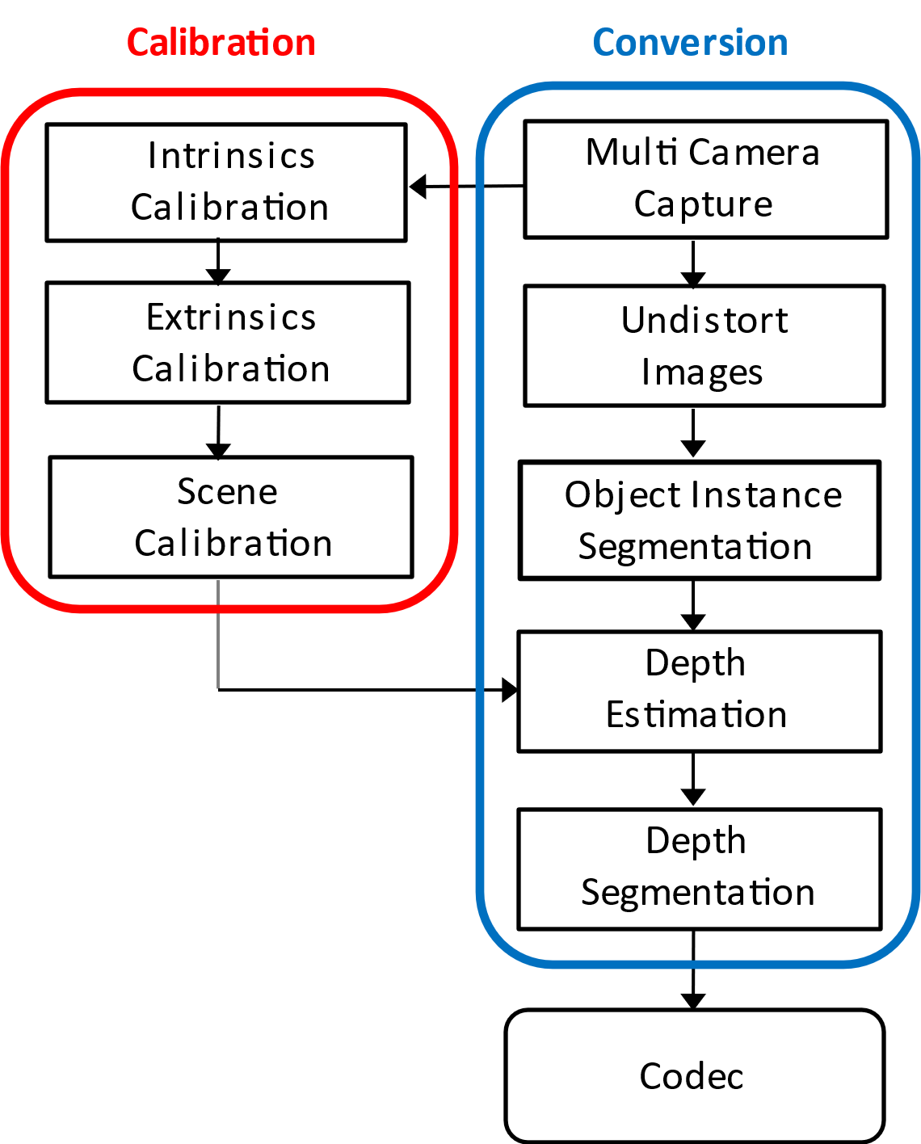
Figure 1: Example processing flow

4.3.4.3 Rendering and Display Systems
Some examples of open source rendering implementations for the multi-view representation are the Reference view synthesizer [M6], Test model for MPEG immersive video [M7], and OpenDIBR [M8]. More implementations exist.
Real-time rendering is typically performed on a GPU without dedicated hardware.
Rendering can be on:
- a device for 2D presentation (fixed viewpoint) such as a phone,
- a device for 3D presentation (multiple viewpoints) such as an autostereoscopic display,
- a device for 6DoF presentation (dynamic viewports) such as an HMD or an autostereoscopic display with eye tracking.
When a viewing space is used, then:
- What is rendered is one or two viewports with perspective projection and with 6 degrees of freedom (3-D position and 3-D orientation).
- The pose of the viewport is within a viewing space that can be signaled or implicitly determined from a decoded frame. A viewing space can limit both position, orientation or both in combination. For instance, it is generally not intended for a viewport to intersect with scene elements.
- When a viewport is rendered that is outside of the viewing space, then the renderer has to perform a mitigation to avoid a viewing experience that is not intended by the content provider.

4.3.4.4 Supporting Information

4.3.4.4.1 Camera placement
For range-sensing cameras a minimum requirement is that scene elements are present in at least one view frustum (seen by at least one camera). This implies that view frustums of adjacent cameras are overlapping at and beyond the nearest object distance.
With multi-view depth estimation, the minimum requirement is that scene elements are present in at least two view frustums (seen by at least two cameras). The additional overlap is needed for stereo correspondence checks.
- Given the above, cameras do not have to be placed on a line, plane or any specific geometry.

4.3.4.4.2 Spatial resolution
The 3-D spatial resolution relates to video resolution and depth map bit depth. Because perspective projection and normalized disparity are most common, equations are provided for this case only.
Perspective unprojection maps a sample position x_{image} to a scene position in respect to the camera x_{camera}:
$$x_{camera}=\left[\begin{matrix}x_{camera} \\ y_{camera} \\ z_{camera}\end{matrix}\right]=\frac{r}{f}\left[\begin{matrix}x_{image}−p_{x} \\ y_{image}−p_{y} \\ f\end{matrix}\right],$$
with principal point p and focal length f, both in pixel units. The coordinate system is only a convenient example.
Normalized disparity expansion maps sample value i to depth range value r in scene units, e.g. meters:
$$r=\frac{1}{\frac{1}{r_{far}}+\left(\frac{1}{r_{near}}−\frac{1}{r_{far}}\right)\frac{i}{i_{max}}}=\frac{r_{far}r_{near}}{r_{near}+\left(r_{far}−r_{near}\right)\frac{i}{i_{max}}}$$
One may check that this maps$i∈\left\{0,1…i_{max}\right\}$ to $r∈\left[r_{near}, r_{far}\right]$. Note that nearby objects appear brighter when viewing the depth map directly (as if using a flashlight in a dark room).
In-plane spatial resolution refers to the ability of an imaging system to distinguish between two adjacent points within the same imaging plane. It is a measure of how close two objects can be to each other in the imaging plane while still being resolved as separate entities.
The in-plane spatial resolution can be derived from the first equation:
$$\frac{δx_{camera}}{δx_{image}}=\frac{r}{f}$$
This indicates that a) the in-plane spatial resolution depends on the focal length in pixel units, and b) the spatial resolution decreases with distance from the camera. As an example, when an object is at 1 meter distance, and the focal length is 1000 pixels, a horizontal or vertical shift of one pixel corresponds to a shift of 1 mm in 3-D space.
Out-of-plane spatial resolution refers to the ability of an imaging system to distinguish between points along the axis perpendicular to the imaging plane (typically the z-axis). It represents the system's capability to resolve depth information or separate structures at different depths.
The out-of-plane spatial resolution can be derived by combining the first and second equations:
$$\frac{δz_{camera}}{δi}=\frac{δr}{δi}=\frac{r^{2}}{i_{max}}\frac{r_{far}−r_{near}}{r_{far}r_{near}}$$
With $r_{far}$ much larger than $r_{near}$, this approximates to:
$$\frac{δz_{camera}}{δi}≈\frac{r^{2}}{i_{max}r_{near}}$$
This indicates that a) the out-of-plane spatial resolution depends mainly on the nearest object distance and the depth map bit depth, and b) the spatial resolution decreases quadratically with distance from the camera. As an example, when an object is at $r_{near}=1$ meter distance and bit depth is 8 bit (i_{max} = 255), then $∆z_{camera}≈4 mm$. When instead an object is at 10-meter distance, the step size is about 0.4 m.

4.3.4.4.2 Objective metrics
Objective evaluation on multiview video may be performed by applying 2D video objective metrics (PSNR, SSIM, VMAF, etc.) on each of the source view positions, and averaging them in the correct domain. A higher correlation with subjective evaluation may be obtained by applying immersive video metrics [M9] [M10] that consider that view synthesis may cause pixel shifts that have only a minor influence on subjective scores, but cause PSNR to degrade.

4.3.4.4.3 Coding and delivery options
The content can be encoded using:
- MPEG Immersive Video (MIV)
- MV-HEVC (albeit with some restrictions)
The content can be delivered using regular ISO BMFF based distribution, including streaming with DASH, or delivered in real-time using RTP-based transport.
[Ed.(BK): On acceptance, Philips intend on providing a proposal to rewrite the related scenarios, avoiding overlap with the representation.]

4.3.4.5 Benefits and Limitations

4.3.4.5.1 Benefits
The multiview video representation has the following main benefits:
- Real-time capture is feasible.
- This format is often used as an intermediate step in photogrammetry pipelines such as [ M3].
- The renderings have the appearance of natural video content, as opposed to computer graphics, because all optical effects are baked into the multiple views.

4.3.4.5.2 Limitations
The multiview video representation has the following limitations:
- Need to handle large number of pixels, e.g. by selection.
- For novel view synthesis, multiple views need to be blended for optimal rendering results, to handle non-Lambertian effects.
- Content production depends on the availability of good and efficient depth estimation/refinement tools. Recently, there is a strong progress in the field of computer vision and volumetric approaches specifically, which will benefit applications of this representation.

4.3.X Formats under Research
Editor’s Note: Formats in that section will not be part of the evaluation framework of release 19, due to their maturity status, or complexity. However, it is recommended that 3GPP follows the research work on NERF, INVR and GS and awaits stabilization in the industry to commonly agreed formats.

4.3.X.1 Neural Radiance Fields

4.3.X.1.1 Introduction
Neural Radiance Field (NeRF) is a technology at the intersection of Artificial Intelligence (AI) and 3D graphics, and has gained interest based on remarkable progress in computer vision, neural processing units and graphics processing. NeRF was an important research area over the last few years,[but recently the interest in NeRF has declined and more attention is given to other formats documented in the remainder of this clause 4.3.X]. The documentation reflects the state of the art at the time of writing, but the technology has reached a level of maturity.

4.3.X.1.2 Definition
NeRF is the implicit representation of a 3D scene or object using a fully-connected (non-convolutional) deep network, whose input is a single continuous 5D coordinate (spatial location (x, y, z) and viewing direction (Θ,Φ)) and whose output is the volume density (α) and view-dependent emitted radiance (r, g, b) at that spatial location [N1].
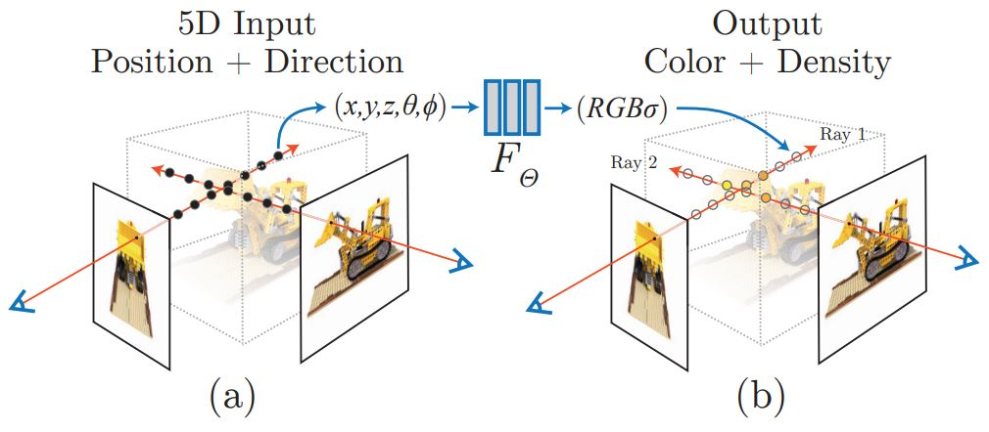
Figure.4.3.X.1.1-1 NeRF representation[N1]
The key idea behind NeRF is to represent the appearance of a scene as a function of 3D position and viewing direction, known as the radiance field. The radiance field describes how light travels through the scene and interacts with its surfaces and can be used to generate images from arbitrary viewpoints [N6].
The following is an overview pipeline for NeRF:
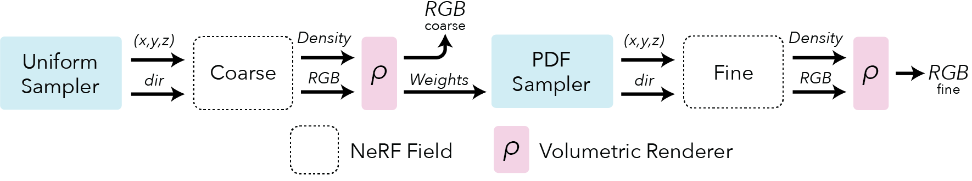
Figure.4.3.X.1.1-2 NeRF pipeline (source: https://docs.nerf.studio/nerfology/methods/nerf.html )
Field representation: For each point in space the NeRF represents a view dependent radiance.
Positional encoding: The input coordinates (x,y,z,θ,ϕ) need to be encoded to a higher dimensional space prior to being input into the network.
Rendering: NeRF rely on classic volumetric rendering techniques to composite the points into a predicted color.
Sampling: NeRF use a hierarchical sampling scheme that first uses a uniform sampler and is followed by a PDF sampler.

4.3.X.1.3 Production and Capturing Systems
Mobile apps such as NeRFCapture (https://github.com/jc211/NeRFCapture), Spectacular AI (https://github.com/SpectacularAI), or Record3D (https://record3d.app/) are available to capture NeRFs.
A tutorial for capturing NeRFs is provided here: https://github.com/NVlabs/instant-ngp/blob/master/docs/nerf_dataset_tips.md.
The NeRFCapture app allows any iPhone™ or iPad™ to quickly collect or stream posed images to InstantNGP. If your device has a LiDAR, the depth images will be saved/streamed as well. It has two modes: Offline and Online. In Offline mode, the dataset is saved to the device and can be accessed in the Files App in the NeRFCapture folder. Online mode uses CycloneDDS to publish the posed images on the network. A Python script then collects the images and provides them to InstantNGP.
The Spectacular AI SDK and apps can be used to capture data from various devices:
- iPhones (with LiDAR)
- OAK-D cameras
- RealSense D455/D435i
- Azure Kinect DK
The Record3D can create a dataset with an iPhone 12 Pro or newer (based on ARKit), a python code is needed to convert the captured data to NeRF (https://github.com/NVlabs/instant-ngp/blob/master/scripts/record3d2nerf.py)
The state-of-art of NeRF at the time of writing includes:
- SMERF (Streamable Memory Efficient Radiance Fields for Real-Time Large-Scene Exploration) is a view synthesis approach that achieves state-of-the-art accuracy among real-time methods on large scenes with footprints up to 300 m² at a volumetric resolution of 3.5 mm³ [N7] . It enables fully 6DoF navigation within a web browser, and renders real-time on smartphones and laptops.
- Instant Neural Graphics Primitives (Instant-NGP) using multi-resolution hash encoding to split the processing into multiple chunks and using parallel processing using cuda software to effectively change run time from hours to seconds [N8]. Instant-NGP is a method that uses hash-grid and a shallow MLP to accelerate training and rendering. This method reaches speedups of 1000x and train very fast (~6 min) and renders also fast ~3 FPS.
- NerfStudio (https://docs.nerf.studio/), which is open-source and combines many radiance fields methods, and supports the storage of NeRF data in a structured format, which includes key elements as follows.
Camera intrinsics:
{
"camera_model": "OPENCV_FISHEYE", // camera model type [OPENCV, OPENCV_FISHEYE]
"fl_x": 1072.0, // focal length x
"fl_y": 1068.0, // focal length y
"cx": 1504.0, // principal point x
"cy": 1000.0, // principal point y
"w": 3008, // image width
"h": 2000, // image height
"k1": 0.0312, // first radial distortion parameter, used by [OPENCV, OPENCV_FISHEYE]
"k2": 0.0051, // second radial distortion parameter, used by [OPENCV, OPENCV_FISHEYE]
"k3": 0.0006, // third radial distortion parameter, used by [OPENCV_FISHEYE]
"k4": 0.0001, // fourth radial distortion parameter, used by [OPENCV_FISHEYE]
"p1": -6.47e-5, // first tangential distortion parameter, used by [OPENCV]
"p2": -1.37e-7, // second tangential distortion parameter, used by [OPENCV]
"frames": // ... per-frame intrinsics and extrinsics parameters
}
Camera extrinsics:
{
// ...
"frames": [
{
"file_path": "images/frame_00001.jpeg",
"transform_matrix": [
// [+X0 +Y0 +Z0 X]
// [+X1 +Y1 +Z1 Y]
// [+X2 +Y2 +Z2 Z]
// [0.0 0.0 0.0 1]
[1.0, 0.0, 0.0, 0.0],
[0.0, 1.0, 0.0, 0.0],
[0.0, 0.0, 1.0, 0.0],
[0.0, 0.0, 0.0, 1.0]
]
// Additional per-frame info
}
]
}
Depth images:
{
"frames": [
{
// ...
"depth_file_path": "depth/0001.png"
}
]
}
Masks:
{
"frames": [
{
// ...
"mask_path": "masks/mask.jpeg"
}
]
}

4.3.X.1.4 Rendering and Display Systems
NeRF heavily relies on the volumetric rendering process to obtain rendered pixels. This rendering function is differentiable, so scene representation can be optimized by minimizing the residual between synthesized and ground truth observed images. The rendering process requires sampling tens to hundreds of points along each ray and inputting them into the neural network to produce the final imaging result. Consequently, rendering a single 1080p image necessitates on the order of 108 neural network forward passes, which often takes several seconds [N2].
Display System: VR HMD, mobile devices.

4.3.X.1.5 Supporting Information
- Typical quality criteria for evaluating the format
- Evaluation metrics such as PSNR (Peak Signal-to-Noise Ratio), SSIM (Structural Similarity Index), and LPIPS (LearnedPerceptual Image Patch Similarity)
- Training iteration, training time, inference speed.
- Conversion from other formats (lossless, lossy)
- Meshes, point clouds
- Uncompressed data size
The original NeRF model has 8 fully connected layers, with a layer width of 256, and each pixel is synthesized based on 128 samplings along the ray. The standard NeRF model demands an impractical 5,600 Terabytes cache size.
- Known compression technologies:
Early research on NeRF compression is ongoing. The MPEG established the ad-hoc group called Implicit Neural Visual Representation (INVR) and is currently exploring the potential standardization of 6 Degree of Freedom (6DoF) video compression using NeRF-based technologies [N5]. The following methods are applied in current research for NeRF compression and encoding:
- Parameter quantization techniques, transform coding, and entropy coding [N3]
- VVC and NNC [N4]
- Extensibility of the format
- Mip-NeRF, Point-NeRF, KiloNeRF, Mega-NeRF and etc [N8].

4.3.X.1.6 Benefits and Limitations

4.3.X.1.6.1 Benefits
- High-quality 3D representation: NeRF can create photo-realistic 3D reconstructions of complex scenes, including fine surface details, reflections and realistic lighting effects.
- Improved view synthesis capabilities: NeRF can synthesize novel views of a scene or object from a small number of input images, allowing rendering from any viewpoint.
- Flexibility: NeRF can handle non-rigid and dynamic scenes, adapting well to varying spatial conditions and changes over time.
- Unsupervised training: NeRF can learn to reconstruct a scene or object without explicit supervision.

4.3.X.1.6.2 Limitations
- More computationally demanding and slower to render compared to photogrammetry and 3D Gaussian Splatting.
- Not reductionistic: The entire scene is encoded in a single NeRF function, which makes it challenging to segment the scene into parts, edit individual objects within the scene, or combine different NeRF scenes into one.
- Currently, NeRF representation formats do not seem to effectively handle dynamic content within 3D scenes.

4.3.X.2 Light Fields Video
Editor’s Note: The copyright for the images under this section needs to be further check.

4.3.X.2.1 Definition
A light field, or lightfield, is a vector function that describes the amount of light flowing in every direction through every point in a space. The term light field was first coined in 1936 by Andrey Gershun [LF-1], for describing the radiometric properties of light in three-dimensional space. Scientifically, light rays are described by the 5-dimensional plenoptic function, which each ray is defined by three coordinates in 3D space (3 dimensions) and two angles to specify their direction in 3D space (2 dimensions).
Light fields were introduced into computer graphics in 1996 for image-based rendering applications, i.e. to compute new views of a scene from pre-existing views without the need for scene geometry [LF-2].
Note that also the term "radiance field" may be used to refer to similar, or identical concepts such as light fields. In an extension, neural radiance fields (NeRFs) a a subject of latest research, for details on NeRFs refer to clause 4.3.Y.1.
Light field representations can be divided into two types:
- the plenoptic function: as shown in Figure 4.3.X.1-1(a), the plenoptic function represents the light field in a 7-dimensional function, which includes the position of viewer’s eye (x, y, z), direction (Θ, Φ in polar coordinates), wavelength (λ), and time (t). However, in practical applications, the 4D light field function L (u, v, s, t) based on two planes, as shown in Figure 4.3.X.1-1(b), is more commonly used. In 4D light field function, (u, v) are the coordinates of the first plane, representing the angular information of the light field, while (s, t) are the coordinates of the second plane, representing the spatial information of the light field.
[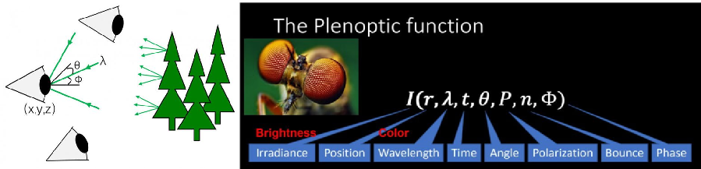]
Figure 4.3.X.1-1(a), 7D plenoptic function
[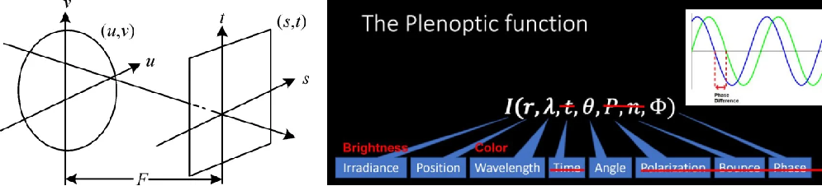]
Figure 4.3.X.1-1(b), 4D plenoptic function
- the reflectance field: as shown in Figure 4.3.X.2, the reflectance field corresponds to the plenoptic function but focuses on the emission surface. It describes the transport of light between the incident light on an object and the light exiting from it.
[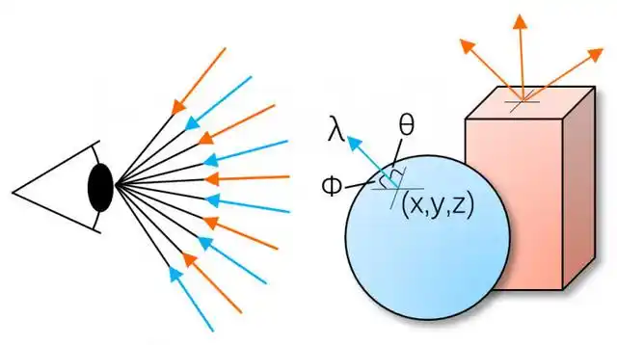]
Figure 4.3.X.2, reflectance field
A light field can capture multiple-dimensional data, including spatial, angular, spectral, and temporal domains. Compared to traditional 2D video, the light field provides more 3D information, offering viewers an immersive visual experience. It also enables intelligent system to better understand the 3D environment or objects.Therefore, light field-related technologies are gradually being applied in fields such as industrial inspection, embodied intelligence, virtual/augmented reality, glasses-free 3D displays and so on, demonstrating vast application potential. For example, in the field of industrial inspection, data captured by light field cameras can be used to compute and render multi-view images, synthesize focus stacks, flexibly control depth of field, and achieve full volumetric reconstruction, thereby improving the accuracy of industrial inspection and quality control. Light field video can also be used in high-precision 3D reconstruction of people, objects, and environments, reducing the cost of digital content production, which can be applied in the metaverse and digital twin cities.
Table 4.3.X.1-1 provides an overview of existing lightfield technologies and their properties.
Table 4.3.X.1-1 Existing lightfield technologies and their properties
Properties | Google  Lightstage X4 [LF-3] | USC  Lightstage X6 [LF-4] | PlenOptic  Stage [LF-5]
Type | Color gradient, polarized light, directional light, OLAT | White gradient, OLAT | Gradient light, polarized light, directional light, color gradient, OLAT
Number of Lights | 331 | 1111 | 162~460
Number of Cameras | 90~100+ | 3 | 6~32
Acquisition speed | 60fps | 990fps | 5fps
Resolution | 4K | 2K | 6K/16K
Output frame rate | 30fps | 30fps | 5fps
Editor’s Note: other resolution may include 1536 * 2048, 3840 * 2160, 7680*4320 (45-100 views)

4.3.X.2.2 Production and Capturing Systems
Light fields are typically produced either by rendering a 3D model or by photographing a real scene. In either case, to produce a light field, views must be obtained for a large collection of viewpoints. Depending on the parameterization, this collection typically spans some portion of a line, circle, plane, sphere, or other shape, although unstructured collections are possible. Devices for capturing light fields photographically may include a moving handheld camera or a robotically controlled camera, an arc of cameras (as in the bullet time effect used in The Matrix), a dense array of cameras, or other optical systems. The number and arrangement of images in a light field, as well as the resolution of each image, are referred to as the "sampling" of the 4D light field.
Some capturing systems for Llight field videos can be captured using several techniques, includingare provided in the following:
- Sequential Imaging: Sequential imaging involves capturing multiple images with a moving camera, recording light field information through a sequence of images. For example, a mechanical system can control the camera to move along a spherical trajectory, thus capturing static light field information inside the sphere. While the sequential imaging method can obtain light field with high spatial and angular resolution, the process is time-consuming due to the camera's mechanical movement, making it unsuitable for light field video capture of dynamic objects or scenes.
[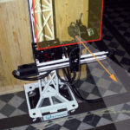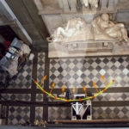]
Figure 4.3.X.2-1, Sequential Imaging
- Camera Array or camera modules: To improve the efficiency of light field acquisition, multiple cameras can be combined into a camera array, capturing the scene from different angles and positions to obtain light field video. Camera array-based light field video acquisition systems are highly time-efficient and can capture dynamic objects. However, due to the typically large size of the camera array and the high hardware costs, along with the challenges of synchronization and data transmission between multiple cameras, its practical application has certain limitations.
[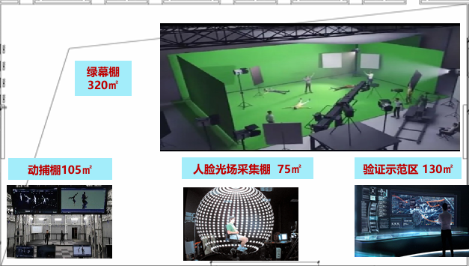]
Figure 4.3.X.2-2(a), Camera Array: China Mobile’s "Metaverse Light Field Capture Center"
[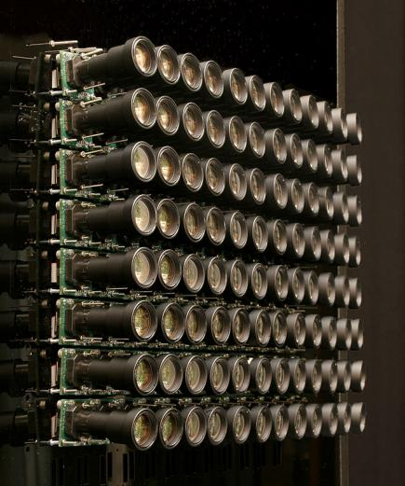]
Figure 4.3.X.2-2(b), An embodyment of the Stanford Multi-Camera Array, using 96 cameras with telephoto lenses
[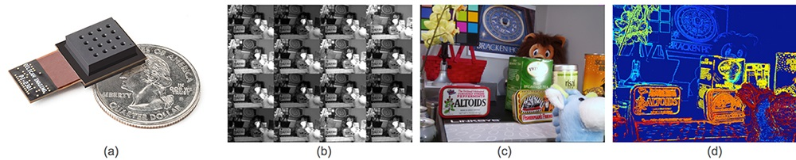]
Figure 4.3.X.2-2(c), Light Field Smartphone: Pelican Imaging
- Plenoptic Camera: To balance system cost and acquisition time, some researchers have proposed using a microlens array combined with a single camera for light field acquisition. A plenoptic camera places the microlens array between the main lens and the image sensor, offering the advantages of portability and low cost. This device can efficiently capture dynamic scenes, therefore they are increasingly being used in light field acquisition. PlenoptiCam is an open-source, cross-platform software tool that processes raw plenoptic camera images into light field data through 4D image alignment and calibration: https://github.com/hahnec/plenopticam.
[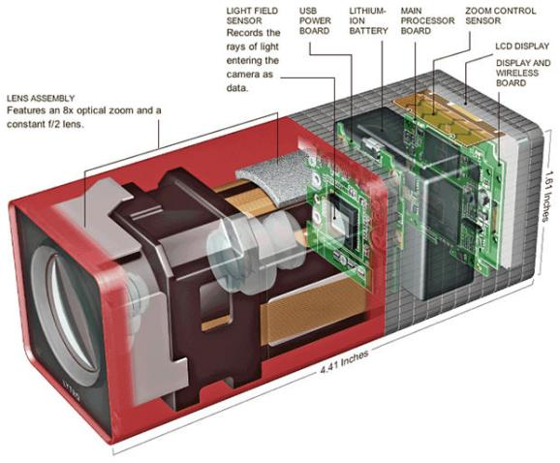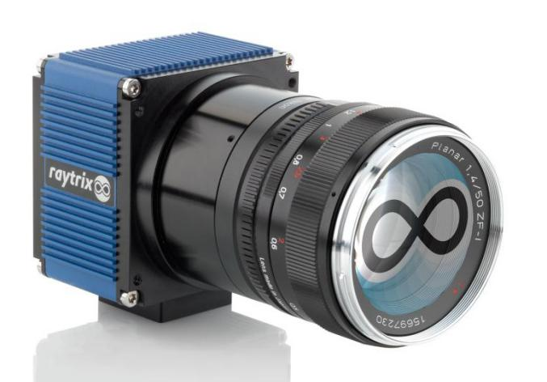]
Figure 4.3.X.2-3, Plenoptic Camera

4.3.X.2.3 Rendering and Display Systems
Light field video can be viewed on different rendering and display systems, including:
- AR glasses: CREALTM light-field AR glasses, https://creal.com/ar/
[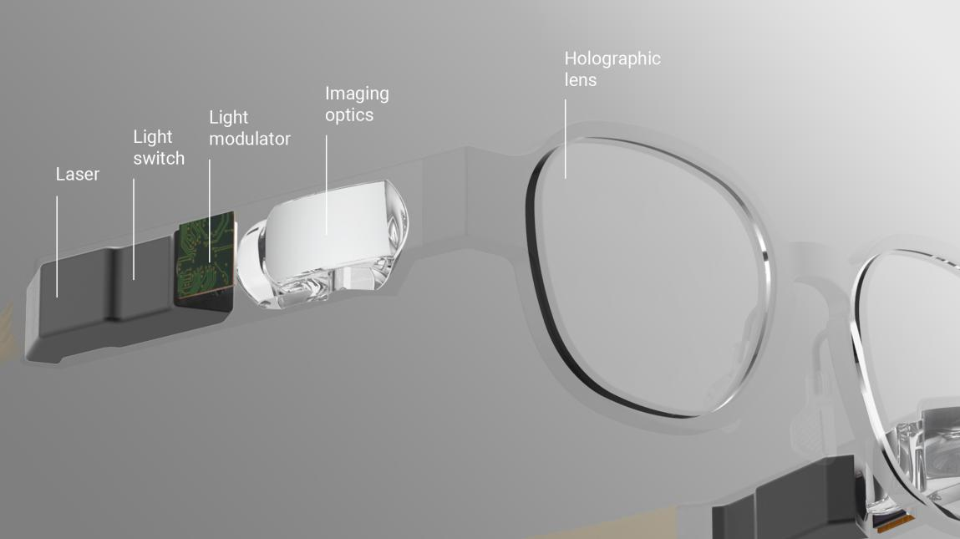]
Figure 4.3.X.3-1,CREALTM light-field AR glasses
- VR HMD: Meta Quest, CREALTM light-field VR HMD, https://creal.com/vr/
- Light Field Display: Looking Glass (https://www.holoxica.com/looking-glass-4k), Leia

[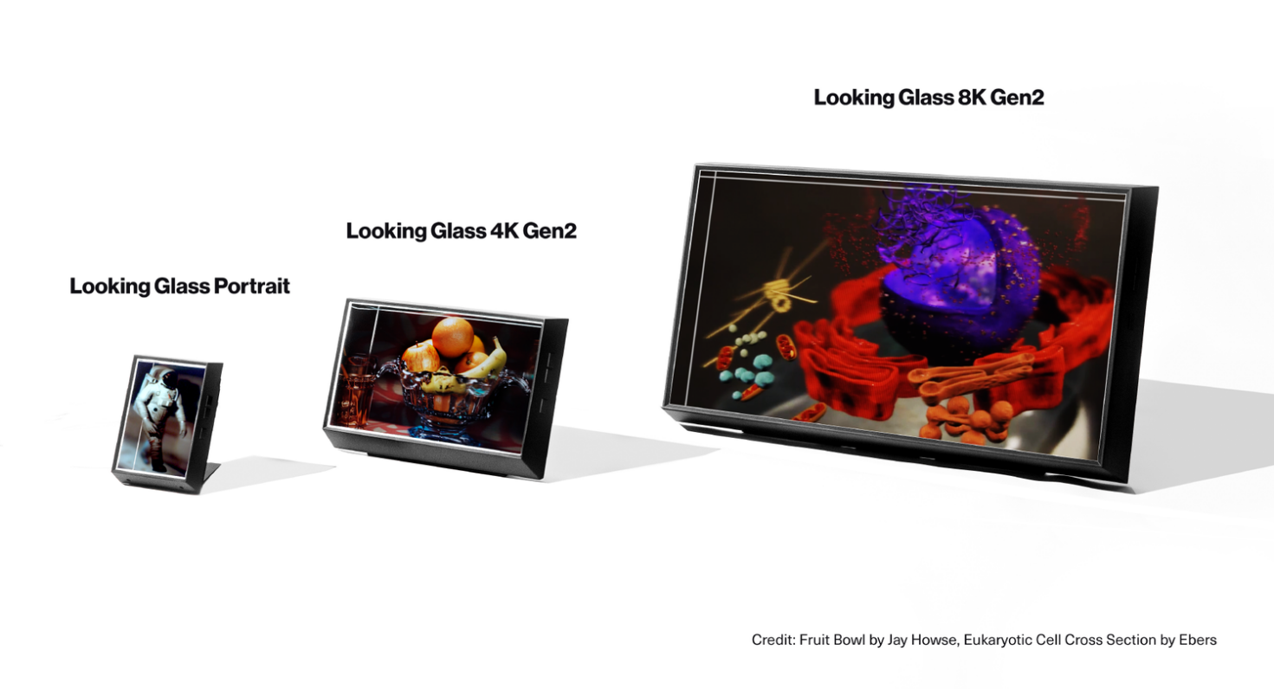]
Figure 4.3.X.3-2, Looking Glass
For rendering light-field video, it takes image rendering toward a “no-geometry-required” solution but use multiple image views. For example, there is an open-source interactive light field renderer using dynamically reparameterized light fields in GitHub: https://github.com/linusmossberg/light-field-renderer.

4.3.X.2.4 Supporting Information
The following is the end-to-end Light Field Video System proposed by Google [LF-6], including capturing, reconstructing, compressing, and rendering high quality immersive light field video. The immersive light fields are recorded using a custom array of 46 time-synchronized cameras distributed on the surface of a hemispherical, 92cm diameter dome. From this data it produces 6DOF volumetric videos with a wide 80-cm viewing baseline, 10 pixels per degree angular resolution, and a wide field of view (>220 degrees), at 30fps video frame rates. The resulting RGB, alpha, and depth channels in these layers are then compressed using conventional texture atlasing and video compression techniques. The final compressed representation is lightweight and can be rendered on mobile VR/AR platforms or in a web browser.
[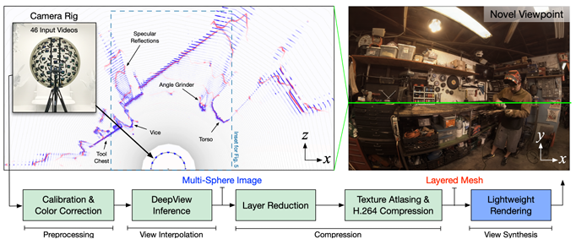]
Figure 4,3,X,4, End-to-end Light Field Video System
Multiple compression techniques have been proposed for the light field video, they are mainly categorized into three groups:
- Transform-based methods: these approaches typically involving using a transformer, such as the discrete cosine transform (DCT) or the discrete wavelet transform (DWT). For example, the MuLE [LF-7], which has been adopted by the JPEG pleno standardization committee.
- Prediction-based methods: some studies interpret light fields as multi-view sequences and use multi-view extension such as MV-HEVC for compression.
- Learning-based methods: these are recent development in light field compression. They leverage the power of machine learning techniques (e.g., GAN or CNN) to improve encoding efficiency,
MPEG is currently working on Lenslet Video Coding (LVC), which focuses on dense light field representations, use cases and requirements, and dedicated codecs .[LF-8].
The content can be delivered with a DASH-compliant framework, an open streaming media standard for field of light displays (SMFoLD) [LF-9] had also been developed for streaming dynamic scene. However, the work appears to have been discontinued, as there have been no updates since 2018.
Typical quality criteria for evaluating light field video includes:
- 3D IQA, PSNR and SSIM Quality Metrics
- FR light field metric [LF-10], which considers global spatial quality metrics based on viewing structure matching, local spatial quality based on near-edge MSE, and angular quality based on multiview quality analysis.
- JPEG is also preparing standardization activities [LF-11] in the domains of objective and subjective quality assessment for light fields, improved light field coding modes, and learning-based light field coding.

4.3.X.2.5 Benefits and Limitations

4.3.X.2.5.1 Benefits
The light field videos offer the following main benefit:
- Immersive visual experience, “cover all the different perspectives so the user can choose which one he wants to have and of course different users can choose different perspectives.” [LF-12]
Some advantages and benefits of lightfields are provided in [LF-13]:
- the light field content production approach has the benefit that it is a full representation of what is captured, is high resolution, one can observe in stereo and can move within this content, to a predefined degree.
- Content can be captured by a micro lens array or produced by computer graphics. Light fields allow the high fidelity of models, textures, lighting, and reflections.
- Lightfield captures are holographic, i.e. they contain all possible views within a preset range that can be defined.
- Light field captures have parallax, an overlap of object depth based on head movement. This increases immersion and presence, which is not available in 3DOF omnidirectional videos.
- Captures can have higher quality reflections, complex lighting, or realistic physics which would not be possible in real-time 3D graphics.
- Light fields focus or aperture can be adjusted on the fly based on depth versus a 2D video which needs to be in focus at the time of filming. This is because light fields can estimate depth based on the data acquired.
- Just like 3D models, multiple light field captures can be incorporated together and can be manipulated.
- Most of the captured data is not needed and can be removed. For example, thousands of high quality photos of small movements can be compressed to be a fraction of this size by removing this redundant visual info.

4.3.X.2.5.2 Limitations
The large number of views and captures in light field videos generate massive amounts of data, leading to significant storage and bandwidth demands. Even when content is delivered promptly, current handheld devices struggle to load these resources in real-time.
Some disadvantages and limitations of lightfields are provided in [LF-13]:
- Lightfields require a massive amount of high quality pixel based information, regardless whether it is from a real camera or from a virtual camera. In addition, the more movement in a scene means more individual captures of this information.
- Lightfields have restrictions in the volume they can capture, so they really only work for content where edges are not visible. Light fields are not useful for everything, but very targeted use cases.
- Lightfields are not truly volumetric (aka 3D), but fake 3D. If you try to go past the window of the capture area, the illusion disappears.
- Though light field technology had been on computer visionaries’ radar since the early 1990’s, even the biggest players struggled to launch a tangible version to market. Often light fields have been relegated to white papers, rarely finding their way into a commercial project.
[With the emergence of AI-based rendering technologies [LF-14], NeRFs are the successors of light fields, addressing some of the weaknesses of light fields. NeRFs are a scene methods in which a single neural network captures the entire scene. The neural network maps the viewing angle onto the color output, providing a continuous representation of the entire scene. The downside of scene-based approaches is that the whole set of weights is required to reconstruct even portions of the scene. This leads to the main disadvantages of whole-scene NeRF methods: encoding and decoding complexity and memory requirements. While NeRFs can be utilized as 3D assets in virtual productions, Gaussian splats can serve the same purpose just as effectively. Additionally, Gaussian splats offer the advantage of being loosely connected to the underlying geometry. This opens up possibilities for editing these 3D assets in various ways. Hence, more effective methods for distributing light field and radiance fields are anticipated.]
Editor’s note: The above paragraph could be relocated to a separate clause under 4.3.X as part of the conclusion.

5 Overview of existing "Beyond 2D" Video Capabilities in 3GPP
Editor’s note: This clause summarized existing beyond 2D video capabilities in 3GPP from at least TS.26.119 and TS.26.118.

5.1 Introduction
<TBD>

5.2 AR Video Capabilities
3GPP TS 26.119 [5] specifies the mandatory and optional media capabilities and profiles to be supported for each XR device type. These media capabilities include support for video codecs (AVC and HEVC), audio codecs (EVS, IVAS and AAC-ELDv2), scene description formats, and XR system capabilities. Table 5.2-1 summarized the Beyond 2D video capabilities defined in clause 7 of TS 26.119 [5].
NOTE: The definition of concurrent video decoder instances can be found in clause 7.1.2.1 of TS 26.119 [5].
Table 5.2-1: Summary of Operation Points
Operation Point Name | Max Concurrent Video Decoder Instances | Decoding Capabilities
AVC-FullHD-Dec-2 | 2 | Aggregate decoding capabilities of H.264/AVC HP@L4.0
AVC-UHD-Dec-4 | 4 | Aggregate decoding capabilities of H.264/AVC HP@L5.1
HEVC-UHD-Dec-4 | 4 | Aggregate decoding capabilities of H.265/HEVC MP10@L5.1
UHD-Dec-4 | 4 | Aggregate capabilities of AVC-UHD-Dec-4
 |  | Aggregate capabilities of HEVC-UHD-Dec-4
 |  | Decoding up to 4 bitstreams, each not exceeding the capabilities of H.264/AVC HP@L4.0 or H.265/HEVC MP10@L4.1.
AVC-8K-Dec-8 | 8 | Aggregate capabilities of H.264/AVC HP@L6.1
HEVC-8K-Dec-8 | 8 | Aggregate capabilities of H.265/HEVC MP10@L6.1
8K-Dec-8 | 8 | Aggregate capabilities of AVC-8K-Dec-8
 |  | Aggregate capabilities of HEVC-8K-Dec-8
 |  | Decoding up to 8 bitstreams, each not exceeding the capabilities of H.264/AVC HP@L4.0 or H.265/HEVC MP10@L4.1.
 |  | Decoding up to 4 bitstreams, each not exceeding the capabilities of H.264/AVC HP@L5.1 or H.265/HEVC MP10@L5.1.

5.3 VR Video Profiles
The VR profiles for streaming services are defined in TS 26.118 [6], specifying the coded representation and media profile of 360 VR distribution signals. Table 5.3-1 provides an overview of the 360 VR relevant formats considered in the context of 3GPP VR Profiles.
For restrictions on source formats such as resolution and frame rates, content generation and encoding guidelines, refer to TS 26.118 [6], Annex A.
Table 5.3-1: High-level Summary of Operation Points
Operation Point name | Decoder | Bit depth | Typical  Original  Spatial  Resolution | Frame  Rate | Colour space format | Transfer  Characteristics | Projection | Rotation | RWP | Stereo
Basic H.264/AVC | H.264/AVC HP@L5.1 | 8 | Up to 4k | Up to 60 Hz | BT.709 | BT.709 | ERP w/o padding | No | No | No
Main H.265/HEVC | H.265/HEVC MP10@L5.1 | 8, 10 | Up to 6k in mono and 3k in stereo | Up to 60 Hz | BT.709  BT.2020 | BT.709 | ERP w/o padding | No | Yes | Yes
Flexible H.265/HEVC | H.265/HEVC MP10@L5.1 | 8, 10 | Up to 8k in mono and 3k in stereo | Up to 120 Hz | BT.709  BT.2020 | BT.709,  BT.2100 PQ, BT.2100 HLG | ERP w/o padding  CMP | No | Yes | Yes
Main 8K H.265/HEVC | H.265/HEVC MP10@L6.1 | 10 | Up to 8k in mono and 6k in stereo | Up to 60 Hz for 8K and 120 Hz for 4k | BT.709  BT.2020 | BT.709,  BT.2100 PQ, BT.2100 HLG | ERP w/o padding | No | Yes, but restricted to coverage | Yes

Table 5.3-2 summarizes the video operation point, sample entry, and DASH integration associated with each video media profiles defined in clause 5.2 of TS 26.118 [6].
Table 5.3-2 Video Media Profiles
Media Profile | Operation Point | Sample Entry | DASH Integration
Basic Video | Basic H.264/AVC | resv  avc1 | Single Adaptation Set  Single Representation streaming
Main Video | Main H.265/HEVC or Main 8K H.265/HEVC | resv  hvc1 | Single or Multiple independent Adaptation Sets offered  Single Representation streaming
Advanced Video | Flexible H.265/HEVC | resv  hvc1, hvc2 | Single or Multiple dependent Adaptation Sets offered  Single or Multiple representation streaming

5.4 Messaging Services
3GPP TS 26.143 [7] specifies the media types, formats, codecs capabilities and profiles for the messaging applications used over the 5G System. The document extends to codecs for speech, audio, video, still images, bitmap graphics, 3D scenes and assets, and other media in general, as well as scene description.
Specifically, the 2D video capabilities defined in TS 26.143 [7] clause 6.2 are fully aligned with 5G Media Streaming in 3GPP TS 26.511 [8]:
- AVC with HD and Full-HD resolutions
- HEVC with HD, Full-HD and UHD resolutions
For Beyond 2D video capabilities, as HEVC simulcast and HEVC frame packing already been included in SA4 specifications and given the coding benefits MV-HEVC provides compared to these solutions, the support for stereoscopic MV-HEVC for low delay applications of stereoscopic 3D video was recommended by TR 26.966 [9]. This aspect is being addressed in a Rel-19 work TS 26.265 [10].

6 Evaluation and Characterization Framework

6.1 Overview
Generally, the test and characterization framework as documented in TR 26.955, clause 5 also applies to this document. This clause only documents differences and extensions that are needed for beyond 2D Evaluation and characterization framework.
The overview of the evaluation framework for the B2D messaging is presented in Figure 6.1-1. Representative reference sequences are collected and stored in a well-defined B2D format. For a video encoder, the configuration is provided that matches the application constraints. The resulting video streams are “pseudo”-packaged in order to determine the file size/bitrate. The data is then unpackaged, and a B2D video decoder is used to reconstruct data in the B2D format again. The data is stored. The original sequence and the recovered sequence are used determine metrics. The sequences may also be inspected subjectively.
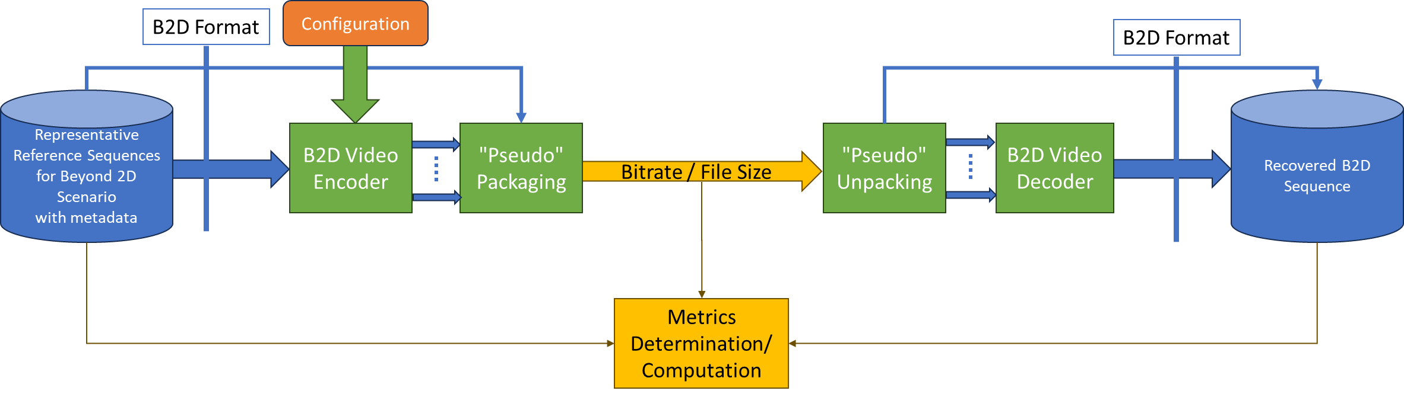
Figure 6.1-1 B2D Evaluation framework

6.2 Reference Sequences
This document provides reference sequences that are used to generate anchors and are also made available in order to generate test bitstreams for other codecs. Reference sequences are selected to be representative for a scenario.
Reference sequences are described in Annex C of this document along with their properties and their licenses. A format for raw reference sequences based on a JSON schema is defined in clause B.2.
Annex D describes how to upload new proposed reference sequences and how to download the reference sequences.

6.3 Reference Software Tools
Editor’s Note: For further study

6.4 Metrics
Editor’s Note: For further study
The metrics in clause 5.5 of TR 26.955 also apply for this report.
In addition, the following is defined
Editor’s Note: For further study
For metrics reporting, the following csv scheme is defined: tbd

6.5 Encoding Constraints
The encoding constraint definition in clause 5.6 of TR 26.955 also apply for this report.
In addition, the following is defined:
- Equal Quality Views: equal quality views refers to the encoding such that each view when decoded has the same quality target, typically applying the same QP.
Editor’s Note: More details are to be defined

7 Considered Scenarios

7.1 Introduction
Editor’s note: This clause collects end-to-end scenarios and corresponding workflows for beyond 2D video, based on the template defined in Annex A. Alignment with the generalized media delivery architecture defined in TS 26.501/506 is expected, primarily addressing reference points M2 and M4.

7.2 Scenario 1: UE-to-UE Stereoscopic Video Live Streaming

7.2.1 Motivation
Live Streaming services can be deployed across various platforms, including social media platforms like YouTube Live™, Facebook Live™, and TikTokTM, as well as though e-commerce platforms such as eBayTM and TaobaoTM [LS-1]. It significantly impact marketing by providing a dynamic and interactive channel to directly connect markets and their target audiences in real time. To continue captivating users, it’s essential to explore a more immersive live streaming experience by incorporating beyond 2D video.
Most of the current Beyond 2D streaming services provided by network operators, services providers, and device manufacturers on the market are based on the stereoscopic video format, as defined in clause 4.3.2. In terms of distribution, existing stereoscopic 3D video formats, such as frame-compatible side-by-side and 2D video plus depth. Particular emphasis is given to the DVB systems [LS-3] and IP transport, focusing HTTP/TCP streaming, adaptive HTTP streaming, RTP/UDP streaming, P2P Networks, and Information-Centric Networking-ICN. Hybrid transport technologies, combining broadcast and broadband networks for video delivery are also addressed. The most important standards are MPEG-2 systems, which is used for digital broadcast and storage on Blu-ray discs, real-time transport protocol (RTP), which is used for real-time transmissions over the Internet, and the ISO base media file format, which can be used for progressive download in video-on-demand applications [LS-4].In cause 6.2 of TR 26.905 [LS-5], it provides a DASH-based streaming solution for streaming Stereoscopic 3D video.

7.2.2 Description of the Anticipated Application

7.2.2.1 Overall Description
3GPP until now has very restricted set of services but based on the considerations in clause 7.2.1, the following encoding benchmark capabilities are considered for decoding:
- The capability of supporting up to two (N=2) concurrent decoder instances with the aggregate capabilities of H.265 (HEVC) YUV 4:2:0, 10 bit, Max Resolution 4096 x 2048..
The considered scenarios is low-latency streaming. Important aspects that are expected to be considered when evaluating a codec in the context of this UE-to-UE Stereoscopic Video Live Streaming scenario are:
- Quality and Coding Efficiency:
- High and uninterrupted visual quality, taking into account the services constraints.
- The ability to compress 2 or more B2D streams in real-time to minimize latency requirements.
- Any savings can provide significant benefits due to the expected large volume of the traffic either in quality or network utilization.
- Considered settings for encoding:
- Low-latency settings
- Encoding in this scenario is typically done as:
- Live and On-Demand distribution and encoding
- Sever and Cloud-based Encoding

7.2.2.2 Capturing and processing
The existing and emerging capture methods include:
- Stereoscopic camera: a dual-lens camera which can directly capture stereo 3D video. For example, the SpatialLabs Eyes™, a stereoscopic camera cable of capturing at up to 8-MP (aka 4K) per eye at 30 fps or 2K per eye at 60 fps (https://www.tomshardware.com/cameras/3d-call-me-maybe-acers-new-spatiallabs-camera-live-streams-impressive-3d-video-in-8k-but-few-can-view-it). Another example is the ZTE Nubia Pad 3D II™, which can capture stereo 3D video at up to 13-MP per eye at 30 fps with the rear camera and 8-MP per eye at 30 fps with the selfie camera.
- 3D Camera Rig: The cameras setup is shown in the figure below, which consists of two identical HD camcorders (Canon HG-20™) and an adjustable stereo mount. The mount ensures that optical axes of the cameras are parallel and supports the continuous adjustment of the camera distance in the range 7-50 cm. To ensure matching of the focal length the wide angle end of the zoom lens with a focal length of 43 mm has been used. In order to match the cameras with each other the focal length, white balance and shutter speed have been set manually. The synchronized operation of the two camcorder is ensured through the use of a single remote control. The camcorders support the capture of images with a resolution of 1920×1080 pixels and store them as high quality JPEG files.
Figure 7.x.1-1 Camera Rig for stereoscopic video capture
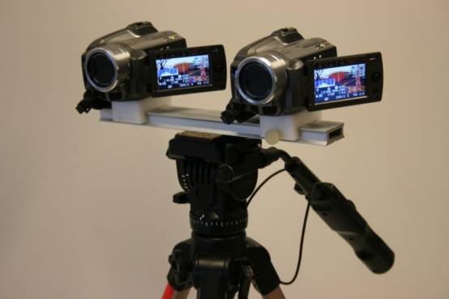
- AI Based 2D-to-Stereo3D Conversion: The AI-based conversion leverages deep neural networks to perform real-time, end-to-end conversion of 2D videos and images into stereoscopic 3D format [LS-2]. This technology is proving commercially viable and meets the growing demand for high-quality stereoscopic images, as demonstrated by commercial services.
For UE capable of directly capturing stereoscopic video on the device, it pre-processes the captured video frames into a well-defined B2D format and sends them to the encoder as input. The encoded B2D video streams are then streamed to the streaming server within the network, where the server may transcode them into different bitrates and distribute them to various audiences. The receiving end decodes B2D video streams and perform post-processing to adapt to the rendering system.
For UE limited to capturing only 2D video (e.g., UE with a monocular camera), the UE initially encodes the regular 2D video and streams it to a cloud server capable of real-time 2D-to-beyond 2D transcoding (a generic pipeline for this transcoding process is described in Figure 7.x.1-2). The cloud server then encodes the transcoded B2D video and streams it to the streaming server.
Figure 7.x.1-2 Pipeline for 2D-to-Stereo3D Conversion
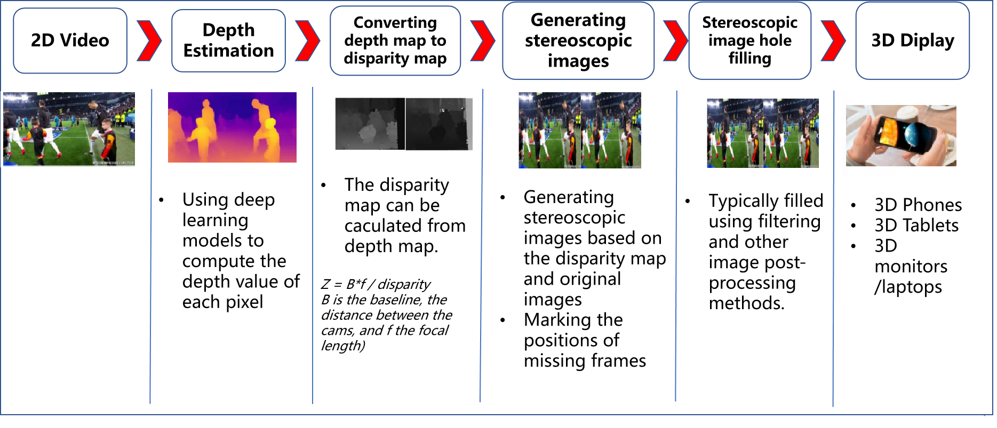

7.2.2.3 Encoding
The following solutions can be used to realize this scenario:
- Concurrent H.265/HEVC
- MV-HEVC

7.2.2.4 Packing and Delivery
The content can be delivered using regular ISO BMFF based distribution, including streaming with DASH/HLS/CMAF.

7.2.2.5 Decoding
The following solutions can be used to realize this scenario:
- Concurrent H.265/HEVC decoding capabilities
- MV-HEVC

7.2.2.6 Rendering
Rendering can be on:
- Backward-compatible to 2D presentation, e.g., a mobile phone, but the stereoscopic effect is lost in this case.
- A device for 3D presentation, e.g., autostereoscopic displays, VR headset, and AR glasses, these devices can track the viewer's eye position and adjusts the 3D effect in real-time for single viewer applications (parallax adjustment) and rendering.

7.2.3 Source Format Properties
Table 7.x.3-1 provides an overview of the different source signal properties for UE-to-UE Stereoscopic Video Live Streaming. This information is used to select proper test sequences.
Table 7.x.3-1 UE-to-UE Stereoscopic Video Live Streaming Source Properties
Source format properties | B2D Live Streaming
Number of views | 2
Spatial resolution for each view | For each view:  1920 x 1080  2560 x 1600
Chroma format | Y’CbCr, RGB
Chroma subsampling | 4:2:0
Picture aspect ratio | 32:9  16:9  16:10
Frame rates | 25, 30, 60, 90,120 Hz
Bit depth | 8, 10

7.2.4 Encoding and Decoding Constraints
Table 7.x.4-1 provides an overview of encoding and decoding constraints for UE-to-UE Stereoscopic Video Live Streaming scenario using H.265/HEVC. This information supports the definition of detailed anchor conditions.
Table 7.x.4-1 Encoding and Decoding Configurations
Encoding and Decoding Constraints | H.265/HEVC
Relevant Codec and Codec Profile/Levels | H.265/HEVC Main 10 Profile  Level 4.1, 5.1
Random access frequency | 1 seconds
Bit rates and quality configuration | Fixed QP: [17, 22, 27, 32, 37]  CBR  Half Width/Height: 5-8Mbps  Full Width/Height: 8-16Mbps  Capped-VBR
Bit rate parameters (CBR, VBR, CAE, HRD parameters) | Covering a range of relevant bitrates and qualities
Latency requirements and specific encoding settings | Low latency requirements
Encoding complexity context | Real-time encoding, Cloud-based encoding
Required decoding capabilities | H.265/HEVC Main 10 Profile  Level 4.1, 5.1

7.2.5 Performance Metrics
[PSNR, SSIM, SIM, BD-Rate, signal-to-noise ratio (SNR)]
<Editor’s Note: Clause 4.2 of the permanent document of TR 26.956 (S4-241868) provides verified Objective Metrics (e.g., HV3D Quality Metrics) and Subjective Assessment methods for stereoscopic video. This content is expected to be discussed and approved by the SA4 group before being added to the TR.>

7.2.6 Interoperability Consideration
For UE-to-UE Stereoscopic Live Streaming, DASH-based solutions are expected.

7.2.7 Reference Sequences
Table 7.x.7-1 provides the selected reference sequences for this scenario. Keys are identified to refer to the sequences in the context of the scenario. The sequences are named and a reference to the details of the sequence is provided. A justification is provided, why this sequence is selected.
<Editor’s Note: Clause 2.5.9 of the permanent document of TR 26.956 (S4-241868) lists public datasets, generation software, and capturing tools for creating source sequences for UE-to-UE Stereoscopic live streaming. This content is expected to be reviewed and approved by the SA4 group before being added to the TR.>
Table 7.x.7-1 Reference Sequences for UE-to-UE Stereoscopic Live Streaming
Key | Name | Reference | Justification/Comment
SX-R01
SX-R02
SX-R03
SX-R04

7.2.8 Anchor Definition
<Editor’s Note: This part of content will be addressed in a separate contribution.>

7.2.9 Anchor Result
<Editor’s Note: This part of content will be addressed in a separate contribution>

7.3 Scenario 2: Streaming of professionally produced Volumetric Video with single asset containing people

7.3.1 Scenario name
Streaming of professionally produced Volumetric Video with single asset containing people.

7.3.2 Motivation for the scenario
The scenario addresses on-demand streaming of post-produced volumetric video with single asset containing people, providing experiences beyond what is achievable with 2D content. Particularly in AR application, the user can watch the volumetric video asset from all directions as if the asset were naturally present. In both AR and VR applications, the user can move smoothly around the asset, change its size or make the asset rotate.
The content is in the form of volumetric video, which is a frame-based immersive experience whereby each frame represents a volumetric region in 3D space in which any point is either non-occupied or has a colour that may depend on the viewing direction. Volumetric video has the potential to provide a more immersive and interactive experience than 2D content.
Several use cases for on-demand volumetric video streaming can be envisioned related to various domains including but not limited to entertainment, education and industrial monitoring. For example, in the entertainment domain users can stream a performance from their favorite singer or band to their living room and experience greater immersion potentially combined with spatial audio. Another example is the education/training domain, where a produced volumetric video of a fitness instructor shows how to perform an exercise that helps a student to better understand how the exercise is done and thus replicate it in a correct way. Yet another example in the education domain would be a mechanic giving a tutorial on how to assemble a mountain bike. A trainee can watch the movements of the mechanic from different angles and get an improved understanding of the different steps due to depth perception and different viewpoints.
For first implementations of relevant use cases the content can be quite simple without hindering the purpose, consisting of a camera captured 6 DoF person as asset and a 3D graphics background or an AR camera background coming from the rendering device. As an alternative a person could be captured with an object (e.g. a ball) or two persons together. Important is that everything is in a single asset.

- Technology evaluation on the market
KDDI experimented transmission of produced volumetric video over mobile networks including real time encoding and decoding [R1].
Volucap, based in Potsdam Germany, developed several showcases and tested these on the market. The number of showcases is growing and the current list can be consulted here: https://volucap.com/showcases/.
The following showcases illustrate particularly the proposed scenario:
- Sports training: Volucap and Deutsche Telekom produced a clip to learn cool dribbles and precise throws from the former basketball star Josh Mayo: https://volucap.com/portfolio-items/meeting-josh/
- Music Group: Volucap and the music group “Boss Hoss” prototyped the your favorite band in your living room: https://volucap.com/portfolio-items/the-bosshoss-augmented-reality/
- Tagesschau: Volucap and the German news broadcaster Tagesschau collaborated to capture a volumetric representation of a news: https://volucap.com/portfolio-items/tagesschau-2025/
- Book enhanced with AR: Volucap enhanced a children song book with AR content on a smartphone: https://volucap.com/portfolio-items/rolf-zuckowski/
- XR Fashion show: Volucap and Lana Mueller, a Berlin based designer, produced a fashion presentation in XR: https://volucap.com/portfolio-items/lana-mueller-fashion/
- Charité medical VR training: This immersive simulation uses advanced volumetric video technology to bring users into the heart of a realistic surgical environment, ideal for virtual reality (VR) training scenarios: https://volucap.com/portfolio-items/charite-medical-vr-training/
- Industry activities
Several industry activities regarding on-demand volumetric video streaming have been experimented between various mobile network operators, volumetric capture studios and technology providers. Some of these industry activities are listed here:
- Volograms, based in Dublin, Ireland
- Provides professional volumetric content creation services to feed AR use cases such as augmented museum, training or fashion experiences: https://www.volograms.com/made-with-volograms
- The company has also developed an AI based solution to enable AR volumetric content from 2D single photo or video: https://www.volograms.com/
- 8i, Mantis Vision, Metastage, Volograms, XD Productions, etc. present volumetric capturing projects on their websites, similar to Volucap
- XD Productions and Volograms content (both professional and AI-based) has been showcased in public trade shows and conferences by InterDigital as part of MPEG-I V3C platform demonstration with the V-PCC player
- Zerospace and Canon are collaborating to open a volumetric video capturing studio. With over 100 Canon Cinema EOS cameras, it claims to offer unmatched capabilities. The website illustrates capture of sports content (e.g. basketball, Karate): https://www.zerospace.co/studios/canon-volumetric-capture
- Brazilian SBTVD Forum has adopted volumetric video for inclusion in their TV 3.0 standards (support is not be mandatory in all receivers; focus is on content distribution over the Internet and consumption on smartphones and HMDs). TV 3.0 services are planned to be launched in 2025 [R2]
- The Volumetric Format Association has been formed to ensure interoperability of volumetric video capturing, processing, compression and playback [R3]
- Production tools/companies
The following is a non-exhaustive list of companies providing tools, equipment or services to produce volumetric video content:
- 4D People: Renderpeople is a company that provides large libraries of different kinds of scanned people in 3D and 4D, where 4D includes the dimension of time and corresponds to Volumetric Video: https://4dpeople.com/
- 4D Views: 4D Views is a company that provides a volumetric capturing system named Holosys including HW, SW, support and editing software. A volumetric player is provided to review volumetric demo sequences: https://www.4dviews.com/
- 8i: Provides a volumetric capturing system including HW, SW and a solution to stream content to devices, browsers and HR/VR headsets: https://8i.com/
- Arcturus: Provides volumetric capturing services and commercializes a volumetric capturing system named HoloCapture and a volumetric video post-production and streaming solution named HoloSuite. A number of volumetric production studios are installed around the world such as Dimension in London, Metastage in Los Angeles, ifland Studio in Seoul (SK Telecom), Nikon Creates Corporation in Tokyo and at ETH in Zurich. See more information: https://arcturus.studio/
- CIVIT: https://civit.fi/volumetric-capture-studio/
- Dimension Studio: https://dimensionstudio.co/
- Evercoast : https://evercoast.com/
- Mantis Vision : https://mantis-vision.com/
- Metastage : https://metastage.com/
- Volucap: Volucap claims to have the world’s highest resolution for capturing volumetric video with 700 megapixels for each shot and a unique lighting system: https://volucap.com/
- XD Prod : https://www.xdprod.com/
Capturing systems typically integrate with 3D editing tools such as Maya, Blender for post producing content.
- Delivery solutions
Arcturus provides an on-demand adaptive streaming solution for volumetric video [R4]
8i provides a solution to stream volumetric video produced with their capturing system [R5]
An end-to-end implementation of a MPEG V3C standardized platform for packaging and delivery of volumetric video over content delivery network (CDN) is available [R6]
- Content decoding and rendering

Arcturus provides a play-back solution with broad delivery capabilities including support for Unreal, Unity, iOS and Android [R7].
8i provides a solution to decode and render volumetric video on a browser running on CE devices and AR/VR headsets [R5].
5G-MAG hosts a V3C Immersive Platform [R8]. It provides a Unity package to decode, render and play V3C content in Unity using the V3C Immersive Platform – Decoder Plugin.

7.3.3 Description of the scenario
This scenario covers Streaming of professionally produced Volumetric Video with single asset containing people.
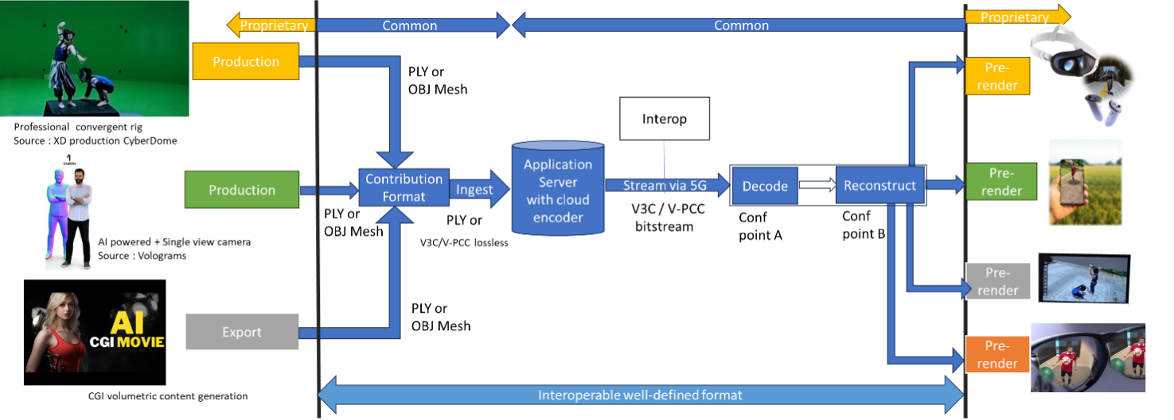
Figure f1: Streaming of professionally produced Volumetric Video with single asset containing people (content courtesy XD Productions)
- Capturing and processing
Capturing of high-quality 6 DoF assets as a volumetric video is typically done with a rig of cameras aligned on a circle around the asset(s) to be captured. Depending on the rig, there can be one or more layers of cameras at different height positions. The number of cameras per layer depend again on the designer of the rig and in the year 2024 there are typically between 30 and 100 cameras per layer. Cameras can be equipped with depth sensors. Hardware such as cameras and depth sensors are mostly off the shelf equipment, but the assembly in the rig is vendor dependent and proprietary.
The various camera and depth sensor signals are fed into a production pipeline that produces the volumetric video. Production includes stitching the various signals, filling holes, correcting occlusions, etc. Persons or physical objects (e.g. a ball or an instrument) can be combined in an asset or separate assets can be used for each person or object. For simplification and not hindering the purpose, the use case described in this document is limited to a single asset. The representation format of a produced asset is typically a dense dynamic point cloud or a dynamic mesh.
As an example, in the following the production pipeline of the company XD Productions is illustrated.
The figures below show the XD Productions CYBERDOME capture rig and associated real time viewing to control acquisition.
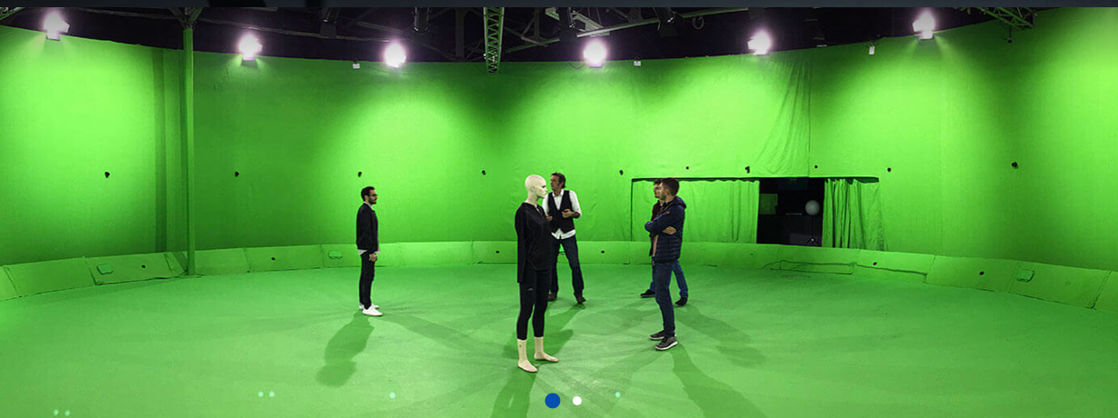
Figure f2: XD Productions capture rig (https://www.xdprod.com/services/studio/studio-virtuel/)
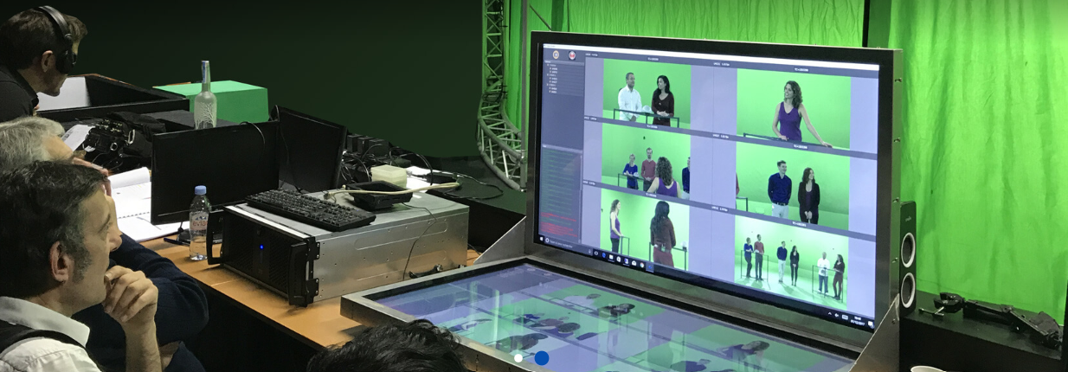
Figure f3: XD Production real time virtual production (https://www.xdprod.com/services/studio/studio-virtuel/)
The figures below show CYBERDOME acquisitions covering single or multiple characters in dynamic scenes.
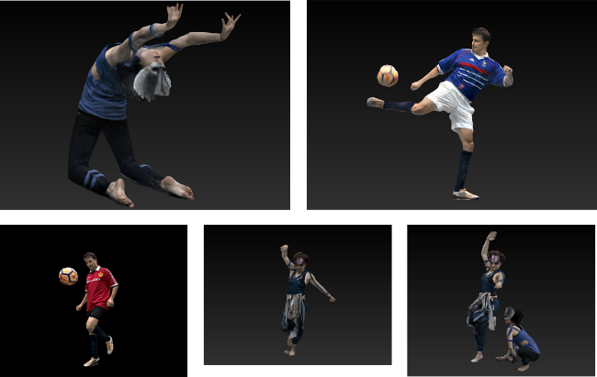
Figure f4: XD Productions contents screenshots, from top right to left: Acrobat01, Soccer Blue, Soccer Red, Dancer01 and Acrobat Duo
The acquisition processing pipeline includes a rig of about sixty 4K cameras, arranged in hemispheres around the scene to be captured. The set is 15-meter in diameter for a 7-meter diameter capture area. Two types of lenses are simultaneously used, with variable focal lengths, which allows to adapt the size of the capture area, and to mix wide shots and close-ups on the same captures to improve the quality of the textures. Each content item is then converted into point cloud frames. The processing output is provided in the PLY format.
Another example on how single asset volumetric video is produced is shown in a video by Metastage.
There are several companies that provide volumetric video capturing technology or entire volumetric video capturing studios. More detailed information can be found in chapter 5.4.4 of the DVB Study Mission report S101 on Volumetric Video.[R9]
The Volumetric Format Association [R3] describes an end-to-end volumetric chain including capturing, processing, encoding, decoding and rendering. After capturing the processing generates a point cloud that can be encoded and delivered as dense dynamic point cloud and reconstructed either as a point cloud or as a mesh for rendering.
The Ultra Video Group of Tampere University describes the process of generating volumetric video content with the Mantis Vision system in their paper [R10]. In a first step from the signals from multiple camera units on the rig a raw point cloud of the person or object is generated. In a second step a mesh is generated by using surface reconstruction algorithms. In a third step the mesh is sampled to generate a point cloud, which can then be voxelized on a regular 3D grid and normal can be calculated if needed.
It can be concluded that dense dynamic point clouds and dynamic meshes are used by industry to represent persons or objects as volumetric video.
A candidate solution to evaluate this scenario is described below as MPEG V-PCC.
- Encoding
Volumetric video can be represented in the representation format dense dynamic point clouds. MPEG has developed a specification named V-PCC for compressing and delivering the representation format dense dynamic point clouds at bitrates enabling consumer applications. V-PCC is standardized in ISO/IEC 23090-5 Visual Volumetric Video-based Coding (V3C) and Video-based Point Cloud Compression (V-PCC) – 2nd edition [R11].
During its experimentation with V-PCC KDDI implemented a real time V-PCC encoder [R1].
The following figure shows the V-PCC encoder main steps.
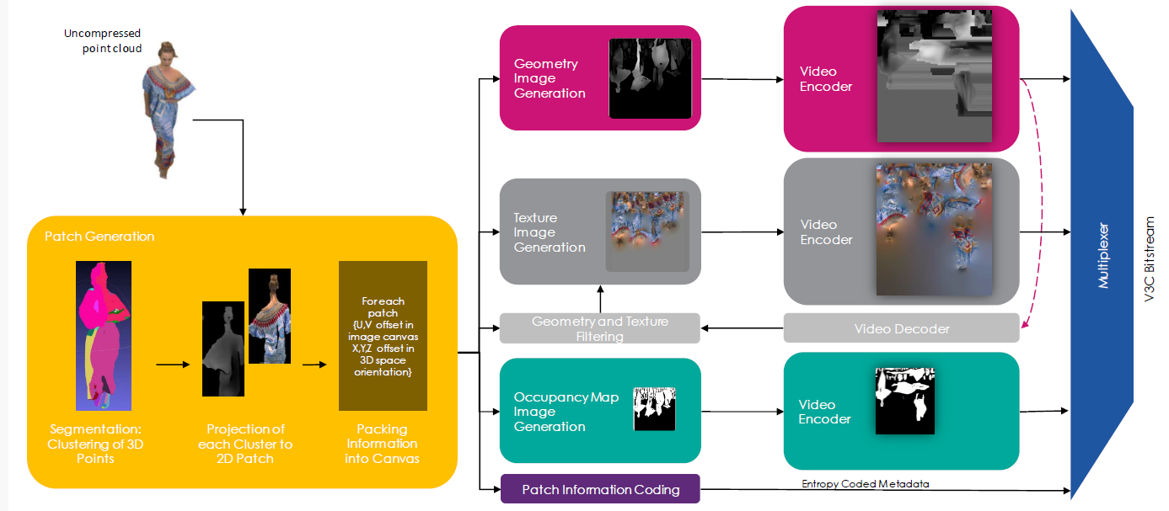
Figure f5 V-PCC encoder main steps (Content courtesy 8i)
For encoding of geometry, texture and occupancy map V-PCC relies on 2D video codecs. Due to its efficiency and market penetration HEVC aka H.265 is the choice of 2D video codec for the presented scenario.
- Packaging and delivery
MPEG has developed a specification addressing storage and delivery V-PCC coded data published as ISO/IEC 23090-10 Carriage of visual volumetric video-based coding data – 1st edition [R12].
- Decoding
For the dense dynamic point cloud representation format, decoding can rely on the V-PCC specification. No dedicated hardware is required for V-PCC real-time decoding on consumer devices. If the encoder uses HEVC for the 2D video encodes, the decoder in the device can make use of integrated hardware HEVC video decoder capabilities for all pixel data, and a small number of metadata is decoded by a CPU. The following figure shows the architecture of a V-PCC decoder.
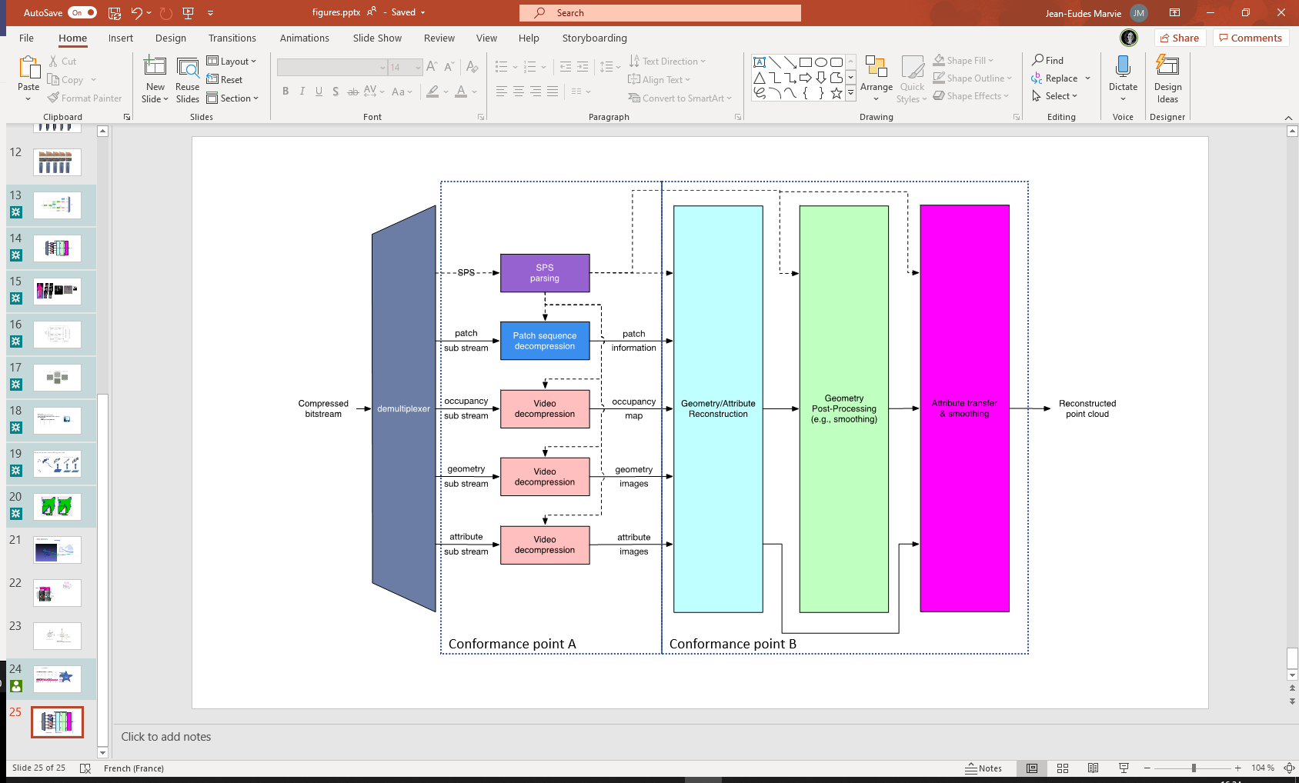
Figure f6 V-PCC decoder main steps
Decoding of the dense point cloud is terminated at the output of the video decoders, but these images are just intermediate results and do not represent a useable image for the human eye. Additional stages are needed to reconstruct the dense point cloud in 3D space and render it to the display of a consumer device. It can be rendered to 2D displays of e.g. smartphones and tablets, but also on head mounted devices or other 3D displays.
An example of point cloud data decoding processing has been described in [R13].
During its experimentation with V-PCC KDDI implemented a real time V-PCC decoder [R1].
Futuresource estimates that by the end of 2023 there are 4.1 billion Smartphones globally in the field with the capacity to decode HEVC video [R14].
- *Post-processing
Post-processing is implementation dependent, but it is typically performed on a GPU without dedicated V-PCC hardware.
- Rendering
Rendering is implementation dependent, but it is typically performed on a GPU without dedicated V-PCC hardware. More information can be found in section 4.3.3.3.
- General constraints on latency, bandwidth, reliability and complexity
For delivery, the volumetric video frames are organized using a random-access reference frame structure.
All decoder and renderer processes are real-time and may have a latency in the order of a few frames.

7.3.4 Source format properties
As source format for the scenario the representation format dense dynamic point clouds is considered. Section 4.3.3 describes the dense dynamic point cloud format and the present section provides more detail in direct relation with the scenario.
The following table includes signal properties that are typically used in the near/mid term to represent people or objects.
Source format properties | Volumetric Video with single asset
Number of points /Spatial Resolution | Up to 2 million points per frame
Chroma format | RGB
Chroma subsampling | Not Applicable
Picture aspect ratio | Not Applicable
Frame rates | 25, 30 Hz
Bit depth | 8 and 10
Colour space formats | RGB 444 nonlinear, BT.709
Transfer characteristics | BT.709
Viewpoints | All assets can be viewed from all directions and different distances
Table X1 Signal properties for dense point cloud format
For highly dynamic sports sequences higher frame rates such as 50 or 60 fps may be useful and this is left for the future.
In the following the quality of the dense point cloud representation format for representing people is further investigated.

7.3.4.1 Conversion and quantization
If volumetric video source sequences are delivered in production quality, then bandwidth for consumer delivery may be too high and a conversion/quantization is necessary to reduce the number of points and use the fixed-point format. The result of that conversion is that the sequence is in a bounding box of 10, 11 or 12 bit which is named in the following as Vox10, Vox11 and Vox12.
- Vox 12 creates a quality that is close to the quality that comes out of the production system for most provided sequences. Emotional facial expressions are clearly visible and tissue structure of cloths is visible. See figures Y2 and Y5 below.
- Vox 11 creates a quality that allows viewing the sequence from a wider distance and it allows to zoom closer. Emotional facial expressions and patterns on cloths is visible. See figures Y3 and Y6 below.
- Vox 10 creates a quality allowing to view the sequence from a wider distance, but getting too close is less recommended. See figures Y4 and Y7 below.

7.3.4.2 Impact of rendering
It is referred to section 4.3.3.3 that covers rendering and display systems. Rendering is typically not covered by standards and allows manufacturers to differentiate. The referred section discusses hole filling, but also techniques such as local meshing could be applied.

7.3.4.3 Impact of the background
To avoid interference between the background and the test sequence, it is recommended to use a neutral background colour for evaluation. If a VR or AR background is used instead of a neutral background, potential artefacts in the sequence are less visible, as the human eye concentrates on the overall picture and not only on the sequence.
This means also that in a real service where a background is used, potential artefacts in a sequence are less visible.
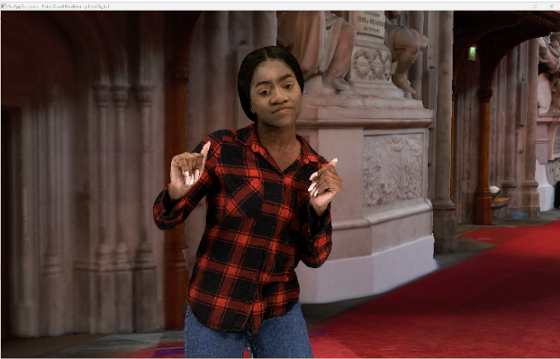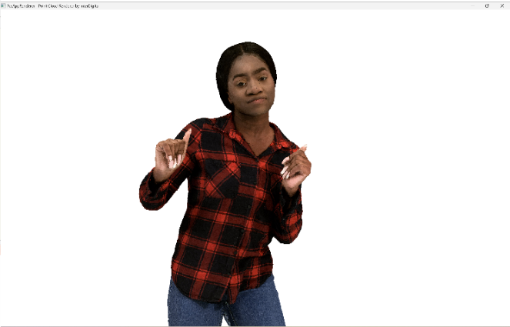
Figure Y1 Impact of background on perceived quality (content courtesy RenderPeople [R1])

7.3.4.5 Visual quality examples sequences in dense dynamic point cloud format
In the following the impact of number of points in a frame and type of renderer on the visual quality of the dense point cloud representation format is demonstrated. In this section still pictures are used to judge the preserved detail. In a volumetric video sequence some artefacts in the snapshots may not be visible.
It can be observed that sequences represented as dense point clouds of around 1M points/frame allow to watch a sequence with a person in AR from a wider distance (e.g. from 3m*) and point clouds of around 2M points/frame allow to get closer (e.g to around 1.5m distance) at good quality for the target scenario. In the latter emotional facial expressions and tissue structure of cloths is visible. More points per frame improve the details, but this may not be required for the target scenario. But if a scenario would require it, a high-end volumetric video production system is able to capture details from e.g. skin or finer details of tissue and it can be represented with the point cloud representation format.
*A typical demonstration scenario would be to use e.g. a smartphone or tablet running a volumetric video application showing a real person of e.g. 3m distance on the screen captured by the camera and rendering at the same time a second person rendered from a point cloud next to the first person.
In the following the sequence Volucap_T003_ThomasScenic-03 from Volucap [R2] is used.

7.3.4.5.1 Thomas near with representative renderer (splat blend mode) and neutral background
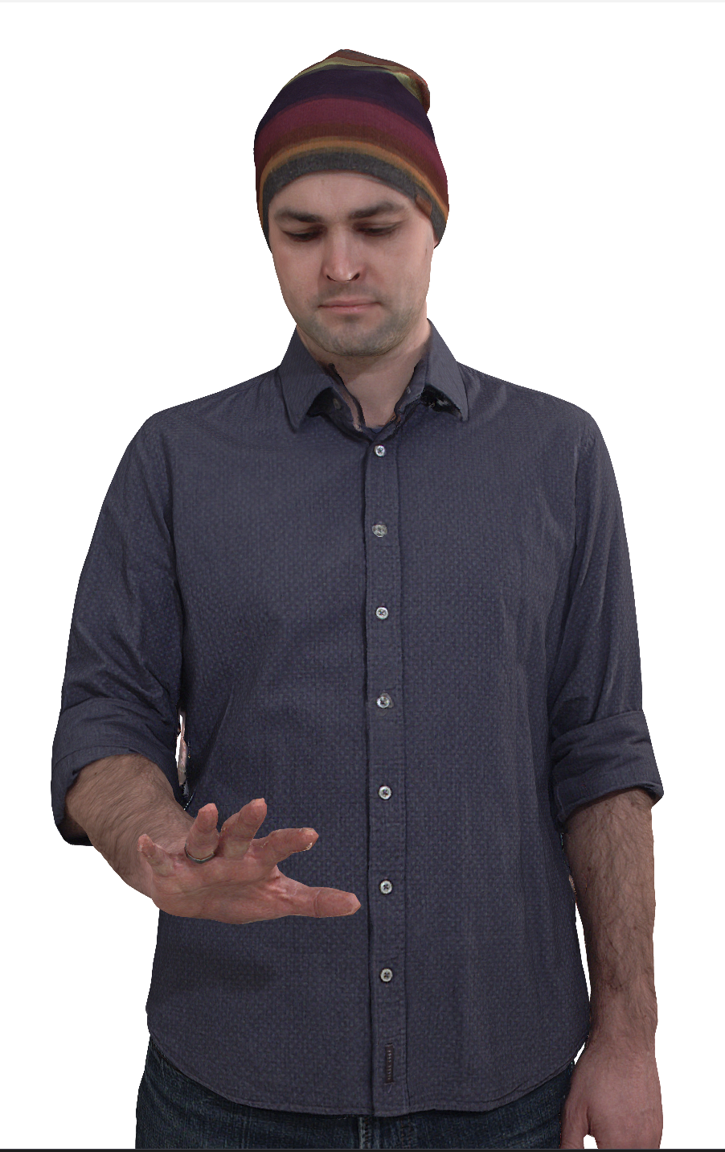
Figure Y2 Vox 12 with 9.5M points per frame (content courtesy by Volucap [R2])

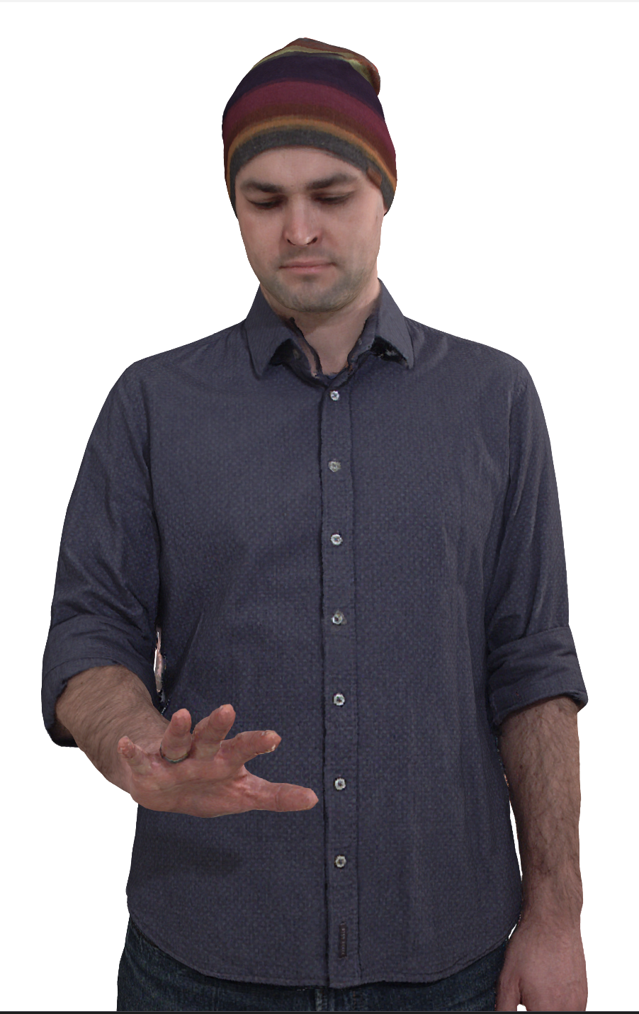
Figure Y3 Vox 11 with 2.3M points per frame (content courtesy by Volucap [R2])

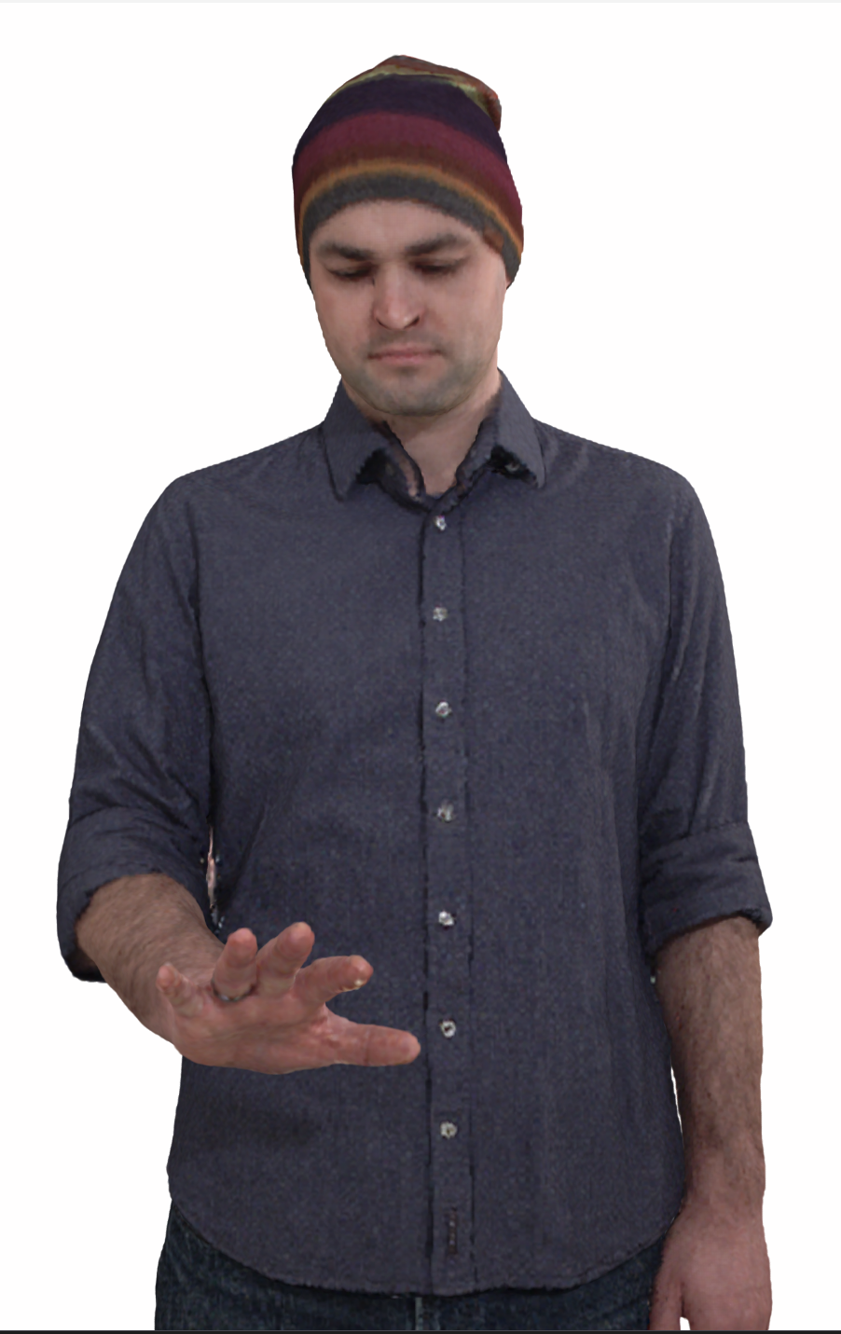
Figure Y4 Vox 10 with 600K points per frame (content courtesy by Volucap [R2])

7.3.4.5.2 Thomas near with representative renderer (cube mode) and neutral background
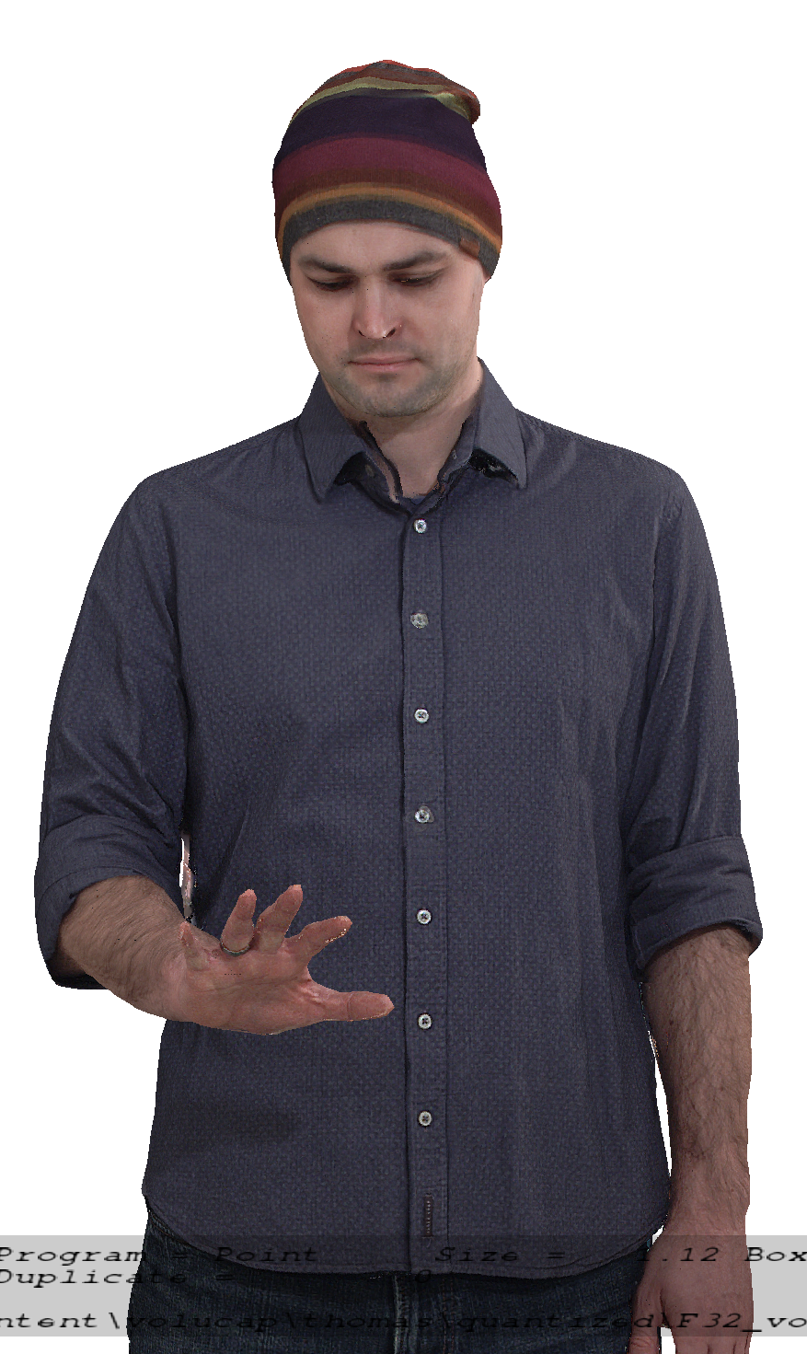
Figure Y5 Vox 12 with 9.5M points per frame (content courtesy by Volucap [R2])

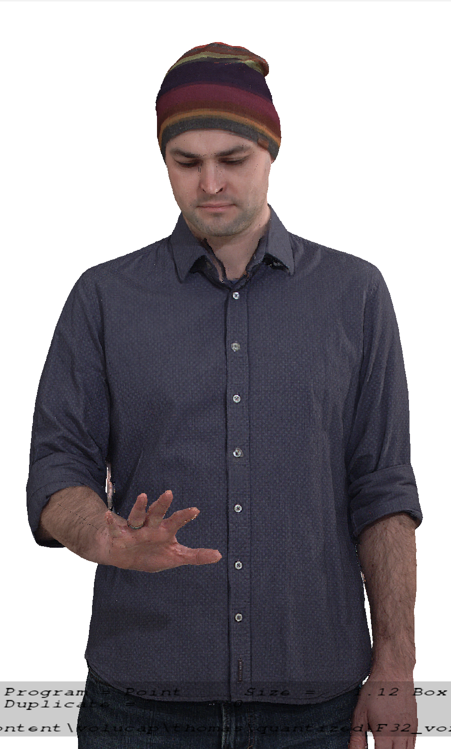
Figure Y6 Vox 11 with 2.3M points per frame (content courtesy by Volucap [R2])

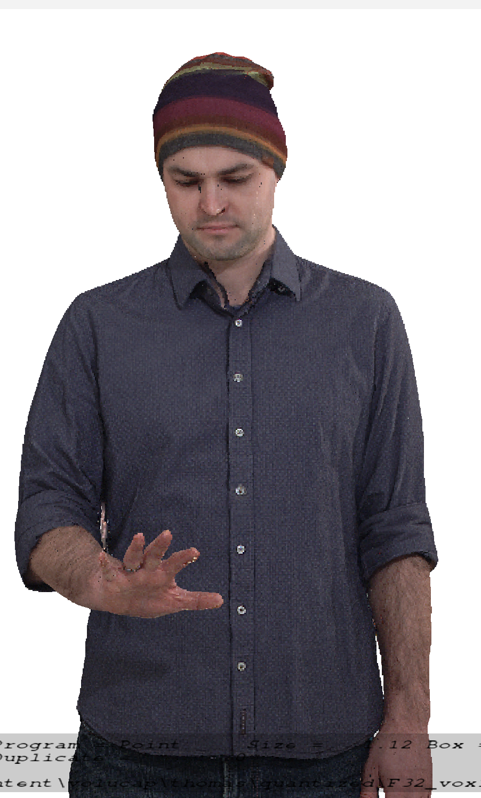
Figure Y7 Vox 10 with 600K points per frame (content courtesy by Volucap [R2])

7.3.5 Encoding and decoding constraints and settings
The following table provides an overview of encoding and decoding constraints for V-PCC with H.265/HEVC as codec for the Volumetric Video with single asset streaming scenario. Contribution aspects are not considered in this table.
Encoding and Decoding Constraints | V-PCC with H.265/HEVC
Relevant Codec and Codec Profile/Levels | H.265/HEVC Main 10 Profile  Level 4.1, 5.1  Metadata stream parsing
Random access frequency | 1 seconds
Bit rates and quality configuration | Fixed QP Geometry: [32;28;24;20;16]  Fixed QP Texture: [42;37;32;27;22]  bitrates [1;50 Mbps]
Bit rate parameters (CBR, VBR, CAE, HRD parameters) | Covering a range of relevant bitrates and qualities
Latency requirements and specific encoding settings | No specific latency requirement
Encoding complexity context | Cloud-based encoding, offline encoding
Required decoding capabilities | 3 decoder instantiations of H.265/HEVC Main 10 Profile  Level 4.1, 5.1 for (occupancy, geometry and color)  One synchronized metadata bitstream (Atlas)
Table X2 Encoding and decoding constraints

7.3.6 Performance Metrics and Requirements

7.3.6.1 Anchors
There is no specification in 3GPP that references a volumetric video anchor codec suitable for the streaming single asset scenario. MPEG V-PCC [R1] is the first codec supporting the dense dynamic point cloud representation format with inter coding and therefore no anchor codec can be selected.

7.3.6.2 Objective tests
Objective tests for dense dynamic point cloud codecs follow the principles as defined in TR 26.955, besides that there is no anchor:
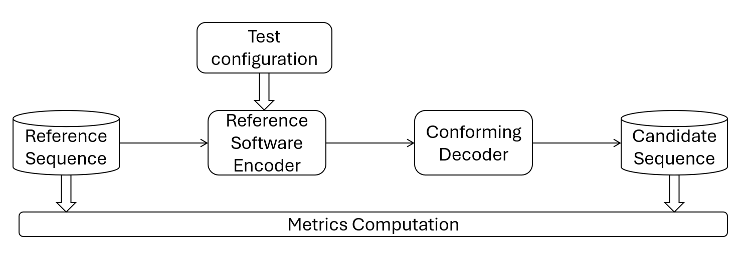
Figure fx Test architecture for objective test
MPEG WG7 specified an objective metric that allows to characterize point cloud codecs. This objective metric is described in in annex B of the Call for Proposals for Point Cloud Compression [R2]. MPEG WG7 used this “point-based” metric to develop codecs for point cloud compression. The “point-based” metric operates in 3D space and provides information on geometry and color distortion.
From 2D video objective testing it is known that a single objective metric is limiting, therefore “PCQM” [R3] is added as a second objective metric in addition to the “point-based” metric.
Both objective metrics, the “point-based” metric and PCQM will be reported for all rate points and for all reference test sequences.
To compute metrics, a patched version of mpeg-pcc-mmetric is provided for internal usage [R4]. The software will be provided and derived from the branch “bugfixes_gcc8.5_eqTFAN” with version v1.1.6. The metric software implements the “point-based” metric and the PCQM metric as described in section 7 of this scenario. A patch to enable computation of the Point2Plane metric is needed on top of this version. The metric software with patch will be provided.
Five rate points that cover a range from low quality to high quality for codecs to be characterized will be selected.
A spreadsheet will be provided to 3GPP SA4 that can be used to visualize the objective results.
Note that objective results obtained with the selected metrics can only be used for comparison with other point cloud codecs. There is no known objective metric that allows to compare different volumetric video codecs (e.g. dense point cloud against mesh) in a fair manner.

7.3.6.3 Subjective tests
Persons or objects in the “Streaming of professionally produced Volumetric Video with single asset containing people” scenario can be viewed from any angle and distances. To cope with this free viewpoint, MPEG WG7 developed a special procedure how to subjectively evaluate such volumetric sequences: The selected reference sequences are rendered with a point cloud renderer by following a pre-defined camera path into a 2D video. The procedure is done with the source reference sequence and with the codec/decoded reference sequence. Both 2D videos can then be evaluated with well-known 2D video evaluation methods.
The software tool that implements rendering of 2D videos from dense dynamic point clouds by following a camera path will be provided to 3GPP SA4 for internal usage.
This representative renderer [R5] used is derived from the mpeg-pcc-renderer where a new rendering mode has been added named “splat blend” mode. This mode draws a camera facing semitransparent splat of radius PointSize centered on the point position. The transparency (or alpha) varies with the distance from the center from fully opaque at the center to nearly transparent at the edge, to provide blending between points and reduce aliasing. In order to correctly use alpha blending, the points are sorted relative to the camera plane. Two blending modes are available, gaussian and linear, and the alpha falloff speed is customizable using the "pointFocus" setting.
This representative renderer supports two methods how to render voxels, one method is like cubes of a fixed size, the second method is splat blend. For objective compression performance tests against the source reference, the first method is recommended. For tests of the dense dynamic point cloud format against other volumetric representation formats such as mesh, the splat blend rendering is recommended as it fills holes between voxels. The representative renderer allows to activate a 3D background model or a neutral background. It also allows to activate a floor so that the test sequences look grounded. The Point Cloud Renderer will be provided to 3GPP SA4 for internal usage.
A characteristic camera path for each volumetric test sequence will be pre-defined to get a length of the output video as close as possible to 10s. A camera path that includes a full person view and a closer view at typical distance to the face is a good example.
The representative renderer produces uncompressed RGB 2D videos that can then be compressed with high bitrate HEVC. Resolution of the videos is 1080p, the frame rate and color space is aligned with the input point cloud.
The produced compressed 2D videos will be made available to SA4 members so that they can judge the quality and make up their mind on a codec to be characterized.
Videos rendered with splat blending can be used to compare sequences dense dynamic point format sequences with sequences in other volumetric video formats such as dynamic mesh.
There is no plan to engage an independent subjective test lab.

7.3.6.4 Correlation between the objective and subjective metrics
The objective metrics described in section 7.3.6.2 and the subjective comparison using the representative renderer in cube mode described in section 7.3.6.3 are used to evaluate coding distortions.
From MPEG there is no information available on the correlation between objective and subjective results and this may be investigated on a best effort basis.
A potential way of obtaining such correlation is described: the 4 licensed test sequences used in the MPEG subjective verification test report for V-PCC [R6] can be obtained from the rights holders, the test sequences can be prepared as used in the verification test and objective metrics described in section 7.3.6.2 can be generated. The objective results can then be compared with the subjective results from the verification test and the correlation can be analysed.

7.3.6.5 Verification and crosscheck
All produced bitstreams, metric results and produced videos shall be crosschecked by at least one other 3GPP SA4 member to ensure that results are correct.

7.3.7 Interoperability Considerations for the application
MPEG-DASH is used with ISO/IEC 23090-10 Carriage of visual volumetric video-based coding data – 1st edition.[R3]
RTP is not proposed for this scenario.

7.3.8 Test Sequences
Editor’s Note: The content of this scenario relates to moving persons.

7.3.8.1 Candidate source dense point cloud sequences
This section presents candidate raw dense point cloud sequences that are available for testing. Some sequences have been made freely available under license agreement and must be kept protected with a password when stored on a server. Some sequences are not free but can be openly purchased by those who need to work with the source sequences. Yet other sequences are freely and openly available for download by respecting the license.
XD Productions[X1] kindly made available some source sequences for internal usage under license. These source sequences cannot be publicly shared on the Internet and they were provided in the dense point cloud format.
- JuggleSoccer, 125 frames @ 25 fps
- Soccer02, 249 frames @ 30 fps
- Acrobat01, 449 frames @ 30 fps
- Acrobat02, 211 frames @ 30 fps
- Dancer01, 153 frames @ 30 fps
- Fakeswords, 250 frames @ 30 fps
Volucap [X2] kindly made available some sequences for internal usage under license. These source sequences cannot be publicly shared on the Internet. These source sequences were delivered in the dense point cloud format and mesh format.
- Thomas, 748 frames @ 25fps
- Mitch, 475 frames @ 25 fps
Renderpeople [X3] provides a free and publicly downloadable “4D People” source sequence under license. This source sequence is provided in file formats for 3ds Max, Maya, Blender, Cinema 4D and Alembic and can be stored or converted to mesh or dense point cloud format.
- DancingAliyah (RenderPeople), 1112 frames @ 30 fps
Renderpeople[X4] provides a catalogue of currently 130 “4D People” under license and the catalog is growing. These source sequences are provided in file formats for 3ds Max, Maya, Blender, Cinema 4D and Alembic and can be stored or converted to mesh or dense point cloud format. The quality is similar to the Renderpeople free sequence. Those who need to work with the source sequence such as the proponent and the crosscheckers need to purchase the sequence. These two sequences are selected from the catalogue:
- Nathalie Dancing 925 frames @ 30 fps
- Henry Stretching 733 frames @ 30 fps
Ultra Video Group of Tampere University [X5] kindly provides 12 sequences in the dense point cloud format @25 fps under license.
- BlueBackpack
- BlueSpin
- BlueSquat
- CasualSpin
- CasualSquat
- ElegantDance
- ElegantWave
- FlowerDance
- FlowerWave
- Gymnast
- HelloGoodbye
- ReadyForWinter

[7.3.8.2 Selected source dense point cloud sequences
This section lists 5 raw point cloud sequences that have been selected for objective and subjective testing. The following sequences have been selected for performing objective and subjective tests.
Test sequences have been selected based on visual quality and that these have not been used during codec development in MPEG. The following table lists the selected test sequences:
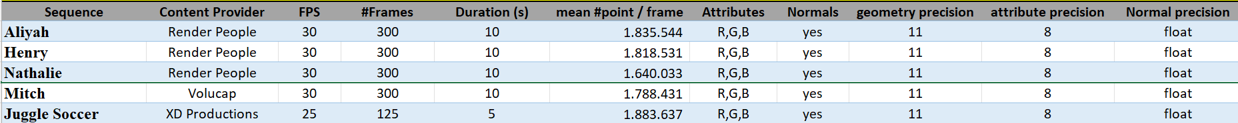
Table T1 Selected source point cloud sequences
The following thumbnails illustrate the selected test sequences:
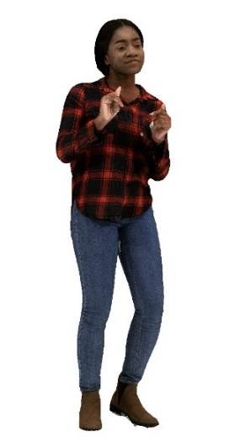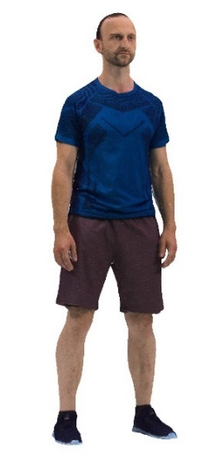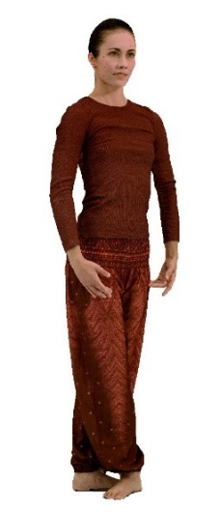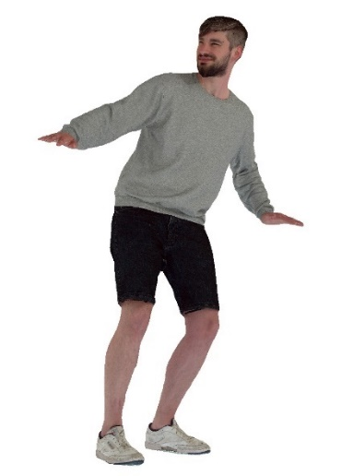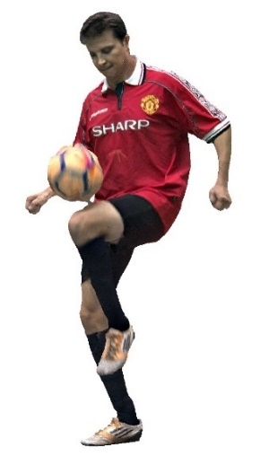
Figure F1 Aliya, Henry, Nathalie, Mitch and Joggle Soccer (content courtesy by Renderpeople, Volucap and XD Productions)
The selected licensed source point cloud sequences can be grouped as follows:
- Group 1 - Freely available to 3GPP members: Mitch and Joggle Soccer
- Group 2 - Publicly purchasable: Henry and Nathalie
- Group 3 - Publicly free available: Aliyah]

7.3.8.3 Metadata for source dense point cloud sequences

7.3.8.3.1 Overview
For a raw dense point cloud sequence used in the context of this Technical Report, the following metadata is proposed:
- Name of the sequence
- Scenario
- Sequence key as provided in TR 26.956
- URI to zip file containing PLY files (URL to weblink where the original sequence is available)
- Name Format of files
- Frame count
- Start frame number
- Frame rate
- Geometry precision
- Color format
- Peak Value (bounding box resolution e.g. 1023, 2047)
- Copyright statement
- Contact Person
Optionally, the following metadata can be added:
- Background
- TR26.956 reference
- Thumbnail preview
- Preview MP4
- Average point number per frame
- Duration
- MD5 of the zip file containing all point cloud frames
Size in bytes of the zip file containing all point cloud frames.
A JSON scheme is defined in clause 2.2 for this matter. An example is provided in clause 2.3

7.3.8.3.2 JSON Scheme
JSON schema for the raw format is attached to the zip file:
{
"$schema": "http://json-schema.org/draft-07/schema",
"$id": "https://dash-large-files.akamaized.net/WAVE/3GPP/Beyond2D/ReferenceSequences/B2DPC-schema.json",
"type": "object",
"title": "The root schema",
"description": "Schema for beyond 2D point cloud sequences.",
"default": {},
"required": [
"Sequence",
"Properties",
"CopyRight",
"Contact"
],
"properties": {
"Sequence": {
"$id": "#/properties/Sequence",
"type": "object",
"title": "Schema for the Sequence",
"description": "Includes all information about the sequence",
"default": {},
"required": [
"Name",
"Scenario",
"Key"
],
"properties": {
"Name": {
"$id": "#/properties/Sequence/properties/Name",
"type": "string",
"title": "The Name schema",
"description": "Provides a unique name of the sequence."
},
"Background": {
"$id": "#/properties/Sequence/properties/Background",
"type": "string",
"title": "The Background schema",
"description": "Provides a background information on the sequence."
},
"Scenario": {
"$id": "#/properties/Sequence/properties/Scenario",
"type": "string",
"title": "The Scenario schema",
"description": "Provides information to which Scenario this sequence relates."
},
"Key": {
"$id": "#/properties/Sequence/properties/Key",
"type": "string",
"title": "The Key schema",
"description": "Provides the key used in TR 26.956.",
"examples": [
"S41"
]
},
"TR26.956": {
"$id": "#/properties/Sequence/properties/TR26.956",
"type": "string",
"title": "The TR26.956 schema",
"description": "Provides the reference to TR26.956 used.",
"examples": [
"S41"
]
}
},
"additionalProperties": true
},
"Properties": {
"$id": "#/properties/Properties",
"type": "object",
"title": "The Properties schema",
"description": "the properties of the raw video.",
"required": [
"URI",
"NameFormat",
"frameCount",
"startFrame",
"frameRate",
"geometryPrecision",
"colorformat",
"peak"
],
"properties": {
"URI": {
"$id": "#/properties/Properties/properties/URI",
"type": "string",
"title": "The URI schema",
"description": "Provides a reference/URL to the sequence point cloud data."
},
"thumbnail": {
"$id": "#/properties/Properties/properties/thumbnail",
"type": "string",
"title": "The thumbnail schema",
"description": "Provides a reference/URL to a typical frame of the video."
},
"preview": {
"$id": "#/properties/Properties/properties/preview",
"type": "string",
"title": "The preview schema",
"description": "Provides a reference/URL to an mp4 encoded video."
},
"NameFormat": {
"$id": "#/properties/Properties/properties/NameFormat",
"type": "string",
"title": "The NameFormat schema",
"description": "Provides a name of the sequence to which a frame index is added.",
"examples": [
"exemple%04d.ply"
]
},
"frameCount": {
"$id": "#/properties/Properties/properties/frameCount",
"type": "integer",
"title": "The frameCount schema",
"description": "The number of point cloud frames in the sequence.",
"examples": [
327
]
},
"startFrame": {
"$id": "#/properties/Properties/properties/startFrame",
"type": "integer",
"title": "The startFrame schema",
"description": "The first frame in the sequence that is to be used starting from 1.",
"default": 1,
"examples": [
1
]
},
"frameRate": {
"$id": "#/properties/Properties/properties/frameRate",
"type": "integer",
"title": "The frameRate schema",
"description": "Framerate of the video.",
"examples": [
30
]
},
"pointsCountMean": {
"$id": "#/properties/Properties/properties/pointsCountMean",
"type": "integer",
"title": "The average of points number per frame schema",
"description": "The average point number per frame.",
"examples": [
857241
]
},
"geometryPrecision": {
"$id": "#/properties/Properties/properties/geometryPrecision",
"type": "integer",
"title": "The geometry procision schema",
"description": "geometry precision in bits of the point cloud sequence.",
"default": "10",
"examples": [
10
]
},
"colorformat": {
"$id": "#/properties/Properties/properties/colorformat",
"type": "string",
"title": "The colorformat schema",
"description": "Format of texture attribute",
"default": "rgb",
"enum": [
"rgb",
"yuv"
],
"examples": [
"rgb"
]
},
"peak": {
"$id": "#/properties/Properties/properties/peak",
"type": "integer",
"title": "The peak schema",
"description": "peak of the point cloud sequence.",
"default": "1023",
"enum": [
1023,
2047
],
"examples": [
1023
]
},
"duration": {
"$id": "#/properties/Properties/properties/duration",
"type": "number",
"title": "The duration schema",
"description": "Duration of the sequence in seconds.",
"examples": [
5.46
]
},
"md5": {
"$id": "#/properties/Properties/properties/md5",
"type": "string",
"title": "The md5 string",
"items": {
"description": "md5 of the zip files containing all point cloud frames.",
"type": "string",
"examples": [
"d055a94f35f7594776186fc5d09a9fa4"
]
}
},
"size": {
"$id": "#/properties/Properties/properties/size",
"type": "integer",
"title": "The size integer",
"items": {
"description": "Size in bytes of the zip file containing all point cloud frames.",
"type": "integer",
"examples": [
149190147
]
}
}
},
"additionalProperties": true
},
"CopyRight": {
"$id": "#/properties/CopyRight",
"type": "string",
"title": "The CopyRight schema",
"description": "Copyright statement."
},
"Contact": {
"$id": "#/properties/Contact",
"type": "object",
"title": "The Contact schema",
"description": "A contact for the sequence.",
"required": [
"Name"
],
"properties": {
"Name": {
"$id": "#/properties/Contact/properties/Name",
"type": "string",
"title": "The Name schema",
"description": "The name of a person."
},
"Company": {
"$id": "#/properties/Contact/properties/Company",
"type": "string",
"title": "The Company schema",
"description": "Company."
},
"e-mail": {
"$id": "#/properties/Contact/properties/e-mail",
"type": "string",
"title": "The e-mail schema",
"description": "e-mail or web page link."
},
"generation": {
"$id": "#/properties/Contact/properties/generation",
"type": "string",
"title": "The generation schema",
"description": "Information on how the data was generated"
}
},
"additionalProperties": true
}
},
"additionalProperties": true
}

7.3.8.3.3 Example
An example is attached to the zip file:
{
"Sequence": {
"Name": "Exemple",
"Background": "This is a B2DV format example",
"Scenario": "Streaming of Beyond 2D Produced VoD Content",
"Key": "S01",
"TR26.956": "Annex X.Y.Z"
},
"Properties": {
"URI": "https://dash-large-files.akamaized.net/WAVE/3GPP/Beyond2D/ReferenceSequences/file.zip",
"thumbnail": "https://dash-large-files.akamaized.net/WAVE/3GPP/Beyond2D/ReferenceSequences/file.png",
"preview": "https://dash-large-files.akamaized.net/WAVE/3GPP/Beyond2D/ReferenceSequences/file.mp4",
"NameFormat": "exemple%04d.ply",
"frameCount": 320,
"startFrame": 0,
"frameRate": 30,
"pointsCountMean": 1000000,
"geometryPrecision": 10,
"colorformat": "rgb",
"peak": 2047,
"duration": 10.0,
"md5": "d055a94f35f7594776186fc5d09a9fa4",
"size": 11510343938
},
"CopyRight": "Conditions that are suitable for this study",
"Contact": {
"Name": "Celine Guede",
"Company": "InterDigital",
"e-mail": "celine.guede@interdigital.com",
"generation": "provided by contact"
}
}

7.3.9 Detailed test conditions

7.3.9.1 V-PCC test model and configuration files
The public version of the MPEG V-PCC test model named tmc2 in release R24.0 master branch is used to encode and decode dense dynamic point clouds [R1].
Editor’s note: Configuration files to be validated
For using tmc2 in Random Access (RA) mode, MPEG provides a configuration file [R2].
For each selected test sequence, a configuration file containing information needed for tmc2 configuration will be provided.

7.3.9.2 Rate points and test conditions
In line with the V-PCC verification test [R3], 5 rate points R1 to R5 for Random Access (RA) will be used for each test sequence. Rates are obtained with the following V-PCC codec parameters:
 | R1 | R2 | R3 | R4 | R5
QP geometry | 32 | 28 | 24 | 20 | 16
QP Texture | 42 | 37 | 32 | 27 | 22
Occupancy Precision | 4 | 4 | 4 | 4 | 2

Editor’s note: Configuration files to be validated
For using this rate configuration, MPEG provides configuration files for each rate [R4].

7.3.9.3 Profiles
In line with the V-PCC verification test [R3], the following profiles are evaluated:
- Basic which corresponds to V-PCC profile HEVC Main10 V-PCC Basic Rec0. This profile uses the basic V-PCC toolset and a simple reconstruction of points in 3D space.
- Enhanced which corresponds to V-PCC profile HEVC Main10 V-PCC Basic Rec2. This profile uses the basic V-PCC toolset and a more sophisticated reconstruction of points in 3D space.
- High which corresponds to V-PCC profile HEVC Main10 V-PCC Extended Rec2. This profile uses the extended V-PCC toolset and a more sophisticated reconstruction of points in 3D space.

7.3.9.4 Bitstream Generation, output
The MPEG V-PCC test model will be used to encode and decode test sequences as described previously [R1].
To compute metrics, a patched version of mpeg-pcc-mmetric is provided for internal usage [R5]. The software will be provided and derived from the branch “bugfixes_gcc8.5_eqTFAN” with version v1.1.6. The metric software implements the “point-based” metric and the PCQM metric as described in section 7 of this scenario. A patch to enable computation of the Point2Plane metric is needed on top of this version. The metric software with patch will be provided.
Python scripts will be provided to be able to:
- Encode each sequence for each condition, rate and profile
- Decode the corresponding sequence
- Compute metrics
- Generate tables and graphs
Below are examples of command lines for the basic profile for a vox11 sequence:
- to encode a test sequence:
mpeg-pcc-tmc2/bin/PccAppEncoder \
--config=mpeg-pcc-tmc2/cfg/common/ctc-common.cfg \
--config=mpeg-pcc-tmc2/cfg/condition/ctc-random-access.cfg \
--config=mpeg-pcc-tmc2/cfg/sequence/${test_sequence}.cfg \
--config=mpeg-pcc-tmc2/cfg/rate/ctc-r1.cfg \
--configurationFolder=mpeg-pcc-tmc2/cfg/ \
--uncompressedDataFolder=${source_sequence}/ \
--compressedStreamPath=${test_sequence}.bin \
--normalDataPath=${source_sequence}/${source_sequence}_%04d.ply \
--frameCount=32 \
--resolution=2047 \
--mapCountMinus1=0 \
--profileToolsetIdc=0 \
--profileReconstructionIdc=0

- to decode a test sequence:
mpeg-pcc-tmc2/bin/PccAppDecoder \
--startFrameNumber=0 \
--compressedStreamPath=${test_sequence}.bin \
--reconstructedDataPath=${test_sequence}_dec_%04d.ply \
--inverseColorSpaceConversionConfig=mpeg-pcc-tmc2/cfg/hdrconvert/yuv420toyuv444_16bit.cfg

- to compute metrics of a test sequence:
mpeg-pcc-mmetric/build/Release/bin/mm sequence \
--firstFrame 0 \
--lastFrame 31 END \
compare --mode pcc \
--inputModelA source_sequence_%04d.ply \
--inputModelB test_sequence_dec_%04d.ply END \
compare --mode pcqm \
--inputModelA source_sequence_%04d.ply \
--inputModelB test_sequence_dec_%04d.ply

For each test, outputs are:
- Bitstream file
- Log files containing metrics information
- Encoder log output
- Decoder log output
- Metric log output
A CSV file containing concatenated metrics information for each condition and one profile is generated for all sequences and rates.
The following information will be stored:
- SeqId: identifier of the sequence
- CondId: tested condition (RA)
- RateId: tested rate number [R1..R5]
- nbFrame: number of tested frames
- NbInputPoints: number of points in the source sequence
- NbOutputPoints: number of points in the candidate test sequence
- MeanOutputPoints: mean number of points in the candidate test sequence
- MeanDuplicatePoints: mean number of duplicated points (with same geometry) in the candidate test sequence
- TotalBitstreamBits: size of the bistream in bits
- geometryBits: size of the geometry stream in bits
- metadataBits: size of the metadata stream in bits
- attributeBits: size of the attribute stream in bits
- D1Mean: mseF,PSNR (p2point)
- D2Mean: mseF,PSNR (p2plane)
- LumaMean: c[0],PSNRF
- CbMean: c[1],PSNRF
- CrMean: c[2],PSNRF
- PCQM: PCQM PSNR
- SelfEncoderRuntime: encoder time for current process
- ChildEncoderRuntime: encoder time for child processes
- SelfDecoderRuntime: decoder time for current process
- ChildDecoderRuntime: decoder time for child processes
From this CSV file, an excel spreadsheet is generated to get tables and graphs for interpretation of the results.

7.3.9.5 Videos Generation for subjective tests
The representative renderer [R6] used is derived from the mpeg-pcc-renderer where a new rendering mode has been added named “splat blend” mode. This mode draws a camera facing semitransparent splat of radius PointSize centered on the point position. The transparency (or alpha) varies with the distance from the center from fully opaque at the center to nearly transparent at the edge, to provide blending between points and reduce aliasing. In order to correctly use alpha blending, the points are sorted relative to the camera plane. Two blending modes are available, gaussian and linear, and the alpha falloff speed is customizable using the "pointFocus" setting.
To avoid interference between the background and the test material, a neutral background with a color will be selected. A floor makes the rendered scene more realistic by preventing interference with the test material.
The representative renderer software will be provided. A script will be provided to generate videos with chosen camera path.
For each sequence, a video is generated. A camera path and blend parameter options adapted to each sequence is provided [R8]. The output of this video generation with a camera path is stored as high-quality video sequence of a length as close as possible to 10s.
The generation is done into two steps: first the generation of the RBG raw file with the camera path and then the conversion into YUV or MP4 files.
Here is an example of the two command lines:
1-To generate a RGB raw file with a specific camera path
./PccAppRenderer.exe -d ${test_sequence}\
-i 1 \
-n 32 \
--play=1 \
--playBackward=1 \
--height=1080 --width=1920 \
--type=3 --alphaFalloff=6 --size=3.2 --blendMode=0 \
--floor=1 --overlay=0 \
--camera=${camera_path}.txt
--RgbFile=${test_sequence_rgb}

- 2-To convert the RGB file to x265 lossless mp4 file
./scripts/convert_video.sh \
-o ${test_sequence}_x265lossless.mp4 \
--videoType=2
--ffmpeg=ffmpeg.exe
-i ${test_sequence_rgb}.rgb

The video sequences are generated with the following video parameters:
- Video resolution: progressive uncompressed full-range HD format (1920x1080). Note that upsampling by the TV set should be avoided
- Frame rate: The frame rate will be aligned with the frame rate in the test data set
- Color space: ITU-R BT.709
- Sub-sampling: 4:2:0 YUV 10 bits or x265 fast preset lossless

7.3.9.6 Verification / crosschecks
All produced bitstreams, metric results and produced videos will be crosschecked by at least one other SA member to ensure that results are correct.

7.3.10 External Performance data
The subjective verification test report for V-PCC can be downloaded from the public MPEG website [R3]
The Brazilian SBTVD Forum performed objective tests with V-PCC. Full results are available in chapter 6.10 (Candidate Technology I), 6.10.3.2 and 6.10.4 of the following document [R9]

7.3.11 Additional information
Sequences can be decoded and visualized in real time using a 3D background or in Augmented Reality on a smartphone, tablet, head-mounted display using DASH streaming mode or local file system.
Nokia’s real-time V-PCC decoder implementation that was released as open source: https://github.com/nokiatech/vpcc
A simple scene description could be added to enable the placement of the asset in the scene (position, orientation, scale…) but is outside the scope of this document, which is focused on the format and codec evaluation.

7.4 Scenario 3: <tbd>

7.x Scenario x: <tbd>

8 Common Evaluation Features
Editor’s note: Documents common metrics, software, etc..

9 Evaluation of Selected Scenarios
Editor’s note: This clause defines test conditions and parameters, KPIs, Metrics, test sequences, agreed reference signals per scenario.

9.1 Introduction
Editor’s note: Identifies the preferred scenarios

9.2 Scenario 1: <tbd>

9.2.1 Evaluation Overview
Editor’s note: Based on scenario in clause 6, summarizes the source formats parameters used for evaluation, the encoding and decoding constraints, interoperability considerations and the general idea of the performance metrics.

9.2.2 Reference Sequences

9.2.3 Performance Metrics

9.2.4 Candidate Solutions

9.2.4.1 Solution 1: <Name>

9.2.4.1.1 Introduction

9.2.4.1.2 Reference Software

9.2.4.1.3 Parameter Settings

9.2.4.1.4 Distribution

9.2.4.1.5 Evaluation Results

9.2.4.1.6 Network Requirements
Editor’s note: Documents required bitrates as well as possibly other aspects.

9.2.4.2 Solution 2: <Name>

9.2.4.2.1 Introduction

9.2.4.2.2 Reference Software

9.2.4.2.3 Parameter Settings

8.2.4.2.4 Distribution

9.2.4.2.5 Evaluation Results

9.2.4.2.6 Network Requirements

9.2.5 Summary of Evaluation

9.3 Scenario 2: <tbd>

9.4 Scenario x: <tbd>

10 Gaps and Optimization Potential

10.1 Identified Gaps and Deficiencies with Video Capabilities

10.2 Potential Requirements for New Video Capabilities

10.3 Potential Network Optimizations

11 Conclusions and Proposed Next Steps
Editor’s note: This clause provides conclusion and potential areas for normative work as the next phase.

Annex A: Scenario Template

A.1 Introduction
This annex provides a proposed template to introduce a Scenario for Beyond 2D Video. This template has been used to collect the scenarios in this report. The text in blue corresponds to guidelines on the information to be provided with a scenario proposal.

A.2 Template
The following aspects are considered for a scenario:
- Scenario name
- Motivation for the scenario
What is the market relevance of the proposed scenario within the next few years? Are there any commercially available or pre-released products or prototypes?
Market relevance key indicators:
- Technology evaluation on the market
Are there indications of pre-evaluation by service providers, device manufacturers, and/or network operators?

- Industry activities
Is there relevant work in 3GPP MRPs, industry collaborations or among market stakeholders?
- Production tools/companies
What is the availability of capturing setups, and production software? Are there endorsed formats for representation, contribution, compression, and storage? Is there an ecosystem of content creators?

- Delivery solutions
Which delivery type is expected to be used? What are the expected transport formats? Is there SW or HW support and providers?

- Content decoding and rendering
Is there decoding SW/HW support, and providers? Are there rendering devices and displays available yet?

- Description of the scenario
This provides a description of beyond 2D video end-to-end workflows, which includes identifying and defining beyond 2D formats being used in the context and representation technologies to delivery these formats. The following aspects may be considered for each workflow:
- Capturing and processing
- Encoding
- Packaging and delivery
- Decoding
- *Post-processing
- Rendering
- General constraints on latency, bandwidth, reliability and complexity
- Supporting companies and 3GPP members
- This documents the 3GPP members that support this scenario in terms of providing the information, test material, test requirements and the characterization for the tests. For each of the identified necessities, a tick box is created in the template.
- Preferably several 3GPP members are included in the support, and in addition a video service provider may be included (not necessarily a 3GPP member).
- Cross-verification is preferably done by the supporters of the scenario.
- Source format properties
This defines a clear range of the considered and relevant source formats, including the signal properties, but also the characteristics of the content. As an example, the texture and depth format properties of the source may be used which include:
- Spatial resolutions
- Chroma Format
- Chroma Subsampling
- Aspect ratios
- Frame rates
- Colour space formats
- Transfer Characteristics
- Bit depth
- Viewpoints
- Other signal properties
- Encoding and decoding constraints and settings
Typical encoding constraints and settings such as:
  - Relevant Codec and Codec Profile/Levels according to 3GPP TS (e.g., TS 26.119),
  - Random access frequency
  - Error resiliency requirements
  - Bitrates and quality requirements
  - Bitrate parameters (CBR, VBR, CAE, HRD parameters)
  - ABR encoding requirements (switching frequency, etc.)
  - Latency requirements and specific encoding settings
  - Encoding context: real-time encoding, on device encoding, cloud-based encoding, offline encoding, etc.
  - Required decoding capabilities
  - Synchronization requirements
- Performance Metrics and Requirements
- A clear definition on how the performance needs to be evaluated including metrics, etc addressing the main KPIs of the scenario.
- Objective measures such as PSNR, VMAF, etc, may be used
- Justification on whether objective metrics are sufficient and representative of the subjective performance.
- Interoperability Considerations for the application
- Streaming with DASH/HLS/CMAF/QUIC
- RTP based delivery
- Test Sequences
A set of selected test sequences that are provided by the proponents in order to do the evaluation. They should cover a set of source format properties
- Detailed test conditions
Provides a proposal for detailed test conditions, for example based on a reference software together with the sequences and configuration parameters.
- External Performance data
References to external performance data that can be added, for example other SDOs, public documents and so on.
- Additional Information
- Industry activities
Is there Relevant work in industry forums?
- Implementation constraints
Are there any indications about scalability of the technology with regards to network and devices?
- Innovation
Does the technology address a current or a future need on the market? Can it potentially disrupt existing markets?

Annex B: Data Formats and Metrics

B.1 Introduction
<TBD>

B.2 Raw Video Sequences

B.2.1 Overview
<TBD>

B.2.2 JSON Schema
JSON schema for the raw format is here
< https://dash-large-files.akamaized.net/WAVE/3GPP/Beyond2D/ReferenceSequence/raw-schema.json>
- {
- "Sequence": {
- "Name": "Example",
- "Background": "This is a B2DV format example",
- "Scenario": "On-demand",
- "Key": "Identifier",
- "TR26.956": "Annex X.Y.Z"
- },
- "Views": [
- {
- "ViewId": "v0",
- "Extrinsics": {
- "orientation": {
- "qw": 0.9999915361,
- "qx": 0.0024327517,
- "qy": 0.0024349121,
- "qz": -0.0022688841
- },
- "position": [
- -0.0006123598,
- 0.3035059273,
- 0.0012498678
- ]
- },
- "Intrinsics": {
- "focalLength": 1002.349976,
- "principalPoint": {
- "horizontalNorm": 960.0,
- "vertical": 540.0
- }
- },
- "ProjectionPlaneSize": {
- "columnCount": 1920,
- "rowCount": 1080
- },
- "Quantization": {
- "highNormDisp": 2.000000,
- "lowNormDisp": 0.200000
- },
- "Components": [
- {
- "ComponentId": "texture",
- "Data": {
- "URI": "https://dash-large-files.akamaized.net/WAVE/3GPP/some/url/file.yuv",
- "md5": "e537665c18e32bbaf8e5e9d63e18dd2c",
- "thumbnail": "https://dash-large-files.akamaized.net/WAVE/3GPP/some/url/file.png",
- "preview": "https://dash-large-files.akamaized.net/WAVE/3GPP/some/url/file.mp4",
- "size": 7962624000,
- "md5-10": "1c3550197120f95502c4add38d7ebd33"
- },
- "Properties": {
- "width": 1920,
- "height": 1080,
- "format": "yuv",
- "packing": "planar",
- "scan": "progressive",
- "subsampling": "420",
- "bitDepth": 8,
- "frameRate": 30,
- "colourPrimaries": "1",
- "transferCharacteristics": "1",
- "matrixCoefficients": "1",
- "sampleAspectRatio": "1",
- "duration": 10,
- "frameCount": 600,
- "startFrame": 1,
- "videoFullRangeFlag": "0",
- "chromaSampleLocType": "0"
- }
- },
- {
- "ComponentId": "depth",
- "Data": {
- "URI": "https://dash-large-files.akamaized.net/WAVE/3GPP/some/url/file.yuv",
- "md5": "e537665c18e32bbaf8e5e9d63e18dd2c",
- "thumbnail": "https://dash-large-files.akamaized.net/WAVE/3GPP/some/url/file.png",
- "preview": "https://dash-large-files.akamaized.net/WAVE/3GPP/some/url/file.mp4",
- "size": 7962624000,
- "md5-10": "1c3550197120f95502c4add38d7ebd33"
- },
- "Properties": {
- "width": 1920,
- "height": 1080,
- "format": "yuv",
- "packing": "planar",
- "scan": "progressive",
- "subsampling": "420",
- "bitDepth": 16,
- "frameRate": 30,
- "colourPrimaries": "2",
- "transferCharacteristics": "8",
- "matrixCoefficients": "0",
- "sampleAspectRatio": "1",
- "duration": 10,
- "frameCount": 600,
- "startFrame": 1,
- "videoFullRangeFlag": "1",
- "chromaSampleLocType": "0"
- }
- }
- ]
- }
- ],
- "copyRight": "Conditions that are suitable for this study",
- "Contact": {
- "Name": "Bart Kroon",
- "Company": "Philips",
- "e-mail": "bart.kroon@philips.com",
- "generation": "provided by contact"
- }
- }

Annex C: Reference Sequences

C.1 Introduction
This annex provides a summary of candidate reference sequences that where discussed to be potentially suitable for one or multiple of the scenarios introduced in clause 6 of this Technical Report. For each candidate reference sequence, at least the following information is provided.
- A summary of the sequence characteristics
- A screenshot of the sequence
- Source sequence properties
- Information where the source sequence is hosted
- Copyright and license information
The content is provided in JSON files here: https://dash-large-files.akamaized.net/WAVE/3GPP/Beyond2D/ReferenceSequence. The format of the reference sequences follows the proposed format in Annex B.2.
The sequences are summarized here: https://dash-large-files.akamaized.net/WAVE/3GPP/Beyond2D/ReferenceSequences/sequences.csv.

Annex <X> (informative):
Change history

Change history
Date | Meeting | TDoc | CR | Rev | Cat | Subject/Comment | New version
2024-04 | SA4#127-bis | S4-240825 |  |  |  | Initial Version | 0.0.1
2024-05 | SA4#128 | S4-240947 |  |  |  | Updated version based on SA4-post 127-bis, 24,May,2024 | 0.0.2
2024-05 | SA4#128 | S4-241319 |  |  |  | Update style and include agreed content in S4-241266, S4-241336 and S4-241318 | 0.0.3
2024-08 | SA4#129-e | S4-241491 |  |  |  | Updated version based on agreed Tdoc S4aV240023, S4aV240040  In SA4-post 128 meeting. | 0.0.4
2024-08 | SA4#129-e | S4-241721 |  |  |  | Updated version based on agreed Tdoc S4-241708, S4-241709 and S4-241710 during SA4#129-e meeting. | 0.1.0
2024-11 | SA4#130 | S4-241867 |  |  |  | Updated version based on agreed Tdoc S4aV240062 during SA4-post 129-e meeting. | 0.1.1
2024-11 | SA4#130 | S4-242196 |  |  |  | Updated version based on agreed Tdoc S4-241997, S4-242000, S4-241871,S4-242098, S4-242199, S4-242226, S4-242227, S4-242193 during SA4 130 meeting. | 0.2.0

