**3GPP TSG-SA WG4 Meeting #130S4-241942**

**USA, Orlando, 18 – 22 November 2024**

**Source: ZTE Corporation**

**Title: [FS_Beyond2D]pCR on PCC codec tools**

**Spec: 3GPP TR 26.956 v0.1.1**

**Agenda item: 9.8**

**Document for: Decision**

**1. Introduction**

This contribution propose to include new codec tool for Dense Dynamic Point Cloud representation format.

**2. Reason for Change**

In the TR 26.956 document, Section 4.3.3 introduced the representation formats for Dense Dynamic Point Clouds. Furthermore, Section 4.3.3.4.3 specifies three codec tools suitable for point clouds: MPEG V-PCC, MPEG G-PCC, and Draco.

To ensure a comprehensive summary, we propose considering the inclusion of AVS PCC, thereby broadening the range of codec tools under review.

**2.1 What is AVS PCC**

AVS PCC, which stands for Audio Video Coding Standard (AVS) Point Cloud Compression, is a set of standards developed by the AVS Working Group specifically for the compression of 3D point cloud data.

The AVS Working Group was established in June 2002 in order to develop standards for the compression, decompression, processing, and representation of digital audio and video technologies. The group's work outcomes are reviewed and approved to be published as industry or national standards in China.

The AVS PCC standard is part of the AVS suite, focusing on the efficient compression of 3D point cloud data, which has broad applications across industries such as autonomous driving, immersive media, metaverse, and cultural heritage protection.

In October 2024, the AVS Working Group released the final committee draft of AVS PCC.

**2.2 How is AVS PCC**

The coding performance of AVS PCC compared to Draco-v1.3.5 under different test conditions is listed below with Cat1B and Cat3 correspond to dense dynamic point cloud.

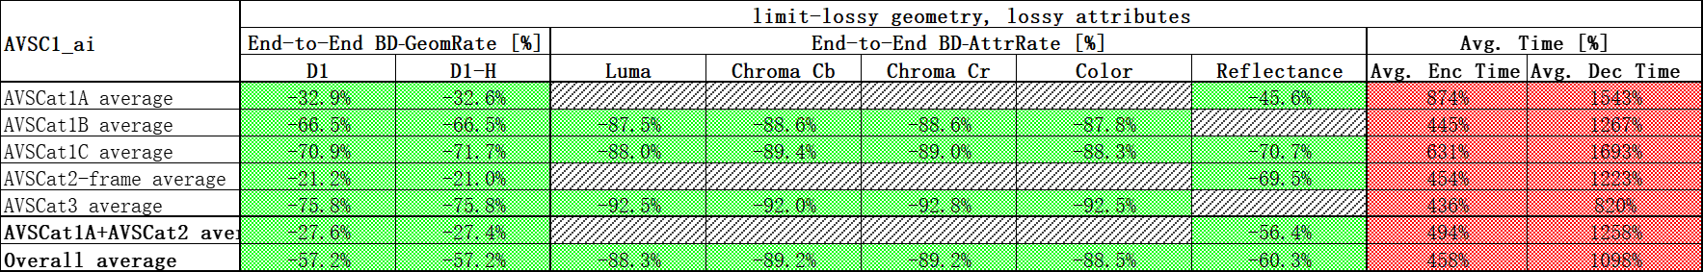

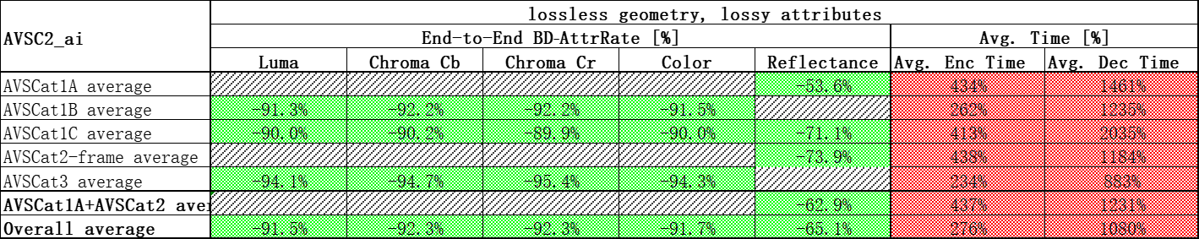

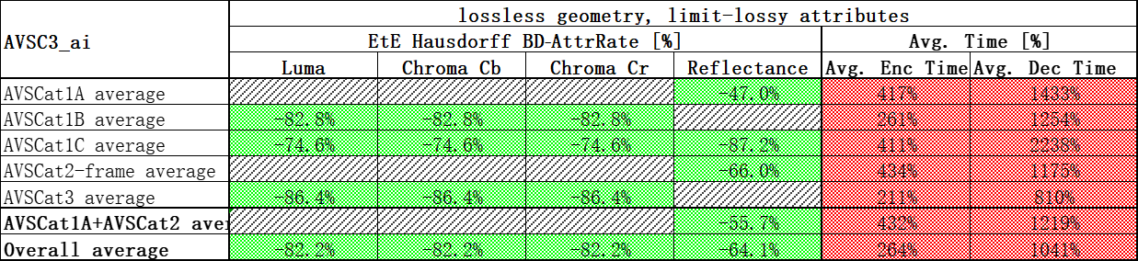

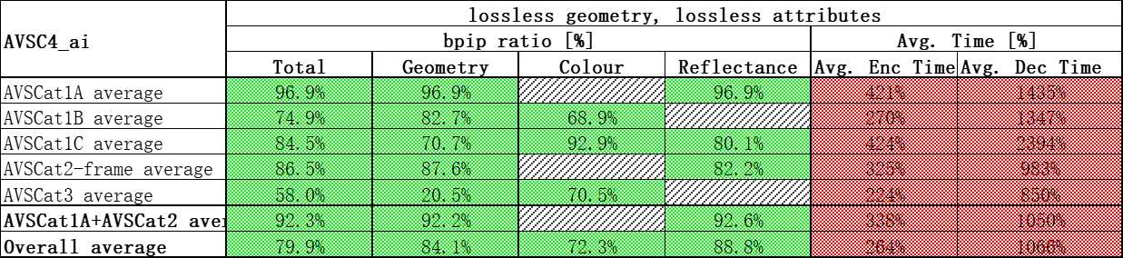

**3. Proposal**

It is proposed to agree the following changes to 3GPP TR 26.956 v0.1.1.

* * * First Change * * * *

# 2 References

The following documents contain provisions which, through reference in this text, constitute provisions of the present document.

- References are either specific (identified by date of publication, edition number, version number, etc.) or non‑specific.

- For a specific reference, subsequent revisions do not apply.

- For a non-specific reference, the latest version applies. In the case of a reference to a 3GPP document (including a GSM document), a non-specific reference implicitly refers to the latest version of that document *in the same Release as the present document*.

[1] 3GPP TR 21.905: "Vocabulary for 3GPP Specifications".

... ....

[D1] Greg Turk, The Polygon File Format, Stanford University, 1994.

[D2] Volumetric Format Association VFA, <https://www.volumetricformat.org/>

[D3] V-PCC, Visual volumetric video-based coding (V3C) and video-based point cloud compression (V-PCC), ISO/IEC 23090-5 2nd Ed, Nov 2023.

[D4] G-PCC, Geometry-based point cloud compression, ISO/IEC 23090-9, Mar 2023

[D5] Draco Bitstream Specification, <https://google.github.io/draco/spec/>

[D6] T/AI 128.2-2024: Information Technology Space-Time Graphical Data Coding Part 2: Point Cloud

* * * Second Change * * * *

#### 4.3.3.4.3 Known compression technology

Visual volumetric video-based coding (V3C) and video-based point cloud compression (V-PCC) [D3]

Geometry-based point cloud compression (G-PCC) [D4]

Draco [D5]

AVS PCC [D6]