3GPP TSG-SA WG4 Meeting #128 S4-241015

South Korea, Jeju, 20 – 24 May 2024

Source: Nokia Corporation
Title: [FS_5G_RTP_Ph2] Sol KI#8: Using PDU Set information to optimize RTP retransmission
Agenda item: 10.8
Document for: Agreement

Introduction
In the RTC SWG telco on May 6, the key issue #8 on RTP retransmission for supporting XR services in 5G was described in S4aR240035. An introduction to RTP retransmission payload format and its usage in WebRTC was provided in S4aR240032.
When PDU Set based handling is used, the PDU Set Information transmitted by the RTP sender and the related assistance information (e.g. PDU Set QoS parameters) could be useful for improving the performance of selective RTP retransmission schemes.
This contribution proposes a solution for using PDU Set information to optimize RTP retransmission.

Proposal
A solution to KI#8 is proposed for incorporation into TR 26.822.

========================== CHANGE 1 (all new) =============================

6.X Solution #X: Using PDU Set information to optimize RTP retransmission

6.X.1 Key Issue mapping
This solution addresses the key issue #8.

6.X.2 Description

When PDU Set based handling is used, RTP receivers can benefit from obtaining PDU Set related information to optimize RTP retransmission. In particular, information related to PDU Set Importance (PSI) and PDU Set Integrated Handling Information (PSIHI) can be useful.

Signaling a PSI threshold

Senders have the best view on which packets are sufficiently important to be retransmitted. Selective RTP retransmission prioritizes the packets that contain crucial data, such as keyframes in video streaming or important audio segments in voice calls.
In this solution, the sender signals a threshold/upper bound to the receiver indicating the PSI values assigned to the PDU Sets that are deemed critical for the application. Such PDU Sets would need to be retransmitted in case they are lost.
The receiver uses the indicated PSI threshold to determine for which lost packets it will send retransmission requests (NACKs). Upon detection of a lost packet, the receiver inspects the PSI values of the received packets with RTP sequence numbers adjacent to the lost packet. From these PSI values, it can derive the PSI value of the lost packet. The receiver then sends a NACK, if the PSI value of the lost packet is lower than or equal to the PSI threshold.
This solution assumes that the PDU Set integrated handling is not used, i.e., the network does not discard the whole PDU Set when one PDU of a PDU Set is lost. In this case, the receiver can use the PSI values from the received PDUs of a PDU Set that have sequence numbers adjacent to the lost PDU to determine the PSI of the lost PDU. If the receiver determines that the lost PDU had a PSI below the indicated PSI threshold, the receiver knows that a NACK needs to be sent to request its retransmission.
Figure X illustrates the solution with two example cases. The labels in the boxes show the PSN values of the PDUs with subscripts showing the PSI values for the respective PDU Sets. In example 1, the PDU with the sequence number 14 (PSN=2, PSSN=3) is lost. When the receiver detects that loss, it can look at either the previous PDU or the next PDU in the the PDU Set 3 to infer the PSI. In example 2, the PDU with the sequence number 15 (PSN=3, PSSN=3) is lost. In this case, the next PDU would not provide the correct PSI since it belongs to PDU Set 4, which has a different PSI value 9. The receiver can first inspect the PSSN value to check whether the next PDU is in a different PDU Set. If that is the case, it can instead use the value from the previous PDU with RTP SN=14 to obtain the correct PSI value 7 for the lost PDU.
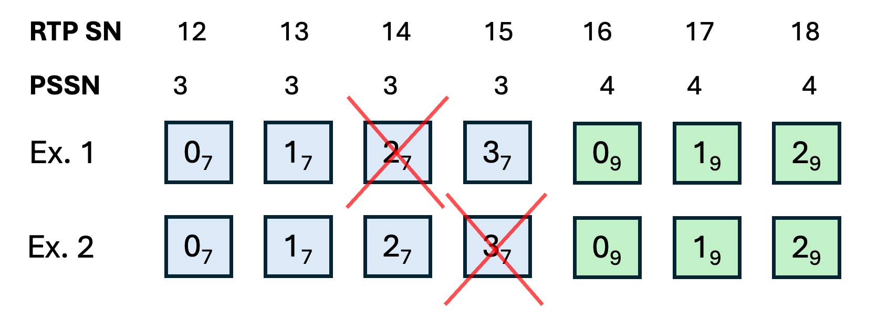
Figure X. Example cases illustration the solution.

The PSI threshold can be sent by the sender in an SDP negotiation or by other means and can be updated by the sender during the session.

Signaling the PSIHI
In this solution, the sender indicates the value of PSIHI to the receiver which uses this information to optimize the frequency of transmission of NACK messages.
If PSIHI is set, i.e, PDU Set integrated handling is used, it is sufficient for the receiver to send NACK only for the first lost PDU of a PDU Set since the sender can infer that all the other PDUs of the PDU Set have been dropped by the network due to integrated handling. The sender can then potentially retransmit all PDUs although it has received NACK only for a single PDU.
For better reliability, the receiver can prefer to send NACK messages for the first few lost PDUs of a PDU Set considering that RTCP packets carrying NACKs may be lost.
The sender may signal PSIHI to the receiver either in the RTP HE for PDU Set marking, in SDP signaling or by other means such as control plane signaling. Since PSIHI is not expected to change very frequently, SDP or control plane signaling are the preferred options.

