3GPP TSG-S4 Meeting #128 S4-240939

Jeju Island, KR, 20-24 May 2024 revision of S4- 240046
CR-Form-v12.0
CHANGE REQUEST
 | 26.512 | CR | 0066 | rev | 4 | Current version: | 18.1.0
For HELP on using this form: comprehensive instructions can be found at
http://www.3gpp.org/Change-Requests.

Proposed change affects: | UICC apps |  | ME | X | Radio Access Network |  | Core Network | X

Title: | [5GMS_Pro_Ph2] Fixes on clause 13
Source to WG: | Tencent
Source to TSG: | S4
Work item code: | 5GMS_Pro_Ph2 |  |  |  |  |  | Date: |  |  | 2024-05-12
Category: | B |  |  |  |  |  | Release: |  |  | Rel-18
 | Use one of the following categories:  F (correction)  A (mirror corresponding to a change in an earlier release)  B (addition of feature),  C (functional modification of feature)  D (editorial modification)  Detailed explanations of the above categories can  be found in 3GPP TR 21.900. |  |  |  |  |  |  |  | Use one of the following releases:  Rel-8 (Release 8)  Rel-9 (Release 9)  Rel-10 (Release 10)  Rel-11 (Release 11)  …  Rel-15 (Release 15)  Rel-16 (Release 16)  Rel-17 (Release 17)  Rel-18 (Release 18)
Reason for change: |  | Assignment of the media delivery session id by the Media Player on its own is not a good practice since the Media Session Handler is the owner of the media delivery session id and it avoids the conflicts between different sessions by assigning unique values.  Additionally, if it is allowed the player to request the session id, instead of being handed over from the app, then minor changes needed to further align clause 13 to 26.510 clause 10.
Summary of change: |  | - 10.1.A: Media Player requests session id from MSH in the case if one is not handed over by the App.  - 13.2.3.2: define the process of obtaining session id if its not handed over but avoid replicating it if its already assigned by MSH.
Consequences if not approved: |  | Entities interacting with the Media Session Handler are not able to unambigously refer to a particular media delivery session.
Q
Clauses affected: |  | 10.1 and 13.2.3.2
 |  | Y | N
Other specs |  | X |  | Other core specifications |  |  |  | TS 26.510 V2.0.0
affected: |  |  | X | Test specifications
(show related CRs) |  |  | X | O&M Specifications
Other comments:
This CR's revision history:

Background
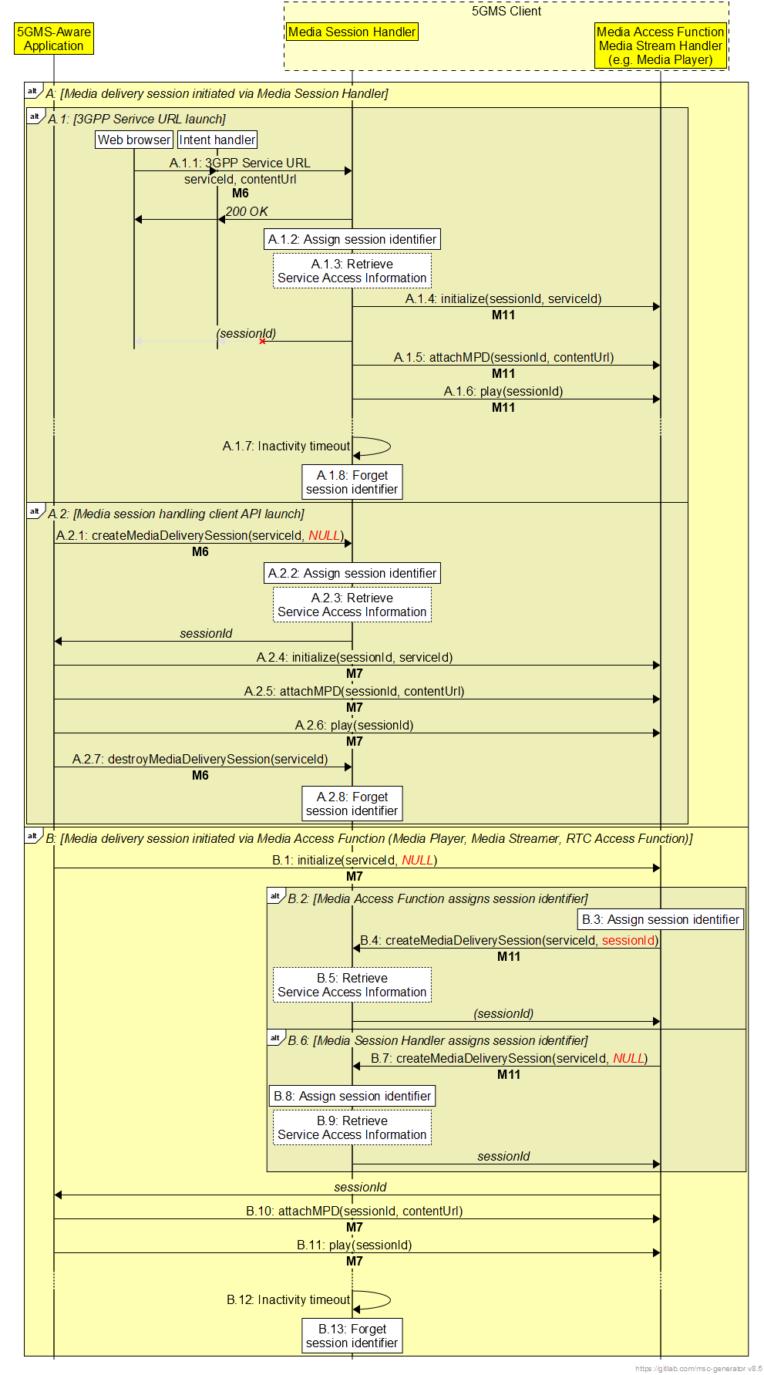
FIRST CHANGE

10 Media Streaming (M4) interface

10.1 General
This clause specifies the interface for downlink and uplink media streaming at reference point M4 using different distribution formats and protocols. TS 26.511 [35] defines the integration of several media codecs into 5G Media Streaming, and provides requirements and recommendations for the support of these media profiles in specific 5G Media Streaming profiles. However, 5GMS is not restricted to the media profiles defined in TS 26.511 [35]: any CMAF media profile that integrates with the APIs specified in the present document may be used for media streaming at this reference point.

10.1A Media delivery session identification
All media requests addressed by the Media Stream Handler (Media Player or Media Streamer) to the 5GMS AS at reference point M4 shall cite a media delivery session identifier using the HTTP header specified in clause 6.2.3.6. The value of this identifier shall be different for every media streaming session and should be assigned as follows:
1. If the media streaming session is initiated by the 5GMS-Aware Application invoking the method specified in clause 10.2.2.1 of TS 26.510 [56] on the Media Session Handler at reference point M6, the media delivery session identifier shall be nominated by the Media Session Handler and included as a parameter of the method specified in clause 13.2.3.2 of the present document when initialising the Media Stream Handler (Media Player or Media Streamer) at reference point M11. The assigned media delivery session identifier shall also be returned to the 5GMS-Aware Application at reference point M6 for use in subsequent interactions at this reference point.
2. If the media streaming session is initiated by a UE application (such as a web browser) requesting a 3GPP Service URL at reference point M6, the media delivery session identifier shall be nominated by the Media Session Handler and included as a parameter of the method specified in clause 13.2.3.2 of the present document when initialising the Media Stream Handler (Media Player or Media Streamer) at reference point M11. The assigned media delivery session identifier should be returned to the UE application if technically feasible.
3. If the media streaming session is initiated by the 5GMS-Aware Application invoking the method specified in clause 13.2.3.2 of the present document on the Media Stream Handler (Media Player or Media Streamer) at reference point M7, either:
a) the media delivery session identifier is nominated by the Media Stream Handler, in which case it shall be included as a parameter of the method specified in clause 10.2.2.1 of TS 26.510 [56] when creating a new media delivery session in the Media Session Handler at reference point M11; or
b) the Media Stream Handler (Media Player or Media Streamer) omits the media delivery session identifier parameter when creating a new media delivery session in the Media Session Handler, and the Media Stream Handler assigns a media delivery session identifier and return it to the Media Stream Handler (Media Player or Media Streamer).
In both of the above cases, the assigned media delivery session identifier shall be returned to the 5GMS-Aware Application at reference point M7 for use in subsequent interactions at this reference point.
NEXT CHANGE

13.2.3.2 Initialize
This clause defines the initialize() method.
No pre-conditions apply.
This method is invoked to create a new Media Player instance. A media delivery session identifier may be assigned to the media delivery session by the Media Player and returned if a value is not supplied by the invoker of the method.
The input parameters of this method are specified in table 13.2.3.2-1.
Table 13.2.3.2-1: Input parameters of initialize() method
Name | Type | O | Description
serviceId | string | M | An external service identifier, as specified in clause 5.4.2.1 of TS 26.510 [56].
sessionId | string | C | A new media delivery session identifier nominated by the Media Session Handler, as specified in clause 7.3.2 of TS 26.510 [56] and in clause 10.1A of the present document.  This parameter shall be included when the method is invoked by the Media Session Handler at reference point M6; it shall be omitted when the method is invoked by a 5GMS-Aware Application at reference point M7.

The following functions are initialized:
- Media Playback Management in order to enable API-based communication through M7d and/or M11d. In particular, the Notifications and Errors API (see clause 13.2.5) and the Status Information (see clause 13.2.6) are established.

If the sessionId parameter is provided, the Media Player shall use this value in its further interactions, in particular the Notifications and Errors API (see clause 13.2.5) and the Status Information (see clause 13.2.6). The Media Player shall invoke the method specified in clause 10.2.2.1 of TS 26.510 [56] at reference point M11d to create a new media delivery session in the Media Session Handler, passing the media delivery session identifier as a parameter.

If the sessionId parameter is omitted, the Media Player shall either assign a new media delivery session identifier itself, or else it shall rely on the Media Session Handler assigning one as a side-effect of invoking the method specified in clause 10.2.2.1 of TS 26.510 [56] at reference point M11d. The Media Player shall use this value in its further interactions, in particular the Notifications and Errors API (see clause 13.2.5) and the Status Information (see clause 13.2.6).
The return value of the method is specified in table 13.2.3.2-2.
Table 13.2.3.2-2: Return value of initialize() method
Type | Description
string | A media delivery session identifier as specified in clause 7.3.2 of TS 26.510 [56] and in clause 10.1A of the present document.

The remaining Media Player methods specified below require the media delivery session identifier to be cited as an input parameter.
End of changes

