3GPP TSG-S4 Meeting # 128 S4-240938
Jeju Island, KR, 20-24 May 2024
CR-Form-v12.2
PSEUDO CHANGE REQUEST
 | 26.510 | CR | pseudo | rev |  | Current version: | 1.2.3
For HELP on using this form: comprehensive instructions can be found at
http://www.3gpp.org/Change-Requests.

Proposed change affects: | UICC apps |  | ME | X | Radio Access Network |  | Core Network | X

Title: | Improving M6
Source to WG: | Tencent Cloud, Qualcomm, BBC
Source to TSG: | S4
Work item code: | 5GMS_Pro_Ph2 |  |  |  |  |  | Date: |  |  | 2024-04-20
Category: | B |  |  |  |  |  | Release: |  |  | Rel-18
 | Use one of the following categories:  F (correction)  A (mirror corresponding to a change in an earlier release)  B (addition of feature),  C (functional modification of feature)  D (editorial modification)  Detailed explanations of the above categories can  be found in 3GPP TR 21.900. |  |  |  |  |  |  |  | Use one of the following releases:  Rel-8 (Release 8)  Rel-9 (Release 9)  Rel-10 (Release 10)  Rel-11 (Release 11)  …  Rel-16 (Release 16)  Rel-17 (Release 17)  Rel-18 (Release 18)  Rel-19 (Release 19)
Reason for change: |  | - Aligning the M6 general APIs with the recent changes in R18:  Exluding B.2-B.5  - The client API for the dynamic policy is not properly specified. The activation and usage of the BDT should be part of the dynamic policy activation over that API.
Summary of change: |  | - 5.4.2.1:updating the process of assigning the media delivery session identifier.  - 10.2.1: new entry in the table  - 10.2.2: updating the methods  - 10.2.3: updating the events  - 10.3: updating dynamic policy APIs
:
Consequences if not approved: |  | M6 is underdefined and not clear.
Clauses affected:
 |  | Y | N
Other specs |  |  | X | Other core specifications |  |  |  | TS/TR ... CR ...
affected: |  |  | X | Test specifications |  |  |  | TS/TR ... CR ...
(show related CRs) |  |  | X | O&M Specifications |  |  |  | TS/TR ... CR ...
Other comments:
This CR's revision history:

Background
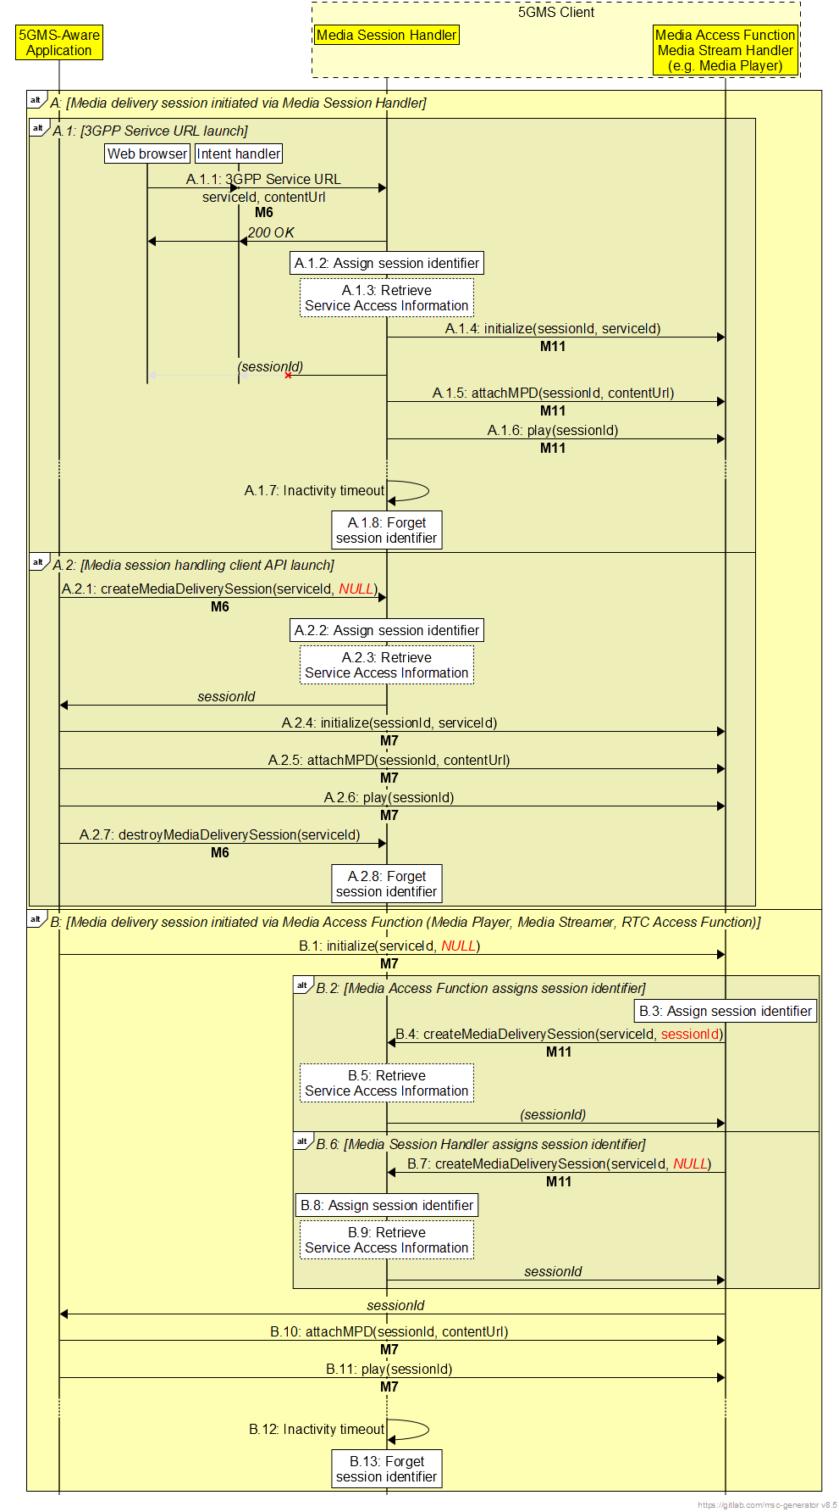

1st Change

5.4.2.1 Explicit media session handling initiation/termination
Media session handling of a new media delivery session may be explicitly initiated by a Media-aware Application or Media Access Function by invoking an appropriate API method on the Media Session Handler at reference points M6 or M11, respectively.
- An external service identifier shall be provided as an input parameter to the API method.
- A Media Entry Point URL, for instance obtained from the Media Application Provider at reference point M8, may optionally be provided as an input parameter in order to initiate media delivery.
In response, the Media Session Handler shall allocate a globally unique media delivery session identifier for use by the Media Client in its subsequent interactions with the Media AF and Media AS.
If it does not already have a fresh copy cached, the Media Session Handler shall attempt to acquire full Service Access Information for the specified external service identifier from the Media AF using the operation defined in clause 5.3.2.3 and, if successful, shall return the media delivery session identifier to the invoker of the API method.
If invoked by a Media-aware Application at reference point M6, the Media Session Handler shall initialise a new Media Access Function instance on behalf of the invoker, and shall initiate media delivery by passing it the Media Entry Point URL.
Subsequent interactions between the Media-aware Application and the Media Session Handler at reference point M6 shall cite the relevant media delivery session identifier.

Subsequent interactions between the Media-aware Application and the Media Access Function at reference point M7 shall cite the relevant media delivery session identifier.
Subsequent interactions between the Media Session Handler and the Media Access Function at reference point M11 shall cite the relevant media delivery session identifier.
Subsequent interactions by the Media Access Client with the Media AS at reference point M4 shall cite the relevant media delivery session identifier to enable media access logged by the Media AS to be correlated with media session handling operations logged by the Media AF.
The Media-aware Application or Media Access Function may explicitly terminate media session handling of the media delivery session by invoking an appropriate API method on the Media Session Handler at reference point M6 or M11, respectively, citing the target media delivery session identifier as input parameter.

2ndChange

10 UE media session handling APIs

10.1 Introduction
This clause defines the abstract client APIs exposed by the Media Session Handler to the Media-aware Application at reference point M6 and to the Media Access Function at reference point M11. The APIs may be used to query a subset of information from Service Access Information and its updates as well as to control the life-cycle of a media delivery session and to receive notifications of various events occurring during that media delivery session.
NOTE: Client-driven management of edge processing resources via reference point EDGE-5 is not specified in this release.

10.2 Media Session Handler client API

10.2.1 Media Session Handler internal properties
The Media Session Handler maintains internal properties as defined table 10.2.1-1. Note that the parameters are conceptual and internal. They serve only for the purpose of defining the media session handling APIs.
Table 10.2.1-1: Parameters of Media Session Handler internal data model
States and Parameters |  | Definition
_Configuration[externalServiceId] |  | The Media Session Handler maintains a separate configuration for each set of Service Access Information it has knowledge of, indexed by its external service identifier or 3GPP Service URL.
 | _streamingAccess | Streaming access configuration.
 | _rtcClient | RTC Client configuration.
 | _networkAssistance | Network Assistance configuration.
 | _policyTemplate | Policy Template configuration.
 | _consumptionReporting | Consumption reporting configuration.
 | _metricsReporting | Metrics reporting configuration.
 | _edgeResources | Edge resources configuration.
_status[mediaDeliverySessionId] |  | The Media Session Handler maintains a separate status record for each currently active media delivery session, indexed by media delivery session identifier.
 | _generalStatus | General status information. (See table 10.2.3-1.)
 | _dynamicPolicyStatus | Dynamic Policy status information. (See table 10.3.2-1)
 | _networkAssistanceStatus | Network Assistance status information. (See table 10.4.2-1)
 | _consumptionReportingStatus | Consumption Reporting status information. (See table 10.5.2-1.)
 | _metricsReportingStatus | Metrics Reporting status information. (See table 10.6.2-1.)

A subset of the above information which is needed by the Application and/or Media Access Function is accessible through reference point M6 and M11, respectfully using the methods specified in the following clauses.

10.2.2 General Media Session Handler methods

10.2.2.1 Create a media delivery session

A 3GPP Service URL (see clause 6) may be used to implicitly trigger the creation of a new media delivery session with the Media Session Handler.
The Media Session Handler also offers the explicit createMediaDeliverySession() method, which is used to create a new media delivery session in the Media Session Handler.
The input parameters of the method are specified in table 10.2.2.1-1:
Table 10.2.2.1-1: Input parameters for createMediaDeliverySession() method
Name | Type | O | Description
serviceId | string | M | The external service identifier (see table 8.2.3.1-1) of the Provisioning Session that this media delivery session pertains to.
entryPoint | Url | O | The location of a Media Entry Point document or media resource.
domainNames | array(string) | O | A set of Fully-Qualified Domain Name (FQDN) of the Media AS endpoint(s) supporting the media delivery session at reference point M4.
accessToken | string | O | An access token that the Media Session Handler presents to the Media AF to authorise invocation of media session handling operations at reference point M5.

If it does not already have a fresh copy cached, the Media Session Handler shall attempt to retrieve a copy of the full Service Access Information from the Media AF at reference point M5 using the procedure specified in clause 5.3.2.
If successful, the Media Session Handler shall assign a new media delivery session identifier to the media delivery session and shall create an entry in its _status array indexed by the media delivery session identifier.
If the entryPoint input parameter is provided, the Media Session Handler shall attempt to initialise the Media Access Function using an appropriate method, and shall pass the Media Entry Point URL to it (as well as the media delivery session identifier) in order to initiate media access.
If the entryPoint input parameter is provided, and indicates a Service Operation Point, the Media Session Handler shall create a Dynamic Policy Instance using the procedure specified in clause 5.3.3 using the Service Operation Point reference as the external reference. The Dynamic Policy Instance shall include a Policy Template binding for each of the domain names listed in the domainNames input parameter, if present.
If all of the above actions are successful, the Media Session Handler shall set sessionHandlingState to ACTIVE (see table 10.2.3-1) and shall send a SESSION_‌HANDLING_‌ACTIVATED notification (see table 10.2.3-2). If any of the above actions fail, the Media Session Handler shall set sessionHandlingState to ERRORED (see table 10.2.3-1).

The return value of the method is specified in table 10.2.2.1-2.
Table 10.2.2.1-2: Return value for createMediaDeliverySession() method
Type | Description
string | The media delivery session identifier.

10.2.2.2 Destroy a media delivery session
The destroyMediaDeliverySession() method is used to end the media delivery session and release the allocated resources by the Media Session Handler. With this method, the Media Session Handler does not maintain the internal properties corresponding to the media delivery session identifier. The input parameters of the method are specified in table 10.2.2.2-1.
Table 10.2.2.2-1: Input parameters for destroyMediaDeliverySession() method
Name | Type | Description
mediaDeliverySessionIdentifier | string | The media delivery session identifier.

The Media Session Handler shall remove the entry from its _status array indexed by the media delivery session identifier.
The Media Session Handler shall send a SESSION_‌HANDLING_‌TERMINATED notification (see table 10.2.3-2).

10.2.3 General Media Session Handler information
Table 10.2.3-1 specifies the status information that can be obtained from the Media Session Handler through reference points M6 and M11.
Table 10.2.3-1: General Media Session Handler Status Information
Status | Type | Parameter | Definition
sessionHandlingState | string enum | Media delivery session identifier | The status of media delivery session:  ACTIVE: The media delivery session is being handled by the Media Session Handler.  ERRORED: An error has occurred and the Media Session Handler is no longer able to handle it.

Table 10.2.3-2 provides a list of general notification events exposed by the Media Session Handler through reference points M6 and M11.
Table 10.2.3-2: General Media Session Handler Notification Events
Event | Definition | Payload
SESSION_HANDLING_ACTIVATED | Triggered when media session handling was activated for a specific Media Entry Point. | Media delivery session identifier,  Media Entry Point URL.
SESSION_HANDLING_TERMINATED | Triggered when media session handling is terminated for a specific Media Entry Point. | Media delivery session identifier,  Media Entry Point URL.
STREAMING_ACCESS_UPDATED | Triggered when an update to the stream access is available for the Provisioning Session associated with the external service identifier supplied when the media delivery session was created (see clause 10.2.2.1). | Media delivery session identifier,  Streaming access.
RTC_CLIENT_CONFIGURATION_UPDATED | Triggered when an update to the RTC Client configuration is available for the Provisioning Session associated with the external service identifier supplied when the media delivery session was created (see clause 10.2.2.1). | Media delivery session identifier,  RTC Client configuration.

Table 10.3.3-3 provides a list of general error events exposed by the Media Session Handler through reference points M6 and M11.
Table 10.2.3-3: General Media Session Handler Error Events
Status | Definition | Payload
ERROR_SESSION_HANDLING | Triggered when there is an error in the media session handling. | Media delivery session identifier.

2nd Change

10.3 Dynamic Policy client API

10.3.1 Dynamic Policy methods

10.3.1.1 Retrieve Background Data Transfer information
The getBDTInfo() method is used to retrieve information about the next Background Data Transfer opportunity window at one of the Service Operation Points that are available in the context of a particular media delivery session.
The input parameters of the method are specified in tables 10.3.1.1-1.
Table 10.3.1.1-1: Input parameters for getBDTInfo() method
Name | Type | Description
sessionId | string | The media delivery session identifier (as specified in clause 7.3.2) of an initialised media delivery session in the Media Session Handler.
serviceOperationPointReference | string | The external reference identifier of a Service Operation Point that uniquely identifies a Policy Template within the context of sessionId.

The return value of the method is specified in table 10.3.1.2-1.
Table 10.3.1.2-1: Return value for getBDTInfo() method
Type | Description
object | Information about a Background Data Transfer opportunity.  The object shall contain the time window start and end times and the maximum allowed data volume in bytes.

10.3.1.2 Activate Dynamic Policy
The activatePolicy() method is employed to request the application of a dynamic policy to a media delivery session that is configured at the Media Session Handler. The scope of the dynamic policy is all application flows that match the application identifier or Media AS domain name declared when the media delivery session was created (see table 10.2.2.1 1). The application may also provide the estimated transfer volume if the media delivery session is expected to be within the bounds of a Background DataTransfer time window. The Media Session Handler conveys the request to the Media AF and provides the corresponding response to the invoker of the method. The input parameters of the method are specified in table 10.3.1.2-1.
Table 10.3.1.2-1: Input parameters for activatePolicy() method
Name | Type | Optionality | Description
sessionId | string | M | The media delivery session identifier (as specified in clause 7.3.2) of an initialised media delivery session in the Media Session Handler.
serviceOperationPointReference | string | M | The external reference identifier of a Service Operation Point that uniquely identifies a Policy Template within the context of sessionId.
estimatedTransferVolume | integer | C | The estimated volume of data to be transferred, expressed in bytes.  Minimum value 1 byte.  Required to be populated when the Policy Template corresponding to the referenced Service Operation Point declares a Background Data Transfer policy.

The return value of the method is specified in table 10.3.1.2-2.
Table 10.3.1.2-2: Return value for activatePolicy() method
Type |  | Description
object
 | recommendedDownlinkBitRate | The recommended downlink bit rate for the requested Service Operation Point.
 | recommendedUplinkBitRate | The recommended uplink bit rate for the requested Service Operation Point.
 | backgroundDataTransferActivated | Indicates whether Background Data Transfer has been successfully activated for the media delivery session for the duration of the indicated time window.

Table 10.3.2-2 provides a list of notification events exposed by the Media Session Handler through reference points M6 and M11 in relation to Dynamic Policies.
Table 10.3.2-2: Notification Events relating to Dynamic Policies
Event | Definition | Payload
POLICY_ACTIVATED | Triggered when a new Dynamic Policy is successfully activated for the media delivery session. | Media delivery session identifier,  Recommended downlink bit rate,  Recommended uplink bit rate.
POLICY_DEACTIVATED | Triggered when the Dynamic Policy for this media delivery session is deactivated. | Media delivery session identifier.
BACKGROUND_DATA_TRANSFER_OPPORTUNITY | Triggered when a new Background Data Transfer opportunity window opens. | Media delivery session identifier,  Service Operation Point reference,  Opportunity windows start date–time,  Opportunity windows end date–time,  Data volume quota,  Maximum uplink bit rate,  Maximum downlink bit rate.

Table 10.3.3-3 provides a list of error events exposed by the Media Session Handler through reference points M6 and M11 in relation to Dynamic Policies.
Table 10.3.2-3: Error Events relating to Dynamic Policies
Status | Definition | Payload
ERROR_INVALID_‌SERVICE_‌OPERATION_‌POINT | Triggered when the provided Service Operation Point reference is not valid for the media delivery session. | Media delivery session identifier,  Service Operation Point reference.
ERROR_UNAUTHORISED | Triggered when the application is not authorised to instantiate a dynamic policy for the provided Service Operation Point reference. | Media delivery session identifier,  Service Operation Point reference.
ERROR_BACKGROUND_DATA_TRANSFER | Triggered when there is an error during a Background Data Transfer, for example if it is cancelled before the end of the advertised opportunity window. | Media delivery session identifier,  Error reason.

