Source: Beijing Xiaomi Mobile Software Co., Ltd
Title: Proposed updates for chapter 5 and 7 in TR 26.933
Document for: Discussion &Agreement
Agenda Item: 7.8

Introduction
This proposal is aimed to update the remaining parts in clauses 5 and 7 of 3GPP TR 26.933[1].

Content

Update of chapter 5
To enhance the organization, the new restructure is proposed as following:
5 Microphones used in audio capture
5.1 Introduction
5.2 Transducer type
5.2.1Dynamic microphone
5.2.2 Condenser microphone
5.2.3 Micro-Electro-Mechanical Systems microphone
5.2.4 Contact microphone
5.2.5 Summary of transducer
5.3 Directional Microphone
5.3.1 Introduction
5.3.2 Directional microphone capsule
5.3.3 Interference tube
5.4 Binaural acoustic simulation
5.5 Summary of microphones used in immersive audio capture
5.6 Other components used in audio capture.

First change

Microphones used in audio capture

5.1 Introduction
The function of microphone is to convert sound pressure signal to analog electrical signal in circuit.
4 types of microphones popular in the market are described in this section. These microphones have unique advantages in UE's immersive audio. They are classified to dynamic microphone, condenser microphone, Micro-Electro-Mechanical Systems (MEMS), contact microphone.

5.2 transducer type

5.2.1 Dynamic microphone
Dynamic microphone is one of the popular microphones on market. The most advantage of dynamic microphone for UE is it doesn’t require external power; and therefore, the entire recording system may become simpler. Another advantage is durability, make it more suitable for loud and high-pressure situation. But it usually has a disadvantage that it is less sensitive to high frequencies.
Dynamic microphone uses a small movable induction coil, which positioned in the magnetic field and is attached to the diaphragm. The current signal generates when the movement of the diaphragm causes the coil to also move within a magnetic field.

5.2.2 Condenser microphone
Condenser microphone is another popular microphone on market, especially for immersive audio. Most immersive system is using condenser microphones, like ambisonic microphone and external stereo microphone for mobile phone. It’s popular for its high sensitivity, wide frequency response, low noise. However, the condenser microphone requires a power source, and in the case of most professional condenser microphones, it specifically requires 48V phantom power. Meeting this requirement can be challenging for UE device consider the channel number of immersive audio.
Condenser microphone uses capacitor to convert sound waves to electrical signal. The capacitor consists of two plates, one of them is a diaphragm that vibrates in response to sound waves. The diaphragm vibrates and changes the distance between the two plates. Then the capacitance changes which influences the electrical signal.

5.2.3 Micro-Electro-Mechanical Systems microphone
In the past decades, microphone for UE has change from carbon microphones to electret condenser microphones. Recently the MEMS microphone is spread rapidly, benefited from its advantages of high stability and small volumes.
According to the techniques of microfabrication, the MEMS microphone is much smaller and allow integrate other components including preamps, ADC with transducer in one package under the control of integrated microelectronics.
Which means for manufacturers, it much easier to build the capture system, MEMS microphone can output the digital signal directly. In other hand, it allows need to select the component more carefully. Since the microphone is much smaller and very uniform in their mechanical properties, it's suitable for UE and make immersive audio become possible for economic portable UE like mobile phone.

5.2.4 Contact microphone
Contact microphone is a type of microphone that senses solid vibrations through direct contact with a surface.
Compared to the acoustic microphones, the contact microphones have the benefit of not to capture sound waves in the air, but to capture mechanical vibrations of the target object. Hence, it’s resistant to noise in air.
Nowadays, bone conduction microphone, which is a special kind of contact microphone, is very popular on TWS headphones. It is used to capture high SNR speech signal even in complex scenarios.

5.2.5 Summary of transducer
From a size perspective, the MEMS microphones are the best choice for most portable UE (like mobile phone, headphone). The primary focus of this study may be on this miniature microphone considering the immersive audio system is much more complex.
Other microphones may also be considered, like the dynamic microphone and condenser microphone still dominate the professional audio industry.

5.3 Directional Microphone

5.3.1 Introduction
Directivity is a very important part in immersive audio, every immersive audio format has requirement on directivity. Even for object audio, we also need take care of the directivity to avoid the influence of environment noise.

5.3.2 Directional microphone capsule
Most directional microphones use two closely diaphragms that electrically subtracted from each other to provide a range of polar patterns.

5.3.3 Interference tube
Interference tube is usually used on shotgun microphones which make it more directional than a typical cardioid or supercardioid microphone.
Interference tube is a long, narrow extended tube that is placed in front of the microphone capsule and has multiple small holes along its length. It creates phase shift for sounds arriving from off-axis directions, the off-axis sound will arrive at the diaphragm with varying phase relationships and so partially cancel one another out.
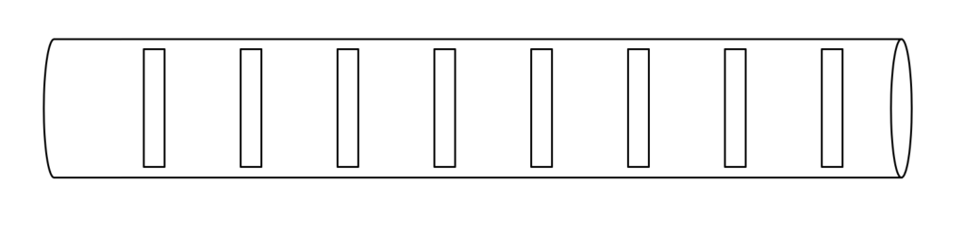Figure 5.3.3-1 The schematic diagram of interference tube

5.4 Binaural acoustic simulation

According to the principle of binaural signal, the typical solution involves placing microphones on each ear of the user or on a model of a human head or ears to capture the binaural cues. This model could be a head with a torso to simulate all influences, including those from the ear, head and reflections from the torso. Alternatively, it could be a single head or simply a model with a pair of ears.

5.5 Summary of microphones used in immersive audio capture
The previous immersive solution primarily relied on selecting specific microphone with a specific placement, which often resulted in larger sizes and higher costs, making it less appealing in today's compact economic portable UE market such as mobile phones. However, advancements in algorithms grant more possibilities on the miniature microphones with the limited placement. Therefore, it may be more feasible to consider utilizing the hardware feature combined with software to get immersive audio.

5.6 Other components used in audio capture.
Traditionally, audio capture required numerous components apart from microphones, including preamps, ADC, and clocks. However, with the advent of digital MEMS microphones, which can directly output digital signals and integrate all those components, audio capture has become significantly more convenient. This innovation is particularly appealing for small-sized devices.

End of First change

2.2 Remove 5.1.1.6, 5.2, 5.3 and 5.4
MEMS microphones, particularly digital MEMS microphones, are commonly used in current UE. These microphones can directly output digital signals and integrate various components such as preamps, ADC, and clock with the transducer in a single package. So it’s reasonable to remove 5.2 preamps, 5.3 DC and 5.4 clock. Since no other microphones are commonly used in the current UE, it is also proposed to remove the 5.1.1.6 other microphone.

Second change

End of Second change

2.2 Update of 7.1 AEC
Third change

7.1.4 AEC for different UE
Theoretically, increasing the distance between the microphone and loudspeakers can enhance AEC performance by reducing the echo level coupling from the loudspeakers to the microphones. However, the demand for additional microphones and loudspeakers due to immersive audio brings the distance significantly closer.
This reduction is especially evident in smaller UE, such as mobile phones and earbuds, where the compact size restricts the distance, leading to a higher echo level and shorter echo delay. In some devices, the microphone and loudspeaker may even be placed in the same sound port.
Conversely, larger UE like cars may experience a longer echo delay, but they offer a more stable acoustic environment since all the microphones and speakers for communication are installed within the cabin.

End of Third change

Conclusion
Above three changes and the new structure for chapter 5 are proposed to update the corresponding parts in 3GPP TR 26.933.

References
- S4-240764_[FS_DaCED] TR 26.933 v0.6.0

