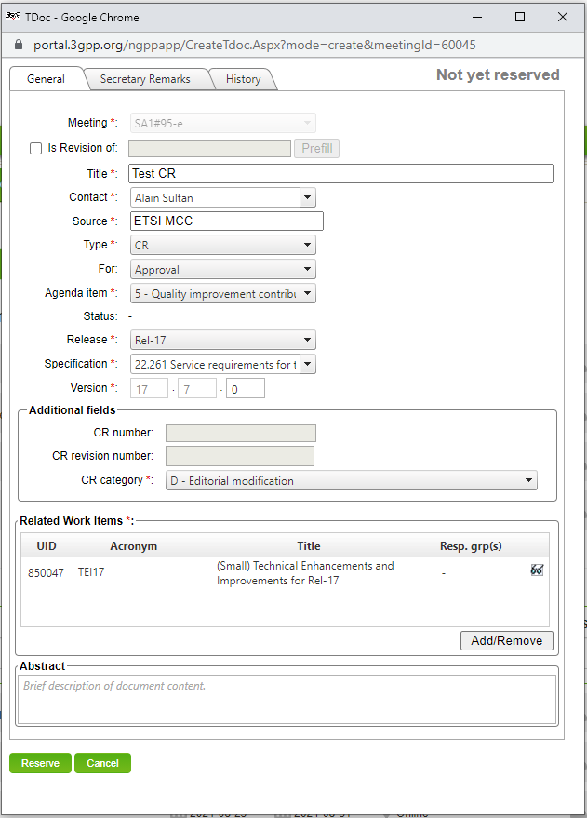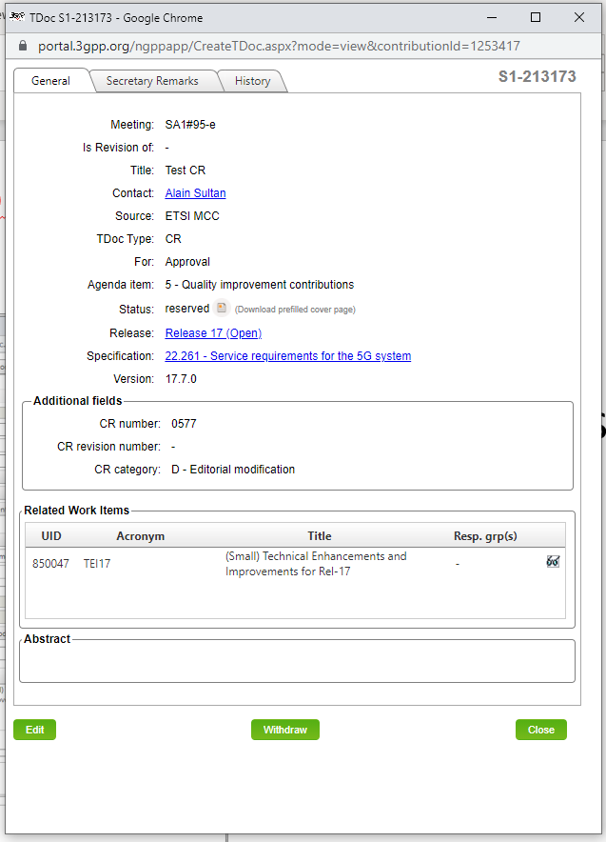

*Note that you can also download the prefilled cover page after your tdoc/CR number request, by editing your tdoc details in the tdoc list (glasses icon).*

How to get the CR Cover Page

* Download the pre-filled cover page

Tdoc/CR number Request form

Portal’s answer

**This one here**