**3GPP TSG-SA3 Meeting #119 draft_S3-245279-r1**

Orlando, US, 11 -15 November 2024

|  |  |  |  |  |  |  |  |  |
| --- | --- | --- | --- | --- | --- | --- | --- | --- |
| *CR-Form-v12.1* | | | | | | | | |
| **CHANGE REQUEST** | | | | | | | | |
|  | | | | | | | | |
|  | **33.535** | **CR** | **0221** | **rev** |  | **Current version:** | **18.5.0** |  |
|  | | | | | | | | |
| *For* [***HE******LP***](http://www.3gpp.org/3G_Specs/CRs.htm#_blank)*on using this form: comprehensive instructions can be found at* [*http://www.3gpp.org/Change-Requests*](http://www.3gpp.org/Change-Requests)*.* | | | | | | | | |
|  | | | | | | | | |

|  |  |  |  |  |  |  |  |  |
| --- | --- | --- | --- | --- | --- | --- | --- | --- |
| ***Proposed change affects:*** | UICC apps |  | ME |  | Radio Access Network |  | Core Network | **x** |

|  |  |  |  |  |  |  |  |  |  |  |
| --- | --- | --- | --- | --- | --- | --- | --- | --- | --- | --- |
|  | | | | | | | | | | |
| ***Title:*** | Notification about AKMA service disabling via NEF | | | | | | | | | |
|  |  | | | | | | | | | |
| ***Source to WG:*** | Huawei, HiSilicon | | | | | | | | | |
| ***Source to TSG:*** | S3 | | | | | | | | | |
|  |  | | | | | | | | | |
| ***Work item code:*** | AKMA_Ph2 | | | | |  | ***Date:*** | | | 2024-11-04 |
|  |  | | | |  | |  | | |  |
| ***Category:*** | **F** |  | | | | | ***Release:*** | | | Rel-18 |
|  | *Use one of the following categories:* ***F*** *(correction)* ***A*** *(mirror corresponding to a change in an earlier release)* ***B*** *(addition of feature),* ***C*** *(functional modification of feature)* ***D*** *(editorial modification)*  Detailed explanations of the above categories can be found in 3GPP [TR 21.900](http://www.3gpp.org/ftp/Specs/html-info/21900.htm). | | | | | | | | *Use one of the following releases: Rel-8 (Release 8) Rel-9 (Release 9) Rel-10 (Release 10) Rel-11 (Release 11) … Rel-15 (Release 15) Rel-16 (Release 16) Rel-17 (Release 17) Rel-18 (Release 18)* | |
|  |  | | | | | | | | | |
| ***Reason for change:*** | | This proposal is to add notification about AKMA service disabling via NEF  As described in clause 6.8, TS 33.535, this clause includes AAnF directly notifies AF about AKMA service disable, without notification about AKMA service disabling via NEF.  As described in Table 7.3.1-1, TS 33.535, services provided by NEF are not complete. | | | | | | | | |
|  | |  | | | | | | | | |
| ***Summary of change:*** | | It is proposed to add notification about AKMA service disabling via NEF and services provided by NEF. | | | | | | | | |
|  | |  | | | | | | | | |
| ***Consequences if not approved:*** | | The procedure for notification about AKMA service disabling via NEF is missing. The services provided by NEF are not complete. | | | | | | | | |
|  | |  | | | | | | | | |
| ***Clauses affected:*** | | 6.8, 6.8.X(new), 7.3.1, 7.3.2 | | | | | | | | |
|  | |  | | | | | | | | |
|  | | **Y** | **N** |  | | | |  | | |
| ***Other specs*** | |  | **X** | Other core specifications | | | | TS/TR ... CR ... | | |
| ***affected:*** | |  | **X** | Test specifications | | | | TS/TR ... CR ... | | |
| ***(show related CRs)*** | |  | **X** | O&M Specifications | | | | TS/TR ... CR ... | | |
|  | |  | | | | | | | | |
| ***Other comments:*** | |  | | | | | | | | |
|  | |  | | | | | | | | |
| ***This CR's revision history:*** | |  | | | | | | | | |

*** Start of The First Change ***

## 6.8 Notification about AKMA service disabling

## 6.8.1 Notification about AKMA service disabling without NEF

This procedure is used when the AKMA sessions have already been started (before roaming was detected), and as soon as PLMN change is detected at the AAnF, the AAnF may execute this procedure based on the roaming policy.



Figure 6.8.1-1: AAnF notification to AF about AKMA service disable

1. UE registers with a (H)PLMN.

2. UE is accessing the AF and key material is provided to AF as described in 6.2.1. While accessing the AAnF, AF may also provide the Notification URI.

3. UE is getting registered in a VPLMN and AAnF detects the PLMN change via the Nudm_EventExposure_Notification received from UDM.

4. AAnF determines if AF(s) have subscribed to receive notifications for AKMA service disabling and roaming policy is configured and restrict the AKMA access in the VPLMN; if yes, steps 5 and 6 are executed. Otherwise, steps 5 and 6 are skipped.

5. If AF(s) are determined at step 5, the AAnF shall send notifications to the subscribed AF(s) about AKMA roaming via Naanf_AKMA_ServiceDisableNotification. The A-KID is the transmitted A-KID for the corresponding AF, which is kept track of in step 8 in clause 6.2.1.

6. The AF shall send the response and based on the notification and internal policy, the AF may stop the UE service, may stop the encryption.

NOTE: By stopping the encryption (e.g., TLS 1.2 NULL cypher negotiation), LI interception could work in the VPLMN.

*** End of The First Change ***

*** Start of The Second Change ***

## 6.8.X Notification about AKMA service disabling via NEF

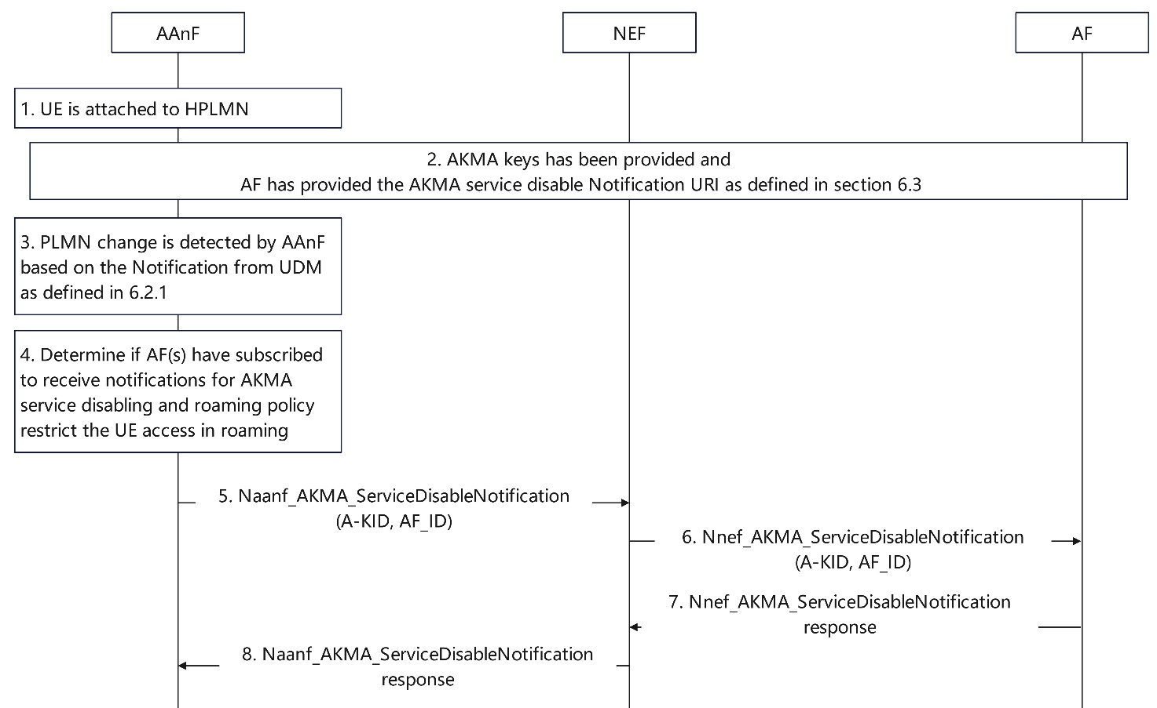

Figure 6.8.X-1: AAnF notification to AF about AKMA service disable via NEF

This procedure is used when AAnF notifies AF about AKMA service disabling via NEF.

1. UE registers with a (H)PLMN.

2. UE is accessing the AF and key material is provided to AF via NEF as described in 6.3. While accessing the AAnF, AF may also provide the Notification URI.

3. For details about step 3, see step 3 in Figure 6.8-1.

4. AAnF determines if AF(s) have subscribed to receive notifications for AKMA service disabling and roaming policy is configured and restrict the AKMA access in the VPLMN; if yes, steps 5-8 are executed. Otherwise, steps 5-8 are skipped.

5. If AF(s) are determined at step 5, the AAnF sends notifications to the subscribed AF(s) via NEF about AKMA roaming. The AAnF sends Naanf_AKMA_ServiceDisableNotification to NEF. The notification includes the A-KID and the AF_ID. The A-KID is the transmitted A-KID for the corresponding AF.

6. Once receiving the notification from AAnF, NEF shall send Nnef_AKMA_ServiceDisableNotification to AF.

7. The AF sends Nnef_AKMA_ServiceDisableNotification response to NEF and based on the notification and internal policy, the AF may stop the UE service, may stop the encryption.

8. Once receiving the response from AF, the NEF sends Naanf_AKMA_ServiceDisableNotification response to AAnF.

NOTE: By stopping the encryption (e.g., TLS 1.2 NULL cypher negotiation), LI interception could work in the VPLMN.

*** End of The Second Change ***

*** Start of The Third Change ***

### 7.3.1 General

The NEF exposes AKMA Application Key derivation service to the requester NF.

The following table shows the NEF Services and NEF Service Operations related to AKMA service.

Table 7.3.1-1: List of NEF Services

|  |  |  |  |
| --- | --- | --- | --- |
| Service Name | Service Operations | Operation  Semantics | Example Consumer(s) |
| Nnef_AKMA | ApplicationKey_Get | Request/Response | AF |
| ServiceDisableNotification | Request/Response | AF |

*** End of The Third Change ***

*** Start of The Fourth Change ***

### 7.3.2 Nnef_AKMA_ApplicationKey_Get service operation

**Service operation name:** Nnef_AKMA_ApplicationKey_Get.

**Description:** The NF consumer requests the NEF to provide AF related key material.

**Input, Required:** A-KID, AF_ID

**Input, Optional:** UEID not needed indication, Service Disable URI.

**Output, Required:** KAF, KAF expiration time.

**Output, Optional:** GPSI (external ID).

*** End of The Fourth Change ***