3GPP TSG-SA3 Meeting #119 draft_S3-245216-r1
Orlano, USA 11 - 15 November 2024 revision of S3-244733

Source: vivo

Title: Address EN in Solution 31

Document for: Approval
Agenda Item: 5.7

1 Decision/action requested
Approve the pCR on EN address on solution #31.

2 References

3 Rationale
There are 2 ENs in solution #31:
Editor’s Note: The nature of valid wait timer and how it is used are FFS.
Editor’s Note: Further evaluation is FFS.
For the 1st EN, it provides an example to clarify the nature of valid wait timer and how to use it.
For the 2nd EN, since evaluation is complete, it is proposed to delete it.

4 Detailed proposal
Start of Change

6.31 Solution #31: Mitigation of Security Issues of Unprotected NAS Reject

6.31.1 Introduction
The solution addresses the key issue #1 “Security protection in Store and Forward Satellite Operation”.
In TR 23.700-29 [2], the following conclusions have been made.
“When UE initiates Attach or TAU procedure, it indicates support for S&F mode to the MME following existing NAS capability, the MME sends Attach or TAU Reject message to the UE if these procedures cannot be completed due to S&F operation. The Attach or TAU Reject message includes:
a) A new information indicating the UE that attach or TAU procedure cannot be completed because of the S&F operation and that the UE can re-attempt the attach or TAU in this PLMN in a next satellite pass. This indicates to the UE that the information contained in the Attach or TAU Request message is stored by the MME and the network will be available to the UE after interaction with ground network.
b) Wait timer: Indicates to the UE the time it should wait before re-attempting the Attach/TAU procedure in the current or another satellite of the same PLMN.
c) Optionally, The list of Satellite IDs over which the UE may re-attempt the Attach/TAU procedure, after wait timer expires. The Satellite IDs are based on the SIB information broadcasted by eNB.”
As there is no integrity or confidentiality protection for Attach or TAU Reject, potential security issues may arise if the newly agreed IEs are forged or tampered with. These security issues include:
- An attacker sending a large wait timer in a NAS Reject message to the UE, leading to a potential DoS attack on the UE for a long period (e.g. 1 hour).
- An attacker sending a forged list of Satellite IDs in a NAS Reject message to the UE, causing the UE to potentially select the wrong satellite and suffer a DoS attack.

6.31.2 Solution details
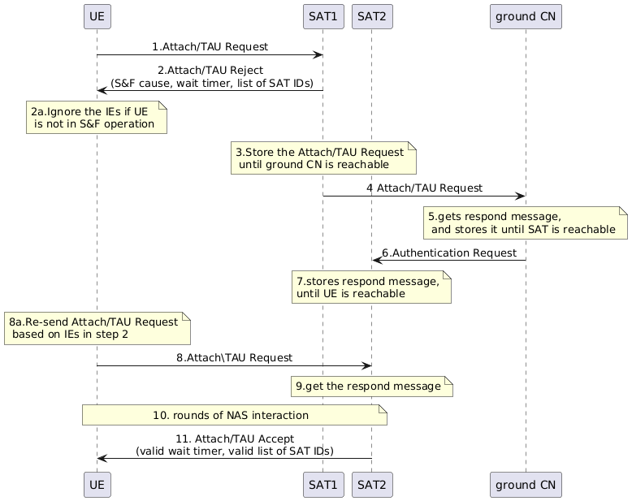
Figure 6.31.2-1 Mitigation of Security Issues of Unprotected NAS Reject
- The network can pre-provision an upper limit of wait timer for UEs to protect themselves from attacks when UEs are not aware of valid satellite IDs and have not learnt possible wait timer ranges.
- The UE sends the Attach/TAU Request message to SAT1.
- The SAT1 sends Attach/TAU Reject to the UE in case of a connection loss with SAT1. The Attach Reject may include S&F cause, wait timer and list of SAT IDs as described in TR 23.700-29 [2].
If the UE needs to respond to the S&F cause, the wait timer or the list of SAT IDs, the UE shall ensure it is in S&F operation. Otherwise, the UE ignores IEs.
- The SAT1 stores the Attach/TAU Request until ground CN is reachable.
- The SAT1 sends the Attach/TAU Request message to the ground CN.
- The ground CN gets the respond message, e.g. Authentication Request, and stores it until SAT is reachable.
- If a new connection between SAT2 and the ground CN is established, the ground CN then sends the respond message to SAT2.
- The SAT2 stores the response message until the UE is reachable.
- Based on received IEs in step 2, the UE re-sends Attach/TAU Request message to the SAT2.
- The SAT2 finds the stored response message.
- The SAT2 and UE may trigger several rounds of NAS interaction.
- After successful NAS security activation, the SAT2 sends the protected Attach/TAU Accept to the UE. The Attach/TAU Accept includes valid wait timer and valid list of SAT IDs. Upper limit of wait timer can also be included in this to help UEs ignore any wait timer above this threshold in any subsequent Attach/TAU Reject messages.
The UE stores the valid wait timer and the valid list of SAT IDs and utilize them to verify the received wait timer and list of satellite IDs from the unprotected NAS Reject from the SAT in step 2 in the subsequent attempt. The valid wait timer and the valid list of SAT IDs has higher priority of the pre-provisioned wait timer and valid SAT IDs.
For instance, the valid wait timer is a timer range determined based on the current satellite deployment, such as 20 minutes to 40 minutes. The UE uses the valid wait timer to check if the received wait timer (e.g. 60 minutes) in the NAS reject falls within the specified range. If the received wait timer is not within the range of valid wait timer, the UE ignore the received wait timer. Otherwise, the UE will consider the received wait timer valid. Additionally, the valid list of SAT IDs includes SAT1, SAT2, and SAT3. The UE uses the valid list of SAT IDs to verify if the received SAT ID (e.g. SAT4) in the NAS reject is within the valid list of SAT IDs.

Editor’s Note: Whether Attach/TAU Accept includes wait timer and/or list of SAT ID needs to be aligned with TS 23.401.

6.31.3 Evaluation
- Assumptions: The unprotected IEs (i.e. wait timer and satellite ID) may be forged or tampered because of unprotection of NAS reject message.
- Dependency on SA2 or RAN: No direct dependency on SA2 or RAN.
- Relevant KI and potential security requirements addressed: This solution addresses KI#1 of DoS requirement.
- Architecture option: The solution is applicable to both split MME architecture and full CN architecture.
- Re-use of legacy security procedures: The solution utilizes existing security procedures.
- Advantages of the solution: After successful NAS activation, the DoS attack will be mitigated.
- Disadvantages of the solution: The UE is still vulnerable to DoS attack caused by forged information in the Reject message at initial attach procedure due to the unprotected Reject message.
- Impacted entities: UE, MME on-board.

End of Change

