**3GPP TSG-WG SA2 Meeting #164 *S2-2408809***

**Maastricht, NL, 19th Aug – 23rd Aug, 2024 (revision of S2-2408373)**

**Source: Huawei, HiSilicon, Nokia**

**Title: KI#4 - Conclusion update for mixed traffic handling**

**Document for: Approval**

**Agenda Item: 19.3.1**

**Work Item / Release: FS_XRM_Ph2 / Rel-19**

*Abstract: Add transfer of UE capability to SMF/PCF regarding the mixed traffic handling in order to resolve the existing EN.*

# 1. Introduction

During last SA2#163 meeting, the interim agreement on the conclusion of the mixed traffic handling is reached while an EN remains to be resolved before the eventual official conclusion. This paper intends to add clarification to resolve the following EN:

Editor's note: Whether there is a need for a new UE capability indication for UL is FFS (e.g. for legacy UE handling and network handling).

Following the interim conclusion made in last meeting, the UE as well as the UPF needs to support an additional new type of Packet Filter in order to differentiate the multiple media flows that share the same legacy packet filter in UL and/or DL. However, the legacy UE, i.e., a pre-R19 UE, is not able to support the additional new type of Packet Filter and thus, the PCF needs to become aware of the UE’s capability before generating the PCC rule(s) and their QoS parameters and Packet Filters for mixed traffic. In addition, the SMF needs to know whether or not to forward the additional new type of Packet Filter to the UE in the QoS rule(s). If the PCF/SMF are unaware of the UE’s capability to support the additional new type of Packet Filter access network resources may be wasted. The SMF may reserve resources for the various multiplexed media flows in the UL twice, individually per media flow via an individual QoS Flow and for all media flows combined via another QoS Flow. Especially for GBR QoS Flows it is not acceptable that the access network reserves resources in the UL which would then never be used as the UE is not able to support the additional new type of Packet Filter(s) to identify the multiplexed media flows in the same transport connection.

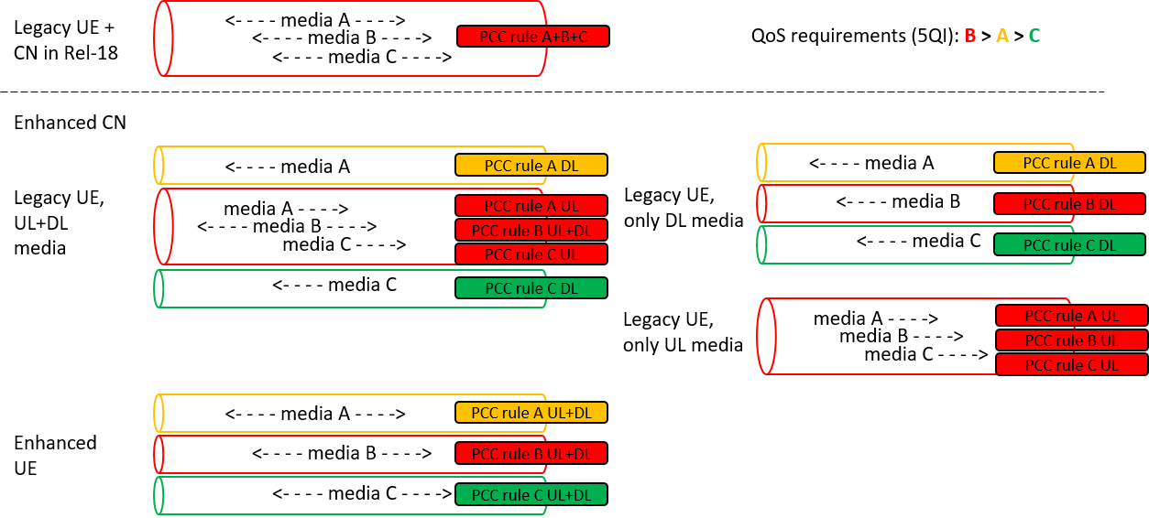

Figure 1: Possible QoS Flow scenarios for mixed traffic

Figure 1 shows the possible QoS Flow scenarios for a mixed traffic with 3 media flows (A, B, C) each having different QoS requirements. Media flow B has the strongest QoS requirements in terms of delay budget and error ratio, followed by media flow A, while media flow C has the weakest QoS requirements.

If the UE is not enhanced with the additional new type of Packet Filter, the UE is not able to separate the media flows in UL direction. Consequently, the UL traffic of all media flows will be transferred in a single QoS Flow and that QoS Flow needs to have a 5QI according to the most stringent QoS requirements of any of the media flows, as otherwise, the QoS requirements would not be fulfilled for that media flow (the other media flows will then be treated in a better way as well but this should not be a problem, at least not for the application).

Therefore, it’s proposed to add UE capability for support of the additional new type of Packet Filter into the UE 5GSM Core Network Capability so that the PCF can determine whether it is necessary to handle the mixed traffic together in a single QoS Flow or whether it is possible that the multiple media flows are handled separately in different QoS Flows, each with different QoS parameters. Once the PCF became aware of the scenario, it can generate the PCC rules for the media flows accordingly with respect to their traffic filters and QoS parameters. Note that we assume that the CN is enhanced with the mixed traffic feature (i.e. PCF, SMF and UPF support the additional new type of Packet Filter) and therefore, the PCC will always generate at least one separate PCC rule for each media flow so that the policy instructions (e.g. for charging, policing, traffic handling, …) can be given on a per media flow basis, regardless of whether the media flows are transferred with the same QoS Flow or not (as the UPF can always separate the media flows).

The conclusion description should be updated accordingly so that the normative work can start. In addition, for better readability, the conclusion description is restructured a bit so that the UL and DL direction are documented separately (where necessary).

# 2. Text Proposal

It is proposed to capture the following changes vs. TR 23.700-70.

* * * * First change * * * *

## 8.4 Conclusions for Key Issue #4

The following aspects are concluded as principles for normative work:

1. The AF may provide QoS requirements for media flows and additional packet filters as part of "AF session with required QoS". The detectable media flows that require different QoS treatment are mapped to distinct QoS Flows. If the AF does not provide any QoS requirement for the media flows or it provides the same QoS requirement, then the media flows can be mapped to the same QoS Flow. For the multiplexed media flows which cannot be differentiated by using the legacy IP Packet Filter, the AF may provide additional Packet Filter in the "AF session with required QoS" procedure to the NEF/PCF.

2. In order to uniquely identify each media flow, the additional packet filter is used together with the legacy packet filter. The additional Packet Filter is used to differentiate the media flow among multiple media flows that share the same legacy packet filter in uplink (in UE) and/or downlink (in UPF) in the following case:

a) For the media flows that are transported in (S)RTP, (S)RTCP and other associated protocols that are multiplexed into a single UDP/IP traffic flow as specified in IETF RFCs 5761, 5764, 7983, 8872, 8843 and 9443, the additional Packet Filter SHALL be the Synchronization Source (SSRC), Payload Type (PT) and RTP-M header fields.

3. A UE supporting the additional new type of Packet Filter shall indicate this to the SMF at PDU Session establishment and the SMF provides this UE capability information to the PCF. The PCC rules are enhanced to support the additional new type of Packet Filter along with legacy packet filter. The PCF generates the PCC rules under consideration of the UE capability for the additional new type of Packet Filter and the QoS requirements provided by the AF, i.e. the PCF needs to decide which PCC rules and associated QoS to generate for the media flows, and sends them to the SMF:

- For mixed traffic in downlink direction only: The PCF may generate a PCC rule per media flow using the additional Packet Filter along with legacy packet filter (assuming here that the UPF supports the new type of Packet Filter), according to the AF request and operator policies.

- For mixed traffic in uplink direction only or for mixed traffic in both directions: If the PCF has received the UE capability information, the UL media flows can be handled separately and the PCF may generate a PCC rule per media flow using the additional Packet Filter along with legacy packet filter (assuming here that the UPF supports the new type of Packet Filter) and sets the QoS parameters according to the individual QoS requirements of the respective media flow and operator policies.

- For mixed traffic in uplink direction only: If the PCF did not receive the UE capability information, the UL media flows are mapped on one QoS Flow, as per legacy specification. The PCF may still generate- a PCC rule per media flow and set the QoS parameters of the common QoS flow based on the AF requirements and PCF local policies.The PCC rules contain the additional Packet Filter along with legacy packet filter (assuming here that the UPF supports the new type of Packet Filter), so that the UPF can treat the UL media flows separately (e.g. for charging and policing purposes). In addition, the PCF notifies the AF that the requested QoS requirements cannot be fulfilled, including information about the allocated QoS parameters to the service data flows.

- For mixed traffic in both directions: If the PCF did not receive the UE capability information, the PCF may follow different approaches for generating the PCC rules depending on operator configuration.

4. The SMF binds the PCC rules to QoS Flows (based on existing principles) and provides N4 Rules to the UPF and QoS rules to the UE with the following enhancements:

- For both directions, the received additional new type of Packet Filter along with legacy packet filter are provided to the UPF in the N4 rules. The PDI in PDR is extended to support the additional new type of Packet Filter.

- For the uplink direction, the QoS rules are enhanced to include the additional new type of Packet Filter when it is received in the corresponding PCC rule and the SMF has received the UE capability information (additional new type of packet filter is not expected to be interpreted by a legacy UE; in case of legacy UE, SMF will use legacy packet filters only). If supported by the UE, the UE uses both the legacy packet filter and the additional new type of packet filter for QoS Flow mapping.

NOTE: Backwards compatibility is ensured as legacy UEs won’t receive additional packet filters and continue to match the XRM traffic to a QoS flow with the legacy packet filters. The details on the UE capability information for support of the additional new type of Packet Filters are left to CT1.

* * * * End of changes * * * *