3GPP TSG-SA WG2#164 S2-2407809
Aug 19th – Aug 23th , Maastricht, NL

Source: China Mobile
Title: Solution 10 – updating AF triggered registration procedures with read-only operations
Document for: Approval
Agenda Item: 19.14
Work Item / Release: FS_AmbientIoT / Rel-19
Abstract of the contribution: This contribution updates AF triggered registration procedure with read-only operations.

1. Text proposal
It is proposed to agree the following changes to TR 23.700-13:

>>>>BEGINNING OF CHANGES<<<<

6.10 Solution #10: Registration procedure for Ambient IoT Devices

6.10.1 Description
This solution is for Key Issue #2 "Identification, Subscription, Registration and Connection management".
As depicted in Architecture Requirements, the DT and DO-DTT traffic types will be studied in this stage. The Ambient IoT devices could be driven by the network for Topology1 or UE for topology 2 before registering to the network. This proposal proposes one potential mechanism for identification, subscription, registration management, and registration procedures as well.
As we know, 5GS uses SUPI with PLMN info, PEI, and GPSI as identifications for device ID based access control, identification, authentication, routing steering, and service purposes. However, due to cost and power consumption, most ambient IoT devices may not have these kinds of IDs. Referencing the RFID solution, most likely, the ambient IoT device has the following IDs:
1) TID (See GS1 TDS Release 2.1 [10]): The AIoT manufacturer configures the tag ID in advance. It is only readable. It can be treated as PEI in the ambient IoT solution.
2) EPC (See GS1 TDS Release 2.1 [10]): Electrical Product Code. The ID can be used to flexibly define one or a group of ambient IoT devices in the ambient IoT service procedure. It can be treated as GPSI in the ambient IoT solution.
Unfortunately, neither TID nor EPC has the operator ID information. Therefore, they are not suitable for device ID based access control, identification, and routing steering purposes. The solution introduces a new device ID. It can be treated as SUPI. The device ID is either allocated by 5GC or the third party. This ID need to be kept internally in 5GS and ambient IoT devices for access control, identification, and route steering purposes. The format of the device ID is Operator ID + Group ID + Instance ID.
Editor's note: Detailed information carried in Operator ID and Group ID is FFS.
To simplify the pre-configuration procedure, only Operator ID and Group ID will be pre-configured in the ambient IoT device. Instance ID doesn’t need to be pre-configured in the ambient IoT devices. Once the AF-triggered registration procedure is performed successfully based on TID and default credentials, the 5GC will generate a new entire device ID with a unique instance ID or will obtain the entire unique device ID from the third party. The device ID’s registration status and binding association with TID are kept in the 5GC. The new device ID will not be synced with the ambient IoT device to realize an AF-triggered registration procedure with read-only operations.
In the subsequent ambient IoT service operations, the ambient IoT will send TID info to 5GC, which will get the actual device ID based on the binding association between the device ID and TID. This is why only the operator ID and group ID are pre-configured in the ambient IoT device, and the newly generated device ID is not synced with the ambient IoT device; however, the 5GC still can get the correct ambient IoT device ID and can perform the access control based on it.
furthermore, EPC ID can also be pre-configured in the ambient IoT device. In the solution, full or partial EPC can be used to match one specific ambient IoT device or a group of ambient IoT devices flexibly. Matched ambient IoT devices will respond with TID and credentials for authentication purposes.
Besides, the credential holder can be flexibly placed in the serving operator, roaming operator, enterprise, or third AF based on Operator ID and Group ID to realize different networking architectures.
The principles/assumptions are given below:
- A new network function named Ambient IoT NF may be adopted to manage Ambient IoT devices and procedures. If not, this relevant function can be supported by AMF.
- In 5GC, each Ambient IoT device has a unique device ID that consists of the Operator ID, group ID, and Instance ID.
- The device ID is kept internally in 5GS and ambient IoT devices for access control, identification, and route steering purposes.
- The ambient IoT device is pre-configured with the EPC, Operator ID + Group ID, TID, and default credentials.
- The credential holder is pre-configured with TID and default credentials.
- The solution is based on an operator-controlled Ambient IoT device.

6.10.2 Procedures

6.10.2.1 Procedures for AF triggered Registration for Topology 1
The following figure presents a procedure of AF triggered registration for Topology 1.
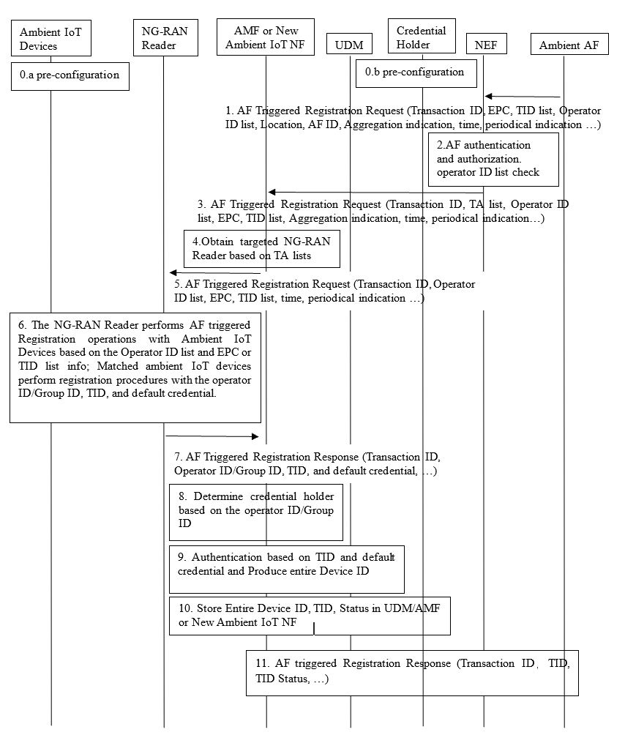

Figure 6.10.2-1: AF triggered Registration Procedure for Topology 1
0.a. The Ambient IoT devices are pre-configured with default AIoT device ID and default credentials. TID (See GS1 TDS Release 2.1 [10]) is configured by AIoT manufacturers in advance. The instance ID value in the default AIoT device ID is set to zero. The ambient IoT device will implicitly know its active or inactive status based on the instance value in the solution.
NOTE 1: How information is configured into ambient IoT device is out of scope of 3GPP.
0.b Meanwhile, the 5GC or the third credential holder is also pre-configured with the TID, default credentials, status (inactive), and so on.
1. AF sends an AF Triggered Registration Request to NEF with the following parameters: Transaction ID, TID list, Operator ID list, location, AF ID, Aggregation indication information, time, periodical indication, and so on.
- Operator ID list: This information is used to define the targeted ambient IoT devices from the operator's perspective, supporting multiple operator ambient IoT device access. It could be one specific operator or a list of operators.
- TID list: The information can be used to define one or a few targeted ambient IoT devices. If the TID list is carried in the message, it means AF wants to trigger one or a few ambient IoT devices defined by the TID list to perform the registration procedure. If the TID list is not carried in the message, it means AF wants to trigger all unregistered Ambient IoT devices in this location to perform the registration procedure. The ambient IoT device will implicitly know its registered or unregistered status based on the instance value in the device ID. If the instance has all zero values in the device ID, then the ambient IoT device has an unregistered status.
- Aggregation indication: It is used to tell the 5GS how to handle the response messages - aggregation response or not.
- Time: when the service will be carried out exactly. This parameter is only carried in the AF-triggered whole unregistered ambient IoT devices performing registration procedure scenarios.
- Periodical indication: whether the service operation will be executed periodically. This parameter is only carried in the AF-triggered whole unregistered ambient IoT devices performing registration procedure scenarios.
2. NEF will perform the below actions towards the third Ambient AF
- Perform authentication to the third Ambient AF to decide whether it is allowed to access 5GS or not.
- Check the authorization to determine whether the third Ambient AF is allowed to perform an AF triggered registration operation or not.
- Check the authorization to determine whether operators in the operator list ID are allowed or not.
- Converting location information to TA List information.
The NEF obtains serving AMF or Ambient IoT NF based on the TA list.
3. The NEF sends AF Triggered Registration Request to the AMF/Ambient IoT NF, including the TID list ID, Transaction ID, Operator ID list, TA list, aggregation indication, time, periodical indication, and so on.
4. The AMF/Ambient IoT NF selects the NG-RAN reader based on the TA list.
5. The AMF/Ambient IoT NF forwards AF triggered the registration request to the NG-RAN reader, including the TID list, Operator ID list, time, periodical indication, and so on.
6. NG-RAN activates one or a few targeted ambient IoT devices that match both the TID list and Operator ID list to perform the registration procedure with the default device ID, TID, and default credentials. If the TID list is not carried by the NG-RAN reader, all unregistered ambient IoT devices that match the operator ID list have to execute the registration procedure . The ambient IoT device will implicitly know its registered or unregistered status based on the instance value in the device ID. If the instance has all zero values in the device ID, then the ambient IoT device has an unregistered status. A receiving limit time may be configured on NG-RAN. Once timeout, the message received after this time will be discarded by NG-RAN.
7. The NG-RAN reader forwards the registration messages with the default device ID, TID, and default credentials to AMF.
NOTE 2: Considering the NG-RAN reader sequence scanning behaviour, don't suggest that NG-RAN perform a response aggregation operation during the interactive authentication procedure between ambient IoT devices and 5GC. Aggregation operations may only be performed in 5GC in this scenario.
8. Upon receiving the registration message from NG-RAN, AMF/New AIoT NF can determine the targeted credential holder based on local configurations related to operator ID and/or group ID derived from the default device ID.
9. Perform an authentication operation based on TID as username and default credentials between AMF/New AIoT NF and the credential holder. Once authentication is successful, a Real device ID with a unique and non-zero instance ID will be produced internally by 5GC or the third party..
10. 5GC stores the new device ID, TID, status (active), and so on in UDM, AMF/New AIoT NF, 5GC sets the device status as active. The status information will be used in the Ambient IoT service procedures to verify the Ambient IoT device.
11. AMF/New AIoT NF will sync up new device IDs with relative ambient IoT devices.
12. The AMF/New AIoT NF returns AF Triggered Registration Response to the AF via NEF.
NOTE 3: Security related mechanisms will be in the remit of SA WG3.

6.10.2.2 Procedures for AF triggered Registration for Topology 2
The registration may be triggered by AF via the UE reader. The UE reader interacts with AMF /New Ambient IoT NF via NG-RAN, which could be regarded as an AF triggered registration procedure for topology 2.
Figure 6.10.2-2: AF triggered Registration Procedure for Topology 2
1. The UE Reader performs the registration procedure, including the fixed or mobile type of UE reader, location, and AF ID.
2. AF sends an AF Triggered Registration Request to NEF with the following parameters: Transaction ID, TID list, Operator ID list, location, AF ID, Aggregation indication information, time, periodical indication, UE GPSI, and so on.
If UE GPSI is included in the message, the third AF wants to perform an AF-triggered registration procedure with a designated UE reader defined by UE GPSI. In addition, time and periodical indication parameters are not included in the message.
If UE GPSI isn't included in the message, the third AF wants to perform an AF-triggered registration procedure without designated UE readers. 5GS determines the involved UE readers based on input info from the third AF, such as location, AF ID, and so on. Considering UE reader posture, such as UE reader antenna pointing direction, only fixed-type UE readers will be involved in the procedure.
3. NEF will perform the below actions towards the third Ambient AF:
- Perform authentication to the third Ambient AF to decide whether it is allowed to access 5GS or not.
- Check the authorization to determine whether the third Ambient AF is allowed to perform an AF-triggered registration operation.
- Check the authorization to determine whether operators in the operator list ID are allowed or not.
- Converting location information to TA List information.
The NEF obtains serving AMF or Ambient IoT NF based on the TA list.
4. The NEF sends AF Triggered Registration Request to the AMF/Ambient IoT NF, including the Transaction ID, Operator ID list, TID list ID, TA list, AF ID, aggregation indication, time, periodical indication, UE GPSI and so on.
5. If UE GPSI isn't included in the message, the AMF/Ambient IoT NF selects the fixed-type UE readers based on the TA, Location list, and AF ID. Alternatively, if UE GPSI is carried in the message, the AMF/Ambient IoT NF selects the designated UE reader based on UE GPSI.
6. First, The AMF/Ambient IoT NF sets up the connection with targeted UE readers. Then, it forwards the AF-triggered registration request to the fixed-type UE readers or the designated GPSI UE reader, including the TID list, Operator ID list, time, periodical indication, and so on.
7. the fixed-type UE readers or the designated GPSI UE reader activate one or a few targeted ambient IoT devices that match both the TID list and Operator ID list to perform the registration procedure with the default device ID, TID, and default credentials. If the TID list is not carried in the message, all unregistered ambient IoT devices in the fixed-type UE readers' or the designated GPSI UE reader's serving area that match the operator ID list have to execute the registration procedure. The ambient IoT device will implicitly know its registered or unregistered status based on the instance value in the device ID. If the instance has all zero values in the device ID, then the ambient IoT device has an unregistered status. A receiving limit time may be configured on NG-RAN. Once timeout, the message received after this time will be discarded by NG-RAN.
NOTE: Considering the latency requirement and reader scanning capability, don't suggest that UE Reader performs a response aggregation operation during the interactive authentication procedure between ambient IoT devices and 5GC. Whether and when the UE Reader should engage the response aggregation should be decided on the service requirements and service scenario, e.g. when the latency exceeds the scanning speed or when the Topology 1 and Topology 2 are in one Registration request.
8. AMF/New AIoT NF Determines the credential holder based on the default Device ID; the credential holder authenticates the ambient IoT device based on the TID and default credential. If authentication is successful, 5GS produces a new Device ID, 5GC sets the device status as active. At the same time, new Device ID, TID, Status (active), and so on are stored in UDM and AMF/ New Ambient IoT NF. The status information will be used in the Ambient IoT service procedures to verify the Ambient IoT device
9. AMF/New AIoT NF will sync up new device IDs with relative ambient IoT devices.
10. The AMF/New AIoT NF returns AF Triggered Registration Response to the AF via NEF.

6.10.2.3 Procedure of AF triggered Registration during AIoT service in Topology 1
The following procedure focuses on the scenario where the AF sends the AIoT inventory request to 5GC with device information and the 5GC identifies there exists unregistered device among the target AIoT devices through locally stored information like device subscription-like data.
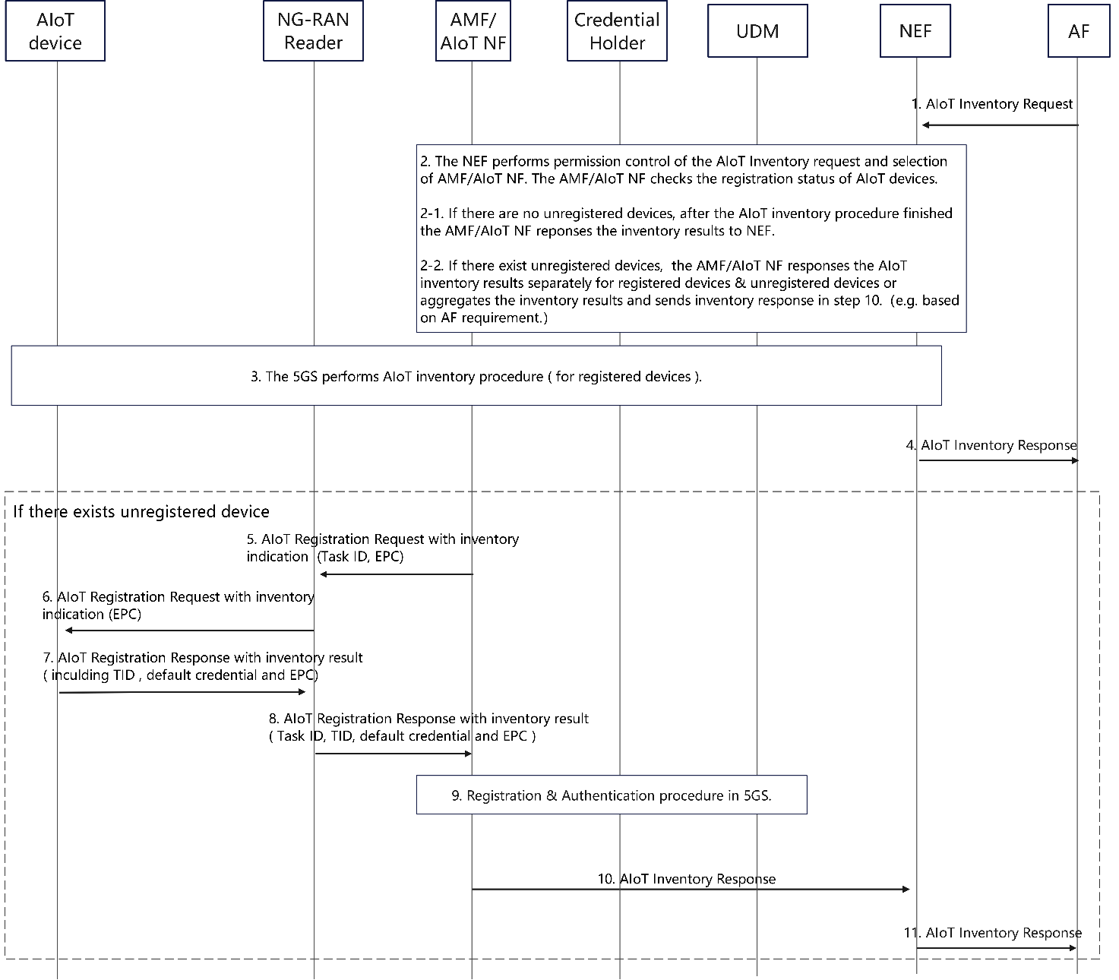
Figure 6.10.2-3: Procedure of AF triggered Registration during AIoT service in Topology 1
- The AF sends the AIoT Inventory Request to the NEF, carrying the AF ID, device information, optional target area information, optional service parameters (e.g. AIoT service time requirement from AF’s perspective).
NOTE 1: Device information is used to limit the inventory to the AIoT Device matching the provided information (e.g. 3rd-party defined device ID like EPC).
NOTE 2: AIoT service time requirement refers to the end-to-end time requirement of the AIoT service operation (i.e. AIoT Inventory procedure or AIoT Command procedure) from AF's perspective.
- The NEF performs the permission control of the AIoT Inventory Request and sends the AIoT Inventory Request to the AMF/AIoT NF. The AMF/AIoT NF also checks the registration status of AIoT devices.
2-1. If there are no unregistered devices, after the AIoT inventory procedure the AMF/AIoT NF responses the inventory results to NEF in step 3. The step 5~step 11 are skipped.
2-2. If there exist unregistered devices, the 5GC performs registration procedure with inventory indication and the AMF/AIoT NF responses the AIoT inventory results separately for registered devices & unregistered devices or aggregates the inventory results and sends inventory response in step 10.（e.g. based on AF requirement.）
NOTE 1: Based on the device registration status retrieved from UDM, the AMF/AIoT NF identifies registered-device information and unregistered-device information.
NOTE 2: If the AIoT Inventory Request from AF does not carry the device information (e.g. only target area information), it is FFS whether the AIoT device can know its registration status by itself and whether it can carry an indication in an UL message to the Reader or CN to trigger the registration process. Whether the AIoT device can keep or update the registration status in its NVM (Non-Volatile Memory) is up to RAN WG design.
NOTE 3: The AMF/AIoT NF may generate a Task ID corresponding to this inventory request in step2.
- The 5GS performs AIoT inventory procedure ( for registered devices ).
- The NEF sends AIoT inventory response to the AF.
If there are no unregistered devices identified in step 2, the following steps are skipped.
- The AMF/AIoT NF sends the AIoT Registration Request with the inventory indication to the NG-RAN reader, carrying the Task ID, unregistered-device information (e.g. 3rd-party defined device ID like EPC).
- The NG-RAN reader activates the AIoT device and forwards the AIoT Registration Request with the inventory indication to the AIoT device.
NOTE: The inventory indication requires AIoT devices to carry the inventory result (i.e. device ID) in the AIoT Registration Response.
- The matched AIoT device sends the AIoT registration response with the inventory result, including the default credential, TID and device ID, to the NG-RAN reader.
- The NG-RAN Reader sends the AIoT Registration Response with the inventory result to CN.
- Registration procedure and authentication procedure in 5GS.
NOTE 1: The 5GS stores the registration status as subscription-like information of the AIoT device after the registration procedure is performed successfully.
NOTE 2: The step 5~9 can be performed in parallel with the procedure in step 3.
- The AMF/AIoT NF sends AIoT Inventory Response to the NEF following the description in step 2-2.
- The NEF sends the AIoT Inventory Response to AF following the description in step 2-2.

6.10.3 Impacts on services, entities and interfaces
NEF:
- Capability to authentication and authorization to the third ambient IoT AF.
- Capability to support verification on operator ID list.
AMF/Ambient IoT NF:
- The AMF/Ambient IoT NF selects the NG-RAN reader and/or UE reader based on the TA list, Location, and AF ID.
- Capability to aggregate the Ambient IoT devices' response.
- Capability to be aware of the Topology types.
- Capability to check the registration state of the AIoT device.
UDM/Credential holder:
- The UDM stores the profile information of Ambient IoT devices.
- Authenticating the ambient IoT device and producing new device IDs.
NG-RAN Reader:
- The NG-RAN reader performs paging and receives responses from Ambient IoT devices in Topology 1.
UE Reader:
- The UE Reader performs paging and receives responses from Ambient IoT devices in Topology 2.
Ambient IoT device:
- The ambient IoT device stores the default AIoT device ID or the and default credentials and updates the device ID if the registration procedure is performed successfully.
- Performing registration procedure once it is matched during the paging procedure.

>>>>END OF CHANGES<<<<

