3GPP TSG-RAN WG4 Meeting #111 R4-2407661
Fukuoka, Japan, 20th – 24th May, 2024
Agenda item: 7.10.3
Source: CAICT
Title: Analysis of FR1 MIMO OTA measurement campaign and Proposals on performance requirements
Document for: Approval

1 Introduction
In 3GPP Rel-18 FR1 MIMO OTA measurement campaign, volunteer labs provided measurement data for specifying FR1 MIMO OTA performance requirements [1]-[5]. This contribution presents the final analysis of all measurement data submitted by volunteer labs based on the approved Framework for FR1 MIMO OTA requirements development [6]. The detailed analysis data is attached in the Excel worksheet of this contribution.

2 Discussion
According to the test plan TS 38.151 V18.0.0, DUTs shall meet the additional criteria as below, otherwise, the DUTs fail the FR1 MIMO OTA test:
The additional criterion in azimuthal orientations shall be met:
- The EUT must meet 70% throughput in 11 of total 12 azimuthal orientations. If the EUT fails to meet this criterion even under maximum downlink power condition (i.e. P_{RS-EPRE-MAX}), the EUT shall fail the FR1 MIMO OTA test.
- The EUT must meet 90% throughput in 10 of total 12 azimuthal orientations. If the EUT fails to meet this criterion even under maximum downlink power condition (i.e. P_{RS-EPRE-MAX}), the EUT shall fail the FR1 MIMO OTA test.

It can be observed from the measurement results that a proportion of the DUTs failed the FR1 MIMO OTA test at bands n28 and n5. The summary of the amount of DUTs failed the test is listed in Table 1.
Table 1. Summary of the amount of DUTs
Band | n28 | n5 | n1
Total amount of DUTs | 23 | 19 | 15
Amount of DUTs fail 90% criteria but pass 70% | 5 | 0 | 0
Amount of DUTs fail 90% and 70% criteria | 10 | 4 | 0

Regarding whether to include the “failed” UEs, there are three options as listed in the WF of the last meeting [7]:
Issue 1-2-2: Whether the measurement data from the “failed” DUTs can be included
Options:
- Option 1: Include all measurements irrespective of whether they failed the test.
- Option 2: Include those devices that only fail the 90% criteria (but pass 70%), but exclude those that fail the 70% criteria.
- Option 3: Exclude all measurements that fail either 70% or 90% TP.
Agreement:
- FFS the options and make decision at the next meeting.

The CDF curves of the measurement data for bands n28, n5, and n1 are plotted in Figs. 1~3, all three options are included for comparison.
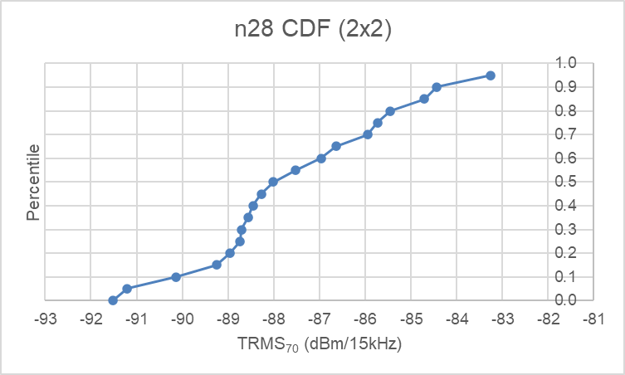
(a) Option 1
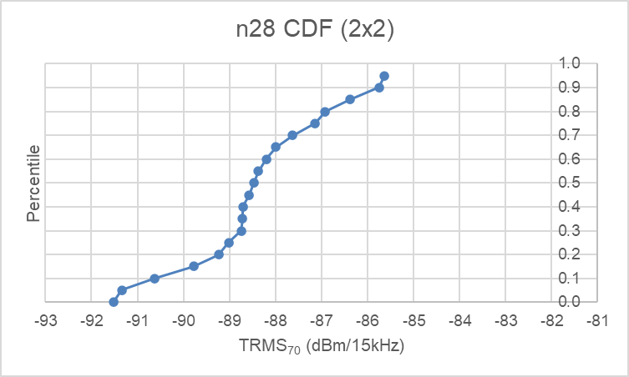
(b) Option 2
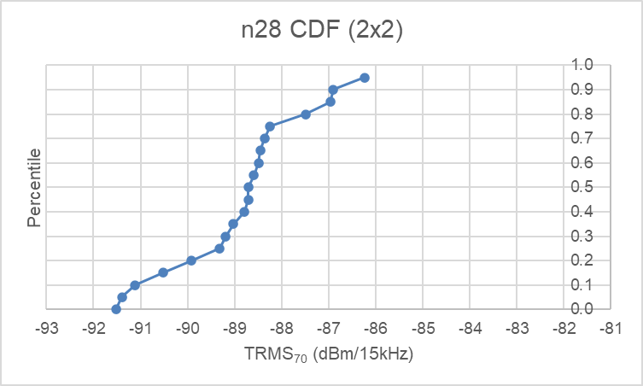
(c) Option 3
Figure 1. CDF of measurement data at band n28
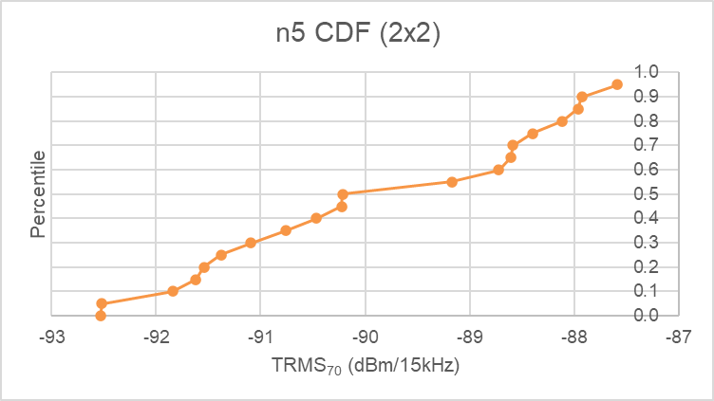
(a) Option 1 and Option 2 (the same)
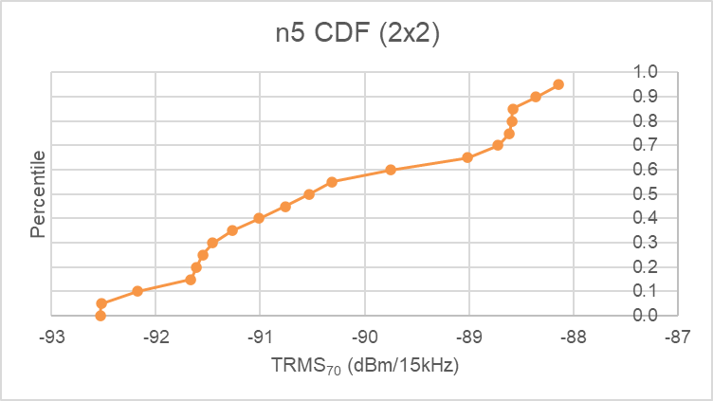
(b) Option 3
Figure 2. CDF of measurement data at band n5
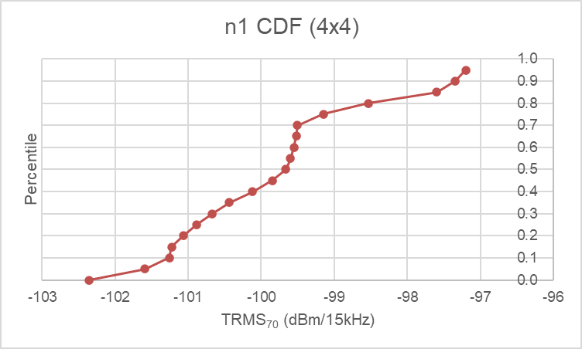
Figure 3. CDF of measurement data at band n1 (Options 1, 2, 3 are the same)
The TRMS values at 80%, 85%, 90%, 95% percentiles of the CDF curves are summarized in Table 2.
Table 2. Summary of CDF analysis results [dBm/15 or 30 kHz]
Options | Percentile (pass rate) | n28 TRMS₇₀ | n5 TRMS₇₀ | n1 TRMS₇₀
Option 1 | 80%-tile | -85.45 | -88.11 | -98.53
 | 85%-tile | -84.71 | -87.96 | -97.60
 | 90%-tile | -84.43 | -87.93 | -97.34
 | 95%-tile | -83.26 | -87.58 | -97.20
 | Total amount of samples  (Threshold: 15) | 23 | 19 | 15
Option 2 | 80%-tile | -86.92 | Same as  Option 1 | Same as  Option 1
 | 85%-tile | -86.38
 | 90%-tile | -85.75
 | 95%-tile | -85.63
 | Total amount of samples  (Threshold: 15) | 18
Option 3 | 80%-tile | -87.49 | -88.59 | Same as  Option 1
 | 85%-tile | -86.96 | -88.58
 | 90%-tile | -86.90 | -88.36
 | 95%-tile | -86.24 | -88.14
 | Total amount of samples  (Threshold: 15) | 13 | 15

In the Framework [6], it was agreed that the value at [85%] percentile of the CDF curve can be selected as the starting point for requirement discussion. Based on the CDF analysis for the three options, we have the following proposal accordingly:
Proposal 1: Adopt the values at 85% percentile of the CDF curves as starting point for requirements discussion.
- For band n28, define the performance requirement in the range of -87.0 to -84.7 dBm/15kHz.
- For band n5, define the performance requirement in the range of -88.6 to -88.0 dBm/15kHz.
- For band n1, define the performance requirement as -97.6 dBm/30kHz.

3 Conclusion
This contribution provides the final analysis of FR1 MIMO OTA measurement campaign and proposals on performance requirements.
Proposal 1: Adopt the values at 85% percentile of the CDF curves as starting point for requirements discussion.
- For band n28, define the performance requirement in the range of -87.0 to -84.7 dBm/15kHz.
- For band n5, define the performance requirement in the range of -88.6 to -88.0 dBm/15kHz.
- For band n1, define the performance requirement as -97.6 dBm/30kHz.

References
- R4-2407660, FR1 MIMO OTA measurement campaign data submission, CAICT, 3GPP RAN4#111, May 2024.
- R4-2408226, Measurement data for Rel-18 FR1 MIMO OTA performance requirements, CMCC, BUPT, 3GPP RAN4#111, May 2024.
- R4-2407810, Test result for FR1 performance requirement, Xiaomi, 3GPP RAN4#111, May 2024.
- R4-2408903, 3GPP Rel-18 FR1 MIMO OTA Measurement Campaign-OPPO, 3GPP RAN4#111, May 2024.
- R4-2407063, On FR1 MIMO OTA measurement results, Apple, 3GPP RAN4#111, May 2024.
- R4-2405468, Updated Framework and time plan for FR1 MIMO OTA performance requirements development (Apr 2024), CAICT, 3GPP RAN4#110bis, Apr. 2024.
- R4-2406083, WF for [110bis][337] NR_MIMO_OTA_enh, CAICT, 3GPP RAN4#110bis, Apr. 2024.

