3GPP TSG-RAN WG4 Meeting #111 R4-2409930
Fukuoka City, Fukuoka, Japan, 20th – 24th May, 2024

Agenda item: 7.9.3
Source: vivo
Title: WF for [111][336] NR_FR1_TRP_TRS_enh
Document for: Approval

Introduction
This WF capture the discussion conclusion for Rel-18 FR1 TRP TRS WI.

Topic #2: Rel-18 TRP TRS requirements related issues

Sub-topic 2-1 RC Harmonization and lab alignment
Issue 2-1-1: Total Harmonization MU
Conclusions:
Total harmonization MU=AC MU+0.2dB

Issue 2-1-2: Maintenance work for RC unavailable results
Conclusions:
Allow to update RC harmonization data in maintenance phase when the unfinished n28 testing from lab 9 is done.

Issue 2-1-3: Rel-18 RC harmonization conclusions
Conclusions:
Conclude RC test method harmonization for bands>3GHz. FFS below 3GHz

Sub-topic 2-2 Additional CBW for band n28/n41/n77/n78 requirements
Issue 2-2-1: Scaling factor to derive requirements on alternate narrow CBW for n28/n41/n77/n78?
Conclusions:
7dB offset value for n41/77/78 TRS, between 100MHz and 20MHz CBW.

Issue 2-2-3: SPOT method for alternative CBW testing
Conclusions:
Capture SPOT method into TR as alternative for TRS measurements when using different channel bandwidth configurations on the same channel.

Sub-topic 2-3 Rel-18 TRP TRS requirements work
Issue 2-3-1: Thresholds of UE information for measured data pool
Conclusions:
- Adopt the following values for the thresholds related to the devices pool for Rel-18.
  - Minimum number of devices for each band, each device size, each power class: 40
  - Minimum number of device models: 30
  - Minimum number of devices' vendors: 5
  - Percentage of devices from second-half 2021 to 2024: 100%
  - Percentage of the devices that are certified by PTCRB/GCF/NAL-CTA/CE/FCC: 100%

Issue 2-3-1: Requirements discussion
Working procedure:
- RAN4 will go to band-by-band discussion for new bands.

Issue 2-3-3: Requirements decision
Discussions for band n1 and n28:

requirements | Talk mode TRP |  | Talk mode TRS |  | Browsing mode TRP |  | Browsing mode TRS
 | n1 PC3 | n28 PC3 | n1 TRS | n28 TRS | n1 PC3 | n28 PC3 | n1 TRS | n28 TRS
initial OEMs proposal | 8 | 6 | -86 | -79.5 | 9 | 8.5 | -88 | -83
initial Operators proposal | 10.96 | 8.19 | -89.38 | -82.11 | 12.92 | 11.3 | -91.21 | -85.33
WI Rapporteur proposal | 10 | 7 |  |  | 11.0 | 10.0
Operator C1 | 10.5 | 8 | -87.5 | -80.5 | 12 | 11 | -89.4 | -83.8
OEMs C1 | 9.5 | 6.5 | [-87] | -80 | 10.5 | 9.5 | [-88.5] | [-83.5]

Discussions for band n41 and n78:
requirements | Talk mode TRP |  | Talk mode TRS |  | Browsing mode TRP (R17) |  | Browsing mode TRS (R17)
 | n41 PC2 | n78 PC2 | n41 TRS | n78 TRS | n41 PC2 | n78 PC2 | n41 TRS | n78 TRS
initial OEMs proposal | 9 | 9 | -78.5 | -78.5 | 12.5 | 13 | -80 | -81.2
initial Operators proposal | 13.46 | 13.58 | -82 | -83.42
WI Rapporteur proposal
Operator C1
OEMs C1

80%-95% CDF as information
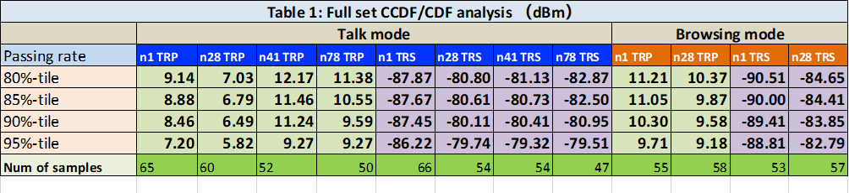

Annex: UE information statistics by RAN4 MCC (for information)
Total Devices | 83
Total Models | 81
Total number of device vendors | 19
Percentage of devices per vendor | 10 | 12.05% | Vendor A
 | 15 | 18.07% | Vendor B
 | 3 | 3.61% | Vendor C
 | 21 | 25.30% | Vendor D
 | 12 | 14.46% | Vendor E
 | 1 | 1.20% | Vendor F
 | 3 | 3.61% | Vendor G
 | 1 | 1.20% | Vendor H
 | 6 | 7.23% | Vendor I
 | 1 | 1.20% | Vendor J
 | 1 | 1.20% | Vendor k
 | 1 | 1.20% | Vendor N
 | 1 | 1.20% | Vendor O
 | 1 | 1.20% | Vendor P
 | 2 | 2.41% | Vendor Q
 | 1 | 1.20% | Vendor R
 | 1 | 1.20% | Vendor J
Percentage of devices per power class per band | 2 | n1 | PC2 | 2.41%
 | 78 |  | PC3 | 93.98%
 | 0 | n28 | PC2 | 0.00%
 | 77 |  | PC3 | 92.77%
 | 61 | n41 | PC2 | 73.49%
 | 14 |  | PC3 | 16.87%
 | 70 | n78 | PC2 | 84.34%
 | 6 |  | PC3 | 7.23%
Percentage of devices per supported band |  |  | n1 | 96.39%
 |  |  | n28 | 88.89%
 |  |  | n41 | 90.36%
 |  |  | n78 | 91.57%
Percentage of devices per year of production | 8 |  | 2021 | 9.64%
 | 30 |  | 2022 | 36.14%
 | 35 |  | 2023 | 42.17%
 | 10 |  | 2024 | 12.05%
Percentage of devices with at least one certification | 83 |  |  | 100.00%
Percentage of devices for each certification | 27 |  | GCF | 32.53%
 | 12 |  | PTCRB | 14.46%
 | 30 |  | NAL(CTA) | 36.14%
 | 30 |  | FCC | 36.14%
 | 35 |  | CE | 42.17%
 | 0 |  | Not Available

