3GPP TSG-RAN WG4 Meeting #111 R4-240xxxx
Fukuoka City, Fukuoka , Japan, 20th – 24th May, 2024
CR-Form-v12.2
CHANGE REQUEST
 | 38.870 | CR | 0010 | rev | 1 | Current version: | 18.1.0
For HELP on using this form: comprehensive instructions can be found at
http://www.3gpp.org/Change-Requests.

Proposed change affects: | UICC apps |  | ME | X | Radio Access Network |  | Core Network

Title: | CR to TR 38.870 on Rel-18 RC lab alignment and harmonization outcome
Source to WG: | vivo
Source to TSG: | R4
Work item code: | NR_FR1_TRP_TRS_enh-Core |  |  |  |  |  | Date: |  |  | 2024-05-08
Category: | F |  |  |  |  |  | Release: |  |  | Rel-18
 | Use one of the following categories:  F (correction)  A (mirror corresponding to a change in an earlier release)  B (addition of feature),  C (functional modification of feature)  D (editorial modification)  Detailed explanations of the above categories can  be found in 3GPP TR 21.900. |  |  |  |  |  |  |  | Use one of the following releases:  Rel-8 (Release 8)  Rel-9 (Release 9)  Rel-10 (Release 10)  Rel-11 (Release 11)  …  Rel-16 (Release 16)  Rel-17 (Release 17)  Rel-18 (Release 18)  Rel-19 (Release 19)
Reason for change: |  | The RC lab alignment and harmonization activity can be concluded, the outcome should be captured in the TR.
Summary of change: |  | Adding Rel-18 RC lab alignment and harmonization working procedure and outcome.
Consequences if not approved: |  | The spec is incomplete.
Clauses affected: |  | 8.1, F.3
 |  | Y | N
Other specs |  |  | X | Other core specifications |  |  |  | TS/TR ... CR ...
affected: |  |  | X | Test specifications |  |  |  | TS/TR CR ...
(show related CRs) |  |  | X | O&M Specifications |  |  |  | TS/TR ... CR ...
Other comments:
This CR's revision history: |  | Revision of R4-2408102

<Start of Changes>

8 Reverberation Chamber test methodology

8.1 General
This clause defines the test method with a Reverberation Chamber (RC) system as an alternate method for FR1 TRP and TRS testing.
The applicability of alternative RC test method is specified as follows:
- Comparison between RC system results and an accredited AC system using golden/reference UEs must be performed on a regular basis.
- For bands >3GHz, RC test method is harmonized with reference AC method, for the case that UE antenna pattern or specific directional EIRP/EIS results are not needed, the RC test method can be used.

<End of changes>

<Start of Changes>

Annex E:
Harmonization outcome of Alternative method and Reference method

E.1 General
This clause records the lab alignment activity of RC test method and harmonization activity between RC and reference AC test method.

E.2 Rel-18 Harmonization activity

E.2.1 Framework and workplan
This clause defines the working procedure on how to proceed the Rel-18 RC lab alignment and harmonization activity. The purpose of RC lab alignment activity is to ensure there is no unexpected lab deviation among different RC systems. The purpose of RC harmonization is for comparison between RC results with reference AC results to demonstrate the gap between different methodologies.
Rel-18 RC lab alignment and RC harmonization activity are performed and analysed based on RC measurement results in Annex E.2.2 and the AC lab alignment results in Annex F.2 and F.3.
RC Test labs are invited to participate to the lab alignment and harmonization test campaign, the following conditions should be fulfilled:
- Participating lab should have Reverberation chamber(s) ready to support testing based on latest version of 3GPP TR 38.870.
- Participating lab should have sufficient test resource to provide the on-time measurement results without delay.
Test methodology:
- Test plan: latest version of 3GPP TR 38.870;
Test cases for RC harmonization Campaign:
- Test bands: n28, n78; one low and one high band is sufficient
- Number of test cases per band for each scenario: left and right at low/mid/high channel, total 6 test cases;
- Use scenario: Both Head and Hand phantom (Talk mode, BHHL and BHHR) and Hand phantom only (Browsing mode, HL and HR);
- Hand Phantom: Wide Grip hand
- Operation mode: NR Standalone (SA)
- Number of Tx chain: UE with 1Tx.
Harmonization Devices:
- Same devices as Rel-18 AC lab alignment activity, listed in Annex F.3.1
Test results submitting:
- Using the same worksheet template in [R4-2313893] to submit the measurement results
- The measurement results of LADs should be submitted to RAN4 by anonymous approach (the UE model should not be disclosed)
- Results shall not be shared between labs before submitting to RAN4 meetings or sharing in the RAN4 reflector. Comparison and lab alignment analysis should only be done in RAN4 meetings/discussions
RC lab alignment criteria:
- The pass/fail criteria are defined as the maximum deviation between the measurement result and the RC reference value
- Confirm the RC reference value derived based on the per-band per-PC averaging approach (linear average with dBm) of RC measurement data pool.
- Apparent outliers will not be considered in averaging process. The value deviates over 1.5*MU from all the other lab’s results should be identified as apparent outlier.
- Pass/fail limit for RC lab alignment should be defined as 0.75*MU as baseline. MU value is the preliminary expanded MU for talk mode and/or browsing mode, defined in Annex B.4.2 and B.5.2.
RC vs AC test methods harmonization criteria:
- The pass/fail criteria are defined as the comparison between each RC results with reference AC value
- Average of AC value per-band per-device in R4-2404644 should be reference value
- Pass fail limits as 0.75*Total harmonization MU
- The harmonization MU value is TBD
Test lab procedures:
- LADs delivery scheme
- LAD delivery scheme is decided after the confirmation of all the RC volunteer labs.
- LAD delivery will also consider the parallel Rel-18 AC lab alignment activity to ensure efficiency
- LAD measurement time in each test lab: finalize LAD measurement within [5] workdays, and deliver to next lab ASAP with LAD delivery In/Out information shared in reflector.
- Encourage test labs to share resulting combined MU based on their own systems

E.2.2 Measurement results
RAN4 use the same LADs in Annex F.3.1 for RC harmonization to ensure the measurement results comparison between AC and RC are based on the same set of devices.
The measurement results from RC test labs are summarized as follows:
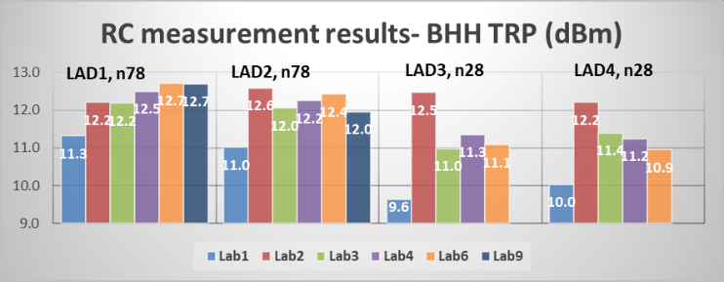
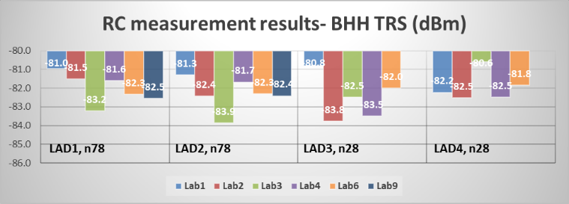
Figure E.2.2-1: Rel-18 RC Talk mode measurement results (no n28 results from Lab9)
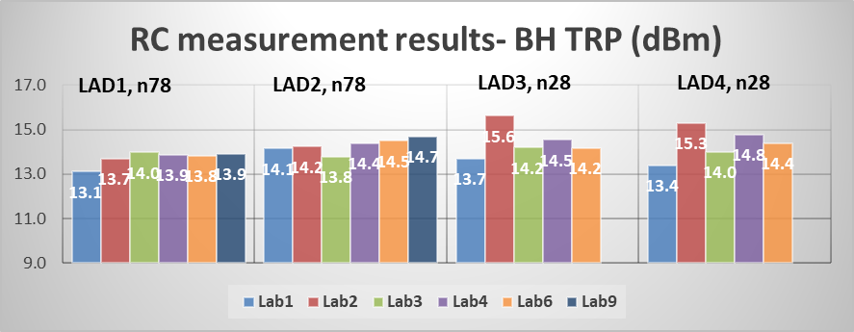
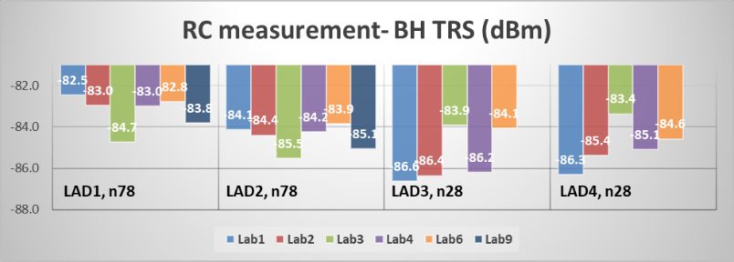
Figure E.2.2-2: Rel-18 RC Browsing mode measurement results (no n28 results from Lab9)
Based on the measured results, the RC lab alignment is analysed and the outcome is as following:
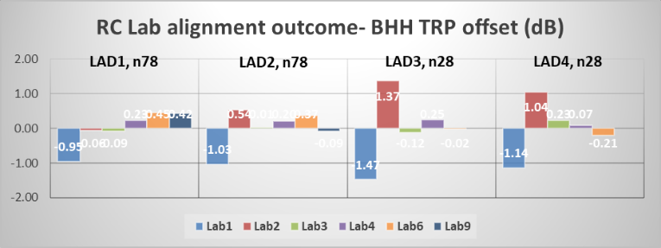
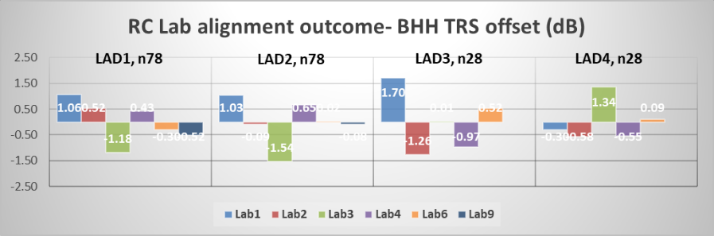
Figure E.2.2-3: Rel-18 Talk mode RC lab alignment analysis, deviation between each test lab and RC reference value (no n28 results from Lab9)
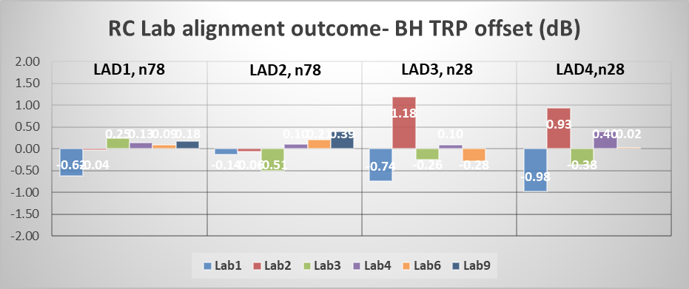
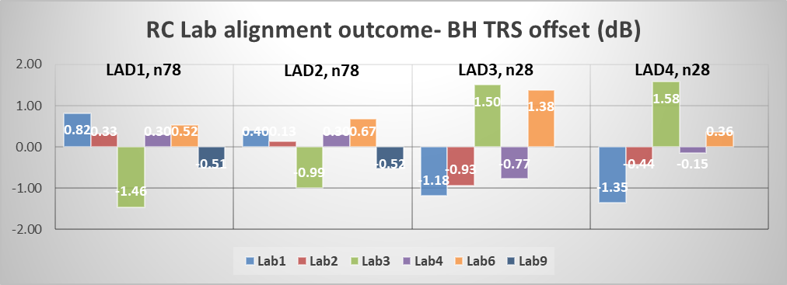
Figure E.2.2-4: Rel-18 Browsing mode RC lab alignment analysis, deviation between each test lab and RC reference value (no n28 results from Lab9)
Based on above analysis in Figure E.2.2-3 and E.2.2-4, the following outcome for RC lab alignment can be observed:
- For n78 and n28 TRP, the RC reference value is derived by the agreed linear average (with dBm) of all the available results, the maximum deviation between test labs and RC reference value is 1.47dB for BHH TRP and 1.18dB for BH TRP.
- For n78 and n28 TRS, the RC reference value is derived by the agreed linear average (with dBm) of all the available results, the maximum deviation between test labs and reference value 1.70dB for BHH TRS and 1.58dB for BH TRS.
Furthermore, the comparison of RC vs AC is also analysed as following:
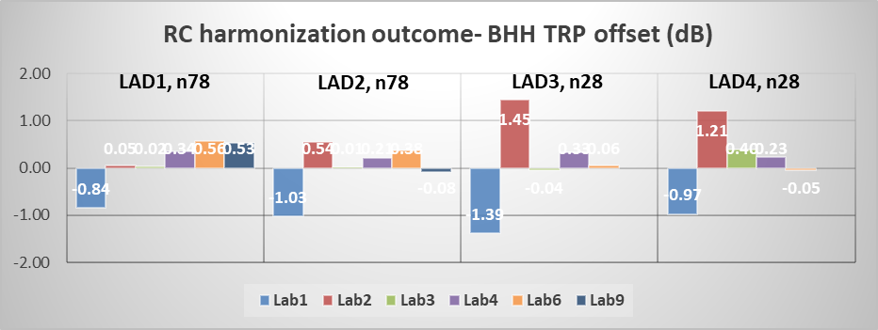
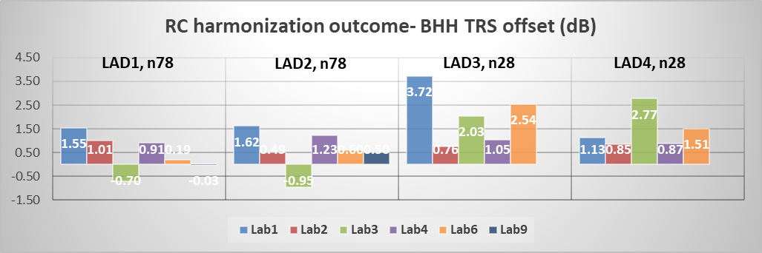
Figure E.3.2-5: Rel-18 Talk mode RC harmonization analysis, deviation between each test lab and AC reference value (no n28 talk mode results from Lab9)
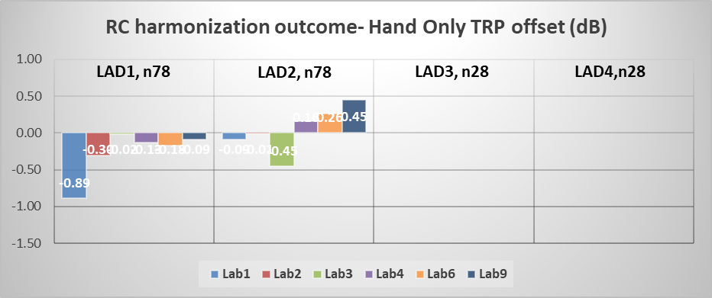
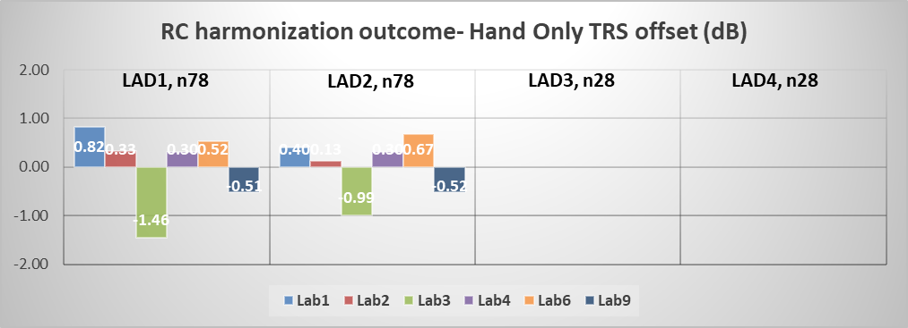
Figure E.3.2-6: Rel-18 Browsing mode RC harmonization analysis, deviation between each test lab and AC reference value (no n28 AC reference value)
Based on above analysis in Figure E.3.2-5 and E.3.2-6, the following outcome for RC harmonization can be observed:
- For Talk mode TRP, the maximum deviation between each RC test lab and AC reference value is 1.03dB for n78 and 1.45dB for n28
- For Browsing mode TRP, the maximum deviation between each RC test lab and AC reference value is 0.89dB for n78
- For Talk mode TRS, the maximum deviation between each RC test lab and AC reference value is 1.62dB for n78 and 3.72dB for n28
- For Browsing mode TRS, the maximum deviation between each RC test lab and AC reference value is 1.46dB for n78
Additional observation is that there is a consistency trend for n28 talk mode TRS, all results (both LAD3 and LAD4) from RC labs are worse than AC reference value.

E.2.3 Pass/fail limit
For RC lab alignment:
For RC lab alignment, the reference value is defined as average value of RC value per-band per-device from all labs in R4-2404644. Pass fail limits is defined as 0.75*RC MU as following.
- TRP: 2.08 dB for talk mode, and 1.90 dB for browsing mode (all FR1 bands)
- TRS: 2.43 dB for talk mode, and 2.28 dB for browsing mode (all FR1 bands)

For RC harmonization:
For RC harmonization, the reference value is defined as average value of AC value per-band per-device from all AC labs in R4-2404644. Pass fail limits is defined as 0.75*Total harmonization MU.
Based on the MU assessment of AC and RC test method in Annex B, the Total harmonization MU is defined as AC MU+0.2dB. The final pass/fail limits for Rel-18 RC harmonization are specified as following:
- Talk mode TRP: 1.62 dB for bands >3GHz, and 1.56 dB for bands <3GHz
- Browsing mode TRP: 1.45 dB for bands >3GHz, and 1.38 dB for bands <3GHz
- Talk mode TRS: 1.88 dB for bands >3GHz, and 1.84 dB for bands <3GHz
- Browsing mode TRS: 1.75 dB for bands >3GHz, and 1.70 dB for bands <3GHz

E.2.4 Conclusions
For RC lab alignment:
Based on the analysis in Annex E.2.2 and pass fail limits defined in Annex E.2.3, 3GPP Rel-18 RC lab alignment activity can be successfully concluded as following:
- All the 6 labs with Reverb chamber system are well aligned at FR1 high band
- All 5 labs with available n28 measurement results from Reverb chamber system are well aligned at FR1 low band

For RC harmonization:
Based on the analysis in Annex E.2.2 and harmonization pass fail limits defined in Annex E.2.3, 3GPP Rel-18 RC harmonization activity can be successfully concluded as following:
- RC test method can be harmonized with reference AC test method at FR1 band >3GHz for TRP and TRS measurements.
- RC test method harmonization with reference AC test method at FR1 FDD bands below 3GHz is not confirmed.

<End of changes>

