3GPP TSG-RAN WG4 Meeting #111 revision of R4-2409550

Fukuoka City, Fukuoka, Japan, 20th – 24th May, 2024
CR-Form-v12.3
CHANGE REQUEST
 | 38.181 | CR | 0023 | rev | 1 | Current version: | 17.4.0
For HELP on using this form: comprehensive instructions can be found at
http://www.3gpp.org/Change-Requests.

Proposed change affects: | UICC apps |  | ME |  | Radio Access Network | X | Core Network

Title: | CR to TS 38.181: Corrections for non-regenerative payload and gateway
Source to WG: | Huawei, HiSilicon
Source to TSG: | R4
Work item code: | NR_NTN_solutions-Perf |  |  |  |  |  | Date: |  |  | 2024-05-13
Category: | F |  |  |  |  |  | Release: |  |  | Rel-17
 | Use one of the following categories:  F (correction)  A (mirror corresponding to a change in an earlier release)  B (addition of feature),  C (functional modification of feature)  D (editorial modification)  Detailed explanations of the above categories can  be found in 3GPP TR 21.900. |  |  |  |  |  |  |  | Use one of the following releases:  Rel-8 (Release 8)  Rel-9 (Release 9)  Rel-10 (Release 10)  Rel-11 (Release 11)  …  Rel-17 (Release 17)  Rel-18 (Release 18)  Rel-19 (Release 19)  Rel-20 (Release 20)
Reason for change: |  | Based on related discussion on Rel-19 regenerative payload (NR_NTN_Ph3-Core WI), in this CR we introduce corrections for non-regenerative payload and gateway terminology in SAN RF test specification.
Summary of change: |  | - Update scope to clarify on non-regenerative payload.  - Update definitions, to align terminology with (non-)regenerative payload (instead of bend pipe, or NTN payload RF).  - Update SAN definition to be generic enough to contain both non-regenerative and regenerative payload options.  - Align usage of the “satellite-gateway” term.  - Update SAN figures to align gateway terminology (gateway vs. satellite-gateway) and payload terminology (remove “NTN payload RF” and replace it with the “satellite payload”).
Consequences if not approved: |  | Non-regenerative payload terminology would remain mis-aligned and ambiguous.
Clauses affected: |  | 3.1, 4.2
 |  | Y | N
Other specs |  | X |  | Other core specifications |  |  |  | TS 38.101-1 CR0093, TS 38.108 CR0073
affected: |  | X |  | Test specifications
(show related CRs) |  |  | X | O&M Specifications
Other comments:
This CR's revision history:

------------------------------ Modified section ----------------------------------

3 Definitions, symbols and abbreviations

3.1 Definitions
------------------------------ Unchanged part omitted ----------------------------------
SAN transponder: part of the SAN permitting to receive, channelize and transmit signals within an allocated bandwidth.
satellite: A space-borne vehicle embarking a transparent payload, or a regenerative payload telecommunication transmitter, placed into Low-Earth Orbit (LEO) or Geostationary Earth Orbit (GEO).
Satellite Access Node (SAN): node providing NR user plane and control plane protocol terminations towards NTN Satellite capable UE, and connected via the NG interface to the 5GC. It encompasses a satellitepayload on board a NTN platform, a satellite-gateway and gNB functions.
satellite-gateway: An earth station or gateway is located at the surface of Earth, and providing sufficient RF power and RF sensitivity for accessing to the satellite.
------------------------------ Next modified section ----------------------------------

4.2 Requirement reference points

4.2.1 SAN type 1-H
For SAN type 1-H, the requirements are defined for two points of reference, signified by radiated requirements and conducted requirements.

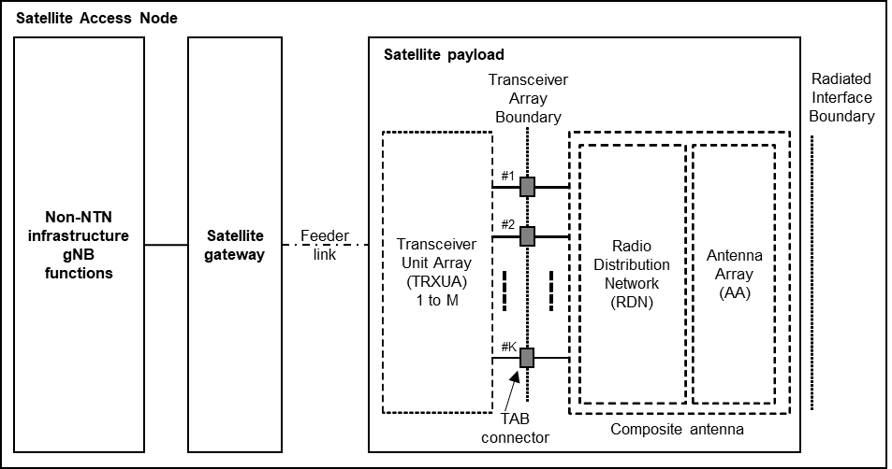
Figure 4.2.1-1: Radiated and conducted reference points for SAN type 1-H
Radiated characteristics are defined over the air (OTA), where the radiated interface is referred to as the Radiated Interface Boundary (RIB). Radiated requirements are also referred to as OTA requirements. The (spatial) characteristics in which the OTA requirements apply are detailed for each requirement.
Conducted characteristics are defined at individual or groups of TAB connectors at the transceiver array boundary, which is the conducted interface between the transceiver unit array and the composite antenna.
The transceiver unit array is part of the composite transceiver functionality receiving and transmitting modulated signal to ensure radio links with users.
The satellite payload is composed by a transceiver unit array and a composite antenna array. The transceiver unit array contains an implementation specific number of transmitter units and an implementation specific number of receiver units.
The composite antenna contains a radio distribution network (RDN) and an antenna array. The RDN is a linear passive network which distributes the RF power generated by the transceiver unit array to the antenna array, and/or distributes the radio signals collected by the antenna array to the transceiver unit array, in an implementation specific way.
How a conducted requirement is applied to the transceiver array boundary is detailed in the respective requirement clause.

4.2.2 SAN type 1-O
For SAN type 1-O, the radiated characteristics are defined over the air (OTA), where the operating band specific radiated interface is referred to as the Radiated Interface Boundary (RIB). Radiated requirements are also referred to as OTA requirements. The (spatial) characteristics in which the OTA requirements apply are detailed for each requirement.

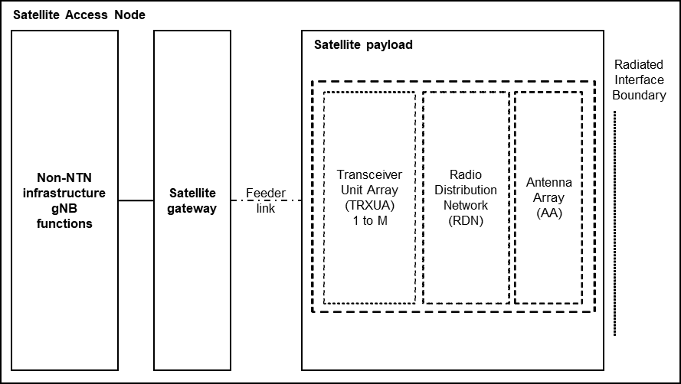
Figure 4.2.2-1: Radiated reference points for SAN type 1-O
------------------------------ End of modified section -------------------------

