3GPP TSG-RAN WG4 Meeting #111 R4-2408014
Fukuoka, Japen, May 20 – 24, 2024

Agenda item: 7.14.3
Source: Apple
Title: Topic summary for [111][217] NR_Mob_enh2_part2
Document for: Information

Introduction
This summary includes the proposals from companies on the following topics:
- RRM core part maintenance of
  - NR-DC with selective activation of cell groups via L3 enhancements
  - Improvement on SCell/SCG setup delay
  - Enhanced CHO configurations
- RRM performance requirements of above objectives
Moderator’s recommendation is also provided under issue.

Recommendation for online discussion:

Topic #1: core part maintenance

Companies’ contributions summary
TDoc | Source | Proposals
R4-2407352 | Apple | Observation 1: allowing validity check for measurement which is obtained during CONNECTED mode before UE goes into IDLE/INACTIVE has no impact on measurement performance in CONNECTED mode.  Proposal 1: It is up to UE implementation whether to perform validity check for measurement which was performed during CONNECTED mode before UE enters IDLE/INACTIVE mode.  Proposal 2: not extend X value with uncertainty in core requirement due to testing issue.
R4-2407484 | CATT | Proposal 1: There is no need to restrict UE from performing validity check for measurements which was performed during CONNECTED mode before UE enters IDLE/INACTIVE mode, and it can be up to UE.  Observation 1: The accuracy requirement for IDLE/INACTIVE mode is more relaxed compared with the requirements for CONNECTED mode.  Observation 2: If some measurements during CONNECTED mode can meet its accuracy requirements, these measurements also will meet the accuracy requirements for IDLE/INACTIVE mode in conditions of validity check.  Proposal 2: The difference of accuracy requirements for measurements between CONNECTED mode and IDLE/INACTIVE mode will not affect the applicability of validity check.  Observation 3: Due to the much shorter time margin compared to X, the impact may be minimal.  Proposal 3: RAN4 should discuss whether only to consider the impact of time margin when testing or also extend X value with uncertainty in core requirement.
R4-2407782 | BeammWave, Nokia | Clause 9.14.5.1:  Correcting “pervious conditions” to “previous conditions”
R4-2407866 | OPPO | For UE supporting [FG-39-8] and idleInactiveNR-MeasReport-r16 or idleInactiveEUTRA-MeasReport-r16, the measurement results on carriers indicated by measIdleCarrierListNR-r16 and/or measIdleCarrierListEUTRA-r16 by higher layers shall be reported.  For UE supporting [FG 39-9], the measurement results on carriers indicated by measReselectionCarrierListNR-r18 by higher layers shall be reported.
R4-2408173 | CMCC | Proposal 1: it is proposed to follow previous agreements that the validity check is only applicable to idle/inactive measurement.
R4-2408435 | Qualcomm Incorporated | Proposal : It is up to UE implementation how to utilize measurement results which was performed during whether to perform validity check for target frequency measurement which was performed during previous CONNECTED mode but within X second before UE transmit msg 1.  Proposal : Issue 1-5 was related to test configuration. No need to change in core requirements.
R4-2408523 | Ericsson | Proposal 1: The validity check shall be only applicable for the connected mode before the RRC_Release.  Proposal 2: It is up to UE implementation whether to perform validity check for measurement which was performed during CONNECTED mode before UE enters IDLE/INACTIVE mode.
R4-2408527 | Ericsson | Update core requirements based on RAN4 agreed feature list and RAN2 signalling.
R4-2408585 | Huawei, HiSilicon | Proposal: It is up to UE implementation whether to perform validity check for measurement which was performed during CONNECTED mode before UE enters IDLE/INACTIVE mode. No spec impact is expected.
R4-2408669 | Nokia | Observation 1: Measurements performed within measIdleValidityDuration or measReselectionValidityDuration can include measurements performed in the connected mode before the UE entered idle/inactive mode. Especially when the value of ValidityDuration is long and/or idle/inactive period is short.  Proposal 1: For all configured measIdleCarrierListNR-r16, measIdleCarrierListEUTRA-r16, measReselectionCarrierListNR-r18 measurements: A, as long as the measurements are performed within the measIdleValidityDuration or measReselectionValidityDuration, the measurements are considered valid.  Observation 2: Option 2 (i.e., UE is not allowed to perform validity check for measurement which was performed during CONNECTED) is limiting UE implementations on how UEs handle the measurement transitions.
R4-2408670 | Nokia | This CR clarifies the introduction section of the endorsed version of the specification.  Endorserd BigCR version (R4-2406513):  The requirements of measurement report for fast CA/DC setup apply in this clause for UE supporting [FG 39-8 and/or 39-9] and configured with measReselectionCarrierListNR-r18 and/or measIdleCarrierListNR-r16 and/or measIdleCarrierListEUTRA-r16 by higher layers.  New proposal:  The requirements of measurement report for fast CA/DC setup apply in this clause for:  - UE supporting [FG 39-8] and configured with measIdleCarrierListNR-r16 and/or measIdleCarrierListEUTRA-r16 by higher layers.  - UE supporting [FG-39-9] and configured with measReselectionCarrierListNR-r18 higher layers.
R4-2408757 | Ericsson | Update core requirements based on RAN4 agreed feature list and RAN2 signalling.
R4-2408877 | vivo | Proposal 1: It is up to UE implementation whether to perform validity check for measurement which was performed during CONNECTED mode before UE enters IDLE/INACTIVE mode.
R4-2409034 | ZTE Corporation, Sanechips | Proposal 1: It is up to UE implementation whether to perform validity check for measurement which was performed during CONNECTED mode before UE enters IDLE/INACTIVE mode.

Open issues summary
Issue 1-1: impact of validity check on measurement accuracy in CONNECTESD mode
- Candidate solutions:
  - Option 1: allowing validity check for measurement which is obtained during CONNECTED mode before UE goes into IDLE/INACTIVE has no impact on measurement performance in CONNECTED mode. (Apple)
  - Option 1a: The difference of accuracy requirements for measurements between CONNECTED mode and IDLE/INACTIVE mode will not affect the applicability of validity check. (CATT)
- Recommended WF
  - Discuss candidate solutions.

Issue 1-2: applicability of validity check based on measurement obtained in CONNECTED mode before UE enters IDLE/INACTIVE mode
- Candidate solutions:
  - Option 1: It is up to UE implementation whether to perform validity check for measurement which was performed during CONNECTED mode before UE enters IDLE/INACTIVE mode. (Apple, QC, E///, HW, vivo, ZTE, CATT)
  - Option 2: as long as the measurements are performed within the measIdleValidityDuration or measReselectionValidityDuration, the measurements are considered valid. (Nokia)
  - Option 3: validity check is only applicable to idle/inactive measurement. (CMCC)
- Recommended WF
  - Discuss candidate solutions.

Issue 1-3: X value and testing issue and impact to core requirements
- Candidate solutions:
  - Option 1: not extend X value with uncertainty in core requirement due to testing issue. (Apple, QC, CATT(prefer))
  - Option 2: Due to the much shorter time margin compared to X, the impact may be minimal. RAN4 should discuss whether only to consider the impact of time margin when testing or also extend X value with uncertainty in core requirement. (CATT)
- Recommended WF
  - Discuss candidate solutions.

Topic #2: performance part

Companies’ contributions summary
TDoc | Source | Proposals
R4-2407353 | Apple | Proposal 1: consider the following test proecedure for validity check:  - Test procedure for EMR measurement validity check  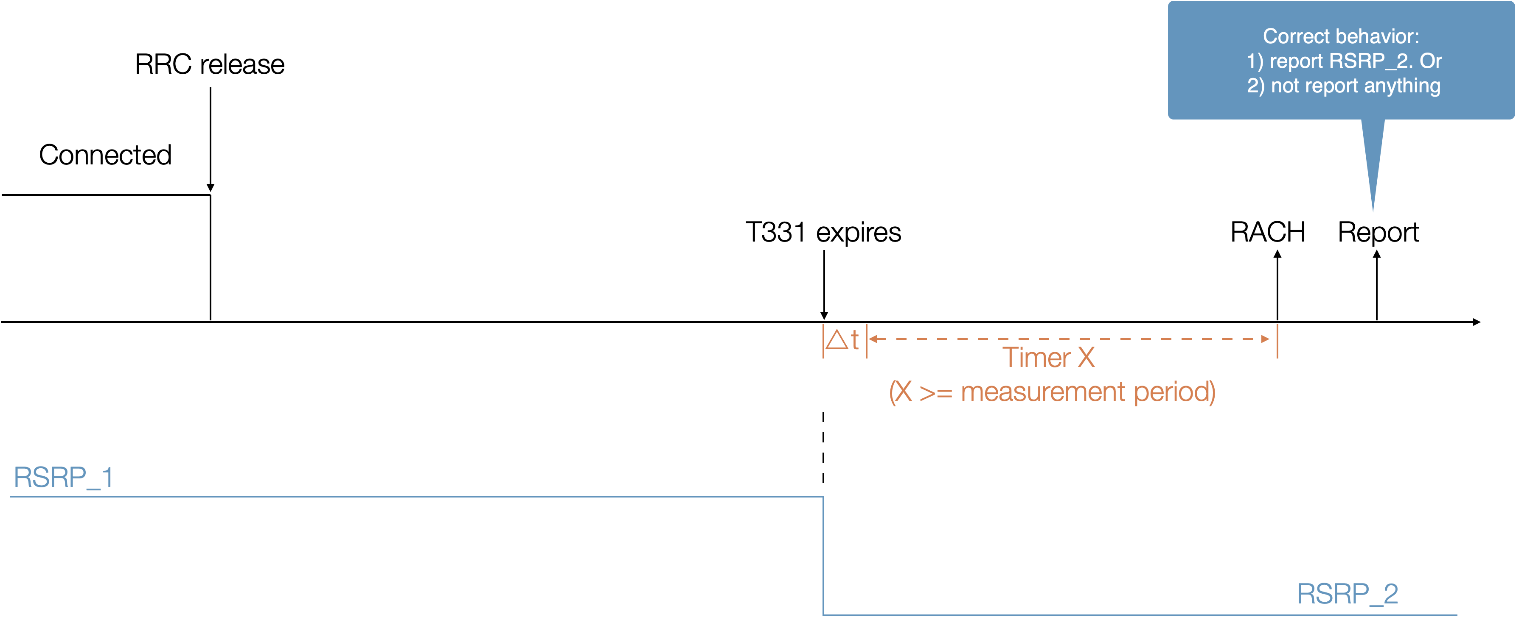  - For non-EMR measurement validity check  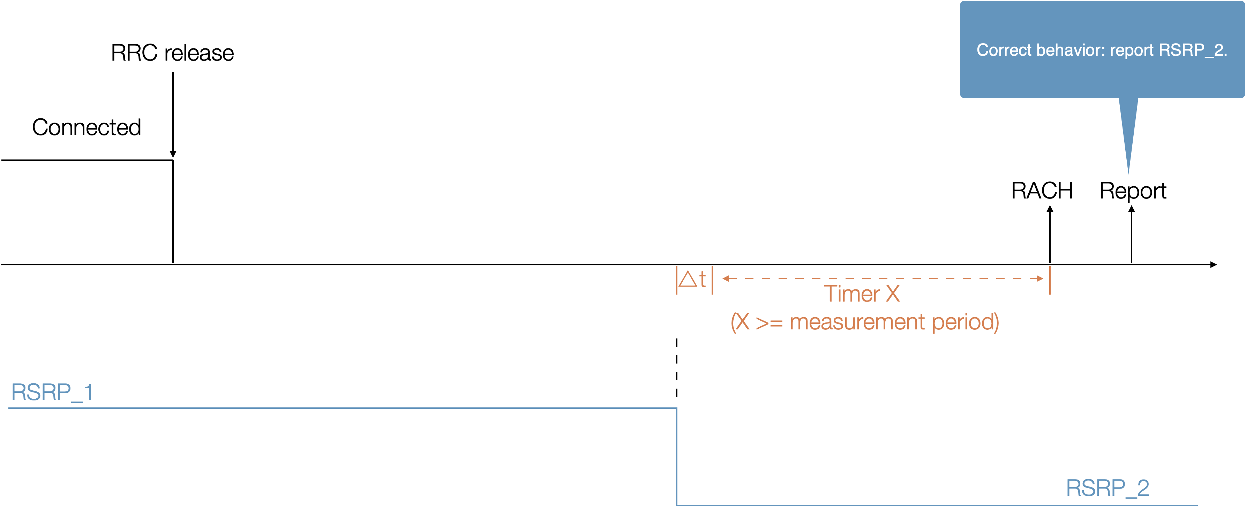  Proposal 2: do not define a test case where X is not configured.
R4-2407354 | Apple | RAN4 agreed to introduce test case for conditional handover including target MCG and candidate SCG with CHO only. RAN4 also agreed that UE can skip the corresponding legacy CHO test case in R16 (approvced WF R4-2403548 in RAN4#110)  Issue 2-2: whether test case for CHO-only is needed  Agreement:  - Introduce one single new test case for CHO-only, selected from existing CHO test case.  - UE capable of R18 enhanced CHO configuration only needs to pass the new R18 test case, i.e. legacy CHO test case in R16 can be skip.  However, when CHO-only test was introduced in RAN4#110bis, the above test applicability is missing.  Following agreement in RAN4#110, add test applicability to allow UE to skip corresponding CHO test case which was introduced in R16. Changes are highlighted in yellow on top of the big CR.
R4-2407486 | CATT | Proposal 1: Introduce test case to verify FG 39-x1 and 39-x2.  - Candidate option: use different power levels before X window starts plus some time margin if the duration of T3 is set to be equal to X.  Observation: Due to the much shorter time margin compared to X, the impact of the time margin is also minimal.
R4-2407868 | OPPO | Introduce test case: CHO including target MCG and candidate SCG: from FR1-FR2 NR-DC to FR1-FR2 NR-DC (resubmit based on endorsed CR R4-2406351)
R4-2408175 | CMCC | T_{Event_DU} is added for subsequent CPA from FR1-FR2 NR-DC to FR1-FR2 NR-DC. The changes are based on the endorsed draft Big CR (R4-2406514).
R4-2408436 | Qualcomm Incorporated | Proposal: TC will verify EMR-UE does not send measurement report which exceeds X second before paging reception.  Proposal : Do not introduce TC for non-EMR UE.  Proposal: TC defined for EMR capable UE with following test framework  - DRX cycle = 640ms, X = 20s, only one target frequency  - Keep the same target frequency cell power before starting the test (T1). Ensure Serving cell power is higher than target frequency cell power to prevent cell reselection.  - T1 : start from receiving RRC release with configuring X, configurations for candidate frequency to report with validity check  - T2 : start from T331 timer expiry and cell power off,  - T2 duration is same as X  - T3 :start from receiving paging for connection setup  - During the connection setup, UE shall not send early measurement report for the candidate frequency.
R4-2408524 | Ericsson | Observation 1: The different UE capabilities of 39-8 and 39-9 can be verified in one case with configure 2 neibouring cell.  Proposal 1: Introduce one single test case for Rel-18 Idle/Inactive measurement for CA/DC setup enhancement to cover both UE capability 39-8 eEMR (Measurement validation based on EMR measurement) and 39-9 IMR (Measurement validation based on non-EMR measurement).  Proposal 2: The different UE capabilities of 39-8 and 39-9 can be verified in one case with configure 2 neibouring cell. When both 39-8 and 39-9 capabilities are claimed, configure 3 cells (1 serving and 2 neighboring cells) for the test case, when only one of the capabilities is claimed, configure 2 cells (1 serving and 1 neighboring cell) for the test case.  Proposal 3: Newly introduced test case shall have 4 scenarios with 2 or 3 cells configured based on UE capability. Validity timer can be verified based on timeline with changing the neighboring cell signal levels.
R4-2408525 | Ericsson | Rel-18 Improvement for Idle/Inactive CA/DC setup test cases (FR1).
R4-2408526 | Ericsson | Rel-18 Improvement for Idle/Inactive CA/DC setup test cases (FR1).
R4-2408590 | Huawei, HiSilicon | Proposal 1: To verify FG 39-8 capable UE execute “validity check” correctly, the following test steps can work, as UE has already passed R16 EMR test.  - Step 1: prior to ([X] seconds+ time margin) before MSG1 transmission, UE performs normally measure on target cell, where measurement result#1 UE obtained is RSRP1;  - Step 2: at the start of the last ([X] seconds+ time margin) before MSG1 transmission, the transmit power of target cell is powered off. When the UE is paged for connection setup and requested by the network to send idle/inactive mode measurements, NO measurement result is reported.  Observation 1: For UE capable of FG 39-9, there is no legacy TC to verify the non-EMR UE correctly report measurement results during connection setup. After passing the reselection result report test, the validity check test is to be verified.
R4-2408591 | Huawei, HiSilicon | On top of endorsed big CR [R4-2406514], some corrections are made on NR conditional handover including target MCG and target SCG from FR1-FR1 NR-DC to FR1-FR1 NR-DC.
R4-2408671 | Nokia | This draft CR provides a high level test case proposals for Rel-18 SCell setup delay improvement test cases.
R4-2408672 | Nokia | Change CPA A1 event to A4 event  Align tables with the test case text.
R4-2408686 | Nokia | Proposal 1: RAN4 to define Rel-18 eEMR test cases for:  - EMR-based idle mode measurements  - UE does not report  - UE reports measurements from X window  - Cell reselection based idle mode measurements  - UE does not report  - UE reports measurements from X window  Proposal 2: Use the following test flow for Rel-18 eEMR test cases (EMR-based and cell reselection based): Two cells in the test: cell 1 (PCell) and cell 2 (neighbor cell)  Two cells in the test: cell 1 (PCell) and cell 2 (neighbor cell)  T1: UE in connected mode and connected to cell 1. UE has no timing information of cell 2. UE is released to idle mode.  T2: Cell 2 becomes detectable and signal level of cell 2 is set to level 1. UE to measure cell 2. Duration of T2 to include the time of measurement period and cell detection.  T3: Signal level of cell 2 is set to level 2. UE to continue measuring cell 2. Duration of T3 equals to X and value for X shall be set so that it includes at least one measurement period for the FR to be tested.  - For the test cases where UE shall report, signal level during T3 is different from T2 (see details below)  - For the test cases where the UE shall not report, signal is turned off during T3.  T4: UE receives paging message. During the connection setup the UE is requested to transmit early measurement report for cell 2. To pass the test, UE has to report measurement results for cell 2 correctly.  - For the case when the UE shall report, the reported results need to be accurate according to signal level 2 (performed within T3/X).  - For the case when the UE shall not report, UE will indicate no results available.  Proposal 3: For the test case where the UE shall report idle mode measurements, set the signal level during T3 Y dB lower than during T2, where Y = 12 dB for FR1 and Y = 15 dB for FR2. Also set the signal level between Cell 1 and Cell 2 so that UE does not perform reselection to Cell 2.  Proposal 4: RAN4 to discuss whether to also define a test case where X is not configured to verify the accuracy of the reported measurements.
R4-2408865 | vivo | Proposal 1: RAN4 to define test cases to support Rel-18 early measurement reporting of both EMR and cell-reselection measurements in FR1 and FR2, respectively.  Proposal 2: For UE capable of 39-x1, design the test to verify that no valid measurement result is reported by turning off the target cell within the validity window.  Proposal 3: For UE capable of 39-x2, design the test to verify the following UE behaviors by setting the different signal levels for the cell before and after validity window:  - UE only reports the valid measurement result  - The reported measurement result only includes the frequency configured by the network when measReselectionCarrierListNR-r18 is enabled  Proposal 4: RAN4 not to define the test case where X is not configured to verify the accuracy of the reported measurements.
R4-2409035 | ZTE Corporation, Sanechips | Proposal 1: RAN4 to define test case on existing measurement for verifying the procedure on validity check by using different power levels before X window starts plus some time margin.  Observation 1: For R18 EMR, R16 EMR test can guarantee UE correctly performs and reports EMR measurement rather than doing nothing.  Proposal 2: Define test case to support Rel-18 early measurement reporting of non-EMR measurement.  Proposal 3: Define test cases for verifying measurement accuracy of the idle/inactive mode measurements reported by the UE.
R4-2409036 | ZTE Corporation, Sanechips | For UE capable of both FR1-FR1 DC and FR1-FR2 DC, UE only needs to pass either 1)+2) or 3)+4)  - Intra-frequency CPC from FR1-FR1 NR-DC to FR1-FR1 NR-DC  - Inter-frequency CPA from FR1-FR1 NR-DC to FR1-FR1 NR-DC  - Intra-frequency CPC from FR1-FR2 NR-DC to FR1-FR2 NR-DC  - Inter-frequency CPA from FR1-FR2 NR-DC to FR1-FR2 NR-DC  Align the descriptions of above four test cases, and UE only needs to pass either 1)+2) or 3)+4)

Open issues summary
Issue 2-1: test scope of solution based on existing measurement for validity check
- Candidate solutions:
  - Option 1: Do not introduce TC for non-EMR UE. (QC)
  - Option 2: (E///)
    - Introduce one single test case for Rel-18 Idle/Inactive measurement for CA/DC setup enhancement to cover both UE capability 39-8 eEMR (Measurement validation based on EMR measurement) and 39-9 IMR (Measurement validation based on non-EMR measurement).
    - The different UE capabilities of 39-8 and 39-9 can be verified in one case by configuring 2 neibouring cells. When both 39-8 and 39-9 capabilities are claimed, configure 3 cells (1 serving and 2 neighboring cells) for the test case, when only one of the capabilities is claimed, configure 2 cells (1 serving and 1 neighboring cell) for the test case.
  - Option 3: (Nokia)
    - RAN4 to define Rel-18 eEMR test cases for:
      - EMR-based idle mode measurements
        - UE does not report
        - UE reports measurements from X window
      - Cell reselection based idle mode measurements
        - UE does not report
        - UE reports measurements from X window
  - Option 4: define test cases to support Rel-18 early measurement reporting of both EMR and cell-reselection measurements in FR1 and FR2, respectively. (vivo)
  - Option 5: Define test case to support Rel-18 early measurement reporting of non-EMR measurement. (ZTE)
- Recommended WF
  - Discuss candidate solutions.

Issue 2-2: test purpose for solution based on existing measurement for validity check
- Candidate solutions:
  - Option 1: TC will verify EMR-UE does not send measurement report which exceeds X second before paging reception. (QC, Apple)
  - Option 1a: (vivo)
    - For UE capable of 39-x1, design the test to verify that no valid measurement result is reported by turning off the target cell within the validity window.
    - For UE capable of 39-x2, design the test to verify the following UE behaviors by setting the different signal levels for the cell before and after validity window:
      - UE only reports the valid measurement result
      - The reported measurement result only includes the frequency configured by the network when measReselectionCarrierListNR-r18 is enabled
- Recommended WF
  - Discuss candidate solutions.

Issue 2-3: test configuration/procedure for solution based on existing measurement for validity check
- Candidate solutions:
  - Option 1: use different power levels before X window starts plus some time margin. (CATT)
  - Option 2: (Apple)
    - For EMR measurement validity check

    - For non-EMR measurement validity check

  - Option 3: (QC)
    - DRX cycle = 640ms, X = 20s, only one target frequency
    - Keep the same target frequency cell power before starting the test (T1). Ensure Serving cell power is higher than target frequency cell power to prevent cell reselection.
    - T1 : start from receiving RRC release with configuring X, configurations for candidate frequency to report with validity check
    - T2 : start from T331 timer expiry and cell power off,
      - T2 duration is same as X
    - T3 :start from receiving paging for connection setup
      - During the connection setup, UE shall not send early measurement report for the candidate frequency.
  - Option 3a: (HW)
    - To verify FG 39-8 capable UE execute “validity check” correctly, the following test steps can work, as UE has already passed R16 EMR test.
      - Step 1: prior to ([X] seconds+ time margin) before MSG1 transmission, UE performs normally measure on target cell, where measurement result#1 UE obtained is RSRP1;
      - Step 2: at the start of the last ([X] seconds+ time margin) before MSG1 transmission, the transmit power of target cell is powered off. When the UE is paged for connection setup and requested by the network to send idle/inactive mode measurements, NO measurement result is reported.
  - Option 4: (E///)
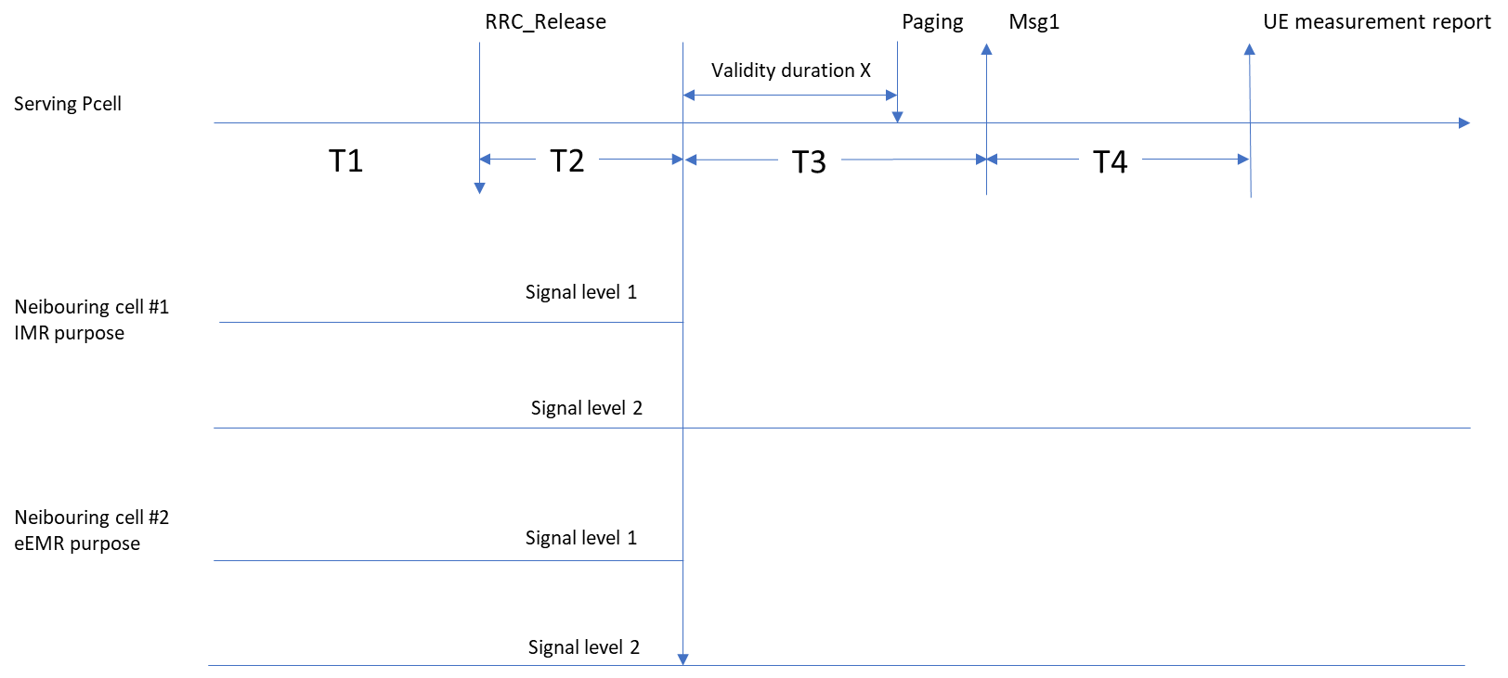
  - Option 5: (Nokia)
    - T1: UE in connected mode and connected to cell 1. UE has no timing information of cell 2. UE is released to idle mode.
    - T2: Cell 2 becomes detectable and signal level of cell 2 is set to level 1. UE to measure cell 2. Duration of T2 to include the time of measurement period and cell detection.
    - T3: Signal level of cell 2 is set to level 2. UE to continue measuring cell 2. Duration of T3 equals to X and value for X shall be set so that it includes at least one measurement period for the FR to be tested.
      - For the test cases where UE shall report, signal level during T3 is different from T2 (see details below)
      - For the test cases where the UE shall not report, signal is turned off during T3.
    - T4: UE receives paging message. During the connection setup the UE is requested to transmit early measurement report for cell 2. To pass the test, UE has to report measurement results for cell 2 correctly.
      - For the case when the UE shall report, the reported results need to be accurate according to signal level 2 (performed within T3/X).
      - For the case when the UE shall not report, UE will indicate no results available.
- Recommended WF
  - Discuss candidate solutions.

Issue 2-4: whether to define a test case where X is not configured
- Candidate solutions:
  - Option 1: do not define a test case where X is not configured. (Apple, vivo)
  - Option 2: discuss whether to also define a test case where X is not configured to verify the accuracy of the reported measurements. (Nokia)
- Recommended WF
  - Discuss the CR directly.

Issue 2-5: others
- Candidate solutions:
  - Proposal 1: Following agreement in RAN4#110, add test applicability to allow UE to skip corresponding CHO test case which was introduced in R16. Changes are highlighted in yellow on top of the big CR. (Apple R4-2407354)
  - Proposal 2: T_{Event_DU} is added for subsequent CPA from FR1-FR2 NR-DC to FR1-FR2 NR-DC. (CMCC R4-2408175)
  - Proposal 3: On top of endorsed big CR [R4-2406514], some corrections are made on NR conditional handover including target MCG and target SCG from FR1-FR1 NR-DC to FR1-FR1 NR-DC. (HW R4-2408591)
  - Proposal 4: Change CPA A1 event to A4 event. Align tables with the test case text. (Nokia R4-2408672)
  - Proposal 5: test applicability for subsequent conditional PSCell addition/change. (ZTE R4-2409036)
- Recommended WF
  - Discuss the CR directly.

