3GPP TSG-RAN WG4 Meeting # 111 R4-240xxxx
Fukuoka, Japan, May 20 – 24, 2024

Agenda item: 7.14.3
Source: Apple
Title: Ad-hoc minutes on RRM requirements for NR_Mob_enh2
Document for: Information

NR_Mob_enh2_part 1
Issue 3-2-1: Extension of known TCI state conditions for cell switch
- Proposals
  - Proposal 1 (Nokia):
    - The target TCI state in the LTM cell switch command is known if the TCI state activation command was received not more than 1280 ms before the cell switch command, or if the RS associated to the target TCI state is available at least every 1280 ms after TCI state activation command.
    - Target TCI state in cell switch command is known, if UE successfully completed PDCCH ordered RACH preamble transmission within 1280 ms before the cell switch command, and if the SSB in the PDCCH order is associated to the target TCI state
    - In cell switch delay requirements, the target TCI state is known if the UE has reported L3-RSRP measurements for the SSB associated to the target TCI state before the cell switch command.
  - Proposal 2 (MTK): In cell switch delay requirements, activated TCI state can be known if the following conditions can be met:
    - SNR of the SSB associated to TCI state ≥ -3dB
    - Beam-level L3 measurement results have been reported in 1280ms
    - L1-RSRP measurement period is no larger than 1280ms in FR2
  - Proposal 3 (Ericsson, QC): update the known TCI state conditions for LTM cell switch:
The target joint DL/UL TCI state or separate DL and UL TCI states in the LTM cell switch command are known if the following conditions are met:
- The target TCI state in the cell switch command is activated not more than X1 ms before the reception of the cell switch command and SNR of the SSB associated to TCI state ≥ -3dB; where X1 is 1280ms for FR1 and 160ms for FR2; or
- The target TCI state in cell switch command is activated before receiving the cell switch command and the SSB associated to target TCI state is available at least once every 160 ms after the TCI state activation command is received and SNR of the SSB associated to TCI state ≥ -3dB; or
- During the period from the last transmission of the RS resource used for the L1-RSRP measurement reporting for the target DL/UL TCI state to the completion of LTM cell switch, where the RS resource for L1-RSRP measurement is the RS in target DL/UL TCI state or QCLed to the target DL/UL TCI state
- LTM cell switch command is received within 1280 ms upon the last transmission of the RS resource for beam reporting or measurement
- The UE has sent at least 1 L1-RSRP report for the target DL/UL TCI state before the LTM cell switch command
- The target DL/UL TCI state remains detectable during the LTM cell switching period
- The SSB associated with the target DL/UL TCI state remain detectable during the cell switching period
- SNR of the TCI state ≥ -3dB
Otherwise, the target joint DL/UL TCI state or separate DL and UL TCI state is unknown.

- Recommended WF
  - Recommend to discuss whether TCI state can be viewed as known if the following conditions are met when SNR of the TCI state≥ -3dB
    - In FR1
      - Condition 1: TCI state has been activated and
        - Condition 1A: the TCI state activation command was received not more than 1280 ms before the cell switch command
        - Condition 1B: Beam-level L3 measurement results have been reported in 1280 ms
        - Condition 1C: The RS associated to the target TCI state is available at least every 1280 ms after TCI state activation command
      - Condition 2: UE has reported L3-RSRP measurements for the SSB associated to the target TCI state in [1280]ms before the cell switch command
    - In FR2
      - Condition 3: TCI state has been activated and
        - Condition 3A: the TCI state activation command was received not more than 1280 ms before the cell switch command
        - Condition 3B: the TCI state activation command was received not more than 160 ms before the cell switch command
        - Condition 3C: The RS associated to the target TCI state is available at least every 1280 ms after TCI state activation command
        - Condition 3D:
          - Beam-level L3 measurement results have been reported in 1280ms
          - L1-RSRP measurement period is no larger than 1280ms in FR2
      - Condition 4: UE has reported L3-RSRP measurements for the SSB associated to the target TCI state in [1280]ms before the cell switch command
Discussion:
HW: if L1-RSRP is not supported, there is no gain for LTM. for unknown target TCI, UE needs to perform L1-RSRP to find the best beam.
QC: we support same agreement between FR1 and FR2. We support to define cell switch delay requirements for the case there is no L1 RSRP report or measurement.
MTK: for FR2 we think L1-RSRP measurement is necessary.
E///: L1-RSRP measurement is not necessary. There may be additinoal complexity at UE side to support L1-RSRP measurement.
HW: L1-RSRP is assumed with fine beam while L3 measurement is assumed with rough beam. Gain of LTM in FR2 comes from fine beam measurement.
CATT: from NW perspective, we cannot restrict NW from using L3 to trigger LTM.
ZTE: same view as E///, QC and CATT.
QC: agree with HW’s argument. Fine beam measurement is beneficial. However, NW vendors may want to implement this feature step by step. We see benefit to allow this.
MTK: this would force UE to support L1 measurement.

Issue 4-1-2: How to reply RAN2 on Question 1

LS from RAN2
RAN2 discussed RAN1 and RAN4 feature lists associated with Rel-18 NR_Mob_enh2. RAN2 discussed wither the following L1 measurement and reporting features are mandatory to support LTM or whether L3 measurement could be used.
45-1 | Intra-frequency L1 measurement and reports for L1-L2 Triggered Mobility (LTM) procedure
45-1a | Inter-frequency L1 measurement and reports for L1-L2 Triggered Mobility (LTM) procedure

RAN2 made the following agreement:
RAN2 makes no further assumptions whether L3 measurements can be used or not to trigger LTM.
RAN2 would like to check the following with RAN1 and RAN4:
Question 1 : Are the above intra-frequency and inter-frequency L1 measurement and reporting features (45-1 and 45-1a) prerequisites to support intra-frequency and inter-frequency LTM, respectively?

- Proposals
  - Option 1 (Apple, CATT, Huawei): L1-RSRP measurements and reporting are the prerequisite to support R18 LTM
    - Option 1a (Apple): answer to question 1: current RAN4 LTM cell switch delay requirements are applicable only to UE supporting L1-RSRP measurement.
    - Option 1b (CATT): Reply RAN2 that RAN4 only consider intra-frequency and inter-frequency LTM triggered by intra-frequency and inter-frequency L1 measurement and reporting.
    - Option 1c (Huawei): FG45-1 should be the prerequisite to support intra-frequency LTM. FG45-1a should be the prerequisite to support inter-frequency LTM.
  - Option 2 (Nokia, vivo, ZTE, MTK, Ericsson, QC): L1-RSRP measurements and reporting are not the prerequisite to support R18 LTM
    - Option 2a (MTK): From the point of RAN4 requirements
      - In FR1: L1 measurement is not necessary and similar benefits can be obtained in FR1 without L1 measurement compared to with L1 measurement
      - In FR2: there are not related requirements if L1 measurement is not supported or configured.
      - Decouple R18 LTM and L1-RSRP measurement.
    - Option 2b (Ericsson, QC)
      - RAN4 to await confirmation from RAN1. If necessary, RAN4 to confirm that RRM requirements are defined to accommodate scenarios where L3 measurement and report are conducted, even if L1 measurement and report were unavailable.
- Recommended WF
  - Need more discussion.

Issue 6-2-1: More test or sub-test cases for cell switch delay
- Proposals
  - Proposal 1 (vivo):
    - Introduce two sub-tests for inter-frequency cell switch test cases so as to cover UEs supporting inter-frequency L1 measurement with gaps and UEs supporting inter-frequency L1 measurement without gaps.
  - Proposal 2 (vivo):
    - For cell switch delay test cases, the RTD condition shall also be set according to UE capability in 39-1, so that UE supporting RTD>CP can be verified.
  - Proposal 3 (ZTE, Ericsson):
    - RAN4 should define test cases for unknown TCI state activation for the test cases involving early TCI state activation.
Moderator: according to the proposed CR R4-2409717, it is to add a TC for RACH-less Intra-frequency PCell switch from FR1 to FR1 with unknown TCI state activation
- Recommended WF
  - Need more discussion

MTK: we don’t support P1 and P2. For P1, no need to test L1 measurement in cell switch test. For P2, the agreed test can cover everything. Support P3 in FR1.
Vivo: if UE doesn’t support inter-freq w gap. How to test inter-f.
MTK: we can use intra-freq test. It is similar.

Agreement:
Define only one test case for cell switch without L1 measurement configuration in FR1.
- RACH-less is configured in the test
- Intra-frequency cell switch is configured in the test
Note: this test case is only applicable to UE supporting early TA acquisition.

Issue 6-2-2: More test cases for PDCCH-order RACH
- Proposals
  - Proposal 1 (Ericsson):
    - RAN4 should define test cases for unknown TCI state activation for the test cases involving early TCI state activation.
Moderator: according to the proposed CR R4-2409717, it is to add a TC for PDCCH-order RACH with unknown TCI state activation on neighbor cell in FR1 when RACH BW is within active UL BWP.
- Recommended WF
  - Need more discussion.

Continue discussing:
Define only one test case for PDCCH-order RACH without L1 measurement configuration in FR1.
- Intra-frequency is configured in the test
- Test requirement is FFS
Note: this test case is only applicable to UE supporting early TA acquisition.

Issue 2-2-1: Measurement period of serving cell L1-RSRP measurement
- Proposals
  - Option 1 (Apple):
    - introduce N_{Layer} in serving cell L1 RSRP measurement requirement and clarify that it is for UE capable of RTD>CP configured with L1 RSRP measurement on neighbour cell.
  - Option 2 (OPPO):
    - Consider to revisit the agreements for L1 RSRP measurement on neighbour cell, e.g., either follow the logic of serving cell L1-RSRP measurement or L3 intra-frequency measurement.
  - Option 3 (Ericsson, QC):
    - RAN4 not to modify the serving cell measurement period by scaling it with N_{Layer} for UE supporting RTD > CP.
- Recommended WF
  - Need more discussion.

Issue 3-1-2-1: Extra time for PL-RS measurement?
- Proposals
  - Option 1 (vivo): The UL TCI activation delay is added into cell switch delay as follows.
    - T_{LTM-interrupt} = T_{LTM-RRC-processing} + T_{LTM-processing} + max(T_{first-RS} + T_{RS-proc}, T_{first_target-PL-RS} + [2]*T_{target_PL-RS} + 2ms) + T_{LTM-IU}
  - Option 2 (MTK):
    - For CBRA cell switch, no additional PL-RS measurement time is needed.
    - For CFRA and RACH-less cell switch, both in FR1 and FR2, the cell switch requirements are only applicable to the case when target PL-RS is maintained, and UE does not need extra time to measure the PL-RS.
    - During cell switch, PL-RS is maintained provided:
- the target PL-RS is associated with or included in the UL or joint TCI states in the active TCI list for PUSCH/PUCCH/SRS transmissions
- Number of active UL TCI states (UL or joint TCI state) for PUSCH/PUCCH/SRS transmissions does not exceed UE capability ltm-MAC-CE-JointTCI-r18 or ltm-MAC-CE-SeparateTCI-r18
- The target pathloss reference signal remains detectable during cell switch delay
- SNR of the target pathloss reference signal≥-3dB
- The associated SSBs with the target pathloss reference signal remain detectable during cell switch delay
- SNR of the associated SSB ≥-3dB
  - Option 3 (Huawei, Nokia, ZTE): No additional delay or conditions are needed for PL-RS measurement.
    - Option 3a (Nokia):
      - If TCI state is activated before cell switch, the UE shall do PL-RS estimation during the early TCI state activation. After TCI state activation, UE shall maintain the PL-RS for the active TCI state(s).
      - UE can perform PL-RS estimation based on the same SSB (T_{first-SSB}/T_{first-RS}) as is used for T/F tracking at TCI state activation.
      - The number of PL-RS the UE shall be able to maintain for LTM candidate cells should be added on top of the number of the 4 PL-RS the UE is expected to be able to keep track of for serving cells. RAN4 to discuss the exact number of LTM candidate cell PL-RS that the UE shall be able to maintain.
  - Option 4 (Ericsson, QC): For the cell switch delay, no additional delay or conditions are needed for PL-RS measurement provided that the following condition are fulfilled:
    - UE has reported L3-RSRP on the SSB associated with PL-RS before reception of LTM configuration and UE is configured to perform L3 or L1 measurements after LTM configuration.
- Recommended WF
  - Recommend following the majority view and agree on
    - No additional PL-RS measurement time is needed
    - Further discuss whether some conditions are needed:
      - Option A: No additional condition
      - Option B: L3-RSRP or L1-RSRP on the SSB associated with PL-RS has been reported
      - Option C: Target PL-RS is maintained.

Issue 1-3-6: UE behaviour of early DL TCI state activation without L1 measurement
- Proposals
  - Option 1 (MTK):
    - When L1 measurement is not configured, after receiving TCI state activation command, UE only performs one shot T/F tracking without any periodic T/F tracking afterward.
- Recommended WF
  - Need more discussion

Issue 6-2-5: TCI state configurations in test case
- Proposals
  - Proposal 1 (vivo): In RRM test case design for LTM, RAN4 avoid TCI configuration with ‘QCL-D’ or ‘UL TCI’ to UE in FR1, which means only Joint TCI with QCL-A/C configuration, and pathloss RS configuration if necessary, shall be provided to UE in FR1, even if UE supports ltm-MAC-CE-SeparateTCI-r18.
- Recommended WF
  - Need more discussion.

Issue 1-3-2: The definition of T_{first-SSB} in early candidate cell’s TCI state activation delay for inter-frequency with gap for known TCI state case
- Proposals
  - Option 1 (Apple, Huawei, MTK):
    - T_{first-SSB} is the time to the first SSB occasion overlapped with MGL after slot n + T_{HARQ} +${3N}_{slot}^{subframe,µ}$ for inter-frequency with gap.
  - Option 2 (vivo):
    - RRM requirements for early TCI activation of a candidate cell whose QCL source RSs and/or PL-RSs i.e. SSBs and/or CSI-RSs are outside active BWP is not defined in Rel-18.
- Recommended WF
  - Recommend following the majority and agree on Option 1:
    - In early candidate cell’s TCI state activation delay for known TCI state case: T_{first-SSB} is the time to the first SSB occasion overlapped with MGL after slot n + T_{HARQ} +${3N}_{slot}^{subframe,µ}$ for inter-frequency with gap.

Issue 1-1-1: The value of T_{SSB} is if the condition of T_{SSB} equal to zero is not met in PDCCH ordered RACH delay requirements
- Proposals
  - Option 1 (Apple, CATT, Huawei, CTC, ZTE, MTK):
    - T_{SSB} is the time to first SSB transmission after PDCCH-order RACH command is decoded by the UE when SSB is within active BWP
    - T_{SSB} is the time to first SSB transmission overlapped with MGL after PDCCH-order RACH command is decoded by the UE when SSB is outside active BWP.
      - Option 1a (CATT): Considering the time for PDCCH-ordered RACH decoding, a little relaxation on T_{first-SSB_RACH} is also acceptable.
      - Option 2b (MTK): in the definition of T_{SSB}, the PDCCH-order decoding time is assumed as 1 slot or ⌈N_{T,2}⌉.
        - the time to first SSB transmission after slot n+1 or n+ ⌈ N_{T,2}⌉, where slot n is the slot that UE receives PDCCH-order RACH command when SSB is within active BWP
        - the time to first SSB transmission overlapped with MGL after slot n+1 or n+ ⌈ N_{T,2}⌉, where slot n is the slot that UE receives PDCCH-order RACH command when SSB is outside active BWP.
  - Option 2 (vivo, ZTE): T_{SSB-proc} = 2 ms should be counted in T_{SSB}
    - Option 2a (Ericsson, QC): In PDCCH ordered RACH delay, T_{SSB} is as follows if the condition of T_{SSB} equal to zero is not met:
      - T_{SSB} is the time to first SSB transmission after the end of the slot of PDCCH + [2]ms when SSB is within active BWP
      - TSSB is the time to first SSB transmission overlapped with MG after the end of the slot of PDCCH + [2]ms when SSB is outside active BWP.
  - Option 3 (Nokia):
    - In PDCCH ordered RACH delay, T_{SSB} is the time to first SSB overlapping or not overlapping with MG after PDCCH-order RACH command is decoded by the UE both when SSB is within or outside the active BWP.
- Recommended WF
  - Recommend agree on:
    - In PDCCH ordered RACH delay, when additional time for T/F tracking is needed, T_{SSB} is:
      - T_{SSB} is the time to first SSB transmission after PDCCH-order RACH command is decoded by the UE when SSB is within active BWP + 2ms
      - T_{SSB} is the time to first SSB transmission overlapped with MGL after PDCCH-order RACH command is decoded by the UE when SSB is outside active BWP +2ms.
      - FFS: Define PDCCH-order decoding time.
Moderator: Generally, following the majority view, and 2ms is added for T_{SSB-proc}

Issue 1-3-1: Whether to consider early TCI state activation for multiple cells at the same time
- Proposals
  - Option 1 (Huawei, vivo, Nokia, MTK):
    - Early TCI state activation delay requirements to be defined for one or more TCI states for a single candidate cell, because one MAC-CE activates TCI states only for a single candidate cell.
  - Option 2 (Ericsson, QC):
    - If all the target LTM TCI states in the active TCI state list are known, if the UE receives TCI state activation command at slot n, UE shall have completed the LTM TCI state list update in slot n + T_{HARQ} +${3N}_{slot}^{subframe,µ}$ + TO_{k}*(T_{first-SSB_List} + T_{SSB-proc}) / NR slot length.
    - If any of the target TCI states in the active TCI state list are unknown, if the UE receives TCI state activation command at slot n, UE shall have completed the LTM TCI state list update in slot n+ T_{HARQ} +${3N}_{slot}^{subframe,µ}$ + (T_{L1-RSRP_list} +TO_{uk}*(T_{first-SSB_List}+ T_{SSB-proc})) / NR slot length.
    - In the TCI state activation requirements for LTM candidate cells, T _{L1-RSRP} = 0 for FR1
    - In the TCI state activation requirements for LTM candidate cells, T_{first-SSB_List} is given by
      - For FR1, T_{first-SSB_List} = max (T_{first-SSB_LTM1}, T_{first-SSB_LTM2, .. ,} T_{first-SSB_LTMn}).
      - For FR2,
        - T_{first-SSB_List} = T_{first-SSB_LTM1} + T_{first-SSB_LTM2 + ... +}T_{first-SSB_LTMn}, if the time to first SSB associated to LTM candidate TCI states are overlapped in FR2.
        - T_{first-SSB_List} = max (T_{first-SSB_LTM1}, T_{first-SSB_LTM2, .. ,} T_{first-SSB_LTMn}.) if the time to first SSB associated to LTM candidate TCI states are not overlapped.
      - Where, the T_{first-SSB_LTMn} is the SSB periodicity of LTM candidate cell n.
- Recommended WF
  - Need more discussion

Issue 1-3-3: Whether and how to support unknown TCI state in FR2
- Proposals
  - Option 1 (vivo):
    - RAN4 further discuss whether the scenario below is an important scenario in FR2, and whether RRM requirements need to be specified.
      - Based on the agreed big CR, and the requirement applicability rules for L1-RSRP measurements, LTM TCI activation delay requirements are not applicable to the case when activated TCI state(s) of one candidate cell already exist, but gNB activates one more unknown TCI state from another candidate cell on top of activated TCI state(s) from the existing candidate cell.
  - Option 2 (Huawei, MTK):
    - Not to define requirements of SSB based TCI state activation delay for FR2 unknown TCI state case.
  - Option 3 (Nokia):
    - When UE is performing and reporting L1 measurements for LTM candidate cells, unknown TCI state activation delay may follow the legacy requirement.
    - When UE is not performing L1 measurements and LTM decision is based on L3 measurements (if supported), L1-RSRP measurement period in legacy unknown TCI state activation delay can be replaced with L3-RSRP measurement period.
  - Option 4 (Ericsson, QC): In the TCI state activation requirements for LTM candidate cells, for FR2, T _{L1-RSRP} is the time for Rx beam refinement in FR2, defined as
    - T_{L1-RSPR_Measurement_Period_SSB} for SSB as specified in clause 9.14 and 9.15,
    - with the assumption of M=1
    - with T_{Report} = 0
    - N_{Neighbor_Cell} is the number of neighbour cells that are to be activated with TCI states
- Recommended WF
  - Need more discussion

Issue 1-3-4: Conditions to support unknown TCI state in FR1
- Proposals
  - Option 1 (Apple, Huawei, MTK): For unknown TCI state in FR1, UE shall have sent a valid L3 measurement report of the TCI associated target cell within [TBD] before the LTM TCI state activation command.
    - Option 1a (Apple):
      - unknown TCI state in FR1 is considered only if target cell is known.
    - Option 1b (MTK):
      - UE has reported beam-level L3 measurement result of the associated SSB of the TCI state within 1280ms
      - SNR of the associated SSB is above -3dB.
  - Option 2 (Ericsson, QC): Unknown TCI state activation requirements are applicable
    - if the TCI state activated is based on the measurement report (e.g., L3-RSRP or L1-RSRP) within last [5 seconds]; and
    - when to be activated unknown TCI states are from one FR1 frequency layer, or when to be activated unknown TCI states are from one FR2 candidate cell.
- Recommended WF
  - Recommend agree on:
    - UE has reported beam-level L3 measurement result of the associated SSB of the TCI state within [1280ms or 5 seconds] before the LTM TCI state activation command.
    - SNR of the associated SSB is above -3dB.

Issue 3-1-1-1: T/F fine tracking when TRS as QCL source in cell switch delay
- Proposals
  - Option 1 (MTK): UE is supposed to perform T/F tracking (if needed) based on SSB during cell switch delay in R18 LTM.
  - Option 2 (Nokia): Add TRS as a possible QCL source for T/F tracking in RAN4 cell switch delay requirements.
- Recommended WF
  - Need more discussion

Issue 3-1-3-1: T_{interruption} of PSCell switch
Interruption on MCG is caused by RF/BB retuning. The interruption on MCG due to PSCell addition is also caused by RF retuning. So the interruption length of PSCell addition can be reused.
- Proposals
  - Option 1 (CTC, MTK):
    - The interruption on MCG due to PSCell change is the same as PSCell addition.
  - Option 2 (Nokia):
    - RAN4 to discuss how long interruption would be needed due to LTM PSCell switch on serving cells in MCG, and at which point during cell switch is the interruption expected to happen.
- Recommended WF
  - Recommend agree on Option 1.

NR_Mob_enh2_part 2
Issue 2-4: whether to define a test case where X is not configured
- Candidate solutions:
  - Option 1: do not define a test case where X is not configured. (Apple, vivo)
  - Option 2: discuss whether to also define a test case where X is not configured to verify the accuracy of the reported measurements. (Nokia)
- Recommended WF
  - Discuss the options.
QC: we support option 1. Without configured X, it is same as EMR.
E///: for eEMR, agree with QC that it is similar. But for non-EMR case, it could be different. As long as there are other tests to verify accuracy of eEMR and non-EMR validity check, it should be fine.

Agreement:
    - Timer X is always configured in all test cases for validity check.

Issue 2-3: test configuration/procedure for solution based on existing measurement for validity check
- Candidate solutions:
  - Option 1: use different power levels before X window starts plus some time margin. (CATT)
  - Option 2: (Apple)
    - For EMR measurement validity check
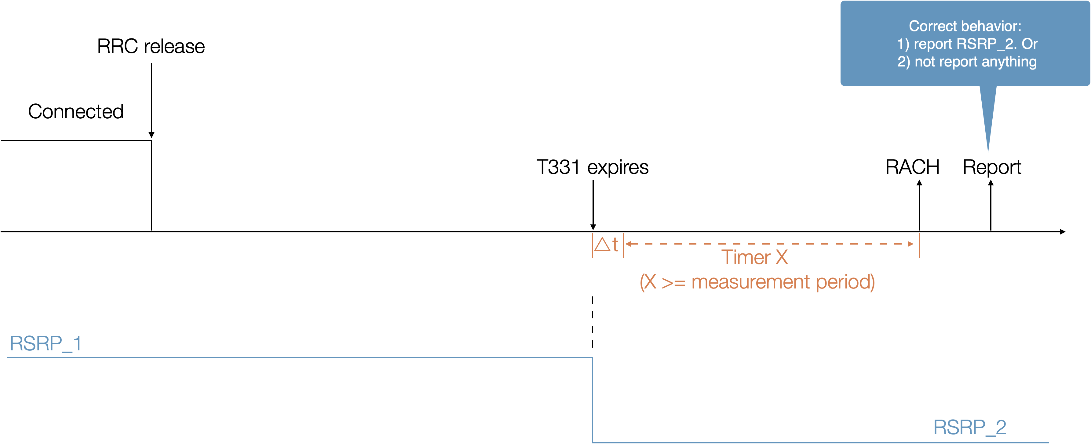

    - For non-EMR measurement validity check
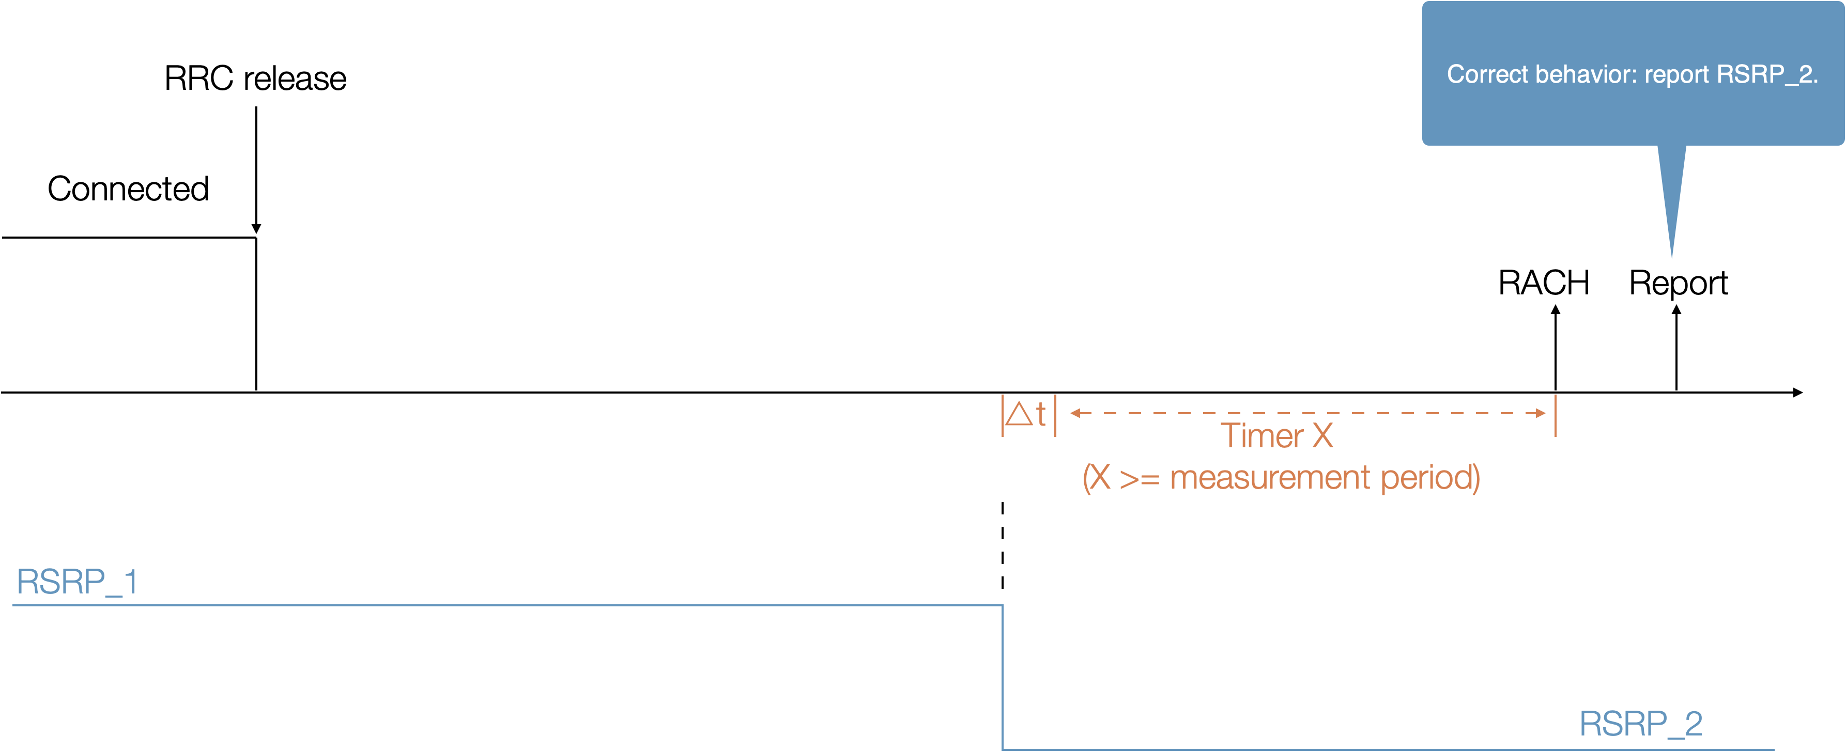

  - Option 3: (QC)
    - DRX cycle = 640ms, X = 20s, only one target frequency
    - Keep the same target frequency cell power before starting the test (T1). Ensure Serving cell power is higher than target frequency cell power to prevent cell reselection.
    - T1 : start from receiving RRC release with configuring X, configurations for candidate frequency to report with validity check
    - T2 : start from T331 timer expiry and cell power off,
      - T2 duration is same as X
    - T3 :start from receiving paging for connection setup
      - During the connection setup, UE shall not send early measurement report for the candidate frequency.
  - Option 3a: (HW)
    - To verify FG 39-8 capable UE execute “validity check” correctly, the following test steps can work, as UE has already passed R16 EMR test.
      - Step 1: prior to ([X] seconds+ time margin) before MSG1 transmission, UE performs normally measure on target cell, where measurement result#1 UE obtained is RSRP1;
      - Step 2: at the start of the last ([X] seconds+ time margin) before MSG1 transmission, the transmit power of target cell is powered off. When the UE is paged for connection setup and requested by the network to send idle/inactive mode measurements, NO measurement result is reported.
  - Option 4: (E///)
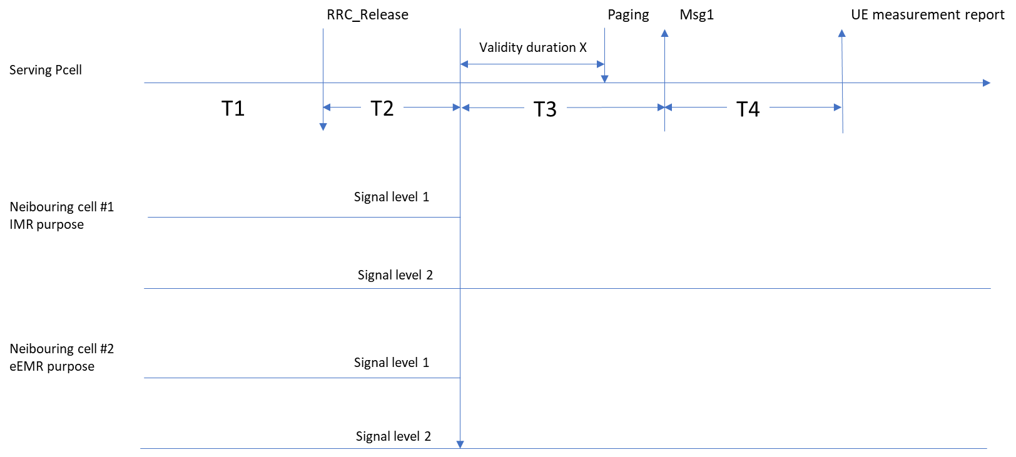
  - Option 5: (Nokia)
    - T1: UE in connected mode and connected to cell 1. UE has no timing information of cell 2. UE is released to idle mode.
    - T2: Cell 2 becomes detectable and signal level of cell 2 is set to level 1. UE to measure cell 2. Duration of T2 to include the time of measurement period and cell detection.
    - T3: Signal level of cell 2 is set to level 2. UE to continue measuring cell 2. Duration of T3 equals to X and value for X shall be set so that it includes at least one measurement period for the FR to be tested.
      - For the test cases where UE shall report, signal level during T3 is different from T2 (see details below)
      - For the test cases where the UE shall not report, signal is turned off during T3.
    - T4: UE receives paging message. During the connection setup the UE is requested to transmit early measurement report for cell 2. To pass the test, UE has to report measurement results for cell 2 correctly.
      - For the case when the UE shall report, the reported results need to be accurate according to signal level 2 (performed within T3/X).
      - For the case when the UE shall not report, UE will indicate no results available.
- Recommended WF
  - Discuss candidate solutions.

Agreement:
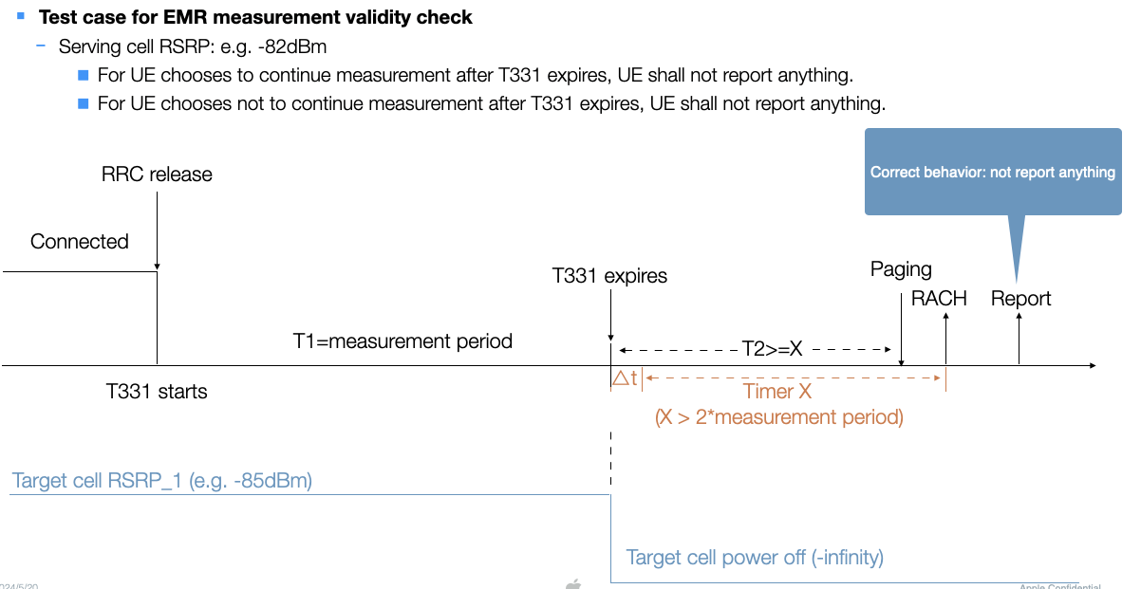

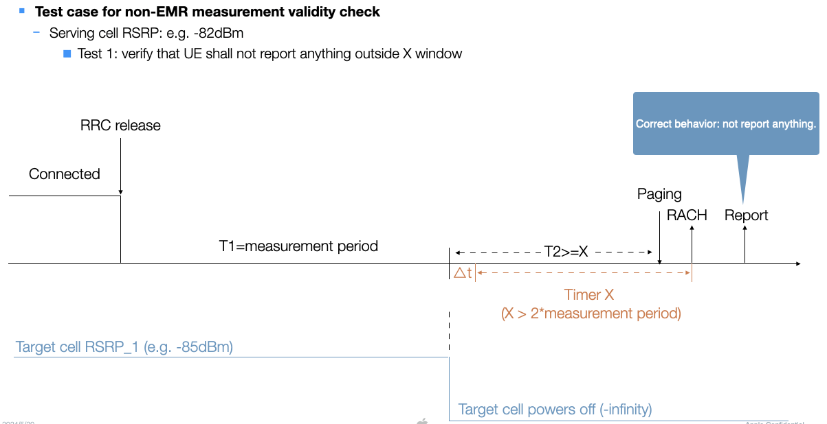

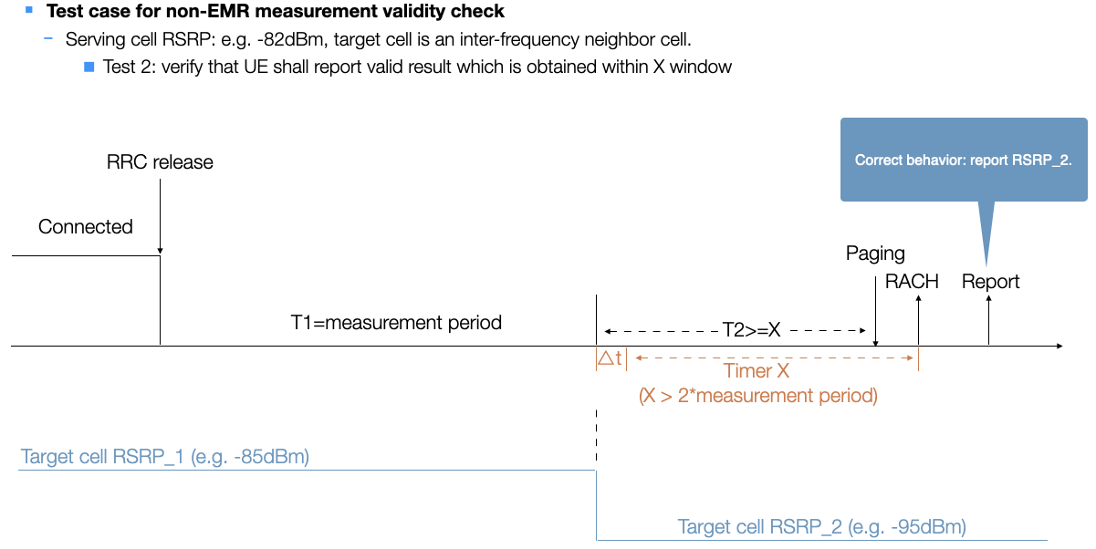
Issue 2-5: others
- Candidate solutions:
  - Proposal 1: Following agreement in RAN4#110, add test applicability to allow UE to skip corresponding CHO test case which was introduced in R16. Changes are highlighted in yellow on top of the big CR. (Apple R4-2407354)
  - Proposal 2: T_{Event_DU} is added for subsequent CPA from FR1-FR2 NR-DC to FR1-FR2 NR-DC. (CMCC R4-2408175)
  - Proposal 3: On top of endorsed big CR [R4-2406514], some corrections are made on NR conditional handover including target MCG and target SCG from FR1-FR1 NR-DC to FR1-FR1 NR-DC. (HW R4-2408591)
  - Proposal 4: Change CPA A1 event to A4 event. Align tables with the test case text. (Nokia R4-2408672)
  - Proposal 5: test applicability for subsequent conditional PSCell addition/change. (ZTE R4-2409036)
- Recommended WF
  - Discuss the CR directly.

CR handling
- Core maintenance:
TDoc | Title | Source | Recommendation
R4-2407866 | Draft CR on measurement report for fast CA/DC setup | OPPO | Merged
R4-2408527 | CR for eEMR core maintenance | Ericsson | Merged
R4-2408670 | draft CR to 38.133 on eEMR core requirements | Nokia | Revised
R4-2408757 | CR for eEMR core maintenance | Ericsson | Merged

- Performance:
TDoc | Title | Source | Recommendation
R4-2407354 | draft CR for performance part of R18 NR mobility further enhancement part 2 | Apple
R4-2407868 | Draft CR for test case of CHO including target MCG and candidate SCG in NR-DC | OPPO | Noted
R4-2408175 | DraftCR on inter-frequency subsequent CPA from FR1-FR2 NR-DC to FR1-FR2 NR-DC | CMCC
R4-2408525 | Draft CR to TS 38.133 for Test case of improment on SCG_Scell setup delay for FR1 | Ericsson
R4-2408526 | Draft CR to TS 38.133 for Test case of improment on SCG_Scell setup delay for FR2 | Ericsson
R4-2408591 | Update on test case for NR conditional handover including target MCG and target SCG from FR1-FR1 NR-DC to FR1-FR1 NR-DC | Huawei, HiSilicon
R4-2408671 | Draft CR for eEMR test case | Nokia | Merged
R4-2408672 | draft CR to TS 38.133 on subsequent CPA test cases | Nokia
R4-2409036 | Correction on subsequent conditional PSCell addition/change | ZTE Corporation, Sanechips

