3GPP TSG-RAN WG4 Meeting #111 R4-2410280
Fukuoka, Japan, May 20 – 24, 2024

Agenda item: 7.14.3
Source: Apple
Title: WF on R18 Further NR mobility enhancement - part 2
Document for: Approval

Core part maintenance
Issue 1-2: applicability of validity check based on measurement obtained in CONNECTED mode before UE enters IDLE/INACTIVE mode
Agreement:
- For the validity check, it is up to UE implementation whether/how to utilize the measurement which was performed during CONNECTED mode before UE enters IDLE/INACTIVE mode.
- No spec change for the above agreement.

Performance part
Issue 2-1: test scope of solution based on existing measurement for validity check
Agreement:
- RAN4 to introduce TC for non-EMR UE based on the understanding that RAN2 will define the corresponding signalling.
- RAN4 can discuss the CR for the TC, and the signaling in the TC is subject to RAN2 agreement.

Issue 2-2: test purpose for solution based on existing measurement for validity check
Agreement:
- For EMR, TC will verify UE does not send measurement report which exceeds X second before paging reception.
- For non-EMR, TC will verify
  - UE send measurement report which is within X second before [paging reception].
  - UE does not send measurement report which exceeds X second before [paging reception] if it is feasible for the testing.

Issue 2-3: test configuration/procedure for solution based on existing measurement for validity check
Agreement:
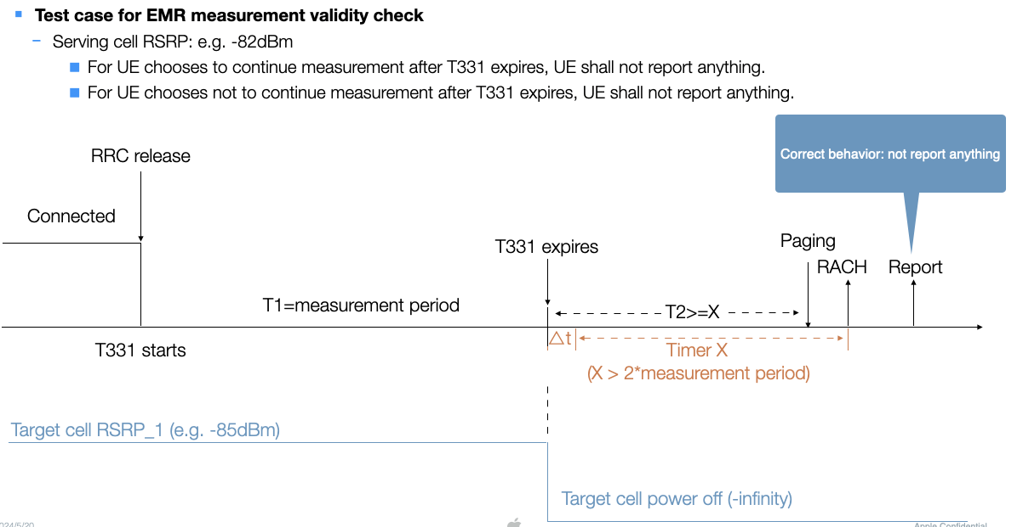

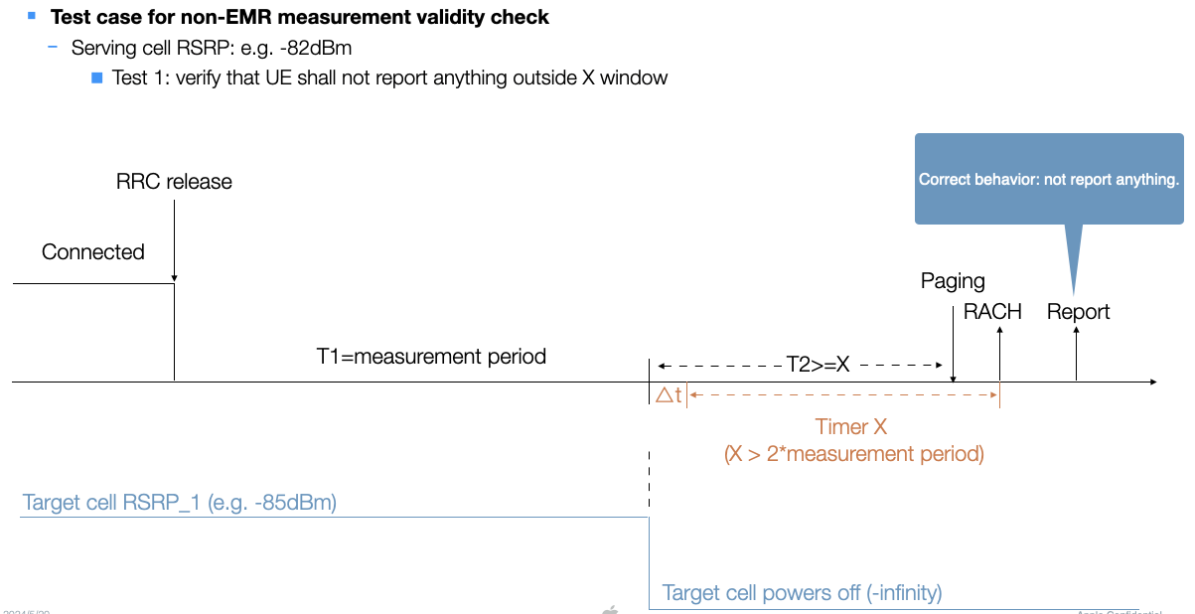

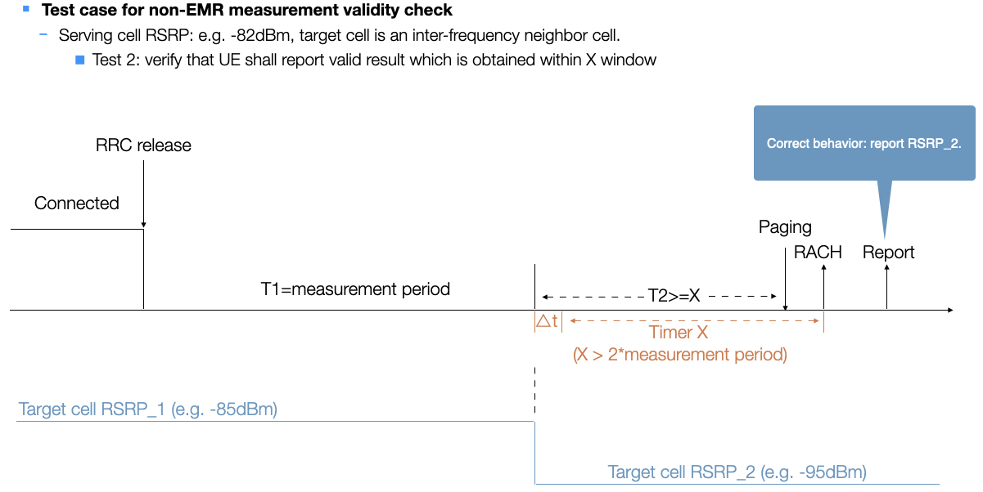

Issue 2-4: whether to define a test case where X is not configured
Agreement:
- Timer X is always configured in all test cases for validity check.

