3GPP TSG-RAN WG4 Meeting #111 R4-24XXXXX
Fukuoka City, Fukuoka, Japan, 20th – 24th May, 2024
Agenda item: 7.13.4
Source: Huawei, HiSilicon
Title: WF on RRM requirements on Multi-carrier enhancements
Document for: Approval

Introduction
The RRM core and performance requirements of WI on Multi-carrier enhancements are provided in WF.

Topic #1: Core requirements for R18 Multi-carrier enhancement

Open issues summary

Sub-topic 1: Core requirements for R18 Multi-Carrier enhancement
(Agreement) Issue 1-1: Whether to introduce new UE capability for Dormant BWP switching on multiple CCs RRM requirements with DCI 0-3/1-3
Background
- A new UE capability 49-9 on SCell dormancy indication within active time in DCI format 0_3/1_3 in NR multi-carrier enhancement were introduced in RAN1.
Features | Index | Feature group | Components | Prerequisite feature groups
49. NR_MC_enh | 49-9 | SCell dormancy indication within active time in DCI format 0_3/1_3 | Support for SCell dormancy indication sent within the active time on PCell with DCI format 0_3/1_3 | 6-5, at least one of {49-1, 49-1b, 49-2,49-2b}
- In existing DCI based BWP switch delay on multiple CCs requirements (in TS38.133 clause 8.6.2A), incremental delay (i.e., D) for simultaneous BWP switch depends on different UE capabilities:
-bwp-SwitchingMultiCCs-r16 for switching between non-dormant BWPs, and
-bwp-SwitchingMultiDormancyCCs-r16 for switching between non-dormant and dormant BWPs.
Where bwp-SwitchingMultiDormancyCCs-r16 (that’s FG 6-3) is defined as below. The prerequisite of FG 6-3 is FG 18-4 or 18-4a, which are for format 0-1/1-1 or format 2-6, respectively
Features | Index | Feature group | Components | Prerequisite feature groups
6. LTE_NR_DC_CA_enh | 6-3 | Dormant BWP switching on multiple CCs RRM requirements | Incremental delay for BWP switch processing on additional SCells in DCI based simultaneous dormant BWP switching on multiple SCells | RAN1 feature 18-4 or 18-4a
18. MR-DC/CA enhancement | 18-4 | SCell dormancy indication within active time | Support for SCell dormancy indication sent within the active time on PCell with DCI format 0_1/1_1 | 6-5
18. MR-DC/CA enhancement | 18-4a | SCell dormancy indication outside active time | Support for SCell dormancy indication sent outside the active time on PCell with DCI format 2_6 | 19-1

- Agreement: Send LS to RAN2 (R4-2410299)
RAN4 discussed the following candidate approaches to address the issue.
- Approach 1: In Rel-18 specification, add Rel-18 RAN1 FG 49-9 as the prerequisite for the FG 6-3 introduced in Rel-16.
Features | Index | Feature group | Components | Prerequisite feature groups
6. LTE_NR_DC_CA_enh | 6-3 | Dormant BWP switching on multiple CCs RRM requirements | Incremental delay for BWP switch processing on additional SCells in DCI based simultaneous dormant BWP switching on multiple SCells | RAN1 feature 18-4 or 18-4a or 49-9
- Approach 2: Introduce a new Rel-18 UE capability. For the new capability, if defined,
  - Define prerequisite feature group as 49-9 and add “with DCI 0-3/1-3” in feature group.
Features | Index | Feature group | Components | Prerequisite feature groups
38.  NR_MC_enh | 38-9 | Dormant BWP switching on multiple CCs RRM requirements with DCI 0-3/1-3 | Incremental delay for BWP switch processing on additional SCells in DCI based simultaneous dormant BWP switching on multiple SCells | 49-9
From RAN4 perspective, approach 1 is preferred if it is feasible for RAN2 design. Otherwise, approach 2 is recommended. RAN4 would like to request RAN2 to make final decision, and RAN4 will update UE feature list later based on RAN2 decision.

Agreement:
For RAN4 RRM requirement, the legacy incremental delay for BWP switching is also applicable to the Rel-18 new mc-DCI format scenario.

(Way Forward) Issue 1-3: DL interruption for Tx switching across 2 bands and 2 TAGs case
- Proposals
  - Option 1: Existing requirements for DL interruption for Tx switching across 2 bands can be applied to DL interruption for Tx switching across 2 bands and 2 TAGs case. (Nokia, E///)
  - Option 2: Existing requirements for DL interruption for Tx switching across 3/4 bands with 2 TAGs can be applied to DL interruption for Tx switching across 2 bands and 2 TAGs case. (HW, MTK, vivo)

Topic #2: Performance requirements for DL interruption for Tx switching across 3/4 bands
Background
The below four TCs have be specified in current spec:
A.6.5.7D.1 DL interruptions at switching across three uplink bands in TDD-TDD CA for single TAG
A.6.5.7D.2 DL interruptions at switching across four uplink bands in FDD-TDD CA for single TAG
A.6.5.7D.3 DL interruptions at Tx switching across three uplink bands in FDD-TDD CA for 2 TAGs
A.6.5.7D.4 DL interruptions at Tx switching across four uplink bands in TDD-TDD CA with different UL/DL pattern for 2 TAGs
(Agreement) Issue 2-3: Principle for SRS configuration and triggering aperiodic CSI-RS for L1-RSRP reporting
Background
It is agreed in [R4-2321390] that DL interruption is to be verified in S slots. However according to current SRS resource configuration, periodicityAndOffset-p is set to sl1,0. which means UE shall send SRS on each carrier in each slot available for UL. In the worst case, the UE may need to send SRSs on 4 carriers at the same time.
Table A.4.4.1.1.1-3: SRS Configuration for Timing Accuracy Test
SRS-Resource | SRS-ResourceId | 0
 | nrofSRS-Ports | Port1
 | transmissionComb | n2
 | combOffset-n2 | 0
 | cyclicShift-n2 | 0
 | resourceMapping  startPosition | 0
 | resourceMapping  nrofSymbols | n1
 | resourceMapping  repetitionFactor | n1
 | freqDomainPosition | 0
 | freqDomainShift | 0
 | freqHopping  c-SRS | 14 for test configuration 1,2,4,5  25 for test configuration 3,6
 | freqHopping  b-SRS | 0
 | freqHopping  b-hop | 0
 | groupOrSequenceHopping | Neither
 | resourceType | Periodic
 | periodicityAndOffset-p | sl1, 0

- Agreement
Update periodicityAndOffset-p in SRS configuration and ensure SRS transmission and aperiodic CSI-RS for L1-RSRP reporting is overlapped/in the special slot.
(Agreement) Issue 2-4: SRS configuration and AP CSI-RS for L1-RSRP reporting for FDD-TDD Tx switching across 3 or 4 bands
- Agreement: In FDD-TDD Tx switching across 3 or 4 bands test cases,
set SRS periodicityAndOffset-p = sl10,6 for Cell 1 and Cell 2, and SRS periodicityAndOffset-p = sl20,3 for Cell 3 (and Cell 4) ,
AP CSI-RS for L1-RSRP reporting is triggered
    - in the slot overlapping with the first S slot of every radio frame on NR TDD cell for Cell 1 and Cell 2,
    - in the second S slot of every radio frame for Cell 3 (and Cell 4).
- For Information
With the proposal option 1, SRS configurations and AP CSI-RS configurations are updated as follow:
- FDD Cells (Cell 1 and Cell 2): set periodicityAndOffset-p = sl10,6, AP CSI-RS for L1-RSRP reporting is triggered in the slot overlapping with the first special slot of every radio frame on NR TDD cell.
- TDD Cell(s) (Cell 3, and Cell 4 if applicable): set periodicityAndOffset-p = sl20,3, AP CSI-RS for L1-RSRP reporting is triggered in the second special slot of every radio frame on NR TDD cell.
The time domain locations of SRS, AP CSI-RS and DL interruption are depicted in Figure 1.
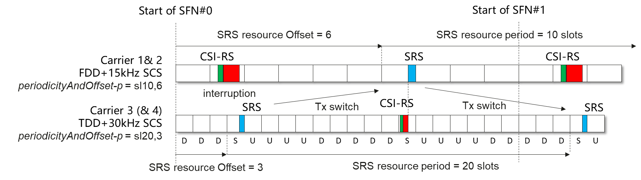
Figure 1: Proposed time domain location of SRS, CSI-RS and interruption under proposed SRS configuration for FDD-TDD Tx switching test

(Agreement) Issue 2-5: SRS configuration and AP CSI-RS for L1-RSRP reporting for TDD-TDD Tx switching across 3 or 4 bands TC
- Agreement: In TDD-TDD Tx switching across 3 or 4 bands test cases,
set SRS periodicityAndOffset-p = sl20,5 for Cell 1 and Cell 2, and SRS periodicityAndOffset-p = sl20,3 for Cell 3 (and Cell 4),
AP CSI-RS for L1-RSRP reporting is triggered
    - in the first special slot of every radio frame for Cell 1 and Cell 2,
    - in the second special slot of every radio frame for Cell 3 (and Cell 4).

- For Information
Under current test configuration (as shown in figure 2) S slot on Cell 1/2 collides with the 2nd S slot of every 8 slots on Cell 3 once every radio frame. Checking DL interruption on all Cells at the same time, which implies SRS shall be transmitted on all Cells at the same time, which violates the intention of testing.
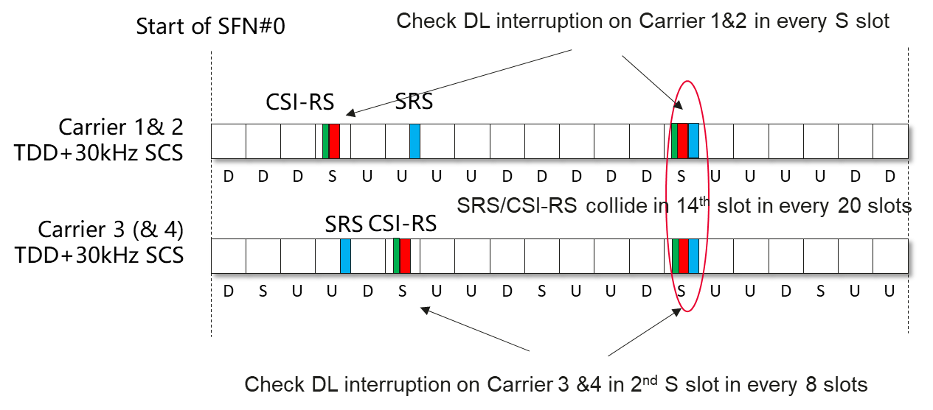
Figure 2: time domain location of SRS, CSI-RS and interruption under current test configuration in current TDD-TDD Tx switching test
With the proposal option 1, SRS configurations and AP CSI-RS configurations are updated as follow:
- TDD Cells with UL/DL pattern “DDDSUUUUDD” (Cell 1 and Cell 2): set periodicityAndOffset-p = sl20,5, AP CSI-RS for L1-RSRP reporting is triggered in the first special slot of every radio frame on Cell 1 and Cell 2.
- TDD Cell(s) with UL/DL pattern “DSUU” (Cell 3, and Cell 4 if appplicable): set periodicityAndOffset-p = sl20,3, AP CSI-RS for L1-RSRP reporting is triggered in the second special slot of every radio frame on Cell 3 (and Cell 4).
The time domain locations of SRS, AP CSI-RS and DL interruption are depicted in figure 3.
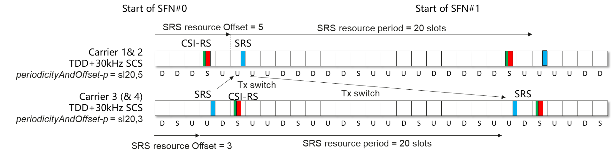
Figure 3: Proposed time domain location of SRS, CSI-RS and interruption under proposed SRS configuration for TDD-TDD Tx switching test

