3GPP TSG-RAN WG4 Meeting #111 R4-24XXXXX
Fukuoka City, Fukuoka, Japan, 20th – 24th May, 2024
Agenda item: 7.13.4
Source: Moderator (Huawei, HiSilicon)
Title: Topic summary for [111][215] NR_MC_enh
Document for: Information

Introduction
This email thread discusses the RRM core and performance requirements of WI on Multi-carrier enhancements.
Online handling
(Online) Issue 1-1: Whether to introduce new UE capability for Dormant BWP switching on multiple CCs RRM requirements with DCI 0-3/1-3
(Online) Issue 2-4: SRS configuration and AP CSI-RS for L1-RSRP reporting for FDD-TDD Tx switching across 3 or 4 bands
(Online) Issue 2-5: SRS configuration and AP CSI-RS for L1-RSRP reporting for TDD-TDD Tx switching across 3 or 4 bands TC
(Online) Issue 1-3: DL interruption for Tx switching across 2 bands and 2 TAGs case

Topic #1: Core requirements for R18 Multi-carrier enhancement

Companies’ contributions summary
T-doc number | Company | Proposals / Observations
R4-2408287 | vivo | Observation 1: bwp-SwitchingMultiDormancyCCs-r16 cannot be used for dormant BWP switching on multiple CCs in RRM requirements if the BWP switch is triggered by SCell dormancy indication in DCI format 0-3/1-3.  Observation 2: bwp-SwitchingMultiCCs-r16 can be reused for BWP switching on multiple CCs in RRM requirements if the BWP switch is triggered by bandwidth part indicator in DCI format 0-3/1-3.  Proposal 1: Revise existing RRM requirements for DCI based BWP switch on multiple CCs to include new DCI 0-1/1-3 based BWP switch.  Proposal 2: Introduce a new UE capability for incremental delay in RRM requirements for DCI-based BWP switch on multiple CCs for multi carrier enhancement as in Table 1.
R4-2408288 | vivo | CR to correct RRM requirements for DCI based BWP switching on multiple CCs for multi-carrier enh
R4-2409471 | Nokia, Nokia Shanghai Bell | - No distinction was made in 1-TAG and 2TAGs cases for 2 bands scenario in the legacy case.  - Existing requirements for DL interruption for Tx switching across 2 bands can be applied to DL interruption for Tx switching across 2 bands and 2 TAGs case.

Open issues summary

Sub-topic 1: Core requirements for R18 Multi-Carrier enhancement
(Online) Issue 1-1: Whether to introduce new UE capability for Dormant BWP switching on multiple CCs RRM requirements with DCI 0-3/1-3
Background
- A new UE capability 49-9 on SCell dormancy indication within active time in DCI format 0_3/1_3 in NR multi-carrier enhancement were introduced in RAN1.
Features | Index | Feature group | Components | Prerequisite feature groups
49. NR_MC_enh | 49-9 | SCell dormancy indication within active time in DCI format 0_3/1_3 | Support for SCell dormancy indication sent within the active time on PCell with DCI format 0_3/1_3 | 6-5, at least one of {49-1, 49-1b, 49-2,49-2b}
- In existing DCI based BWP switch delay on multiple CCs requirements (in TS38.133 clause 8.6.2A), incremental delay (i.e., D) for simultaneous BWP switch depends on different UE capabilities:
-bwp-SwitchingMultiCCs-r16 for switching between non-dormant BWPs, and
-bwp-SwitchingMultiDormancyCCs-r16 for switching between non-dormant and dormant BWPs.
Where bwp-SwitchingMultiDormancyCCs-r16 (that’s FG 6-3) is defined as below. The prerequisite of FG 6-3 is FG 18-4 or 18-4a, which are for format 0-1/1-1 or format 2-6, respectively
Features | Index | Feature group | Components | Prerequisite feature groups
6. LTE_NR_DC_CA_enh | 6-3 | Dormant BWP switching on multiple CCs RRM requirements | Incremental delay for BWP switch processing on additional SCells in DCI based simultaneous dormant BWP switching on multiple SCells | RAN1 feature 18-4 or 18-4a
18. MR-DC/CA enhancement | 18-4 | SCell dormancy indication within active time | Support for SCell dormancy indication sent within the active time on PCell with DCI format 0_1/1_1 | 6-5
18. MR-DC/CA enhancement | 18-4a | SCell dormancy indication outside active time | Support for SCell dormancy indication sent outside the active time on PCell with DCI format 2_6 | 19-1

- Proposals
  - Option 1(vivo): Introduce a new UE capability for incremental delay in RRM requirements for DCI-based BWP switch on multiple CCs for multi carrier enhancement
Features | Index | Feature group | Components | Prerequisite feature groups | Need for the gNB to know if the feature is supported | Applicable to the capability signalling exchange between UEs (V2X WI only)”. | Consequence if the feature is not supported by the UE | Type  (the ‘type’ definition from UE features should be based on the granularity of 1) Per UE or 2) Per Band or 3) Per BC or 4) Per FS or 5) Per FSPC) | Need of FDD/TDD differentiation | Need of FR1/FR2 differentiation | Capability interpretation for mixture of FDD/TDD and/or FR1/FR2 | Note | Mandatory/Optional
38.  NR_MC_enh | 38-9 | Dormant BWP switching on multiple CCs RRM requirements with DCI 0-3/1-3 | Incremental delay for BWP switch processing on additional SCells in DCI 0-3/1-3 based simultaneous dormant BWP switching on multiple SCells | 49-9 | Yes | N/A | There may be additional unclear BWP switching delay if simultaneous dormant BWP switching is triggered by DCI 0-3/1-3. | Per UE | No | No | N/A | The candidate values are:  ● {100us, 200us} for UE indicates type1 in bwp-SwitchingDelay  ● {200us, 400us, 800us, 1000us} for UE indicates type 2 in bwp-SwitchingDelay  The total BWP switching delay will be captured in TS38.133  UE needs to indicate either of the candidate values | Optional with capability signalling
- Recommended WF
Further discussion.

Issue 1-2: Update on RRM requirements for DCI based BWP switch on multiple CCs, if the capability in issue 1-1 is introduced
- Proposals
  - Option 1(vivo): Revise existing RRM requirements for DCI based BWP switch on multiple CCs to include new DCI 0-1/1-3 based BWP switch.
- clause 8.6.2A DCI based BWP switch delay on multiple CCs
<omit non-related content>
D is the incremental delay for each additional CC involved in simultaneous BWP switch and depends on UE capability bwp-SwitchingMultiCCs-r16 [TS 38.306, 14] for switching between non-dormant BWPs, and bwp-SwitchingMultiDormancyCCs-r16 or [UE capability for incremental delay with DCI format 0-3/1-3] for switching between non-dormant and dormant BWPs.

- Recommended WF
Further discussion.

(Online) Issue 1-3: DL interruption for Tx switching across 2 bands and 2 TAGs case
- Proposals
  - Option 1(Nokia): Existing requirements for DL interruption for Tx switching across 2 bands can be applied to DL interruption for Tx switching across 2 bands and 2 TAGs case.
- Recommended WF
Further discussion.

Topic #2: Performance requirements for DL interruption for Tx switching across 3/4 bands

Companies’ contributions summary
T-doc number | Company | Proposals / Observations
R4-2408547 | Huawei, HiSilicon | Observation 1: The time offset settings in Rel-18 Tx switching with dual TAGs test cases don’t match WF R4-2321390 and the TAG settings are unclear.  Observation 2: Under current SRS configuration, UE transmits SRS to every serving cell in every slot.  Proposal 1: Clarify the following in TX switching across 3 or 4 bands for dual TAGs test cases:  - For A.6.5.7D.3:  - Cell 1 and Cell 2 belong to a TAG, Cell 3 belongs to the other TAG.  - Time offset to Cell 1 is set to 0 us and 9 us for Cell 2 and Cell 3 respectively.  - For A.6.5.7D.4:  - Cell 1 and Cell 2 belong to one TAG, Cell 3 and Cell 4 belong to the other TAG.  - Time offset to Cell 1 is set to 0 us, 9 us and 9 us for Cell 2, Cell 3 and Cell 4 respectively.  Proposal 2: Align the nominal RSRP levels of all cells to -84dBm/SCS in Rel-18 Tx switch test cases. Es/Noc level are updated accordingly.  Proposal 3: Update periodicityAndOffset-p of SRS to ensure SRS is transmitted in special slot.  Proposal 4: In FDD-TDD Tx switching across 3 or 4 bands test cases, set SRS periodicityAndOffset-p = sl10,6 for Cell 1 and Cell 2, and SRS periodicityAndOffset-p = sl20,3 for Cell 3 (and Cell 4)  Proposal 5: In FDD-TDD Tx switching across 3 or 4 bands test cases, AP CSI-RS for L1-RSRP reporting is triggered  - in the slot overlapping with the first S slot of every radio frame on NR TDD cell for Cell 1 and Cell 2,  - in the second S slot of every radio frame for Cell 3 (and Cell 4).  Proposal 6: In TDD-TDD Tx switching across 3 or 4 bands test cases, set SRS periodicityAndOffset-p = sl20,5 for Cell 1 and Cell 2, and SRS periodicityAndOffset-p = sl20,3 for Cell 3 (and Cell 4).  Proposal 7: In TDD-TDD Tx switching across 3 or 4 bands test cases, AP CSI-RS for L1-RSRP reporting is triggered  - in the first special slot of every radio frame for Cell 1 and Cell 2,  - in the second special slot of every radio frame for Cell 3 (and Cell 4).  Proposal 8: Update SRS and AP CSI-RS configurations in Rel-16/17 Tx switch test cases in the same way.
R4-2408548 | Huawei, HiSilicon | Correction CR to multi-carrier enhancement RRM test cases_R18

Open issues summary

Sub-topic 1: DL interruption TC
Background
The below four TCs have be specified in current spec:
A.6.5.7D.1 DL interruptions at switching across three uplink bands in TDD-TDD CA for single TAG
A.6.5.7D.2 DL interruptions at switching across four uplink bands in FDD-TDD CA for single TAG
A.6.5.7D.3 DL interruptions at Tx switching across three uplink bands in FDD-TDD CA for 2 TAGs
A.6.5.7D.4 DL interruptions at Tx switching across four uplink bands in TDD-TDD CA with different UL/DL pattern for 2 TAGs
Issue 2-1: Clarification of TAG and time offsets in Dual TAGs test cases
- Proposals
  - Option 1 (Huawei): Clarify the time offset in TX switching across 3 or 4 bands for dual TAGs test cases:
For A.6.5.7D.3:
Cell 1 and Cell 2 belong to a TAG, Cell 3 belongs to the other TAG.
Time offset to Cell 1 is set to 0 us and 9 us for Cell 2 and Cell 3 respectively.
For A.6.5.7D.4:
Cell 1 and Cell 2 belong to one TAG, Cell 3 and Cell 4 belong to the other TAG.
Time offset to Cell 1 is set to 0 us, 9 us and 9 us for Cell 2, Cell 3 and Cell 4 respectively.
- Recommended WF
It is agreed in [R4-2321390] that time offset is 0us for the same TAG and 9us for 2TAG. The proposal is to clarify that all time offsets are compared to Cell1. Is option 1 agreeable?
Issue 2-2: Alignment of RSRP Levels among Tx switching test cases
Background
In current TCs, Noc, Es/Noc, SS-RSRP and Io level are various. From RAN5 perspective, all cells having the same RSRP reporting range can significantly simplify RAN5 TT analysis.
 | FDD Cells (15KHz SCS + 10MHz CBW) |  |  |  | TDD Cells (30KHz SCS + 40MHz CBW)
 | Noc  (in dBm/ 15kHz) | Es/Noc  (in dB) | Nominal SS-RSRP  (in dBm/ SCS) | Io  (in dBm/Ch BW) | Noc  (in dBm/ 15kHz) | Es/Noc  (in dB) | Nominal SS-RSRP  (in dBm/ SCS) | Io  (in dBm/Ch BW)
A.6.5.7D.1 | N/A | N/A | N/A | N/A | -104 | 17 | -84 | -55.79
A.6.5.7D.2 | -104 | 17 | -87 | -58.96 | -104 | 14 | -87 | -55.79
A.6.5.7D.3 | -104 | 17 | -87 | -58.96 | -104 | 14 | -87 | -55.79
A.6.5.7D.4 | N/A | N/A | N/A | N/A | -104 | 17 for Cell 1  14 for other Cells | -84 for Cell 1  -87 for other Cells | -55.79 for all Cells
- Proposals
  - Option 1 (Huawei): Align the nominal RSRP levels of all cells to -84dBm/SCS in Rel-18 Tx switch test cases to reduce RAN5 work load.
- Recommended WF
Further discussion
Issue 2-3: Principle for SRS configuration and triggering aperiodic CSI-RS for L1-RSRP reporting
Background
It is agreed in [R4-2321390] that DL interruption is to be verified in S slots. However according to current SRS resource configuration, periodicityAndOffset-p is set to sl1,0. which means UE shall send SRS on each carrier in each slot available for UL. In the worst case, the UE may need to send SRSs on 4 carriers at the same time.
Table A.4.4.1.1.1-3: SRS Configuration for Timing Accuracy Test
SRS-Resource | SRS-ResourceId | 0
 | nrofSRS-Ports | Port1
 | transmissionComb | n2
 | combOffset-n2 | 0
 | cyclicShift-n2 | 0
 | resourceMapping  startPosition | 0
 | resourceMapping  nrofSymbols | n1
 | resourceMapping  repetitionFactor | n1
 | freqDomainPosition | 0
 | freqDomainShift | 0
 | freqHopping  c-SRS | 14 for test configuration 1,2,4,5  25 for test configuration 3,6
 | freqHopping  b-SRS | 0
 | freqHopping  b-hop | 0
 | groupOrSequenceHopping | Neither
 | resourceType | Periodic
 | periodicityAndOffset-p | sl1, 0

- Proposals
  - Option 1 (Huawei): Update periodicityAndOffset-p in SRS configuration and ensure SRS transmission and aperiodic CSI-RS for L1-RSRP reporting is overlapped/in the special slot.
- Recommended WF
Further discussion
(Online) Issue 2-4: SRS configuration and AP CSI-RS for L1-RSRP reporting for FDD-TDD Tx switching across 3 or 4 bands
- Proposals
  - Option 1 (Huawei): In FDD-TDD Tx switching across 3 or 4 bands test cases,
set SRS periodicityAndOffset-p = sl10,6 for Cell 1 and Cell 2, and SRS periodicityAndOffset-p = sl20,3 for Cell 3 (and Cell 4) ,
AP CSI-RS for L1-RSRP reporting is triggered
    - in the slot overlapping with the first S slot of every radio frame on NR TDD cell for Cell 1 and Cell 2,
    - in the second S slot of every radio frame for Cell 3 (and Cell 4).
- For Information
With the proposal option 1, SRS configurations and AP CSI-RS configurations are updated as follow:
- FDD Cells (Cell 1 and Cell 2): set periodicityAndOffset-p = sl10,6, AP CSI-RS for L1-RSRP reporting is triggered in the slot overlapping with the first special slot of every radio frame on NR TDD cell.
- TDD Cell(s) (Cell 3, and Cell 4 if applicable): set periodicityAndOffset-p = sl20,3, AP CSI-RS for L1-RSRP reporting is triggered in the second special slot of every radio frame on NR TDD cell.
The time domain locations of SRS, AP CSI-RS and DL interruption are depicted in Figure 1.
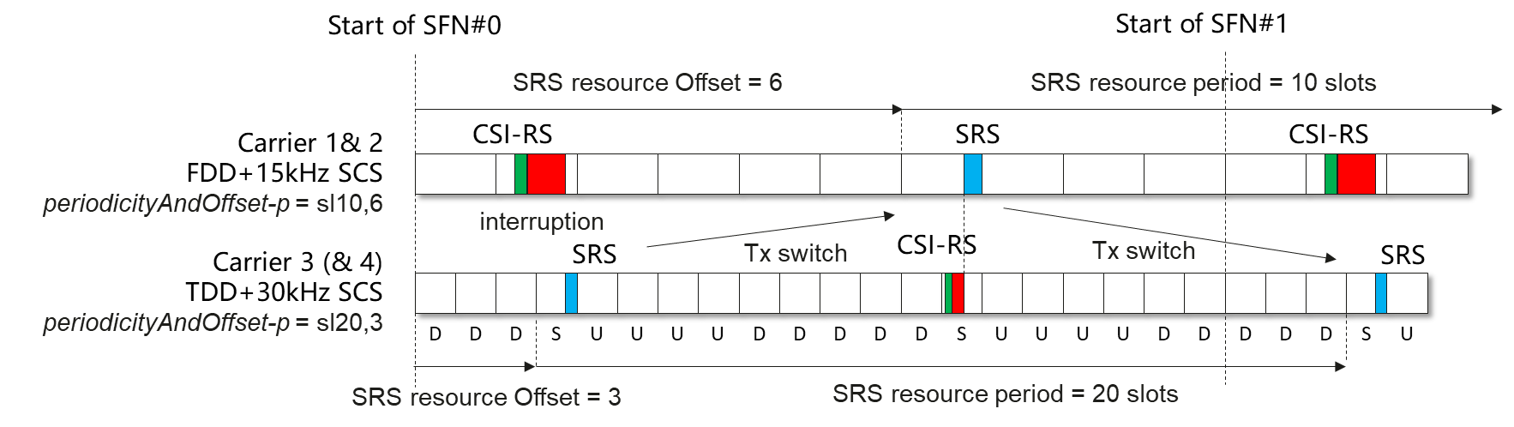
Figure 1: Proposed time domain location of SRS, CSI-RS and interruption under proposed SRS configuration for FDD-TDD Tx switching test
- Recommended WF
Further discussion

(Online) Issue 2-5: SRS configuration and AP CSI-RS for L1-RSRP reporting for TDD-TDD Tx switching across 3 or 4 bands TC
- Proposals
  - Option 1 (Huawei): In TDD-TDD Tx switching across 3 or 4 bands test cases,
set SRS periodicityAndOffset-p = sl20,5 for Cell 1 and Cell 2, and SRS periodicityAndOffset-p = sl20,3 for Cell 3 (and Cell 4),
AP CSI-RS for L1-RSRP reporting is triggered
    - in the first special slot of every radio frame for Cell 1 and Cell 2,
    - in the second special slot of every radio frame for Cell 3 (and Cell 4).

- For Information
Under current test configuration (as shown in figure 2) S slot on Cell 1/2 collides with the 2nd S slot of every 8 slots on Cell 3 once every radio frame. Checking DL interruption on all Cells at the same time, which implies SRS shall be transmitted on all Cells at the same time, which violates the intention of testing.
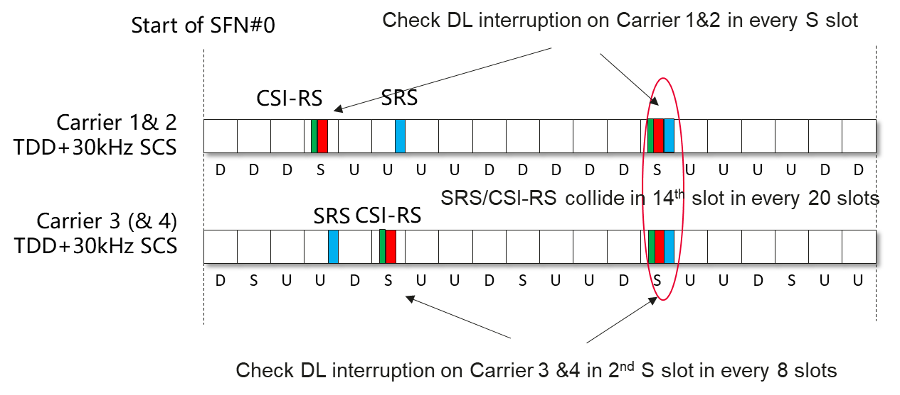
Figure 2: time domain location of SRS, CSI-RS and interruption under current test configuration in current TDD-TDD Tx switching test
With the proposal option 1, SRS configurations and AP CSI-RS configurations are updated as follow:
- TDD Cells with UL/DL pattern “DDDSUUUUDD” (Cell 1 and Cell 2): set periodicityAndOffset-p = sl20,5, AP CSI-RS for L1-RSRP reporting is triggered in the first special slot of every radio frame on Cell 1 and Cell 2.
- TDD Cell(s) with UL/DL pattern “DSUU” (Cell 3, and Cell 4 if appplicable): set periodicityAndOffset-p = sl20,3, AP CSI-RS for L1-RSRP reporting is triggered in the second special slot of every radio frame on Cell 3 (and Cell 4).
The time domain locations of SRS, AP CSI-RS and DL interruption are depicted in figure 3.
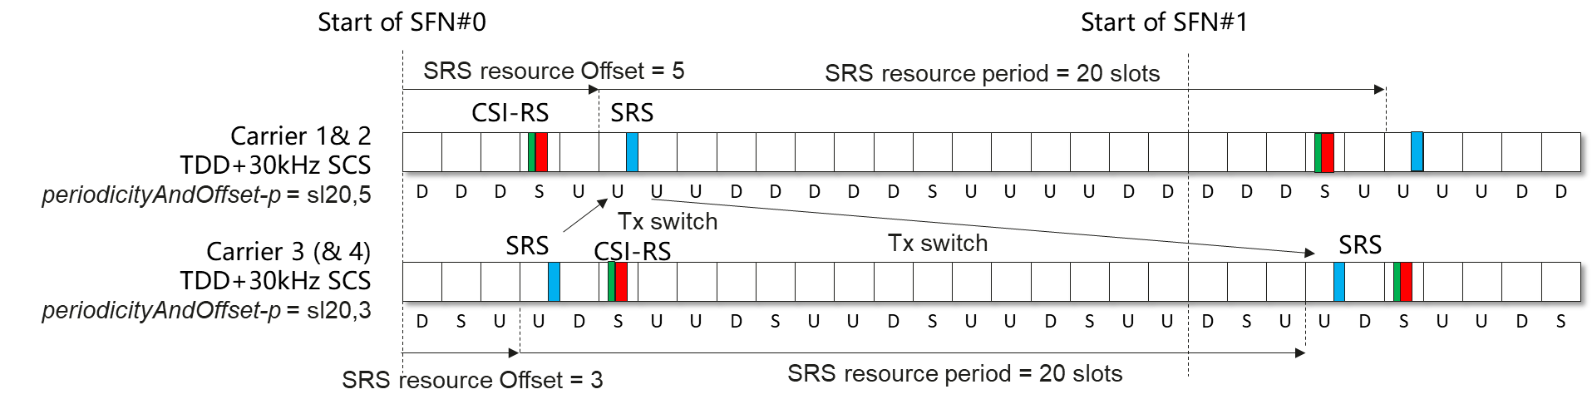
Figure 3: Proposed time domain location of SRS, CSI-RS and interruption under proposed SRS configuration for TDD-TDD Tx switching test
- Recommended WF
Further discussion
Issue 2-6: Update on Rel-16/17 Tx switch test cases
- Proposals
  - Option 1 (Huawei): Update SRS and AP CSI-RS configurations in Rel-16/17 Tx switch test cases in the same way.
- Recommended WF
If the above technical issues have achieved conclusions, the same principle can be applied to early release. No need to discuss on this issue.

