3GPP TSG-RAN4 Meeting # 111 R4-2408561
Fukuoka City, Fukuoka , Japan, 20th – 24th May, 2024
CR-Form-v12.3
CHANGE REQUEST
 | 38.133 | CR | Draft | rev | - | Current version: | 18.5.0
For HELP on using this form: comprehensive instructions can be found at
http://www.3gpp.org/Change-Requests.

Proposed change affects: | UICC apps |  | ME | X | Radio Access Network |  | Core Network

Title: | DraftCR on TC3 fast beam sweeping for R18 FR2 multi-Rx
Source to WG: | Huawei, HiSilicon
Source to TSG: | R4
Work item code: | NR_FR2_multiRX_DL-Perf |  |  |  |  |  | Date: |  |  | 2024-05-01
Category: | B |  |  |  |  |  | Release: |  |  | Rel-18
 | Use one of the following categories:  F (correction)  A (mirror corresponding to a change in an earlier release)  B (addition of feature),  C (functional modification of feature)  D (editorial modification)  Detailed explanations of the above categories can  be found in 3GPP TR 21.900. |  |  |  |  |  |  |  | Use one of the following releases:  Rel-8 (Release 8)  Rel-9 (Release 9)  Rel-10 (Release 10)  Rel-11 (Release 11)  …  Rel-17 (Release 17)  Rel-18 (Release 18)  Rel-19 (Release 19)  Rel-20 (Release 20)
Reason for change: |  | Following TC is to be introduced per WF R4-2406365  - TC3: Fast beam sweeping for RLM OOS
Summary of change: |  | Introduce following TC:  - TC3: Fast beam sweeping for RLM OOS
Consequences if not approved: |  | The requirements can not be verified.
Clauses affected: |  | A.5.5.1.X1 and A.7.5.1.X1
 |  | Y | N
Other specs |  |  | X | Other core specifications |  |  |  | TS/TR ... CR ...
affected: |  | X |  | Test specifications |  |  |  | TS 38.533
(show related CRs) |  |  | X | O&M Specifications |  |  |  | TS/TR ... CR ...
Other comments:
This CR's revision history:

<Start of Change #1>

A.5.5.1.X1 Radio Link Monitoring Out-of-sync Test for FR2 PSCell configured with SSB-based RLM RS in non-DRX mode for UE supporting fast beam sweeping in multi-Rx

A.5.5.1.X1.1 Test Purpose and Environment
The purpose of this test is to verify that the UE properly detects the out of sync for the purpose of monitoring downlink radio link quality of the PSCell. This test will partly verify the FR2 radio link monitoring requirements in clause 8.1.
In the test, UE is configured to perform RLM on SSB, with detectionResource included in RadioLinkMonitoringRS set to SSB#0 and SSB#1, and purpose set to ‘rlf’. Supported test configurations are shown in table A.5.5.1.X1.1-1. The test parameters are given in Tables A.5.5.1.X1.1-2, and A.5.5.1.X1.1-3. There are two cells, Cell 1 is the E-UTRAN PCell, and Cell 2 is the PSCell, in the test. The E-UTRAN PCell setting refers to Table A.3.7.2.1-2. The test consists of three successive time periods, with time duration of T1, T2 and T3 respectively. Figure A.5.5.1.X1.1-1 shows the variation of the downlink SNR in the active cell to emulate out-of-sync and in-sync states, and Figure A.5.5.1.X1.1-2 shows the Time multiplexed downlink transmissions from each Angle of Arrival. Prior to the start of the time duration T1, the UE shall be fully synchronized to Cell 1 and Cell 2 and configured with groupBasedBeamReporting-r17. The UE shall be configured for periodic CSI reporting with a reporting periodicity of 5 ms.
Table A.5.5.1.X1.1-1: Supported test configurations for FR2 PSCell
Configuration | Description
1 | FDD LTE PCell, NR 120 KHz SSB SCS, 100 MHz bandwidth, TDD duplex mode
2 | TDD LTE PCell, NR 120 KHz SSB SCS, 100 MHz bandwidth, TDD duplex mode
Note: The UE is only required to pass in one of the supported test configurations in FR2

Table A.5.5.1.X1.1-2: General test parameters for FR2 out-of-sync testing in non-DRX mode
Parameter |  |  | Unit | Value
 |  |  |  | Test 1
Active E-UTRA PCell |  |  |  | Cell 1
E-UTRA RF Channel Number |  |  |  | 1
Active PSCell |  |  |  | Cell 2
RF Channel Number |  |  |  | 2
Duplex mode |  | Config 1, 2 |  | TDD
BW_{channel} |  | Config 1, 2 |  | 100: N_{RB,c} = 66
Data RBs allocated |  | Config 1, 2 |  | 24
DL initial BWP configuration |  | Config 1, 2 |  | DLBWP.0.1
DL dedicated BWP configuration |  | Config 1, 2 |  | DLBWP.1.1
UL initial BWP configuration |  | Config 1, 2 |  | ULBWP.0.1
UL dedicated BWP configuration |  | Config 1, 2 |  | ULBWP.1.1
TDD Configuration |  | Config 1, 2 |  | TDDConf.3.1
RMSI CORESET Reference Channel |  | Config 1, 2 |  | CR.3.1 TDD
Dedicated CORESET Reference Channel |  | Config 1, 2 |  | CCR.3.4 TDD
SSB Configuration |  | Config 1, 2 |  | SSB.1 FR2
SMTC Configuration |  | Config 1, 2 |  | SMTC.1
PDSCH/PDCCH subcarrier spacing |  | Config 1, 2 |  | 120 KHz
PRACH Configuration |  | Config 1, 2 |  | Table A.3.8.3.1
SSB index assigned as RLM RS |  | Config 1, 2 |  | 0,1
OCNG parameters |  |  |  | OP.5
CP length |  |  |  | Normal
Out of sync transmission parameters | DCI format |  |  | 1-0
 | Number of Control OFDM symbols |  |  | 2
 | Aggregation level |  | CCE | 8
 | Ratio of hypothetical PDCCH RE energy to average SSS RE energy |  | dB | 4
 | Ratio of hypothetical PDCCH DMRS energy to average SSS RE energy |  | dB | 4
 | DMRS precoder granularity |  |  | REG bundle size
 | REG bundle size |  |  | 6
DRX |  |  |  | OFF
Gap pattern ID |  |  |  | NA
Layer 3 filtering |  |  |  | Enabled
T310 timer |  |  | ms | 0
T311 timer |  |  | ms | 1000
N310 |  |  |  | 1
N311 |  |  |  | 1
CSI-RS for CSI reporting |  | Config 1, 2 |  | CSI-RS.3.1 TDD
reportConfigType |  |  |  | periodic
reportQuantity |  |  |  | cri-RI-PMI-CQI
CSI reporting periodicity |  |  | slot | 40
CSI reporting offset |  |  | slot | 4
TCI states for PDCCH/PDSCH |  |  |  | TCI.State.2
CSI-RS for tracking |  | Config 1, 2 |  | TRS.2.1 TDD
T1 |  |  | s | 0.2
T2 |  |  | s | 1.2*N +0.08 ^{Note 4}
T3 |  |  | s | 1.2*N +0.08 ^{Note 4}
D1 |  |  | s | 1.2*N +0.04 ^{Note 4}
Note 1: All configurations are assigned to the UE prior to the start of time period T1.
Note 2: UE-specific PDCCH is not transmitted after T1 starts.
Note 3: E-UTRAN is in non-DRX mode under test.
Note 4: N is the value indicated by UE for [UEcapablityFastbeamsweeping]

Table A.5.5.1.X1.1-3: OTA related cell specific test parameters for FR2 (Cell 2) for out-of-sync radio link monitoring tests in non-DRX mode
Parameter |  | Unit | Test 1
 |  |  | T1 | T2 | T3 | T1 | T2 | T3
AoA setup |  |  | Setup X2 defined in A.3.15
 |  |  | AoA1 |  |  | AoA2
Assumption for UE beams^{Note 5} |  |  | Rough |  |  | Rough
EPRE ratio of PDCCH DMRS to SSS |  | dB | 4
EPRE ratio of PDCCH to PDCCH DMRS |  | dB
EPRE ratio of PBCH DMRS to SSS |  | dB
EPRE ratio of PBCH to PBCH DMRS |  | dB
EPRE ratio of PSS to SSS |  | dB | 0 |  |  | Not sent
EPRE ratio of PDSCH DMRS to SSS |  | dB
EPRE ratio of PDSCH to PDSCH DMRS |  | dB
EPRE ratio of OCNG DMRS to SSS |  | dB
EPRE ratio of OCNG to OCNG DMRS |  | dB
ssb-Index 0 SNR | Config 1, 2 | dB | 2^{Note 6} | -6^{Note 6} | -15
ssb-Index 1 SNR | Config 1, 2 |  | Not sent |  |  | 2^{Note 6} | -15 | -15
 | Config 1, 2 | dBm/  15kHz | -92.1 |  |  | -92.1
Time multiplexing of the downlink transmissions from each AoA |  |  | Defined in Figure A.5.5.1.X1.1-2
Propagation condition |  |  | TDL-A 30ns 75Hz |  |  | TDL-A 30ns 75Hz
Note 1: OCNG shall be used such that a constant total transmitted power spectral density is achieved for all OFDM symbols.
Note 2: The signal contains PDCCH for UEs other than the device under test as part of OCNG.
Note 3: SNR levels correspond to the signal to noise ratio over the SSS REs.
Note 4: The SNR values are specified for testing a UE which supports 2RX on at least one band. For testing of a UE which supports 4RX on all bands, the SNR during T3 is A.3.6.
Note 5: Information about types of UE beam is given in B.2.1.3, and does not limit UE implementation or test system implementation
Note 6: This value allows up to 1dB degradation from applied SNR to UE baseband

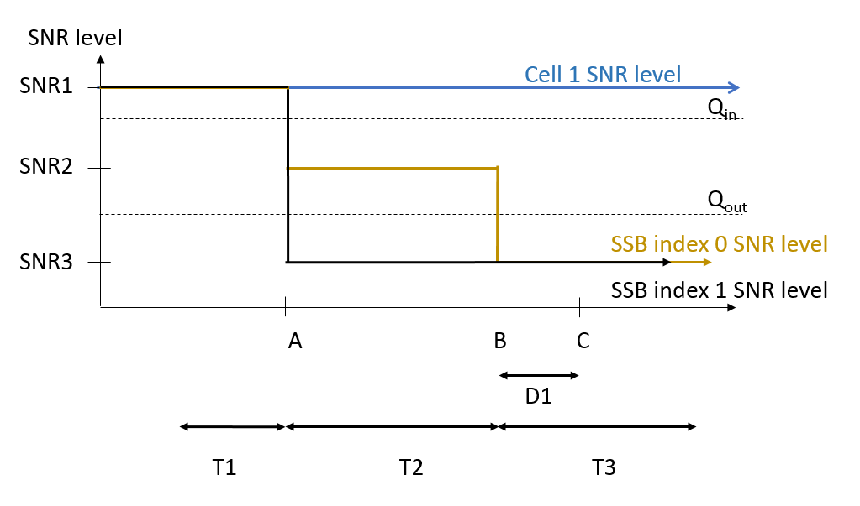
Figure A.5.5.1.X1.1-1: SNR variation for out-of-sync testing
Figure A.5.5.1.X1.1-2: Time multiplexed downlink transmissions

A.5.5.1.X1.2 Test Requirements
The UE behavior in each test during time durations T1, T2 and T3 shall be as follows:
During the period from time point A to time point B the UE shall transmit uplink signal at least in all uplink slots configured for CSI transmission according to the configured periodic CSI reporting.
The UE shall stop transmitting uplink signal in Cell 2 no later than time point C (D1 second after the start of the time duration T3).
The rate of correct events observed during repeated tests shall be at least 90%.

<End of Change #1>

<Start of Change #2>

A.7.5.1.X1 Radio Link Monitoring Out-of-sync Test for FR2 PCell configured with SSB-based RLM RS in non-DRX mode for UE supporting fast beam sweeping in multi-Rx

A.7.5.1.X1.1 Test Purpose and Environment
The purpose of this test is to verify that the UE properly detects the out of sync and in sync for the purpose of monitoring downlink radio link quality of the PCell. This test will partly verify the FR2 radio link monitoring requirements in clause 8.1.
In the test, UE is configured to perform RLM on SSB, with detectionResource included in RadioLinkMonitoringRS set to SSB#0 and SSB#1, and purpose set to ‘rlf’. Supported test configurations are shown in table A.7.5.1.X1.1-1. The test parameters are given in Tables A.7.5.1.X1.1-2, and A.7.5.1.X1.1-3below. There is one cell (Cell 1), which is the active NR cell, in the test. The test consists of three successive time periods, with time duration of T1, T2 and T3 respectively. Figure A.7.5.1.X1.1-1 shows the variation of the downlink SNR in the active cell to emulate out-of-sync and in-sync states, and Figure A.7.5.1.X1.1-2 shows the Time multiplexed downlink transmissions from each Angle of Arrival. Prior to the start of the time duration T1, the UE shall be fully synchronized to Cell 1. The UE shall be configured for periodic CSI reporting with a reporting periodicity of 5 ms. In addition to RLM-RS radio link monitoring using SSB index 0 and SSB index 1.
Table A.7.5.1.X1.1-1: Supported test configurations for FR2 PCell
Configuration | Description
1 | TDD, SSB SCS 120 KHz, data SCS 120KHz, BW 100 MHz

Table A.7.5.1.X1.1-2: General test parameters for FR2 out-of-sync testing in non-DRX mode
Parameter |  |  | Unit | Value
 |  |  |  | Test 1
Active PCell |  |  |  | Cell 1
RF Channel Number |  |  |  | 1
Duplex mode |  | Config 1 |  | TDD
BW_{channel} |  | Config 1 |  | 100: N_{RB,c} = 66
Data RBs allocated |  | Config 1 |  | 24
DL initial BWP configuration |  | Config 1 |  | DLBWP.0.1
DL dedicated BWP configuration |  | Config 1 |  | DLBWP.1.1
UL initial BWP configuration |  | Config 1 |  | ULBWP.0.1
UL dedicated BWP configuration |  | Config 1 |  | ULBWP.1.1
TDD Configuration |  | Config 1 |  | TDDConf.3.1
RMSI CORESET Reference Channel |  | Config 1 |  | CR.3.1 TDD
Dedicated CORESET Reference Channel |  | Config 1 |  | CCR.3.4 TDD
SSB Configuration |  | Config 1 |  | SSB.1 FR2
SMTC Configuration |  | Config 1 |  | SMTC.1
PDSCH/PDCCH subcarrier spacing |  | Config 1 |  | 120 KHz
PRACH Configuration |  | Config 1 |  | Table A.3.8.3.1
SSB index assigned as RLM RS |  | Config 1 |  | 0,1
OCNG parameters |  |  |  | OP.5
CP length |  |  |  | Normal
Out of sync transmission parameters | DCI format |  |  | 1-0
 | Number of Control OFDM symbols |  |  | 2
 | Aggregation level |  | CCE | 8
 | Ratio of hypothetical PDCCH RE energy to average SSS RE energy |  | dB | 4
 | Ratio of hypothetical PDCCH DMRS energy to average SSS RE energy |  | dB | 4
 | DMRS precoder granularity |  |  | REG bundle size
 | REG bundle size |  |  | 6
DRX |  |  |  | OFF
Gap pattern ID |  |  |  | NA
Layer 3 filtering |  |  |  | Enabled
T310 timer |  |  | ms | 0
T311 timer |  |  | ms | 1000
N310 |  |  |  | 1
N311 |  |  |  | 1
CSI-RS for CSI reporting |  | Config 1 |  | CSI-RS.3.1 TDD
reportConfigType |  |  |  | periodic
reportQuantity |  |  |  | cri-RI-PMI-CQI
CSI reporting periodicity |  |  | slot | 40
CSI reporting offset |  |  | slot | 4
TCI states for PDCCH/PDSCH |  |  |  | TCI.State.2
CSI-RS for tracking |  | Config 1 |  | TRS.2.1 TDD
T1 |  |  | s | 0.2
T2 |  |  | s | 1.2*N +0.08 ^{Note 3}
T3 |  |  | s | 1.2*N +0.08 ^{Note 3}
D1 |  |  | s | 1.2*N +0.04 ^{Note 3}
Note 1: All configurations are assigned to the UE prior to the start of time period T1.
Note 2: UE-specific PDCCH is not transmitted after T1 starts.
Note 3: N is the value indicated by UE for [UEcapablityFastbeamsweeping]

Table A.7.5.1.X1.1-3: OTA related cell specific test parameters for FR2 (Cell 1) for out-of-sync radio link monitoring tests in non-DRX mode
Parameter |  | Unit | Test 1
 |  |  | T1 | T2 | T3 | T1 | T2 | T3
AoA setup |  |  | Setup X2 defined in A.3.15
 |  |  | AoA1 |  |  | AoA2
Assumption for UE beams ^{Note 5} |  |  | Rough |  |  | Rough
EPRE ratio of PDCCH DMRS to SSS |  | dB | 4 |  |  | Not sent
EPRE ratio of PDCCH to PDCCH DMRS |  | dB | 0
EPRE ratio of PBCH DMRS to SSS |  | dB
EPRE ratio of PBCH to PBCH DMRS |  | dB
EPRE ratio of PSS to SSS |  | dB
EPRE ratio of PDSCH DMRS to SSS |  | dB
EPRE ratio of PDSCH to PDSCH DMRS |  | dB
EPRE ratio of OCNG DMRS to SSS |  | dB
EPRE ratio of OCNG to OCNG DMRS |  | dB
ssb-Index 0 SNR | Config 1 | dB | 2^{Note 6} | -6^{Note 6} | -15
ssb-Index 1 SNR | Config 1 |  | Not sent |  |  | 2^{Note 6} | -15 | -15
 | Config 1 | dBm/  15kHz | -92.1 |  |  | -92.1
Time multiplexing of the downlink transmissions from each AoA |  |  | Defined in Figure A.7.5.1.X1.1-2
Propagation condition |  |  | TDL-A 30ns 75Hz |  |  | TDL-A 30ns 75Hz
Note 1: OCNG shall be used such a constant total transmitted power spectral density is achieved for all OFDM symbols.
Note 2: The signal contains PDCCH for UEs other than the device under test as part of OCNG.
Note 3: SNR levels correspond to the signal to noise ratio over the SSS REs.
Note 4: The SNR values are specified for testing a UE which supports 2RX on at least one band. For testing of a UE which supports 4RX on all bands, the SNR during T3 is A.3.6.
Note 5: Information about types of UE beam is given in B.2.1.3 and does not limit UE implementation or test system implementation.
Note 6: This value allows up to 1dB degradation from applied SNR to UE baseband

Table A.7.5.1.X1.1-4: Measurement gap configuration for out-of-sync tests in non-DRX mode
Field | Test 1
 | Value
gapOffset | 0

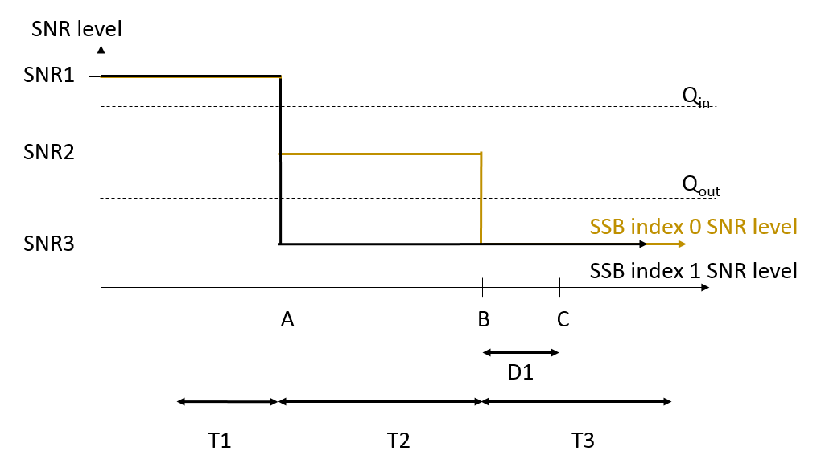
Figure A.7.5.1.X1.1-1: SNR variation for out-of-sync testing
Figure A.7.5.1.X1.1-2: Time multiplexed downlink transmissions

A.7.5.1.X1.2 Test Requirements
The UE behavior in each test during time durations T1, T2 and T3 shall be as follows:
During the period from time point A to time point B the UE shall transmit uplink signal at least in all uplink slots configured for CSI transmission according to the configured periodic CSI reporting.
The UE shall stop transmitting uplink signal no later than time point C (D1 second after the start of the time duration T3).
The rate of correct events observed during repeated tests shall be at least 90%.

<End of Change #2>

