3GPP TSG-RAN WG4 Meeting # 111 R4-240xxxx
Fukuoka, Japan, 20 – 24 May, 2024

Agenda item: 4.8
Source: Moderator (Huawei, HiSilicon)
Title: Topic summary for [111][201] Maintenance_up_to_R17
Document for: Information

Introduction
This document provides summary for RRM related Tdocs submitted to the following AI
4.4 RRM requirements [WI code]
4.7 Rel-15/16/17 TEI [TEI]
Please kindly take following notes for Tdoc handling in this topic thread.
- Open issues are based on Discussion papers.
- Based on Chair’s guidance, all CRs in this email thread will be first handled in NWM flagging procedure which will be triggered separately.
- Tdocs that are withdrawn or revised in the Tdocs list will not be handled in the summary document or the NWM flagging procedure.
- Cat-A CRs will not be handled in the summary document or the NWM flagging procedure.
Recommended issues for online discussion:
Sub-topic 4-1: Measurement of deactivated SCell in NCSG
Sub-topic 2-1: Interruption requirements for R16 NFG
Sub-topic 2-2: Measurement requirements for R16 NFG
Sub-topic 5-1: Alignment of terminology for satellite orbit types
Sub-topic 1-1: MAC CE based active TCI state list update delay
Sub-topic 3-1: Applicability of tci-ActivatedConfig for SCell

Topic #1: R15 NR

Companies’ contributions summary
T-doc number | Company | Proposals / Observations
R4-2407289 | Apple | Proposal 1: It is proposed to specify the active TCI state list update delay as follows:  “If the target TCI state is known, upon receiving PDSCH carrying MAC-CE for activation/deactivation of UE-specific PDSCH TCI state as defined in clause 6.1.3.14 of TS 38.321 [7] at slot n, UE shall be able to receive PDCCH, which schedules PDSCH with the new target TCI state, at the first slot that is after n+ T_{HARQ} +${3N}_{slot}^{subframe,µ}$ +TO_{k}*(T_{first-SSB} + T_{SSB-proc}) / NR slot length, and the UE is not expected to receive such PDCCH before that. Where T_{HARQ}, T_{first-SSB,} T_{SSB-proc} and TO_{k} are defined in clause 8.10.3.”
R4-2407758 | vivo | Observation 1 The DCI based TCI state switch delay shall be captured in 8.10.4 of TS 38.133. However, currently the ‘slot n’ defined in 8.10.4 is still not clear enough.  Observation 2 The gNB has no information on when the TCI state list update is finished by the UE, and the indication of PDSCH TCI via DCI could be late. Hence, it is not always ensured that UE can receive PDSCH with the new TCI at the slot after n+ T_{HARQ} +${3N}_{slot}^{subframe,µ}$+TO_{k}*(T_{first-SSB} + T_{SSB-proc}) / NR_slot_length + ceiling(timeDurationForQCL/14).  Proposal 1 Adopt the text proposal in [5].
R4-2408138 | Nokia | - Update the test case to reflect the UE requirements.  We have provided a correction CR in [4].

Open issues summary

Sub-topic 1-1: MAC CE based active TCI state list update delay
- Proposals
  - Option 1 (Apple):
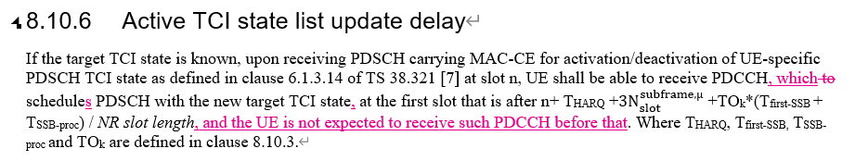
  - Option 2 (vivo):
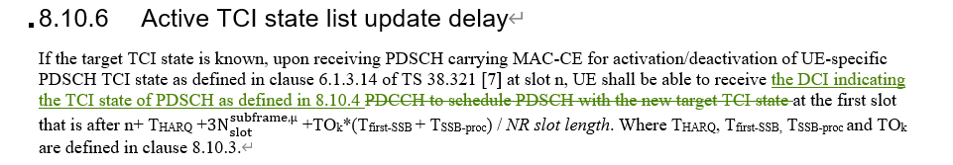
  - Option 3 (Nokia):
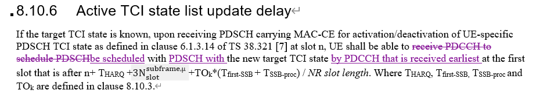
- Recommended WF
  - Discuss the options

Sub-topic 1-2: DCI based active TCI state switch delay
- Proposals
  - Option 1 (vivo):
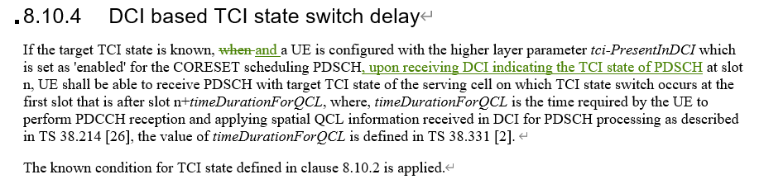
- Recommended WF
  - Discuss the options

Sub-topic 1-3: Test case for MAC CE based active TCI state switching delay
- Proposals
  - Option 1 (Nokia): for A.7.5.8.1.1 (NR PCell FR2 active TCI state switch for a known TCI state)
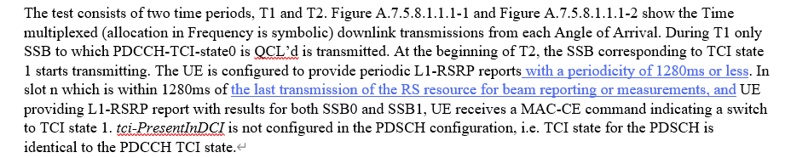
- Recommended WF
  - Discuss the options

Topic #2: R16 NR_RRM_enh

Companies’ contributions summary
T-doc number | Company | Proposals / Observations
R4-2409127 | Nokia, Deutsche Telekom, Orange, NTT DOCOMO, INC., TELECOM ITALIA S.p.A., Telia Company, T-Mobile USA, Verizon, Vodafone | Proposal 1: For Scenario 1 (LTE – NR inter-RAT measurement): Clarify that a UE supporting interRAT-NeedForGaps-r16=FALSE may cause interruptions with a ratio of X %.  Proposal 2: For Scenario 2: If needForInterruptionConfigNR-r18 is not enabled, a UE indicating “no-gap” as part of NeedForGapsInfoNR-r16 may cause interruptions with a ratio of X %.  Proposal 3: For Scenario 1 (LTE – NR inter-RAT measurement): a UE supporting interRAT-NeedForGaps-r16=FALSE may cause interruptions with a ratio of 5 % for FR1 and 8% for FR2.  Proposal 4: For Scenario 2: If needForInterruptionConfigNR-r18 is not enabled, a UE indicating “no-gap” as part of NeedForGapsInfoNR-r16 may cause interruptions with a ratio of 3 % in FR1 and 7 % in FR2.  Proposal 5: For Scenario 1: If the SMTC of the NR interRAT carrier is partially overlapping with measurement gaps, the UE shall perform NR interRAT measurements using the gaps.  Proposal 6: For Scenario 2: If the SMTC is partially overlapping with measurement gaps, the UE shall perform the measurements using the gaps.

Open issues summary

Sub-topic 2-1: Interruption requirements for R16 NFG
- Proposals
  - Option 1 (Nokia):
    - For Scenario 1 (LTE – NR inter-RAT measurement): a UE supporting interRAT-NeedForGaps-r16=FALSE may cause interruptions with a ratio of 5 % for FR1 and 8% for FR2.
    - For Scenario 2: If needForInterruptionConfigNR-r18 is not enabled, a UE indicating “no-gap” as part of NeedForGapsInfoNR-r16 may cause interruptions with a ratio of 3 % in FR1 and 7 % in FR2.
- Recommended WF
  - Discuss the options

Sub-topic 2-2: Measurement requirements for R16 NFG
- Proposals
  - Option 1 (Nokia):
    - For Scenario 1: If the SMTC of the NR interRAT carrier is partially overlapping with measurement gaps, the UE shall perform NR interRAT measurements using the gaps.
    - For Scenario 2: If the SMTC is partially overlapping with measurement gaps, the UE shall perform the measurements using the gaps.
- Recommended WF
  - Discuss the options

Topic #3: R17 LTE_NR_DC_enh2

Companies’ contributions summary
T-doc number | Company | Proposals / Observations
R4-2408153 | Nokia | - tci-ActivatedConfig can be configured for any SCell unconditionally.  tci-ActvatedConfig can only be configured for a PSCell which is activated when configured.  tci-ActivatedConfig can be configured for a deactivated SCell and a direct activated SCell.  We propose either of:  - Update the RAN4 UE requirements capturing that tci-ActivatedConfig can be configured for a deactivated SCell and a direct activated SCell.  - If proposal 1 is not agreeable, send LS to RAN2 clarifying the RAN2 understanding of the applicability of tci-ActivatedConfig.

Open issues summary

Sub-topic 3-1: Applicability of tci-ActivatedConfig for SCell
- Proposals
  - Option 1 (Nokia):
    - Update the RAN4 UE requirements capturing that tci-ActivatedConfig can be configured for a deactivated SCell and a direct activated SCell.
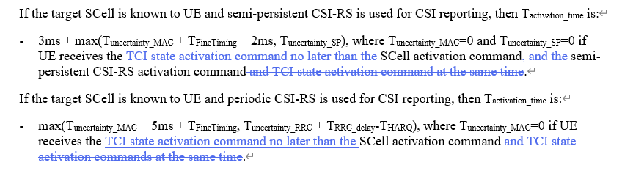
    - If proposal 1 is not agreeable, send LS to RAN2 clarifying the RAN2 understanding of the applicability of tci-ActivatedConfig.
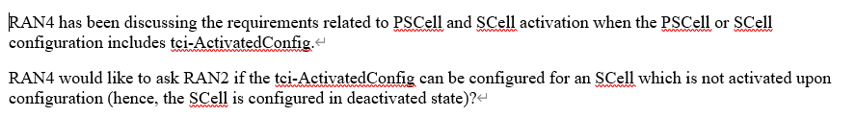
- Recommended WF
  - Discuss the options

Topic #4: R17 NR_MG_enh

Companies’ contributions summary
T-doc number | Company | Proposals / Observations
R4-2407873 | OPPO | Observation 1: It has been captured in TS 38.133 spec that when the SMTC of deactivated SCell is fully or partially overlapped with NCSG, the deactivated SCell is measured via NCSG.  Observation 2: It is unclear whether intraFreq-needForNCSG is limited to the activated SCell.  Observation 3: The two NCSG patterns in each of the following groups are the same in terms of ML and VIRP:  - NCSG pattern 0 and 13  - NCSG pattern 1 and 14  - NCSG pattern 4 and 12  - NCSG pattern 5 and 15  - NCSG pattern 6 and 16  - NCSG pattern 7 and 17  - NCSG pattern 8 and 18  - NCSG pattern 9 and 19  Observation 4: When both the serving cells and measurement purpose are in FR2, and the per-UE gap (pattern #12-25) is configured, the switching time is 0.25ms rather than 0.5ms.  Observation 5: When both the serving cells and measurement purpose are in FR2 only, and the per-UE NCSG (pattern #12-23) is configured, VIL is defined as 1ms in current spec, which is not aligned with the principle of RF switching time for MG pattern.  Proposal 1: Option 2 can be supported if the following clarification is added in the spec:  - intraFreq-needForNCSG is limited to the activated SCell and UE is capable to measure the deactivated SCell within NCSG by default.  Propose 2: VIL should be specific to NCSG patterns, i.e. VIL=1ms for NCSG pattern #0-11 and VIL=0.75ms for NCSG pattern #12-23.  Propose 3: Consider the following two methods to capture proposal 2 is agreed:  - Option 1: explicitly capture VIL in the NCSG patterns in Table 9.1.9.3-1, e.g. by adding one more column for VIL.  - Option 2: implicitly associated VIL with NCSG patterns in the VIL requirements, e.g. Table 9.1.9-1 for NCSG pattern #0-11 and Table 9.1.9-2 for NCSG pattern #12-23.
R4-2408328 | Ericsson | Observation 1: Deactivated SCell will be measured within NCSG regardless of FR type has already captured in spec.  Proposal 1: In Rel-17, when UE supports NCSG capability, all deactivated SCell are measured within NCSG provided that NW configures NCSG.
R4-2408625 | vivo | Proposal 1: For the question “Will all deactivated Scell be measured via NCSG regardless the UE capability report of intraFreq-needForNCSG”, prefer “when the SMTC of deactivated SCell is fully or partially overlapped with NCSG, the deactivated SCell is measured via NCSG regardless the UE capability report of intraFreq-needForNCSG”.  Proposal 2: No new UE capability is needed for the support of NCSG for deactivated SCell.
R4-2409159 | Nokia | Proposal 1: For Rel-17 deactivated SCell measurements using NCSG, agree option2: The Rel-17 UE behaviour is that when the SMTC of deactivated SCell is fully or partially overlapped with NCSG, the deactivated SCell is measured via NCSG regardless the UE capability report of intraFreq-needForNCSG. Otherwise, the UE performs the deactivated SCell measurements outside of NCSG.  Proposal 2: RAN4 not to consider a new UE capability for NCSG based deactivated SCell measurements in Rel-17, as unique behavior of UEs supporting NCSG is desirable.

Open issues summary

Sub-topic 4-1: Measurement of deactivated SCell in NCSG
- Proposals
  - Option 1 (OPPO, Ericsson, vivo, Nokia):
    - The Rel-17 UE behaviour is that when the SMTC of deactivated SCell is fully or partially overlapped with NCSG, the deactivated SCell is measured via NCSG regardless the UE capability report of intraFreq-needForNCSG. Otherwise, the UE performs the deactivated SCell measurements outside of NCSG.
    - RAN4 not to consider a new UE capability for NCSG based deactivated SCell measurements in Rel-17
  - Option 1a (OPPO):
    - Clarify in spec that intraFreq-needForNCSG is limited to the activated SCell and UE is capable to measure the deactivated SCell within NCSG by default
- Recommended WF
  - Agree on option 1
  - Discuss whether any spec change such as option 1a is needed.

Sub-topic 4-2: NCSG patterns
- Proposals
  - Option 1 (OPPO):
    - VIL should be specific to NCSG patterns, i.e. VIL=1ms for NCSG pattern #0-11 and VIL=0.75ms for NCSG pattern #12-23.
    - Consider the following two methods to capture proposal 2 is agreed:
      - Option a: explicitly capture VIL in the NCSG patterns in Table 9.1.9.3-1, e.g. by adding one more column for VIL.
      - Option b: implicitly associated VIL with NCSG patterns in the VIL requirements, e.g. Table 9.1.9-1 for NCSG pattern #0-11 and Table 9.1.9-2 for NCSG pattern #12-23.
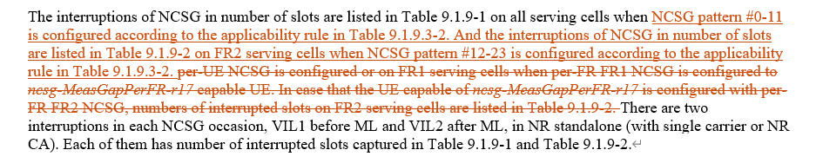
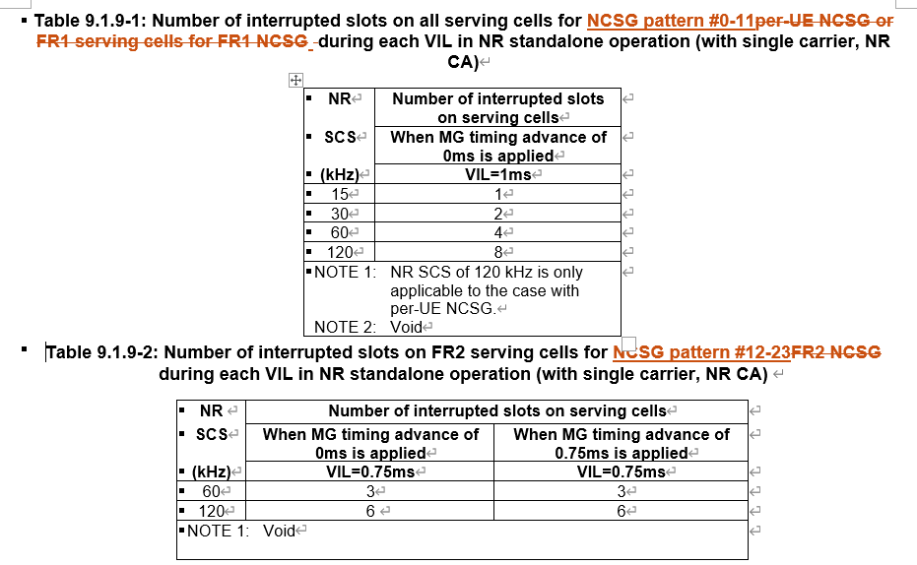
- Recommended WF
  - Discuss the options

Topic #5: R17 NR_NTN_solutions

Companies’ contributions summary
T-doc number | Company | Proposals / Observations
R4-2408507 | Nokia | Observation 1: UE are note expected to be capable to differentiate between GEO and Non-GEO satellites in GSO orbits.  Proposal 1: In the core part of TS 38.133, align the terminology by replacing GEO for GSO (Geosynchronous Orbits).  Observation 2: Requirements in NTN are applicable not only for LEO but for all satellites in NGSO domain.  Proposal 2: In TS 38.133, replace the terminology LEO by NGSO.
R4-2408704 | Ericsson | Proposal: Approve the LS reply to RAN2 in Annex.  RAN4 takes this opportunity to highlight that the NGSO naming is not used in the RAN4 SAN (Satellite Access Node) RF specification (TS 38.104, v17.7.0) but appears once in RAN4 RRM specification (TS 38.133 v17.13.0), which indicates the scenario for applying the capability maxNumber-LEO-SatellitesPerCarrier-r17. Indeed, RAN4 only studied NGSO, LEO600 and LEO1200 types of satellite, introducing 2 SAN classes: GEO (for NGSO) and LEO (for LEO600 and LEO1200).  Considering that other types of satellite have not been studied by RAN4, it’s not RAN4’s intention to update “LEO” naming to “NGSO” in RAN4 RF and RRM specifications for the time being. This might be done later based on the conclusion of the corresponding studies if any.  Nevertheless, as the mentioned fields (enhancedMeasurementLEO and maxNumber-LEO-SatellitesPerCarrier-r17) are not used in RAN4 RF and RRM specifications, RAN4 would respect RAN2’s decision to update them or not.

Open issues summary

Sub-topic 5-1: Alignment of terminology for satellite orbit types
- Proposals
  - Option 1 (Nokia):
    - In the core part of TS 38.133, align the terminology by replacing GEO for GSO (Geosynchronous Orbits).
    - In TS 38.133, replace the terminology LEO by NGSO.
  - Option 2 (Ericsson):
    - It’s not RAN4’s intention to update “LEO” naming to “NGSO” in RAN4 RF and RRM specifications for the time being.
    - This might be done later based on the conclusion of the corresponding studies if any.
    - Whether to change IE names as in RAN2 LS is up to RAN2
- Recommended WF
  - Discuss the options

Topic #6: R17 NR_RRM_enh2

Companies’ contributions summary
T-doc number | Company | Proposals / Observations
R4-2408549 | Huawei, HiSilicon | Observation 1: In legacy multiple SCell activation requirements as specified in section 8.3.7, it is always assumed that Cell search is not needed for an FR2 to-be-activated SCell.  Observation 2: Only sharing of cell search among FR1 Cells are considered in legacy requirements.  Observation 3: The sharing of cell search between FR1 and FR2 PUCCH SCell are not considered in existing requirements.  Proposal 1:  - If the to-be-activated FR2 PUCCH SCell is unknown without active serving cell(s) or known to-be-activated non-PUCCH SCell (s) on the same band, Tactivation_time_multiple_scells is the SCell activation delay in milliseconds for FR2 PUCCH SCell equal to T_{activation_time} + T_{FR1_N1,}  - T_{activation_time} is specified in section 8.3.2, and  - T_{FR1_N1} is the maximum length among {T_{FirstSSB_MAX_multiple_scells} + T_{SMTC_MAX_multiple_scells}+T_{rs}*N₁} of SCells counted in N₁ as defined in 8.3.7.  Otherwise, Tactivation_time_multiple_scells is the target SCell activation delay in millisecond in multiple SCell activation scenario as specified in section 8.3.7.
R4-2408552 | Huawei, HiSilicon | Observation 1: The reason why sync/async is further differentiated is that NW is more possible to avoid the interruption for sync case, thus symbol level interruption is useful at least for sync case.  Observation 2: The number of interruption symbols is calculated by aggressive CC symbol length +30 us/victim CC symbols length, where MRTD and MTTD is not used in the calculation.  Proposal 1: The SRS AS interruption requirements for NR SA shall be modified as following two cases:  - Interruption length in symbols of victim CC when 1 SRS symbol is configured  - Interruption length in slots of victim CC for rest of the SRS configurations

Open issues summary

Sub-topic 6-1: PUCCH SCell activation with multiple SCell
- Proposals
  - Option 1 (Huawei):
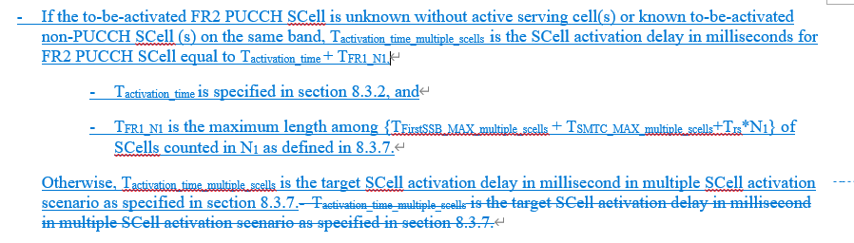
- Recommended WF
  - Discuss the options

Sub-topic 6-2: Interruption requrirements for SRS antenna switching
- Proposals
  - Option 1 (Huawei):
    - Void Table 8.2.2.2.16.2 (Interruption length in slots of victim CC when 1 SRS symbol is configured, and aggressor and victim cells are asynchronized)
    - The SRS AS interruption requirements for NR SA shall be modified as for the following two cases:
      - Interruption length in symbols of victim CC when 1 SRS symbol is configured
      - Interruption length in slots of victim CC for rest of the SRS configurations
- Recommended WF
  - Discuss the options

Topic #7: R17 NR_SmallData_INACTIVE

Companies’ contributions summary
T-doc number | Company | Proposals / Observations
R4-2409134 | Nokia | Observation 1: The design of power levels for SDT testing must be defined considering the relative measurement accuracy, please refer to tables 10.1.2.1.2-1 for FR1 and 10.1.3.1.2-1 for FR2. That means ±3dB for FR1 and ±6dB for FR2..  Observation 2: Current FR2 cg-SDT-RSRP-ChangeThreshold used in test parameters are too small in comparison to the FR2 relative RSRP accuracy.  Proposal 1: The cg-SDT-RSRP-ChangeThreshold of A.7.2.1 should be changed to 14dB. Same applies for equivalent test in RedCap. The cd-SDT-RSRP-ChangeThreshold of A.6.2.1 is suggested changed to 8dB. Same applies for equivalent test in RedCap.  Proposal 2: The values for the power in A.7.2.1 for T1, T3 and T6 to be changed from -100 to -104dBm/SCS, power for T2 from -87 to -80dBm/SCS and the values for T4 and T5 to be changed from -75.5dBm to -78dBm. Same applies for equivalent test in RedCap, resulting in an Io range from -72 to -49 dBm/BW.  Proposal 3: The values for the power in A.6.2.1 for T2 to be changed from -92dBm to -88dBm and the values for T4 andT5 to be changed from -82dBm to -86dBm. Same applies for equivalent test in RedCap. The range for Io is within the range of -50 to -70dBm/BW.  Proposal 4: RAN4 to review the P0 value of the RedCap SDT test for FR2. For SDT RedCap test case, a value of -104dBm/BW is suggested.

Open issues summary

Sub-topic 6-1: Power levels and thresholds in SDT TCs
- Proposals
  - Option 1 (Nokia):
    - The cg-SDT-RSRP-ChangeThreshold of A.7.2.1 should be changed to 14dB. Same applies for equivalent test in RedCap. The cd-SDT-RSRP-ChangeThreshold of A.6.2.1 is suggested changed to 8dB. Same applies for equivalent test in RedCap.
    - The values for the power in A.7.2.1 for T1, T3 and T6 to be changed from -100 to -104dBm/SCS, power for T2 from -87 to -80dBm/SCS and the values for T4 and T5 to be changed from -75.5dBm to -78dBm. Same applies for equivalent test in RedCap, resulting in an Io range from -72 to -49 dBm/BW.
    - The values for the power in A.6.2.1 for T2 to be changed from -92dBm to -88dBm and the values for T4 andT5 to be changed from -82dBm to -86dBm. Same applies for equivalent test in RedCap. The range for Io is within the range of -50 to -70dBm/BW.
    - RAN4 to review the P0 value of the RedCap SDT test for FR2. For SDT RedCap test case, a value of -104dBm/BW is suggested.
- Recommended WF
  - Discuss the options

