3GPP TSG-RAN WG4 Meeting #1111 R4-240xxxx
Fukuoka City, Fukuoka, Japan, 20th – 24th May, 2024
Title: [draft] WF on Rel-17 NCSG
Agenda Item: 4.4
Source: OPPO
Document for: Approval

Background
Ambiguity #1:
- When both the serving cells and measurement purpose are in FR2 only, and the per-UE gap (pattern #12-25) is configured, the switching time is 0.25ms rather than 0.5ms.
- When both the serving cells and measurement purpose are in FR2 only, and the per-UE NCSG (patterns #12-23) is configured, VIL is defined as 1ms in current spec, which is not aligned with the principle of RF switching time for the corresponding MG pattern.
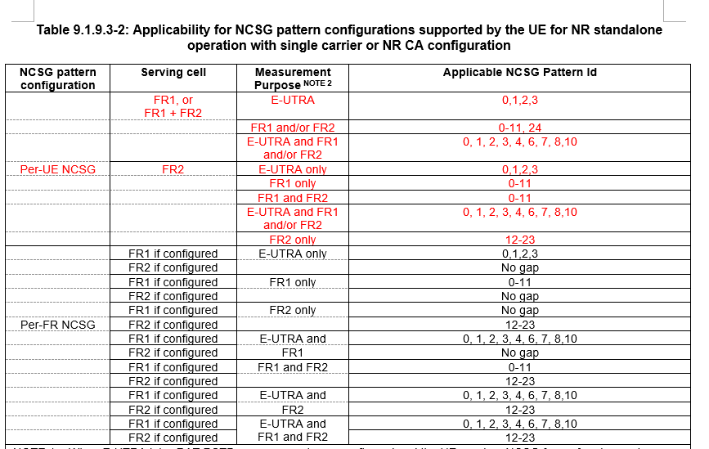
Ambiguity #2:
- For current Rel-17 NCSG patterns, only ML and VIRP are considered and VIL is not considered as a part of NCSG pattern, where ML_{NCSG} is derived by MGL_{legacy} - 2*RRT(switching time) for the corresponding MG patterns as illustrated in the table above. Then, some NCSG patterns are exactly the same, for example NCSG pattern #0 and #13, #1 and #14, etc.

MG pattern |  |  | NCSG pattern
Gap Pattern Id | Measurement Gap Length (MGL, ms) | Measurement Gap Repetition Period  (MGRP, ms) | NCSG Pattern Id | Measurement Length during which there is no gap (ML, ms) | Visible interruption Repetition Period  (VIRP, ms)
0 | 6 | 40 | 0 | 5 | 40
1 | 6 | 80 | 1 | 5 | 80
2 | 3 | 40 | 2 | 2 | 40
3 | 3 | 80  ML=MGL-2*0.5ms | 3 | 2 | 80
4 | 6 | 20 | 4 | 5 | 20
5 | 6 | 160 | 5 | 5 | 160
6 | 4 | 20 | 6 | 3 | 20
7 | 4 | 40 | 7 | 3 | 40
8 | 4 | 80 | 8 | 3 | 80
9 | 4 | 160 | 9 | 3 | 160
10 | 3 | 20 | 10 | 2 | 20
11 | 3 | 160 | 11 | 2 | 160
12 | 5.5 | 20 | 12 | 5 | 20
13 | 5.5 | 40 | 13 | 5 | 40
14 | 5.5 | 80 | 14 | 5 | 80
15 | 5.5 | 160  ML=MGL-2*0.25ms | 15 | 5 | 160
16 | 3.5 | 20 | 16 | 3 | 20
17 | 3.5 | 40 | 17 | 3 | 40
18 | 3.5 | 80 | 18 | 3 | 80
19 | 3.5 | 160 | 19 | 3 | 160
20 | 1.5 | 20 | 20 | 1 | 20
21 | 1.5 | 40 | 21 | 1 | 40
22 | 1.5 | 80 | 22 | 1 | 80
23 | 1.5 | 160 | 23 | 1 | 160

Way forward
Issue 1: Rel-17 NCSG clarification
- FFS whether and how to update VIL requirements in case of per-UE NCSG pattern #12-23 is configured
- FFS whether and how to distinguish NCSG pattern #0-11 and NCSG pattern #12-23.
  - Option 1: clarify VIL in Table 9.1.9.3-1: NCSG Configurations supported by the UE.
  - Option 2: modify VIL specific to NCSG patterns, e.g. Table 9.1.9-1 for NCSG pattern #0-11 and Table 9.1.9-2 for NCSG pattern #12-23.
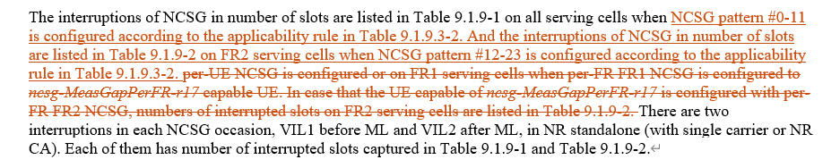
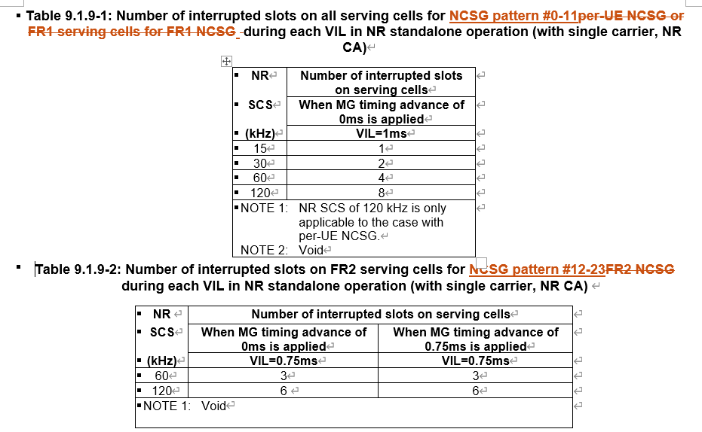

References
[1] R4-2407873, Discussion on Rel-17 NCSG maintenance issues, OPPO, RAN4 #111
[2] R4-2407874, CR on Rel-17 NCSG requirements, OPPO, RAN4 #111

