3GPP TSG-RAN WG4 Meeting #111 R4-24XXXXX
Fukuoka, Japan, 20 – 24 May, 2024

Agenda item: 4.8
Source: Huawei, HiSilicon
Title: Ad-hoc minutes #1 for [111][201] Maintenance_up_to_R17
Document for: Approval

Introduction
The document provides minutes for ad-hoc session #1 for [111][201] Maintenance_up_to_R17.

Topic #1: Open issues

Sub-topic 4-1: Measurement of deactivated SCell in NCSG
- Proposals
  - Option 1 (OPPO, Ericsson, vivo, Nokia):
    - The Rel-17 UE behaviour is that when the SMTC of deactivated SCell is fully or partially overlapped with NCSG, the deactivated SCell is measured via NCSG regardless the UE capability report of intraFreq-needForNCSG. Otherwise, the UE performs the deactivated SCell measurements outside of NCSG.
    - RAN4 not to consider a new UE capability for NCSG based deactivated SCell measurements in Rel-17
  - Option 1a (OPPO):
    - Clarify in spec that intraFreq-needForNCSG is limited to the activated SCell and UE is capable to measure the deactivated SCell within NCSG by default
- Recommended WF
  - Agree on option 1
  - Discuss whether any spec change such as option 1a is needed.

Agreement
- The Rel-17 UE behaviour is that when the SMTC of deactivated SCell is fully or partially overlapped with NCSG, the deactivated SCell is measured via NCSG regardless the UE capability report of intraFreq-needForNCSG. Otherwise, the UE performs the deactivated SCell measurements outside of NCSG.
- RAN4 not to consider a new UE capability for NCSG based deactivated SCell measurements in Rel-17
- FFS whether any spec change is needed or not.

Sub-topic 2-1: Interruption requirements for R16 NFG
- Proposals
  - Option 1 (Nokia, Deutsche Telekom, Orange, NTT DOCOMO, INC., TELECOM ITALIA S.p.A., Telia Company, T-Mobile USA, Verizon, Vodafone):
    - For Scenario 1 (LTE – NR inter-RAT measurement): a UE supporting interRAT-NeedForGaps-r16=FALSE may cause interruptions with a ratio of 5 % for FR1 and 8% for FR2.
    - For Scenario 2: If needForInterruptionConfigNR-r18 is not enabled, a UE indicating “no-gap” as part of NeedForGapsInfoNR-r16 may cause interruptions with a ratio of 3 % in FR1 and 7 % in FR2.
- Recommended WF
  - Discuss the options

Discussion
Nokia: we have R18 discussion. For R16 whether there is interruption is not defined. We derive the interruption ratio based on interruption length from R18 and measurement period from R16. Suggested to capture the requirements in spec.
Apple: not OK to define requirements for R16 UE. R16 is closed long time ago.
vivo: we can understand the logic to derive requirements, but defining new requirements to R16 is too late.
QC: same as Apple and vivo. The proposal is conflicting with R18 agreement. There are commercial R16 UE.
MTK: same as Apple, vivo and QC.
Nokia: the numbers are aligned with practical implementations. We want to give some clarity to NW on how much interruption would be. The issue was not closed with “may or may not”. Our proposal is already a compromise. How about defining the requirements from R17?
QC: do not support to change requirements for R16 feature in R17. This was already agreed in early R18 discussion.
CMCC: we agreed that R18 NFG will be early implemented to R17. This can be captured in 307. There are 2 types of R17 UE, one supporting R18 NFG, the other as Nokia proposed is supporting the new proposed requirements.
Charter: we can accept not changing R16 UE. We had agreement, is the proposal aligned to the same direction?
Nokia: There is parallel R18 discussion. We can try to have more offline this week.

Sub-topic 2-2: Measurement requirements for R16 NFG
- Proposals
  - Option 1 (Nokia, Deutsche Telekom, Orange, NTT DOCOMO, INC., TELECOM ITALIA S.p.A., Telia Company, T-Mobile USA, Verizon, Vodafone):
    - For Scenario 1: If the SMTC of the NR interRAT carrier is partially overlapping with measurement gaps, the UE shall perform NR interRAT measurements using the gaps.
    - For Scenario 2: If the SMTC is partially overlapping with measurement gaps, the UE shall perform the measurements using the gaps.
- Recommended WF
  - Discuss the options
Not discussed

Sub-topic 4-2: NCSG patterns
- Proposals
  - Option 1 (OPPO):
    - VIL should be specific to NCSG patterns, i.e. VIL=1ms for NCSG pattern #0-11 and VIL=0.75ms for NCSG pattern #12-23.
    - Consider the following two methods to capture proposal 2 is agreed:
      - Option a: explicitly capture VIL in the NCSG patterns in Table 9.1.9.3-1, e.g. by adding one more column for VIL.
      - Option b: implicitly associated VIL with NCSG patterns in the VIL requirements, e.g. Table 9.1.9-1 for NCSG pattern #0-11 and Table 9.1.9-2 for NCSG pattern #12-23.
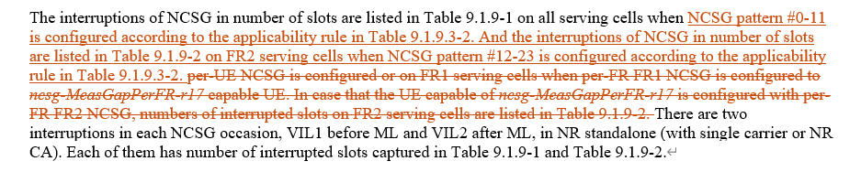
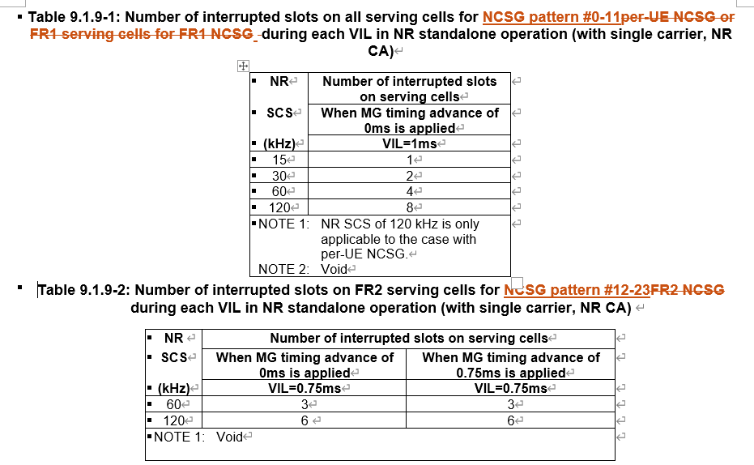
- Recommended WF
  - Discuss the options

Discussion
QC: we do not need the change. Spec is not broken. It is not just clarification.
MTK: current spec is not a mistake. VIL is agreed to be per FR, but some patterns can be used in both FRs.
Nokia: same as QC.
OPPO: when 12-23 is used per UE for FR2 only case, based on current spec VIL=1ms but should be 0.75ms
MTK: FFS whether it should be 0.75ms
Nokia: it should be 1ms.
QC: there can be preferences, but there is agreement already
OPPO: prefer to keep FFS. How about NCSG patterns?
Apple: this was already discussed in R17. Prefer not to change it.
Xiaomi: same as Apple.
MTK: do not want to reopen the discussion.

Sub-topic 5-1: Alignment of terminology for satellite orbit types
- Proposals
  - Option 1 (Nokia):
    - In the core part of TS 38.133, align the terminology by replacing GEO for GSO (Geosynchronous Orbits).
    - In TS 38.133, replace the terminology LEO by NGSO.
  - Option 2 (Ericsson):
    - It’s not RAN4’s intention to update “LEO” naming to “NGSO” in RAN4 RF and RRM specifications for the time being.
    - This might be done later based on the conclusion of the corresponding studies if any.
    - Whether to change IE names as in RAN2 LS is up to RAN2
- Recommended WF
  - Discuss the options

Discussion
Nokia: multiple references/terms in spec LEO, GEO, GSO, NGSO. We try to align.
E///: we can update the signalling based on RAN2 LS, but not sure we can change LEO to NGSO in the requirements, e.g. we excluded some DRX cycle based on LEO, it may not apply to NGSO. We suggest to keep as it is now.
Apple: either we do not change anything or we change both signalling and requirements.
Nokia: we discussed LEO and GEO when defining requirements, but in WID it is GSO and NGSO.
E///: RRM spec defines the applicability, and it only includes GEO and LEO.
Nokia: we may need come to RANP. We have other WGs to align.

Sub-topic 3-1: Applicability of tci-ActivatedConfig for SCell
- Proposals
  - Option 1 (Nokia):
    - Update the RAN4 UE requirements capturing that tci-ActivatedConfig can be configured for a deactivated SCell and a direct activated SCell.
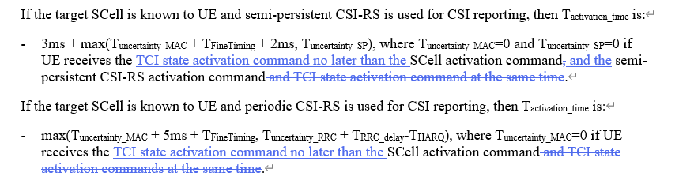
    - If proposal 1 is not agreeable, send LS to RAN2 clarifying the RAN2 understanding of the applicability of tci-ActivatedConfig.
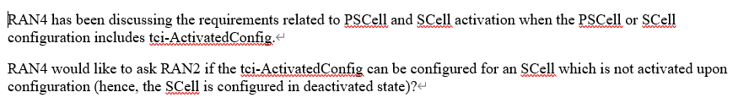
- Recommended WF
  - Discuss the options

Discussions
Nokia: TCI activation may come earlier than SCell activation, i.e. when the SCell is deactivated, via the new signalling. If this is not agreeable, we can check with RAN2.
QC, MTK need to check.
Apple: agree with Nokia observation, but change to the requirements is not fully correct.
E///: do we need TCI MAC CE?
Nokia: no. We can check if it applies to SCG also.

Sub-topic 6-1: PUCCH SCell activation with multiple SCell
- Proposals
  - Option 1 (Huawei):
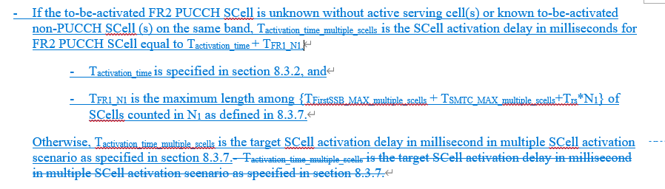
- Recommended WF
  - Discuss the options

Sub-topic 6-2: Interruption requrirements for SRS antenna switching
- Proposals
  - Option 1 (Huawei, vivo):
    - Void Table 8.2.2.2.16.2 (Interruption length in slots of victim CC when 1 SRS symbol is configured, and aggressor and victim cells are asynchronized)
    - The SRS AS interruption requirements for NR SA shall be modified as for the following two cases:
      - Interruption length in symbols of victim CC when 1 SRS symbol is configured
      - Interruption length in slots of victim CC for rest of the SRS configurations
- Recommended WF
  - Discuss the options

Sub-topic 7-1: Power levels and thresholds in SDT TCs
- Proposals
  - Option 1 (Nokia):
    - The cg-SDT-RSRP-ChangeThreshold of A.7.2.1 should be changed to 14dB. Same applies for equivalent test in RedCap. The cd-SDT-RSRP-ChangeThreshold of A.6.2.1 is suggested changed to 8dB. Same applies for equivalent test in RedCap.
    - The values for the power in A.7.2.1 for T1, T3 and T6 to be changed from -100 to -104dBm/SCS, power for T2 from -87 to -80dBm/SCS and the values for T4 and T5 to be changed from -75.5dBm to -78dBm. Same applies for equivalent test in RedCap, resulting in an Io range from -72 to -49 dBm/BW.
    - The values for the power in A.6.2.1 for T2 to be changed from -92dBm to -88dBm and the values for T4 andT5 to be changed from -82dBm to -86dBm. Same applies for equivalent test in RedCap. The range for Io is within the range of -50 to -70dBm/BW.
    - RAN4 to review the P0 value of the RedCap SDT test for FR2. For SDT RedCap test case, a value of -104dBm/BW is suggested.
- Recommended WF
  - Discuss the options

Sub-topic 1-1: MAC CE based active TCI state list update delay
- Proposals
  - Option 1 (Apple):
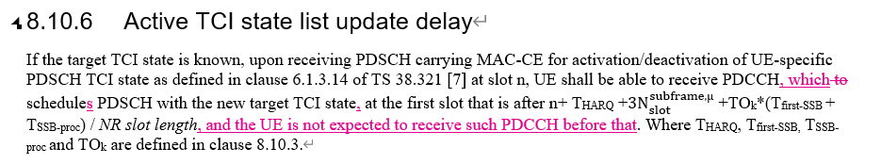
  - Option 2 (vivo):
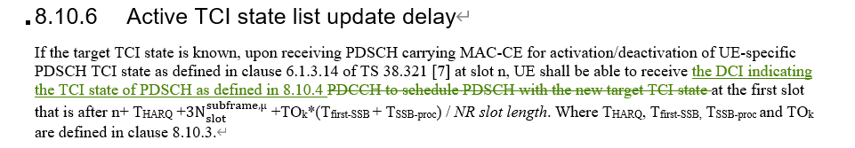
  - Option 3 (Nokia):
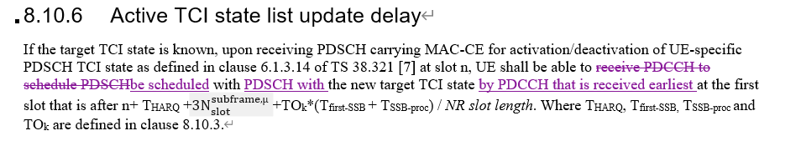
- Recommended WF
  - Discuss the options

Sub-topic 1-2: DCI based active TCI state switch delay
- Proposals
  - Option 1 (vivo):
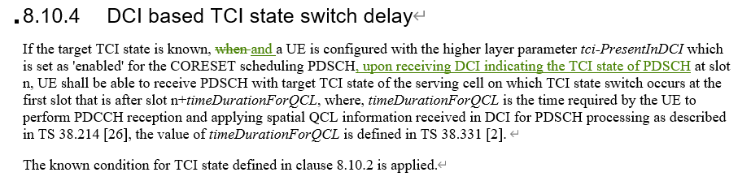
- Recommended WF
  - Discuss the options

Sub-topic 1-3: Test case for MAC CE based active TCI state switching delay
- Proposals
  - Option 1 (Nokia): for A.7.5.8.1.1 (NR PCell FR2 active TCI state switch for a known TCI state)
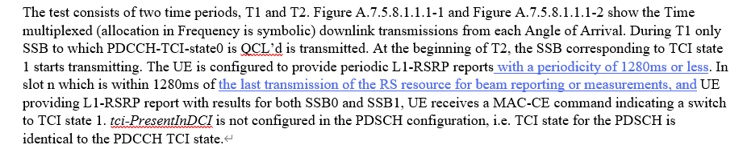
- Recommended WF
  - Discuss the options

