3GPP TSG-RAN WG4 Meeting # 111 R4-2410567
Fukuoka, Japan, 20th May 2024 - 24th May 2024

Agenda item: 10.13.4
Source: Moderator (CMCC)
Title: WF on co-existence evaluation for ambient IoT
Document for: Information

Introduction
This way forward captures the agreements for co-existence evaluation for Rel-19 ambient IOT study item.
The summary in RAN4#111 is R4-2408945. The way forward agreed in RAN4#110bis is in R4-2406714.

Deployment scenarios and spectrum usage

Topic 2-1: Deployment scenario
Issue 2-1-1: deployment scenarios for D1T1
Agreement in RAN4#110bis:
Issue 2-1-1: deployment scenarios for D1T1
Option 1-1: Legacy NR gNB are outdoor macro gNB while AIoT reader/CW/devices are all indoors. Legacy NR UE is only allowed outdoors.
Option 1-2: Legacy NR gNB are outdoor macro gNB while AIoT reader/CW/devices are all indoors. Legacy NR UE is indoor accessing to outdoor NR marco gNB
Option 2-1: Legacy NR gNB are co-located with AIoT reader and CW. All of NR and AIoT BS/UE/Reader/Device/CW are indoors. AIoT reader /CW and Legacy gNB share same hardware
Option 2-2: Legacy NR gNB are co-located with AIoT reader and CW. All of NR and AIoT BS/UE/Reader/Device/CW are indoors. AIoT reader /CW and Legacy NR gNB do not share same hardware. (less limitation on the power boosting)
Agreement:
- RAN4 to first evaluate co-existence for deployment scenario of option 1-1 and 1-2, and further study option 2-1 and 2-2.
Issue 2-3-2: Priorities of spectrum deployment mode for co-existence evaluation
Agreement:
- Prioritize the following spectrum deployment mode for RAN4 co-existence evaluation
  - A-IoT is located within a NR transmission bandwidth configuration
  - A-IoT which is operating indoor shares in-band spectrum with outdoor macro BS

Agreement in RAN4#111:
- Consider only adjacent RB/channel co-existence evaluation for in-band deployment scenario for NR and AIOT
- Encourage companies to provide the simulation results for option 1-1 and 1-2
  - FFS on co-site scenario (option 2-1 and 2-2)
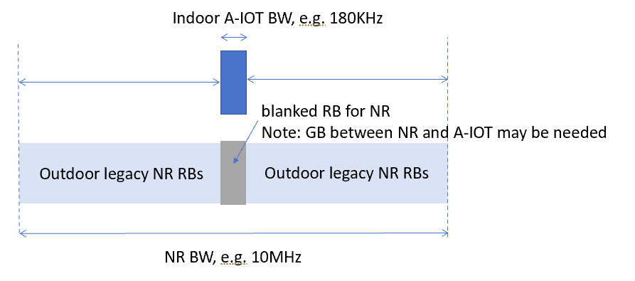

Issue 2-1-2: deployment scenarios for D2T2
Agreement in RAN4#110bis:
Option 1-1: Legacy NR gNB are outdoor macro gNB, AIoT intermediate UE/CW/devices are all indoors. Legacy NR UE is only allowed outdoor.
Option 1-2: Legacy NR gNB are outdoor macro gNB, AIoT intermediate UE/CW/devices are all indoors. Legacy NR UE is indoor.
Agreement:
- For D2T2 co-existence evaluation, Legacy NR gNB are outdoor macro gNB, AIoT intermediate UE/CW/devices are all indoors.
  - Consider option 1-1 and option 1-2 as the starting point

Topic 2-2: Spectrum usage
Issue 2-2-1: Spectrum usage for R2D in D1T1
Agreement in RAN4#110bis:
- FFS on whether to prioritize FDD DL spectrum for R2D for D1T1 for co-existence evaluation.

Agreement in RAN4#111:
- Use FDD DL as starting point for co-existence evaluation for R2D in D1T1
  - FFS on FDD UL spectrum.

Issue 2-2-2: Spectrum usage for CW transmission in D1T1 for the case that D2R backscattering is transmitted in the same carrier as CW for D2R backscattering
Agreement in RAN4#110bis:
For the case that D2R backscattering is transmitted in the same carrier as CW for D2R backscattering, and for topology 1, the following cases for CW transmission are studied.
· Case 1-1: CW is transmitted from inside the topology, transmitted in DL spectrum
· Case 1-2: CW is transmitted from inside the topology, transmitted in UL spectrum
· Case 1-4: CW is transmitted from outside the topology, transmitted in UL spectrum

Agreement:
- For the case that D2R backscattering is transmitted in the same carrier as CW for D2R backscattering, consider the following for co-existence evaluation
  - CW transmits in either UL or DL spectrum
  - FFS on inside topology and outside topology.

Agreement in RAN4#111:
- Use inside topology as starting point for co-existence evaluation (case 1-1, case 1-2) for calibration.
- Further discuss the difference of outside topology (case 1-4) from co-existence study perspective.

Issue 2-2-4: Spectrum usage for R2D in D2T2
Agreement in RAN4#110bis:
- Use FDD UL spectrum for R2D in D2T2.

Issue 2-2-5: Spectrum usage for CW transmission in D2T2 for the case that D2R backscattering is transmitted in the same carrier as CW for D2R backscattering
Agreement in RAN4#110bis:
For the case that D2R backscattering is transmitted in the same carrier as CW for D2R backscattering, and for topology 2, the following cases for CW transmission are studied.
· Case 2-2: CW is transmitted from inside the topology (i.e., intermediate UE), transmitted in UL spectrum
· Case 2-3: CW is transmitted from outside the topology, transmitted in DL spectrum
· Case 2-4: CW is transmitted from outside the topology, transmitted in UL spectrum
Agreement:
- For the case that D2R backscattering is transmitted in the same carrier as CW for D2R backscattering
  - Use UL spectrum as the starting point for co-existence evaluation.
    - It won’t preclude the use of DL for backscattering transmission.
    - FFS on the minimum distance between the intermediate UE and A-IoT device

Agreement:
- Use case 2-2 as starting point for co-existence evaluation for calibration.
- FFS on case 2-3
- Further discuss the difference of outside topology (case2-4) from co-existence study perspective.

Evaluation methodology and cases

Topic 3-1: Evaluation methodology
Issue 2-4-1: Evaluation methodology
Agreement in RAN4#110bis:
- Use the Monte-Carlo method as baseline for co-existence evaluation, i.e. Section 5.3 in TR38.803
- Depending on the discussion on deployment scenarios, for some cases, calculation for the worst interference link may be enough.
- FFS on whether RAN4 needs to perform link level simulation

Agreement in RAN4#111:
- Use the Monte-Carlo method as baseline for co-existence evaluation, i.e. Section 5.3 in TR38.803
- FFS on whether RAN4 needs to perform link level simulation

Issue 2-4-2: Performance metric for AIOT
Agreement in RAN4#110bis:
- For NR system, use 5% throughput loss as performance metric as legacy.
- For AIOT system, including reader, device, intermediate UE, further discuss the performance metric:
  - Option 1: [10%] BLER, [Rx power]
  - Option 2: SINR degradation
  - Other options are precluded

Agreement in RAN4#111:
- Use SINR for calibration purpose
- FFS on performance metric for co-existence evaluation and requirements definition.

Issue 2-4-2: SINR definition for D2R
Agreement in RAN4#111:
Do not consider CW interference for calibration purpose for D1T1-A2 and D2T2-A2
FFS on how to consider CW cancellation capability in formal simulation

Issue 2-4-2: SINR definition for R2D
Agreement in RAN4#111:
SINR for R2D for calibration purposes
- signal power of device to the noise and interference within 10MHz
  - Assume interference NR BW is 10MHz
- FFS on BB LPF

Topic 3-2: Evaluation cases
Issue 3-2-1: device type
Agreement in RAN4#110bis:
- Prioritize device 1 and 2a without a frequency shifter for coexistence evaluation.

Issue 3-2-4: Evaluation cases for D1T1 for device 1 and 2a between NR and AIOT
Agreement in RAN4#111:
Use the following cases for calibration purposes.
Deployment scenario and topology | spectrum | aggressor | victim | Note
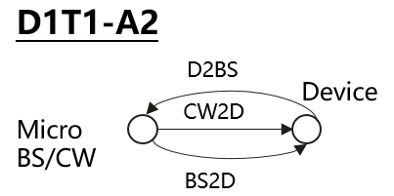  · Case 1-1: CW is transmitted from inside the topology, transmitted in DL spectrum  Case 1-2: CW is transmitted from inside the topology, transmitted in UL spectrum | R2D: DL  CW2D and D2R: UL | device | NR UL | D2R
 |  | NR UL | reader | D2R
 |  | reader | NR DL | R2D
 |  | NR DL | device | R2D
 | R2D: DL  CW2D and D2R: DL | device | NR DL | D2R
 |  | NR DL | reader | D2R

Issue 3-2-5: Evaluation cases for D2T2 for device 1 and 2a between NR and AIOT
Agreement in RAN4#111:
Use the following cases for calibration purposes.
Deployment scenario and topology | spectrum | aggressor | victim | Note
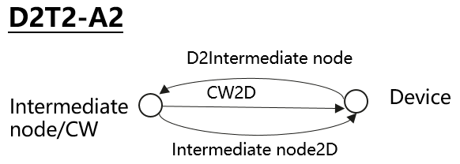  \  Case 2-2: CW is transmitted from inside the topology (i.e., intermediate UE), transmitted in UL spectrum | R2D: UL  CW2D and D2R: UL | device | NR UL | D2R
 |  | NR UL | reader | D2R
 |  | reader | NR UL | R2D
 |  | NR UL | device | R2D

Issue 3-2-7: Multi-operator scenario
Agreement in RAN4#111:
FFS on co-existence between AIOT system and adjacent operator NR system
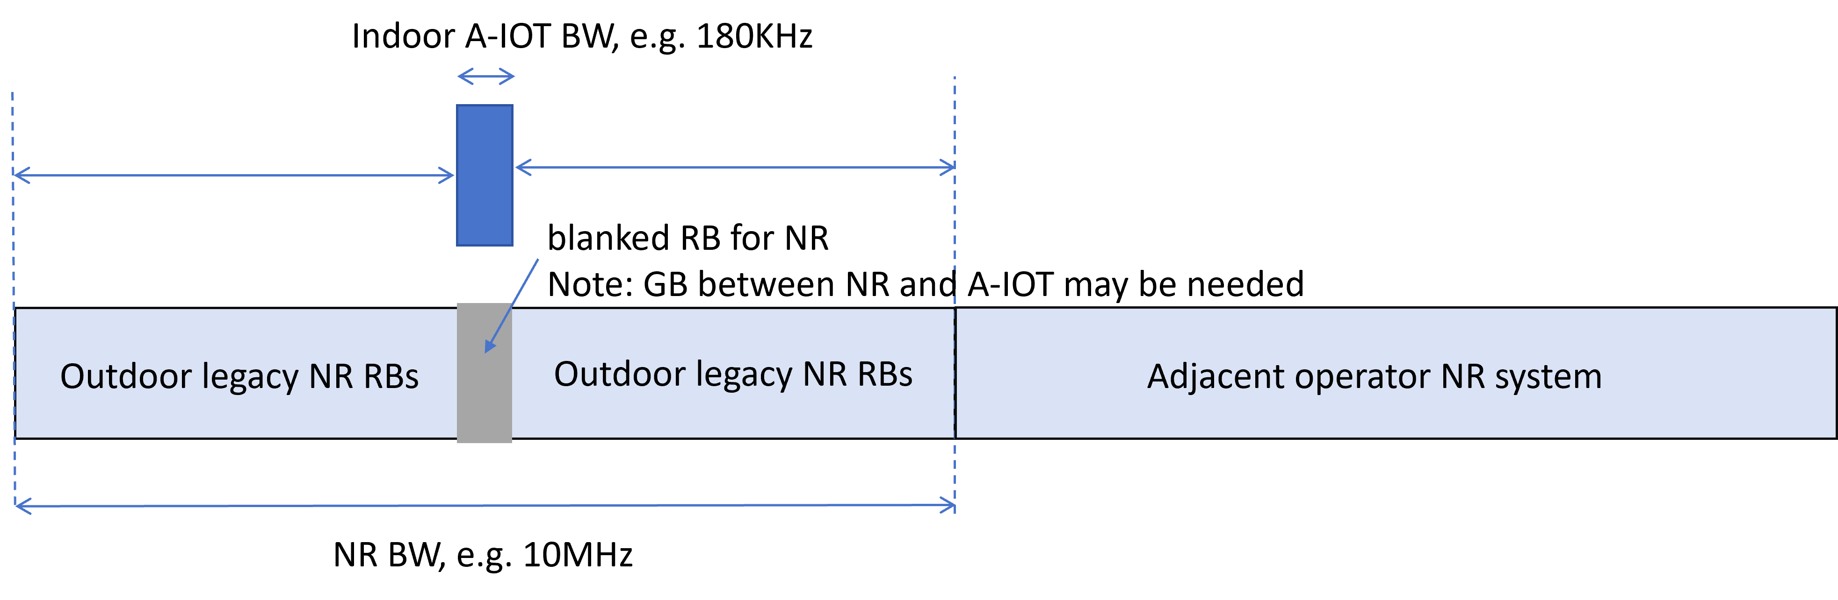

Evaluation parameters

Topic 4-1: Adjacent RB Tx and Rx charateristics
Issue 4-1-1: A-IOT reader
Agreement in RAN4#111:
For calibration purpose, use 0RB guard band between AIOT and NR for in-band spectrum deployment mode
 |  | In-band
 |  | Tx | Rx
NR UE/A-IOT Intermediate UE | For calibration purpose | Legacy UE IBE | ACS
NR BS | For calibration purpose | ACLR of legacy gNB | ACS of legacy gNB
A-IOT BS | For calibration purpose | ACLR of legacy gNB (i.e. 45) | ACS of legacy gNB

Issue 4-1-2: Tx for device 1 and 2a
Agreement in RAN4#111:
For device 1 and 2a, 25dBc is used for calibration purposes.
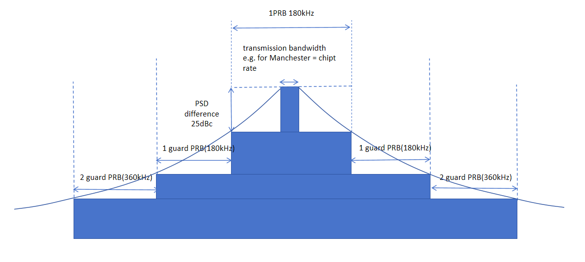
Issue 4-1-3: Rx for device 1 and 2a
Agreement in RAN4#111:
Assume no frequency selectivity for co-existence evaluation for calibration purposes for device 1 and 2a.

Topic 4-2: General paramters and layout
Issue 4-2-1: General parameters
Agreement in RAN4#111:
Use following parameters for calibration purposes.
General Parameter | D1T1&D2T2  Values for calibration purposes
Carrier frequency | 900MHz
BW for NR | 10MHz with 15KHz SCS
BW for AIOT system | 180KHz
Waveform (CW) | CW: Unmodulated single tone
Waveform (R2D) | OOK waveform generated by OFDM modulator
A-IoT DL power control | No
A-IoT UL power control | No
Traffic model | Full buffer
Frequency reuse | 1

Issue 4-2-2: Layout for D1T1
Agreement in RAN4#111:
Use following parameters for calibration purposes, i.e. scenario 1-1 and 1-2.
For Indoor NR, parameters are FFS, i.e. scenario 2-1 and 2-2.
Parameter | Assumptions for D1T1
Scenario | InF-DH
Hall size | 120x60 m
Room height | 10 m
Sectorization | None
Pathloss model | NLOS and LOS in TR38.901
BS deployment / Intermediate UE dropping | For D1T1-A2: 18 BSs on a square lattice with spacing D, located D/2 from the walls.  - L=120m x W=60m; D=20m  - BS height = 8 m  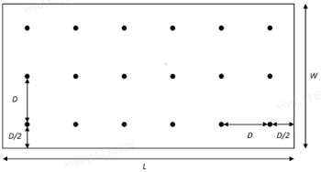  For D1T1-A1:  - FFS on layout: one node as transmission and CW, the neighbour node as reception
Device distribution | Device Height= 1.5 m  AIoT devices drop uniformly distributed over the horizontal area  Number of A-IoTs = Total area × activated density (1.5 A-IOT devices/m²)  1 active AIOT device under one reader at one drop  MCL between device and reader is 45dB for calibration.
NR BS deployment (outdoor), i.e. scenario 1-1 and 1-2 | Hexagonal grid, 19 macro sites, 3 sectors per site with wrap around, 1 AIOT indoor scenario per sector  the minimum 2D distance between macro BS and indoor factory centre is set as 100m.  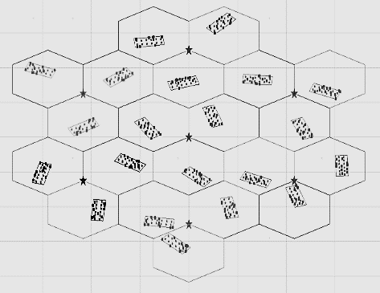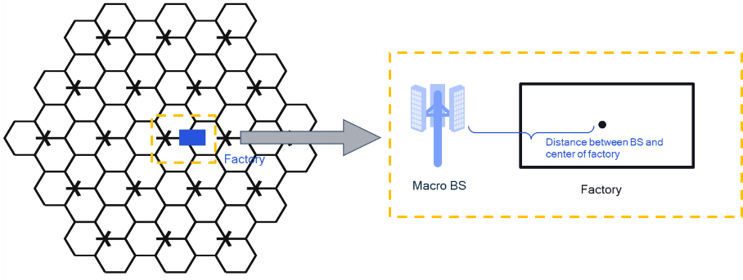
NR BS Inter-site distance | 750
Minimum NR BS – NR UE distance (2D) | 35 m
NR UE (D1T1) dropping | For scenario option 1-1, uniformly distributed outdoor.  For scenario option 1-2, uniformly distributed, 80% indoor, 20% outdoor  UE number:  DL active: 1 UE per cell  UL active UE: 3UE per cell
O2I penetration loss | High penetration loss as in TR 38.901 for calibration

Issue 4-2-3: Layout for D2T2
Agreement in RAN4#111:
Use InH-office as baseline for D2T2 co-existence evaluation.
Use following parameters for calibration purposes, i.e. scenario 1-1 and 1-2.
Parameter | Assumptions for D2T2
Scenario | InH-office
Hall size | 120 x50 m
Room height | 3m
Sectorization | None
Pathloss model | LOS and NLOS in TR38.901
BS deployment / Intermediate UE dropping | - L=120m x W=50m;  - Intermediate UE height = 1.5 m  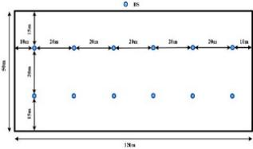  For D2T2-A2:  The intermediate UEs selected from the fixed positions.  Number of intermediate UE for calibration:  - Option 1: 2 UE at one drop  - Option 2: 12 UE at one drop  For D2T2-A1: FFS on layout
Device distribution | Device Height= 1.5 m  AIoT devices drop uniformly distributed over the horizontal area  Number of A-IoTs = Total area × activated density (1.5 A-IOT devices/m²)  1 active AIOT device under one reader at one drop  Minimum distance between reader and device is 1m
NR BS deployment | Hexagonal grid, 19 macro sites, 3 sectors per site with wrap around, 1 AIOT indoor scenario per sector  the minimum 2D distance between macro BS and indoor factory centre is set as 100m.
NR UE dropping | For scenario option 1-1, uniformly distributed outdoor.  For scenario option 1-2, uniformly distributed, 80% indoor, 20% outdoor  UE number:  - DL active UE: 1 UE per cell  - UL active UE: 3 UE per cell
O2I penetration loss | High penetration loss as in TR 38.901

Topic 4-3: Paramters for AIOT BS/intermedaite UE and device
Issue 4-3-1: AIOT micro-BS parameters for D1T1
Agreement in RAN4#111:
Use following parameters for calibration purposes.
A-IoT micro BS parameters | Values for calibration purposes
A-IoT micro-BS total Tx power | 33dBm
A-IoT micro-BS receiver Noise Figure（dB） | 10
A-IoT micro-BS antenna gain (dBi) | 6 dBi
Antenna pattern | Refer to TR25.942

Issue 4-3-2: Intermediate UE parameters for D2T2
Agreement in RAN4#111:
Use following parameters for calibration purposes.
intermediate UE parameters | Values for calibration purposes
intermediate UE total Tx power（dBm） | 23dBm
gain of antenna intermediate UE (dBi) | 0
intermediate UE receiver Noise Figure（dB） | 9
Antenna configuration | Omni direction antenna

Issue 4-3-3: CW parameters
Agreement in RAN4#111:
Do not use CW2D for calibration purposes.
FFS on:
- CW interference to NR BS/UE/AIOT
- CW remaining interference after CW cancellation.
  - [CW IBE]

Issue 4-3-4: AIOT device parameters
Agreement in RAN4#111:
Use Device 1 with following parameters for calibration purposes.
A-IoT device parameters | Device 1  Values for calibration purposes
A-IoT device effective antenna gain per Tx or Rx branch (dBi) | 0
A-IoT device reflection （backscatter）loss (dB)  Note: due to, e.g., impedance mismatch | OOK: -6 dB
A-IoT device power gain of reflection amplifier (dB) | N/A
A-IoT Device receiver sensitivity (dBm)  Use this value to determine whether device can camp on the cell. | -36
A-IoT device noise figure (dB) | 24
Guard band | 0PRB

Topic 4-4: Paramters for legacy NR
Issue 4-4-1: NR macro BS parameters
Agreement in RAN4#111:
Use following parameters for calibration purposes.
NR macro-BS Parameter | Values for calibration purposes
Macro-BS Tx power (dBm) | 46
BS antenna gain (dBi) | Refer to TR36.942
Height of macro NR BS (m) | 25
NR Macro-BS Noise Figure(dB) | 5
Network location | outdoor

Issue 4-4-2: NR UE parameters
Agreement in RAN4#111:
Use following parameters for calibration purposes.
NR UE Parameter | Values for calibration purposes
UE TX power in dBm | -40 to 23
NR UE Antenna gain (dBi) | 0
Height of UE antenna (m) | 1.5
NR UE ACLR（dB） | 30
NR UE Noise Figure（dB） | 9
Antenna configuration | Omni direction antenna

